Special Academe Services

|  |  |
| --- | --- |
| Thandokuhle Brian Msane | 202203673 |
| Neliswa Maziya |  |
| Thandolwethu Agnes Nhlabatsi |  |

# Table of Content

1. Part One
   1. Introduction
   2. Problem Identification or Statement
   3. Project objective summary
2. Part Two
   1. The change we seek to solve
   2. The need or niche we want to address
   3. The solution we aim to obtain
   4. The stakeholders
   5. The value for our stakeholders
   6. The context that may affect and influence the project
   7. Project assumptions
3. Part Three
   1. Requirement gathering techniques
   2. Sample interview questions
   3. Sample questionnaire
4. Part Four
   1. Context Diagram
   2. Level 1 data flow diagram
   3. Level 2 data flow diagram
   4. Data dictionary
5. Part Five
   1. Source code submission
   2. Introduction

Often times when a student finishes writing the form five external examination they tend to focus or even project themselves as university students. Unfortunately, between this fantasy and the reality lies a hurdle which is the application process. This process has so many problems which are: unawareness of application dates, misinformation about programs they want to pursue, lots of money spent, to name a few. This information gap can lead to uninformed decision, impacting their future careers and overall satisfaction during the course of their study. The need for a centralized system to assist student in making well-informed decision is apparent.

* 1. Problem Identification

High school graduates encounter several critical issues during the university application process and those includes the following.

1. Limited understanding of available programs: Students often select programs based on advice from others, media influence, or long-held aspiration without fully understanding the program content, admission requirements, or career prospects. This can result in dissatisfaction and hinders career progression. In often times, students end up dropping out because they are required to do things they are not passionate about.
2. Costly application procedures: The traditional application process requires students to physically visit multiple universities and colleges to gather information and submit applications. This methods is time-consuming, expensive, and inefficient, especially for those with limited financial resources. Also, the universities need more human labor to handle this process and that is ultimately costlier.
3. Unawareness of application timeline and costs: Many students are not informed about application opening and closing dates, acceptance periods, and costs associated with the entire process in different institutions. Many miss opportunities due to this.

These challenges not only necessitate a centralized system but also highlight a systematic problem affecting students’ successful transition into tertiary education. The lack of accessible, comprehensive information and streamlined processes necessitate a solution to support students during this critical phase of their lives.

* 1. Project Objective Summary

The proposed system aim to alleviate the mentioned issues by building a very informative, user-friendly, and integrated system. The primary objective is to provide comprehensive program information to applicants. Detailed descriptions, prerequisites, admission criteria, curriculum details and potential career paths associated with each program will be provided. Further, we aim to simplify the application process by creating centralized, one-size-fits-all online platform which allows students to apply from the comfort of their homes to reduce physical visits and travelling costs. Lastly, to mention a few of our objectives, we aim to provide the awareness of application timelines and costs associated with applying.

# Part Two

1. The change we seek to solve

This project aims to address the inefficiencies and challenges associated with manual admission processes into tertiary institutions in Eswatini. The current system involves multiple applications, redundant paper work, delays in processing and lack of transparency which can result in abandoned admissions and missed opportunities for students. The project seeks to automate the admissions process and create a centralized platform that simplifies applications for both students and institutions and is advantageous to all parties involved as elaborated below.

1. The need or niche we want to address

The key needs identified include:

* Streamlining of the admissions process: Simplifying and unifying the application procedures for all institutions of higher education in the country.
* Transparency and accessibility: Allowing applicants to access real-time information on their admission status.
* Reduction of redundant work: Eliminating multiple applications to different institutions and the associated administrative burdens.
* Efficient document verification: Automating the verification of results and documents, reducing the chances of fraud or inaccuracies.
* Broader access to educational opportunities: Providing candidates with more choices and better visibility of available programs and funding opportunities.

Eliminating the chances of students applying for programs which they do not qualify for unknowingly and this results to an obvious rejection by the university or college

1. The solution we aim to obtain

Furthermore, the SAS system will create a single, unified platform that automates the entire admission process, allowing applicants to apply to multiple institutions through a common application. The solution will automate application processing making it easier for candidates to apply and institutions to manage applications. This will also help curb instances where applications get lost in the hands of the institutions when they have been manually submitted as hard copies by students. The system also aims to enhance data security through document certification, ensuring that results and personal information of candidates are legitimate. Furthermore, our goal is to empower candidates by giving them access to more options and the ability to confirm provisional admissions. Our solution will also provide decision-making data for institutions and government entities, helping in educational planning and research. Application statistics (e.g., number of applications per institution, program preferences, acceptance rates), enrolment trends (e.g., which programs and institutions are most popular) and candidate performance data (e.g., exam scores, academic backgrounds) are the types of data to be collected from applicants and institutions (just to name a few) by the SAS system

1. The stakeholders

Project stakeholders are individuals or organizations who are actively involved in the project, or whose interests may be positively or negatively affected as a result of project execution or successful project completion. The stakeholders involved in this project include:

* Tertiary Institutions: Universities, colleges and technical institutions who are responsible for managing admissions.
* Applicants: Students applying for admission to undergraduate programs.
* Government bodies: Agencies seeing education in Eswatini, responsible for policy formulation and data collection.
* Sponsors and funders: Private organizations or individuals looking to sponsor students based on specific criteria.
* SAS development team: The team responsible for designing, implementing and maintaining the system.

1. The value for our stakeholders

The value the project will bring to the stakeholders:

* For applicants: A simplified and transparent admission process, reducing the need for multiple applications submitted to each and every institution in the country that one wishes to apply to and providing access to real-time status updates and more educational opportunities.
* For tertiary institutions: Increased efficiency in processing applications, better quality data on candidates and the ability to manage admissions in batches or instantaneously.
* For sponsors and funders: Easier access to a centralized pool of candidates with various criteria for selection, such as exam scores.
* For government bodies: Reliable data for educational planning, research and decision-making to improve policies.

1. The context that may affect and influence the project

Moreover, the context that may affect and influence the project includes the technological infrastructure which defines the level of internet access and digital literacy among candidates and institutions may affect the adoption and usage of the SAS system. Another being regulatory requirements, which are government policies related to admissions, data privacy and education. Institutional autonomy is another context which may influence how the system is implemented, therefore, maintaining the autonomy of institutions is crucial although the system is centralized. Also, we dived into funding and resources. This basically stresses on the availability of resources to develop, deploy and maintain the SAS system that could affect timelines and scope

1. Project assumptions

We then had to consider a few assumptions as well which we could base our project on. The first one being that candidates and institutions have adequate internet access and basic digital skills to engage with the online system. Secondly, we assumed that all institutions will adopt the SAS system, despite the centralization aspect while still maintaining their autonomy. Thirdly, government and educational authorities will support the project by enforcing its use and providing relevant data as they are to benefit from the system as well.

# Part Three

* 1. Requirement gathering techniques
  2. Sample interview questions
  3. Sample questionnaire

# Part Four

* 1. Context Diagram

The data flow diagram shows the movement of data within the systems and when drawing it we start from the special level called level 0 or the context diagram. This is a special in a way such that it depicts the entire system as just one process, labelled process 0, which can be exploded further in the other levels of dataflow diagramming. This ensures a top down approach to system modelling while making sure that even non-technical users can understand the system. The context diagram is concerned about the major external entities and major data flows as it is with processes and data stores. Below we have the context diagram of our proposed system.

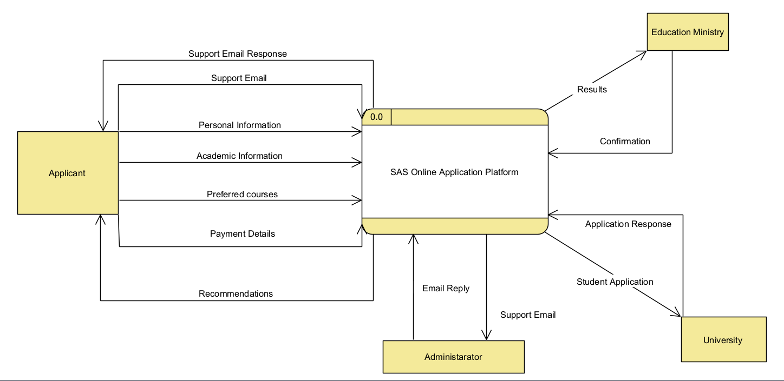

* 1. Level 1 data flow diagram

Exploding the process in the context diagram into 8 sub-processed within the system gives birth to the level one diagram. We further broke down the system into processes which include, processing data, requesting results verification form the education ministry, sieving relevant programs, shortlisting those programs, adding customer support, processing payment, process application.

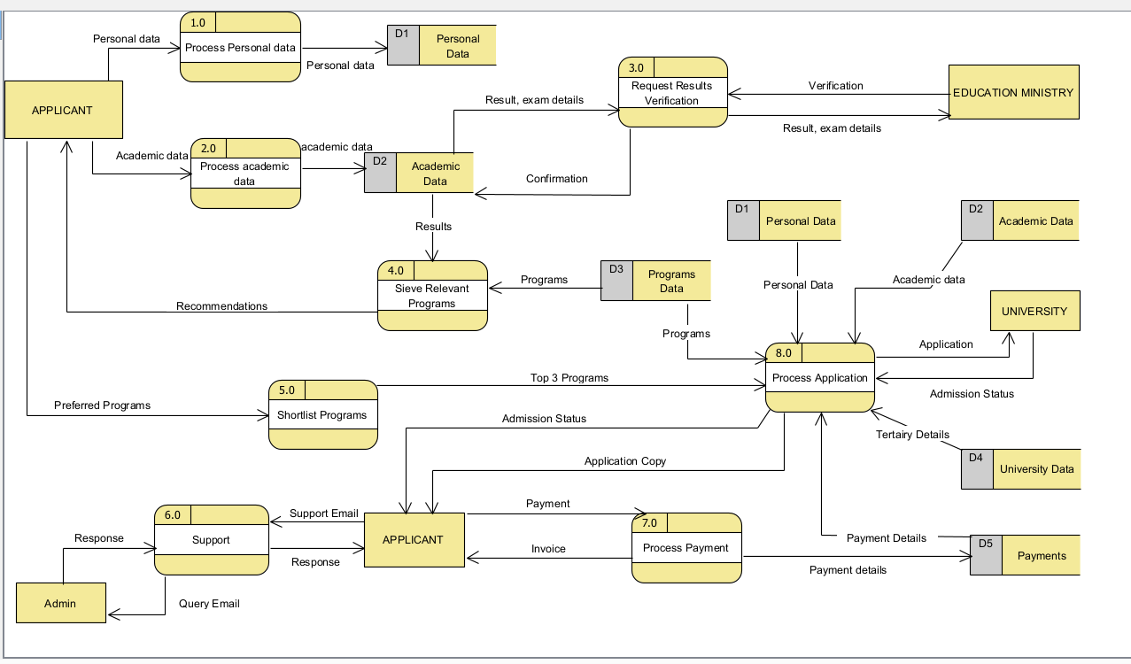

* 1. Level 2 data flow diagram

Exploding the processes can go further until all the processes in the diagram are primitive, that is, they are no longer divisible into sub-processes and as you go deeper, you tend to create as many level of the logical dataflow diagram and it is sometimes leading to the physical dataflow diagram which has system implementation details.

It is important to note that some, if not all, of the process can further be broken down or exploded so to create level two of the SAS data from diagram but we chose to go as further as this level. We needed to ensure that the diagram is free from technical jargons and it is a logical data flow diagram and going further within the level could result in a physical data flow diagram which show how the system will be implemented and almost often, the non-technical stakeholders do not understand that.

Only two processes are shown in the images below. The first process is the Process Academic Data which involves both the textual data and the scanned document of symbols or form five certificate. The two formats are handled separately and the text need to be formatted in a way which makes it compatible with the database constraints and on the document we need to run optical character recognition to get the text on it and parse the symbols. Thereafter, we need to store the data in the data stores.

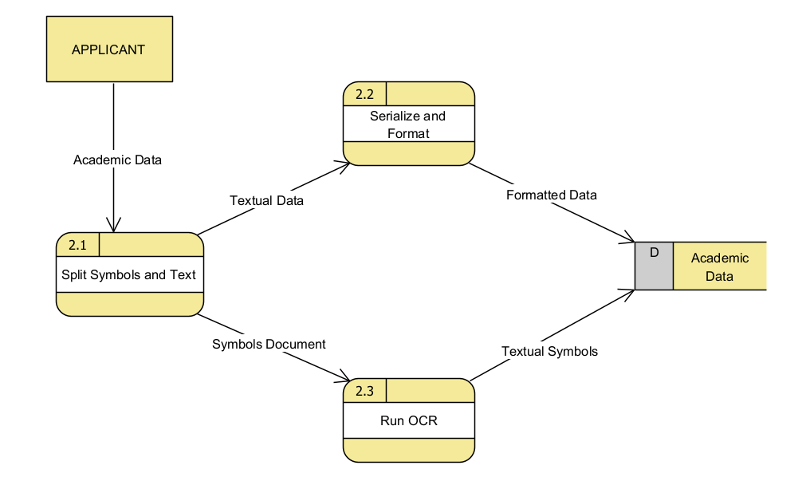

The second process which was exploded is the one for processing the application for the student and sending it to the tertiary institution they would like to apply to.

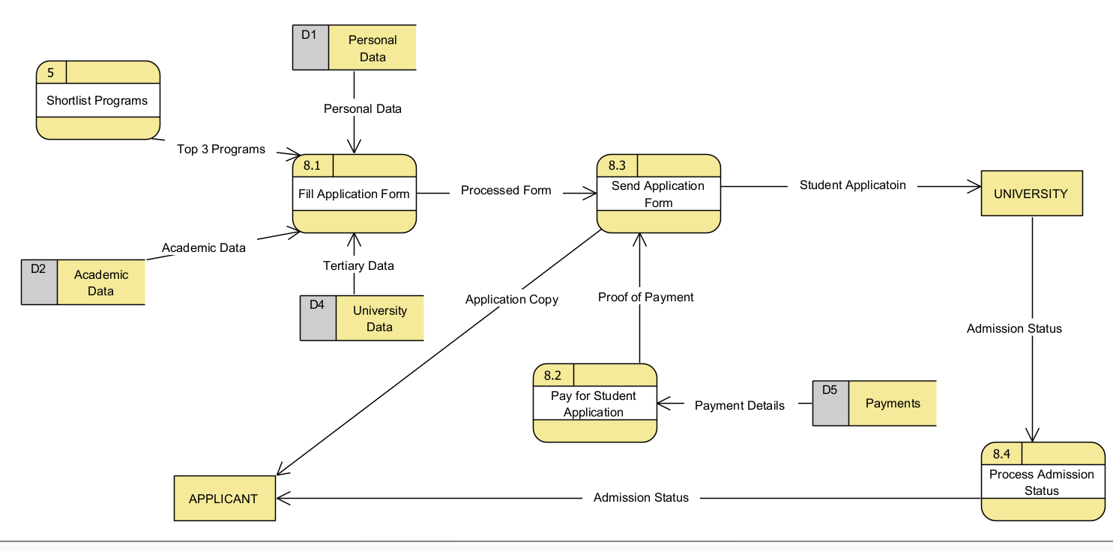

* 1. Data dictionary

--------------------

* 1. Source code submission

As advised, GitHub was used as a version control system that allowed the development team to seamlessly collaborate and track the progress of the project. There are also other services provided by this Git version control system which were used for the purpose of this project and those are GitHub issues, GitHub actions. We mainly incorporated CI/CD into the development while adhering to the SCRUM methodology principles and that necessitated the need to use GitHub issues to create backlogs and maintain changes while documenting the system features. We used a workflow to create a build pipeline which made it easy for us to run unit tests and integration testing to synchronously do system testing.

The link to the GitHub repository is [here](https://github.com/BrianMsane/mini-project.git).

GitHub repository: https://github.com/BrianMsane/mini-project.git