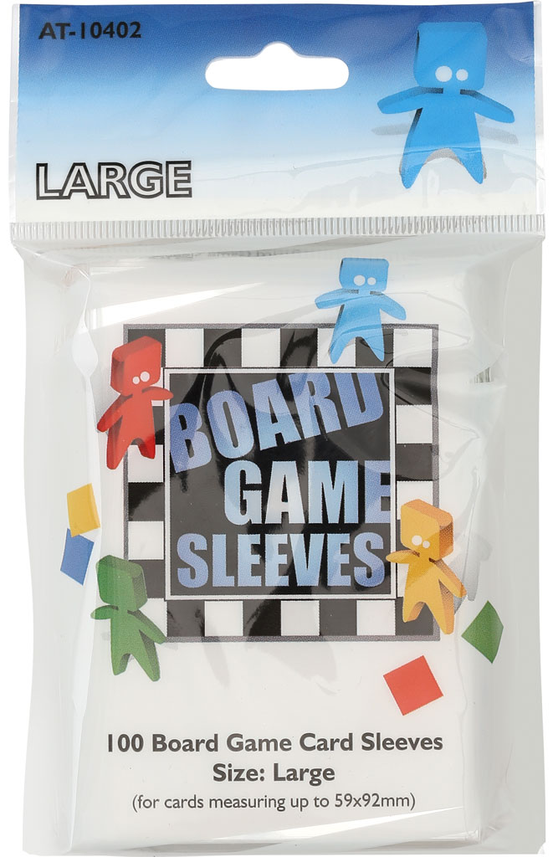

Report Title

REPORT SUBTITLE

Brian Munksgaard & Jens Christian Rasch | EAAA Backend | December 2016

## Problem Definition

## Heading 2

You might like the photo on the cover page as much as we do, but if it’s not ideal for your report, it’s easy to replace it with your own.

Just delete the placeholder picture. Then, on the Insert tab, click Picture to select one from your files.

## Asp.Net MVC Components

In the solution we have used the following Asp.Net MVC components:

|  |  |
| --- | --- |
| **Component** | **Description** |
| Controller |  |
| View |  |
| Partial View |  |
| HTML Helper |  |
|  |  |
|  |  |
|  |  |

## Uml Diagrams

Domain Model