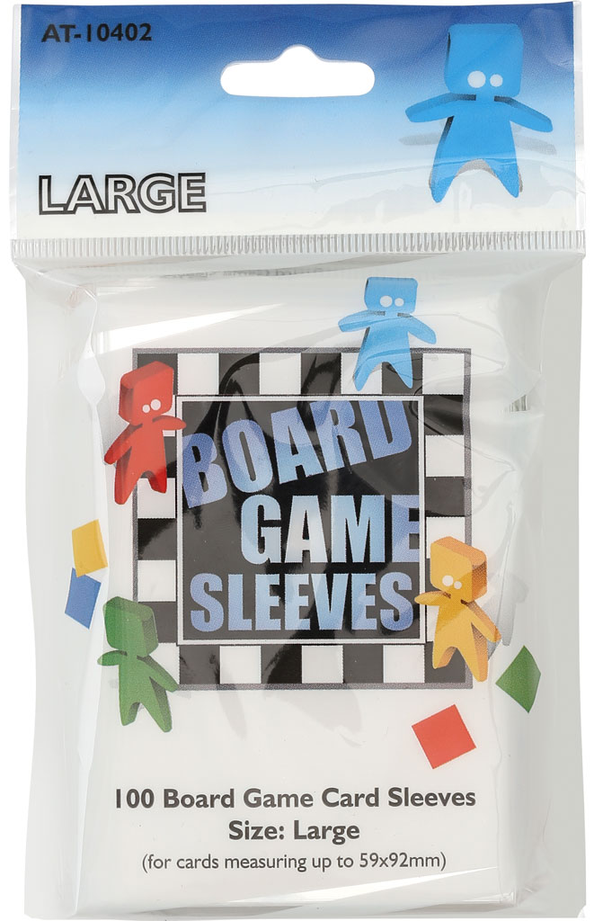

Report Title

REPORT SUBTITLE

Brian Munksgaard & Jens Christian Rasch | EAAA Backend | December 2016

Indholdsfortegnelse

Problem Definition 1

ASP.NET MVC 1

Asp.Net MVC Components 1

Implementation 1

Uml Diagrams 1

# Problem Definition

Arcane Tinmen are in the process of updating their online presence and as part of this work, they want to split their current website up, so that they have different websites for each of their brands. To begin this work, they have asked for an updated website for the brand Board Game Sleeves, to which they have acquired a corresponding domain name (boardgamesleeves.com).

This paper will contain two parts where the first will go through the aspects of an ASP.NET MVC website, the components and conventions that ASP.NET MVC is built upon as well as some theory behind building a website using this framework. The second part of the paper will be a detailed description of how we have used these components and conventions in our implementation of a new website for boardgamesleeves.com as well as a walkthrough of the functionality that we have implemented.

Along with this paper, we have included the code for the website (in a Visual Studio solution) as well as the database with some default data (for testing purposes).

# ASP.NET MVC

## Asp.Net MVC Components

In the solution we have used the following ASP.NET MVC components:

|  |  |
| --- | --- |
| **Component** | **Description** |
| Controller |  |
| View |  |
| Partial View |  |
| Helpers: HTML, Inline & Custom |  |
| Child Actions |  |
| Routes |  |
| Models & ViewModels |  |
| Layouts |  |
|  |  |

# Implementation

## Uml Diagrams

Domain Model