Interface design
  - Aunt Mary Hostel Reservation System
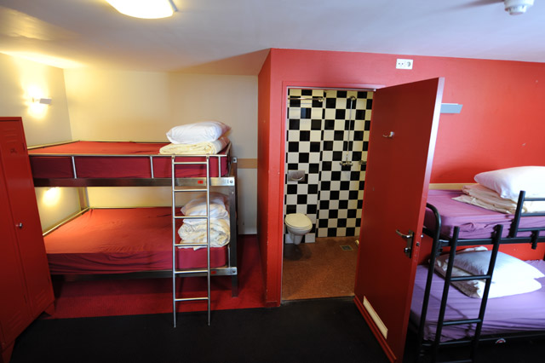
Brian Munksgaard, Jens Christian Rasch
May 19th 2017 – Interface design
table of contents
Problem statement 1
Aunt Mary Hostels 1
What is UX? 2
Personas 3
Traveler 3
Visitor 4
Hostel Manager 4
Hostels Owner 5
Traveler 6
Experiences 6
Affordances and Idioms 7
UI Elements 8
Book Hostel 8
Aesthetic qualities 13
A note on the process 14
Summary 15
Litterature 16

Problem statement

Aunt Mary Hostels
Aunt Mary Hostels is a group of six hostels located in the city of Amsterdam. Aunt Mary Hostels is not just a place where you go to sleep. The hostels arrange meetups, coffee shop tours and other events that attracts young people.
Until now, Aunt Mary Hostels have used an external booking system that takes the user away from their own website. This external system does not integrate and perform very well. Many travelers and visitors complain about the booking system.
The owner and the managers of Aunt Mary Hostels believes that the process of booking a stay at a hostel is a very big part of the experience of using the hostels. Using the booking system should be smooth, secure and easy and add a positive experience to the whole (meta-)experience of a stay. Therefore, they have decided to get a new booking system that will be an integrated part of the website and will help keep the users on the Hotels website as well as being a better part of the meta-experience.

What is UX?
In general terms UX (or User Experience) is the work of creating a design that delivers the best experience a user can get with the product. More specifically, when talking about UX we talk about researching the users, learning what their goals are and how we can create a design that will help the users fulfill these goals.
When talking about UX in the context of interface design we look at user experience more in the rems of how we can create a design that will support the fulfillment of the users’ goals. We do this by employing Normans Design Principles along with Aesthetical Interaction Qualities (AIQ). Normans Design Principles consist of using affordances, signifiers, mapping and feedback as well as discoverability and understandability and the AIQ are pliability, rhythm, dramaturgical structure and fluency. All of these principles and qualities can be applied to interface design and when used together and thought through, they can help design a user interface that will engage the user and create that user experience that will make the user come back and want to spend time on the design.
In later sections of this paper, we will detail how we have used both the design principles and the AIQ to create our design and the reasoning behind our decisions.
Regarding interface design and UX, first of all there has been a shift in the way we talk and think about interface design and UX. Previously the talk has been a lot about how to design the interface whereas now there is more talk about how to design the experience, hence the talk about UX. The difference is that previously the main focus was to create a user interface that looked good and was intuitive to use, from the designers perspective. More recently the turn has been towards looking at what the users are looking for and what their goals are, and then giving the users the best experience they can get when using the interface/product. This brings us to the point of user experiences in interface design. Here we are distinguishing between “an experience” and “experiencing”. Experiencing is an ongoing process without a set ending whereas an experience is something that is defined more precisely, with a beginning and an end. An experience can be split up in smaller experiences which, when combined, make up a meta-experience. Each of these smaller experiences can also be considered an experience and be broken down into smaller experiences and so forth.

Personas
Normally we would identify personas based on user research (user interviews, user observations, subject matter experts and stakeholder interviews). Given the time constraint of this project, we have instead identified the personas based on the problem statement and the personal experience of the authors.
We have identified the following personas:
- Traveler
- Visitor
- Hostel Manager
- Hostel Owner
In the sections bellow we will describe each persona in more detail. The emphasis will be on the usage of a booking system in conjunction with travelling and staying in a capital city like Amsterdam.

Traveler
Brian, a 20-year-old male, is on a 6-month backpacking tour around Europe. The places he is going to sleep during his trip is determined only a few hours, days or maybe a few weeks before reaching the destination. Usually he stays for a week and not just for a couple of nights. As a traveler, Brian very rarely has access to a computer so most hostel reservations will be done on mobile devices and while he is travelling.
Goals:
- Easy, fast and secure booking.
- Monitor and/or change booking status (cancel, change dates etc.).
- Communicate with hostel manager.

Visitor
Jens Christian, a 22-year-old male is going to a concert in Amsterdam in two months. To get to Amsterdam he will travel by plane and then public transportation. After the concert and club visits he wants a cheap place to stay for the night before going home the next day. For Jens Christian, the main criteria when booking his stay is that the booking will be easy, that he quickly can find a room, the price and availability, and that he is certain the reservation has gone through and the bed is there when he gets to the hostel. All of this will be done well in advance, so he doesn't have to think about it later.
Goals:
- Easy, fast and secure booking.
- Monitor and/or change booking status (cancel, change dates etc.).
- Communicate with hostel manager.

Hostel Manager
Christina 36-year-old hostel manager. In her youth, she has stayed on many hostels both as a visitor and as traveler. Because of this, she may be considered a subject matter expert (SME).
As part of her job of managing the hostel, she finds it necessary to be able to always see how many rooms and beds are booked, how many visitors the hostel have on any specific date or period as well as be able to communicate important information and news to current and potential customers.
Goals:
- Monitor occupancy.
- Monitor booking status (booked, payed, cancelled etc.)
- Communicate with guest before arrival and during the stay.

Hostels Owner
Stephanie, 45-year-old owner of the Aunt Mary Hostels. Stephanie did a lot of travelling around Europe in her younger days and have lived in a lot of different hostels and hotels. During her travels, she has come across a lot of different booking systems and experiences and as such can be considered a subject matter expert (SME). Based on her travels she started the first Aunt Mary Hotel with the intention of providing young people with an affordable place to stay when visiting Amsterdam, and at the same time give the visitors a feeling of familiarity and feeling at home.
Goals: Secure, fast and reliable booking to:
- Ensure good word of mouth and customer return.
- Monitor occupancy.

As mentioned earlier, the goals of each persona are all related to the booking process and as such are primarily end goals or behavioral goals. They are all about what the personas want to do and want to accomplish by using the booking system for Aunt Mary Hostels.
Apart from the goals that we have mentioned for each persona, there are also some life and experience goals, with which the hostel owner and managers would like to empower on the website and in the booking system. These are things like wanting the users and visitors to have the feeling of being part of a family (Experience and Life goals) and being recognized (Experience goals) when returning to the website. Some of these goals are more linked to the combined meta-experience of using the application (either website or native/mobile app) than to the booking system specifically.

Traveler
The rest of this paper will be based on the way the booking system will be used by the traveler persona. This means that we will base our design upon the usage on a mobile device and a native app. We will be focusing on the experience that this persona will have fulfilling the end goal: “Easy, fast, secure booking.”
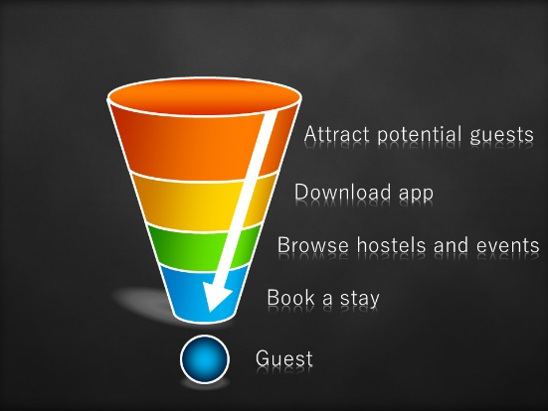
Figure 1 - Booking funnel
Since we have restricted this paper to be about the booking system, we have not given any thoughts about how to attract people to Aunt Mary Hostels, or how to make them download the app, but just expect this to be part of the work to be done by other people. As illustrated in figure 1- Booking funnel, we work only on “Book a stay”.
Besides the end goal: “Easy, fast, secure booking.”, we try to make sure that the users will get a positive experience using the application, and hence make sure that the booking system is not the reason that users choose to book their stay at a competitor.

Experiences
Below we have described three different meta-experiences and tried to visualize the smaller experiences that goes into each one. The way we have done it is that the bigger meta-experience of the 6-month trip consists of trips to different cities around Europe. One of these trips are to Amsterdam, so another meta-experience is the visiting of Amsterdam, where the first smaller experience is booking the hostel. This booking is another meta-experience, which in turn is comprised of smaller experiences. It is this, the third meta-experience, we will try to cover by the design of the booking system.
Meta-experience | Experiences
6-month trip
Visit Amsterdam
Book hostel

Affordances and Idioms
As mentioned under the persona descriptions a traveler typically books using some sort of mobile device. This means that we have usual touch interface affordances and idioms to work with, all of which have become part of the expected functionality on mobile devices: Touch, zoom in/out, scroll/swipe etc. The user interface will be designed with these affordances and idioms in mind. The available affordances determines the available UI elements.

UI Elements
In the table below we have described the most commonly used UI elements in our booking application.
Table 1 - UI Elements. Type s=signifier, m=mapping, f=feedback
UI Element | Type | Description
 | smf | This idiomatic element is used to signify that there are multiple items and that you can swipe left or right to move back and forth between elements. The number of the currently selected item is also shown and when swiping the selected item is updated instantly.
 | smf | This idiomatic element uses pins to display locations on a map. If the user touches a pin, information about the location is displayed in the lower part of the map. The map can also be zoomed in and out and panned around. Pin colors can be used to display extra information depending on the context.
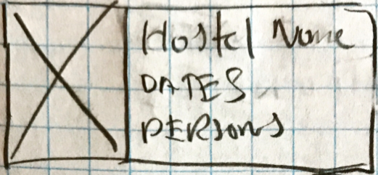 | f | This element is used to display an image and related information. It is used throughout the application as a feedback element.
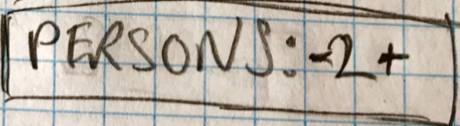 | smf | This element is both idiomatic and metaphoric. From experience, we know what to expect from – and + touchable. The feedback is shown instantly when the number increases or decreases.
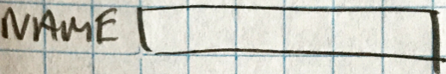 | sf | Simple input field. Experience and visual representations tells us that we can enter information here. Feedback is instant when typed characters are displayed.
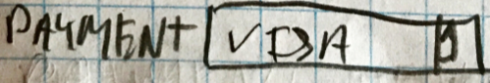 | smf | The wheel selector is also a known UI element. From experience, we expect to be able to choose from a list. The mapping lies in the touch, also known from experience, and the feedback is the selector wheel popping up.
 | smf | The (in)famous burger menu. The burger menu is used to navigate to other parts of the application. In selecting an item in the menu, the current process is cancelled.

Book Hostel
We have made some low fidelity wireframes of the pages needed to go through the booking of a room in one of the Aunt Mary Hostels. Since we are basing the design on a booking system and specifically from the traveler’s point of view, our wireframes are a vertical representation of the pages needed to go through the booking process.
Below we will explain each of the five pages that we have decided will make up the booking process. We will go through the layout of each page and the reasoning behind it as well as explain the thoughts behind our choices, the usage of signifiers, feedback and mapping, as well as how we have incorporated things like pliability, discoverability and understandability.
The first page of the booking system (see figure 2 – Booking front page below) that the user will see, will give the user an overview of any current bookings as well as fields for performing a new search for available rooms/beds in the hostels.
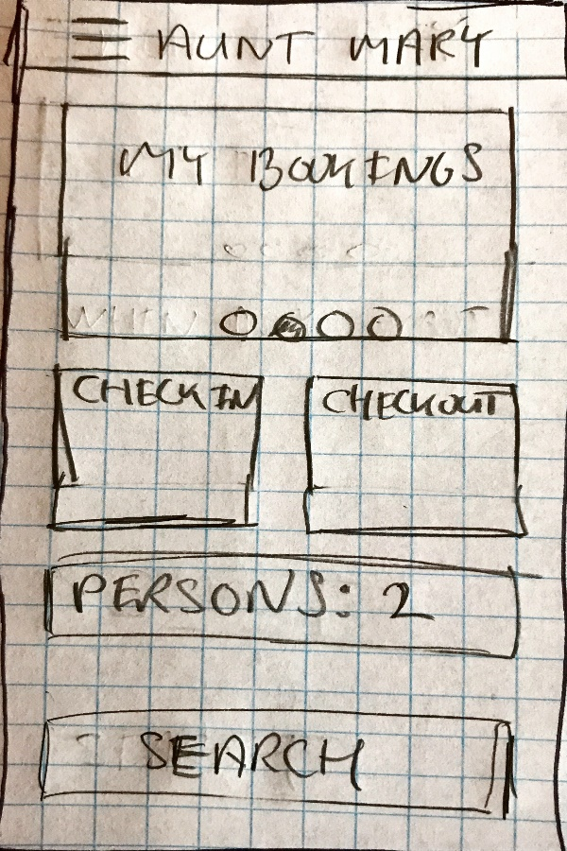
Figure 2 - Booking front page

The area My Bookings displays the bookings that the user has already created. The view uses the circles () to show the number of bookings, as well as indicate the currently displayed booking. As mentioned above this idiom also indicates that you can swipe to move back and forth between bookings.
Check-in and check-out are, of course, used to display the dates. Touching one takes the user to a calendar where the date can be changed.
In the first iteration we made the sketches, in the second we discovered that more signifiers and mappings are needed. “Persons: 2” should be changed to “Persons: - 2 +”, where the minus and plus signs indicate the ability to decrease or increase the number.
When the user touches the “Search” button the next page (see figure 3 – Booking search result below) is displayed.
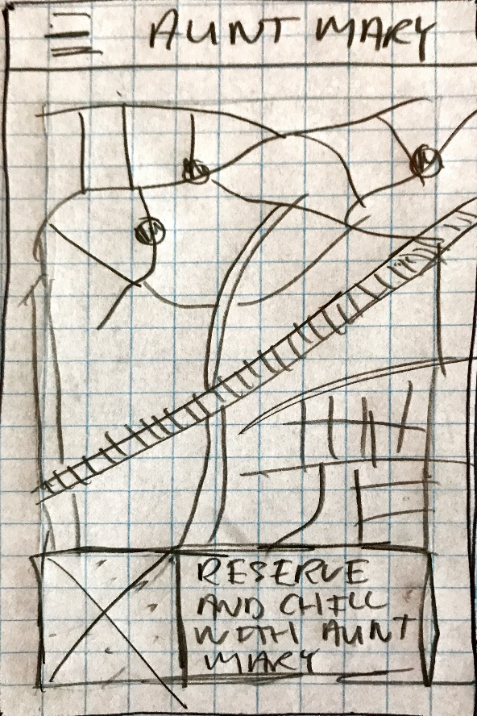
Figure 3 - Booking search result
On this map, we show hostel locations using pins. We also use the color of the pin to show occupancy. Green = available, yellow = Only few beds available, red = No available beds.
If the user touches a pin, information about that hostel is displayed in the lower part of the map. To remove the information, touch the pin again.
When touching the “Reserve and Chill” button, the user is taken to the reservation page.
In the second iteration, we realized that we should have a means to modify or perform another search. This functionality will include showing the current search criteria at the top of the map with the possibility of touching them to modify them and perform another search.

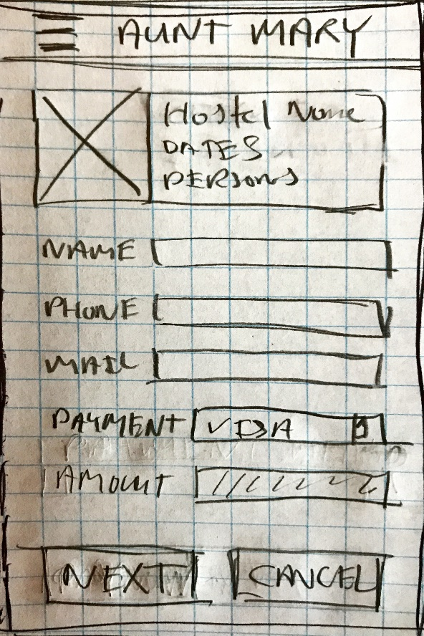
Figure 4 - Booking reservation
On the reservation page the user enters personal information, selects payment type (using the well-known selector) and touches the “Next” button.
Above the input fields there will be a brief summary of what it is the user is about to reserve. The name of the hostel as well as the dates and number of people will be shown here, along with an image of the chosen hostel.
The only error handling that will be on this page is the validation that all fields have been filled out.
In iteration 2, we discovered that we are missing a “Previous” button here.

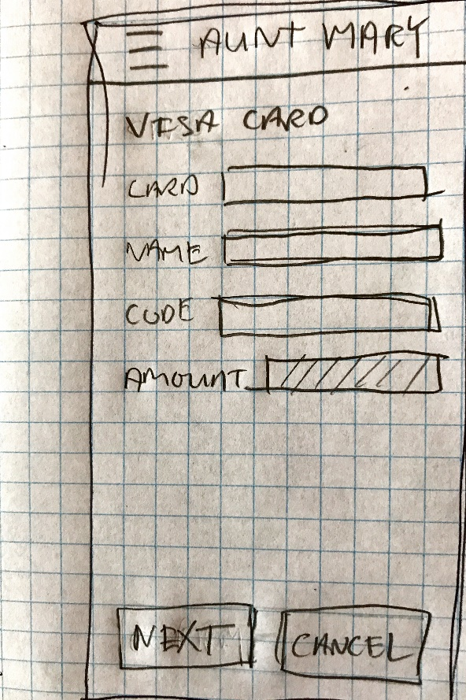
Figure 5 - Booking payment
The payment page is very simple and recognizable in its UI. There are fields for entering the card information, as is standard for these kinds of pages. The user enters the information and touches “Next”.
In iteration 2, we discovered that we are missing a “Previous” button on this page. We should always present the user with the ability to go back, therefore a “Previous” button would be a good addition to the UI.

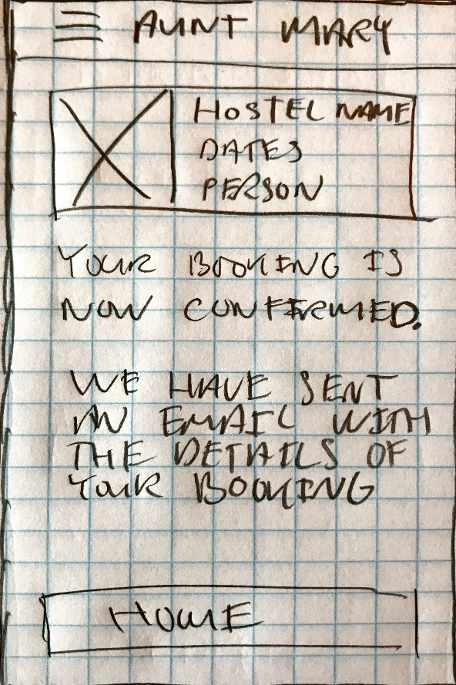
Figure 6 - Booking confirmation
The last page is the conformation page.
At the top of the page will be the same summary as was shown on the reservation page. This reuse of elements will make it easily recognizable for the user and will help underline the understandability of the design.
Another part of this page is that it clearly states that the details about the booking has been sent to the e-mail specified as part of the reservation. Again, an element that will help enforce the feeling of security that the reservation was completed.
Only way out is the “Home” button or the burger menu.

Aesthetic qualities
Throughout the design of the pages described above, we have tried to let each page of the booking process have as few fields and pieces of information as possible. Thereby enforcing a form of rhythm to the whole process by making the time, it takes to complete one page and move on to the next page be as short as possible. Combined with the use of common and well-known idioms and signifiers, this will result in a booking process that is easy and fast.
The only page that fall a bit outside of this rhythm is potentially the search result page. This page is also the only page where there is a degree of pliability. The information displayed on the page depends on the availability based on the criteria the user has entered, and then it is possible for the user to navigate the map by zooming, panning and turning.
Since the design is for the booking process, it is difficult to incorporate any form for immersion or enchantment in the pages. These types of pages are meant to be fast and be a small part of what the application is used for. By creating a design that takes ease and speed into account, we have tried to create an experience that will be as fluent and unobtrusive as possible, making it possible for the users to get on with exploring the other parts of the application.
The dramaturgical and fluency qualities are not used in the booking application.

A note on the process
In the design process, we focused on a single persona fulfilling a single goal. The reasoning behind this decision was primarily the time constraint in the project, but also that we found this persona and goal to best represent the main experience we would like to convey in our design.
Even though we only did two iterations in the design process, we managed to find things to change and improve. In a real-world scenario, we would have started out with some proper, more extensive, user research followed by several iterations on multiple personas.
In our case, each iteration would have included the following tasks:
- Research users (Quantitative/Qualitative).
- Model personas.
- Refine aesthetic qualities and use of UI elements.
- Improve wireframe/sketches.
- Start over.
At some point, we would have started to:
- Create a style guide.
- Building mock-ups and prototypes.
- Introduce user testing.
Followed by:
- Design.
- Code.
- Test.
- Deploy.
- Iterate.
Moving closer and closer to the end product after each iteration.

Summary
During the initial talks about and work with this project we came up with a number of ideas as to how to get people engaged and make them spend more time in the application (either a website or a mobile application). Since this project only revolved around the booking system we quickly deemed these extra features and ideas to be outside the scope of the project.
As we mentioned in the section “A note on the process” above, there are things that we could have done to be more thorough especially in the beginning of the design process. We would have liked to have time to employ qualitative and/or quantitative user research to help in the work of defining the personas as well as the goals.
Another thing we would have liked, was more time for the iterative process of the actual design. The design we have proposed in this paper is built around wireframes and sketches, if we had more time we would have like to include some user testing sessions and evolve the design to be a vertical prototype in Axure, or similar product.
Even though the whole process was short compared to a real-world scenario, we still managed to do a couple of iterations and improve on our initial wireframes. We also got a bit of insight into how big a task it is to get the UX part of a design process right, and that it is not something you get right the first time, but it will come with experience.

Litterature
Norman, The design of everyday things, 2013
Cooper, About Face, 4th edition 2014
Nick Dank, Web design is not dead, 2015 (website)
Sergio Nouvel, Why Web Design is Dead, 2015 (website)
Marc Hassenzahl, Experience Design, 2010.
Jonas Löwgren: Toward an articulation of interaction esthetics, 2009

Goal-directed design (Cooper, About Face)
The design of everyday things, Dan Norman
Jonas Löwgren, Toward an articulation of interaction esthetics, 2009
Nick Dank, Web design is NOT dead (blog entry, 2015)
Hassenzhal, Experience Design, chapter 1
Cooper, About Face, chapter 3
Cooper, About Face, pp. 74-78

