**ANALYSIS OF THE CUSTOMER SATISFACTION SURVEY IN REGARD TO NATIONAL SOCIAL SECURITY FUND (NSSF) BY ASSOCIATE CONSULTING AFRICA LTD**

The Associate Consulting Africa Ltd. was requested by the NSSF to conduct a customer satisfaction survey. The objective of this was further aid the NSSF in understanding the customer view on their product and therein implement better policies in their mission and core values implementation. After gathering responses, the following analysis was performed and conclusions derived as follows

|  |  |  |  |  |  |  |
| --- | --- | --- | --- | --- | --- | --- |
| **Statistics** | | | | | | |
|  | | Gender of respondent | Age in years of respondent | Occupation of respondent | Relationship of respondent to contributor/claimant | Customer location |
| N | Valid | 10 | 10 | 10 | 10 | 10 |
| Missing | 0 | 0 | 0 | 0 | 0 |

From the table above, we can conclude that there were no missing responses, i.e. there was 10 valid responses in regards to the single response questions of gender, age, occupation, location of respondent and their relationship to the concerned contributor/claimant.

**SECTION A   
P1: GENDER**

From the frequency table below, we see that majority which is 60% of the respondents were male with the minority 40% being female.

|  |  |  |  |  |  |
| --- | --- | --- | --- | --- | --- |
| **Gender of respondent** | | | | | |
|  | | Frequency | Percent | Valid Percent | Cumulative Percent |
| Valid | Male | 6 | 60.0 | 60.0 | 60.0 |
| Female | 4 | 40.0 | 40.0 | 100.0 |
| Total | 10 | 100.0 | 100.0 |  |

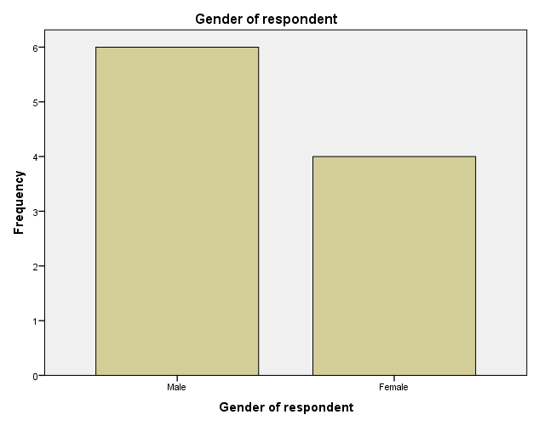

**P2: AGE IN YEARS**

The frequency table shows that respondents aged between 18-24 made up 10%, 25-34 20%, 35-44 30%, 45-54 10%, and 55+ made up 30% of the total respondents. This concluded that the majority were tied between ages 35-44 and 55+, while minority tied between ages 18-24 and 45-54.

|  |  |  |  |  |  |
| --- | --- | --- | --- | --- | --- |
| **Age in years of respondent** | | | | | |
|  | | Frequency | Percent | Valid Percent | Cumulative Percent |
| Valid | 18-24 | 1 | 10.0 | 10.0 | 10.0 |
| 25-34 | 2 | 20.0 | 20.0 | 30.0 |
| 35-44 | 3 | 30.0 | 30.0 | 60.0 |
| 45-54 | 1 | 10.0 | 10.0 | 70.0 |
| 55+ | 3 | 30.0 | 30.0 | 100.0 |
| Total | 10 | 100.0 | 100.0 |  |

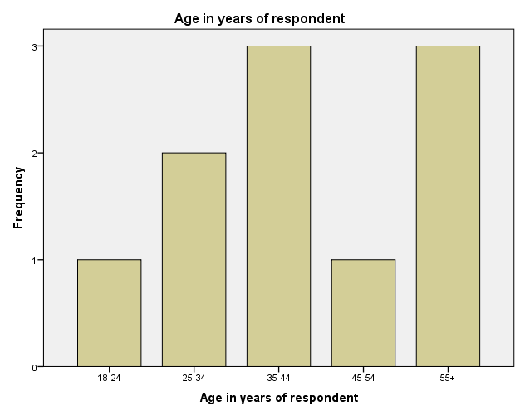

**P3: OCCUPATION**

In regard to occupation, we determined that respondents that were employed, self employed and claimant were 30%, 30% and 40% respectively. This means the majority were claimants, with the minority being tied between employed and self-employed.

|  |  |  |  |  |  |
| --- | --- | --- | --- | --- | --- |
| **Occupation of respondent** | | | | | |
|  | | Frequency | Percent | Valid Percent | Cumulative Percent |
| Valid | Employed | 3 | 30.0 | 30.0 | 30.0 |
| Self Employed | 3 | 30.0 | 30.0 | 60.0 |
| Claimant | 4 | 40.0 | 40.0 | 100.0 |
| Total | 10 | 100.0 | 100.0 |  |

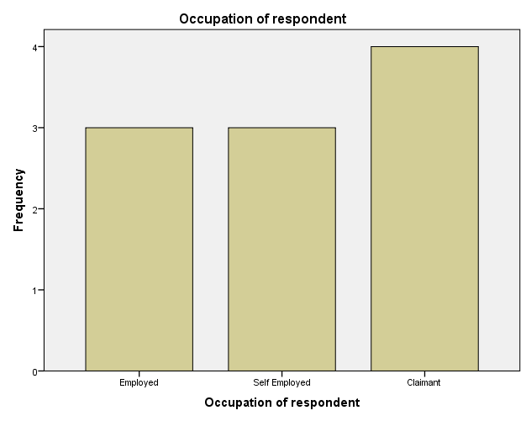

**P4: RELATIONSHIP TO CONTRIBUTOR/CLAIMANT**

When generating the frequency table below, the results confirm that the respondents that were contributors/claimants themselves made up the majority which is 50%; family members were 40% and friends to contributor/claimant were the minority that is 10% of respondents.

|  |  |  |  |  |  |
| --- | --- | --- | --- | --- | --- |
| **Relationship of respondent to contributor/claimant** | | | | | |
|  | | Frequency | Percent | Valid Percent | Cumulative Percent |
| Valid | Self | 5 | 50.0 | 50.0 | 50.0 |
| Family Member | 4 | 40.0 | 40.0 | 90.0 |
| Friend | 1 | 10.0 | 10.0 | 100.0 |
| Total | 10 | 100.0 | 100.0 |  |

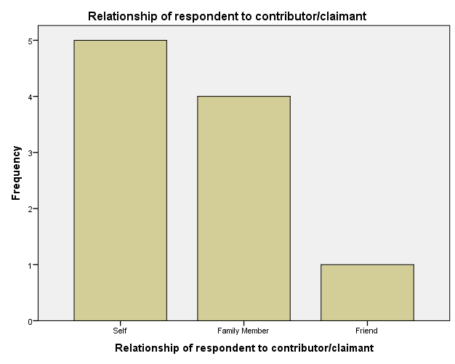

**P5: REGION (CUSTOMER LOCATION)**

The frequency table generated below shows that majority of respondents (30%) were located in Nairobi; 20% in each of Rift Valley, Central/Eastern, Nyanza/Western regions respectively; with the minority that is 10% being located in Coast/Nort Eastern region.

|  |  |  |  |  |  |
| --- | --- | --- | --- | --- | --- |
| **Customer location** | | | | | |
|  | | Frequency | Percent | Valid Percent | Cumulative Percent |
| Valid | Nairobi | 3 | 30.0 | 30.0 | 30.0 |
| Rift Valley | 2 | 20.0 | 20.0 | 50.0 |
| Central/Eastern | 2 | 20.0 | 20.0 | 70.0 |
| Nyanza/Western | 2 | 20.0 | 20.0 | 90.0 |
| Coast/North Eastern | 1 | 10.0 | 10.0 | 100.0 |
| Total | 10 | 100.0 | 100.0 |  |

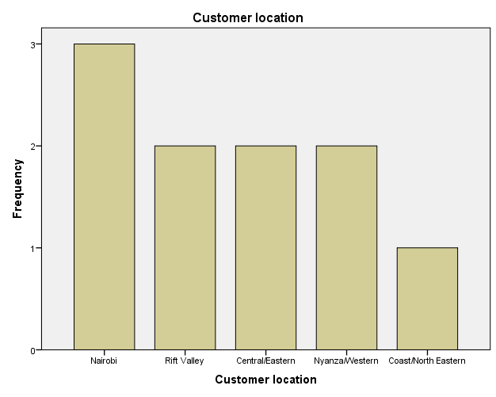

**SECTION B: MULTIPLE RESPONSE**

There were multiple response questions in the survey concerning the respondents’ first sources of NSSF awareness, NSSF benefits known to them, and also their source of awareness about NSSF Benefits. The frequency table below shows that there were no missing values with all 10 responses being valid.

|  |  |  |  |  |  |  |
| --- | --- | --- | --- | --- | --- | --- |
| **Case Summary** | | | | | | |
|  | Cases | | | | | |
| Valid | | Missing | | Total | |
| N | Percent | N | Percent | N | Percent |
| Source of NSSF Awareness | 10 | 100.0% | 0 | 0.0% | 10 | 100.0% |
| Known NSSF Benefits | 10 | 100.0% | 0 | 0.0% | 10 | 100.0% |
| Source of NSSF Benefits awareness | 10 | 100.0% | 0 | 0.0% | 10 | 100.0% |

**Q1a: SOURCES OF NSSF AWARENESS**

From the frequency table below, we determined that; 30% of respondents (minority) became aware of NSSF through publicity boards; 40% through radio, TV, Friends/Relatives/Colleagues respectively; 50% through newspaper, employer and visiting NSSF premises respectively; and the majority (60%) through other ways.

|  |  |  |  |
| --- | --- | --- | --- |
| **Source of NSSF Awareness Frequencies** | | | |
|  | | Responses | Percent of Cases |
| N  4  4  5  4  3  5  5  6 |
| Source | Radio | 40.0% |
| TV | 40.0% |
| Newspaper | 50.0% |
| Friends/Relatives/Colleagues | 40.0% |
| Publicity Boards | 30.0% |
| Employer | 50.0% |
| Visiting their premises | 50.0% |
| Others | 60.0% |
|  | |  |

**Q2a: NSSF BENEFITS KNOWN**

From frequency table below, we can conclude that; minority of respondents (20%) were aware of funeral grant; 30% the survival benefit; 40% the invalidity benefit and emigration benefit each respectively; 50% the withdrawal benefit; and 80% the majority aware of the age/retirement benefit.

|  |  |  |  |  |
| --- | --- | --- | --- | --- |
| **Known NSSF Benefits Frequencies** | | | | |
|  | | Responses | | Percent of Cases |
| N |  |
| NSSF Benefits known | Age/Retirement benefit | 8 |  | 80.0% |
| Survival Benefit | 3 |  | 30.0% |
| Invalidity Benefit | 4 |  | 40.0% |
| Funeral Grant | 2 |  | 20.0% |
| Emigration Benefit | 4 |  | 40.0% |
| Withdrawal benefit | 5 |  | 50.0% |
|  | |  |  |  |

**Q2b: SOURCE OF NSSF BENEFITS AWARENESS**

From the frequency table below, we get that; majority (80%) became aware of NSSF benefits through visiting NSSF premises; and minority (20%) through radio, newspaper, and other means each respectively. The rest comprised of; 50% through the employer; 40% through TV; and 30% through friends/relatives/colleagues.

|  |  |  |  |
| --- | --- | --- | --- |
| **Source of NSSF Benefits awareness Frequencies** | | | |
|  | | Responses | Percent of Cases |
| N  2  4  2  3  5  7  2 |
| Source | Radio | 20.0% |
| TV | 40.0% |
| Newspaper | 20.0% |
| Friends/Relatives/Colleagues | 30.0% |
| Employer | 50.0% |
| Visiting their premises | 70.0% |
| Others | 20.0% |

**Q3: MISSSION AND CORE VALUES**

**Q3a: Mission Items**

In the customer satisfaction survey, a question was forwarded to respondents on their level of satisfaction with how the NSSF mission items are being implemented and practiced by staff. All categories produced 10 valid responses with no missing values as shown below.

|  |  |  |  |  |  |  |  |  |
| --- | --- | --- | --- | --- | --- | --- | --- | --- |
| **QUERYSTATISTICS** | | | | | | | | |
|  | | | Distribution of NSSF offices in the country | Registration process | Modes of contribution to NSSF | Affordability of contribution to NSSF | | Contributions will amount to sufficient income at end |
| N | Valid | | 10 | 10 | 10 | 10 | | 10 |
| Missing | | 0 | 0 | 0 | 0 | | 0 |
|  | | | | | | | | |
|  | | | Safety of contributions made to NSSF | Investments made by NSSF using contributions | NSSF benefits as compared to competitors' benefits | | Decisions and rules exercised by NSSF staff | |
| N | | Valid | 10 | 10 | 10 | | 10 | |
| Missing | 0 | 0 | 0 | | 0 | |

The first question posed was with regard to the distribution of NSSF offices in the country. From the frequency table below; the majority (30%) were satisfied with the distribution with minority (10%) were very dissatisfied. The rest lined up as; 20% being dissatisfied, neutral and very satisfied each respectively.

|  |  |  |  |  |  |
| --- | --- | --- | --- | --- | --- |
| **Level of satisfaction with the distribution of NSSF offices in the country** | | | | | |
|  | | Frequency | Percent | Valid Percent | Cumulative Percent |
| Valid | Very Dissatisfied | 1 | 10.0 | 10.0 | 10.0 |
| Dissatisfied | 2 | 20.0 | 20.0 | 30.0 |
| Neutral | 2 | 20.0 | 20.0 | 50.0 |
| Satisfied | 3 | 30.0 | 30.0 | 80.0 |
| Very Satisfied | 2 | 20.0 | 20.0 | 100.0 |
| Total | 10 | 100.0 | 100.0 |  |

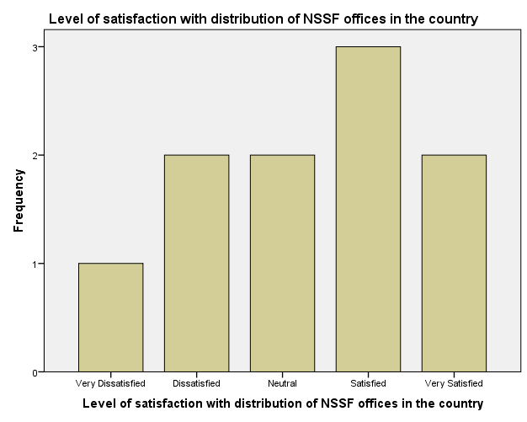

The second question posed was with regard to level of satisfaction with the NSSF registration process. From the frequency table below, the majority (30%) of respondents were tied between dissatisfied and very satisfied each respectively, with minority (10%) were tied between very dissatisfied and satisfied each respectively. The rest 20% responded neutral.

|  |  |  |  |  |  |
| --- | --- | --- | --- | --- | --- |
| **Level of satisfaction with the registration process** | | | | | |
|  | | Frequency | Percent | Valid Percent | Cumulative Percent |
| Valid | Very Dissatisfied | 1 | 10.0 | 10.0 | 10.0 |
| Dissatisfied | 3 | 30.0 | 30.0 | 40.0 |
| Neutral | 2 | 20.0 | 20.0 | 60.0 |
| Satisfied | 1 | 10.0 | 10.0 | 70.0 |
| Very Satisfied | 3 | 30.0 | 30.0 | 100.0 |
| Total | 10 | 100.0 | 100.0 |  |

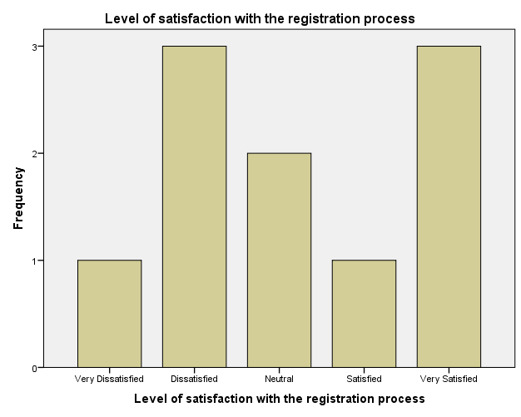

The next question posed was with regard to level of satisfaction with the modes of contribution to NSSF by respondents. From the frequency table below, the majority (30%) of respondents were tied between neutral and very satisfied each respectively, and minority (20%) being tied between dissatisfied and satisfied each respectively.

|  |  |  |  |  |  |
| --- | --- | --- | --- | --- | --- |
| **Level of satisfaction with the modes of contribution to NSSF** | | | | | |
|  | | Frequency | Percent | Valid Percent | Cumulative Percent |
| Valid | Dissatisfied | 2 | 20.0 | 20.0 | 20.0 |
| Neutral | 3 | 30.0 | 30.0 | 50.0 |
| Satisfied | 2 | 20.0 | 20.0 | 70.0 |
| Very Satisfied | 3 | 30.0 | 30.0 | 100.0 |
| Total | 10 | 100.0 | 100.0 |  |

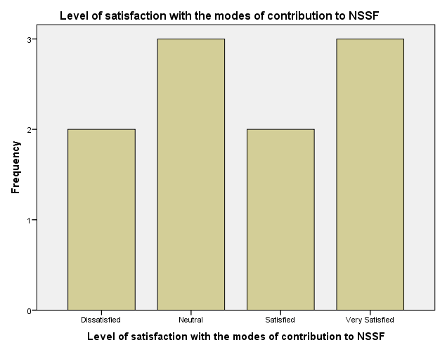

Next was a question posed with regard to affordability of contribution to NSSF. As shown in the table below; the majority (30%) of respondents were tied between dissatisfied and satisfied each respectively, and minority (10%) were tied between very dissatisfied and very satisfied each respectively. The rest 20% responded being neutral.

|  |  |  |  |  |  |
| --- | --- | --- | --- | --- | --- |
| **Level of satisfaction with the affordability of contribution to NSSF** | | | | | |
|  | | Frequency | Percent | Valid Percent | Cumulative Percent |
| Valid | Very Dissatisfied | 1 | 10.0 | 10.0 | 10.0 |
| Dissatisfied | 3 | 30.0 | 30.0 | 40.0 |
| Neutral | 2 | 20.0 | 20.0 | 60.0 |
| Satisfied | 3 | 30.0 | 30.0 | 90.0 |
| Very Satisfied | 1 | 10.0 | 10.0 | 100.0 |
| Total | 10 | 100.0 | 100.0 |  |

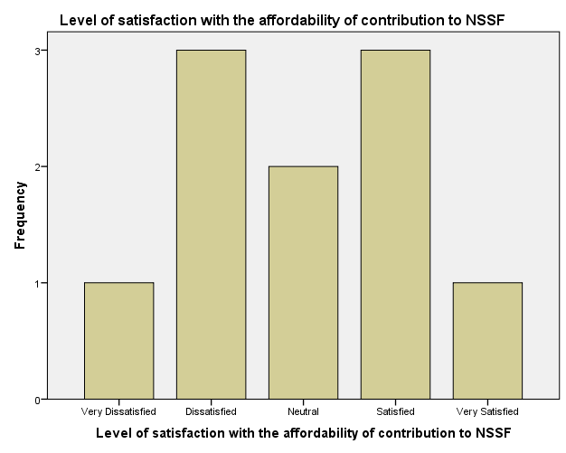

The next question posed was with regard to if the NSSF contributions amount to sufficient income at end. From the frequency table below; the majority (30%) of respondents were neutral, with the minority (10%) being very dissatisfied. The other categories; dissatisfied, satisfied and very satisfied were 20% each respectively.

|  |  |  |  |  |  |
| --- | --- | --- | --- | --- | --- |
| **Level of satisfaction that contributions made will amount to sufficient income at end** | | | | | |
|  | | Frequency | Percent | Valid Percent | Cumulative Percent |
| Valid | Very Dissatisfied | 1 | 10.0 | 10.0 | 10.0 |
| Dissatisfied | 2 | 20.0 | 20.0 | 30.0 |
| Neutral | 3 | 30.0 | 30.0 | 60.0 |
| Satisfied | 2 | 20.0 | 20.0 | 80.0 |
| Very Satisfied | 2 | 20.0 | 20.0 | 100.0 |
| Total | 10 | 100.0 | 100.0 |  |

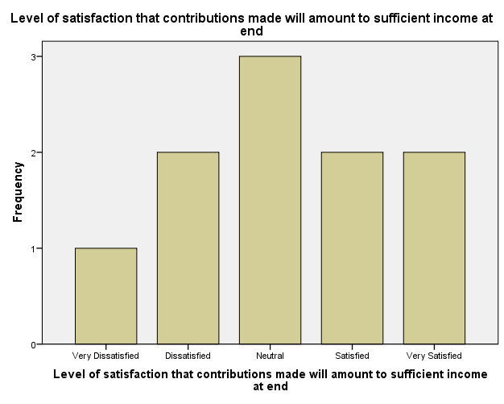

Another question was in regard to the issue of safety of contributions made to NSSF. The frequency table below reveals; that the majority (40%) was neutral, with minority (10%) being tied between very dissatisfied and very satisfied each respectively. The other categories; dissatisfied and satisfied received 20% each respectively.

|  |  |  |  |  |  |
| --- | --- | --- | --- | --- | --- |
| **Level of satisfaction with the safety of contributions made to NSSF** | | | | | |
|  | | Frequency | Percent | Valid Percent | Cumulative Percent |
| Valid | Very Dissatisfied | 1 | 10.0 | 10.0 | 10.0 |
| Dissatisfied | 2 | 20.0 | 20.0 | 30.0 |
| Neutral | 4 | 40.0 | 40.0 | 70.0 |
| Satisfied | 2 | 20.0 | 20.0 | 90.0 |
| Very Satisfied | 1 | 10.0 | 10.0 | 100.0 |
| Total | 10 | 100.0 | 100.0 |  |

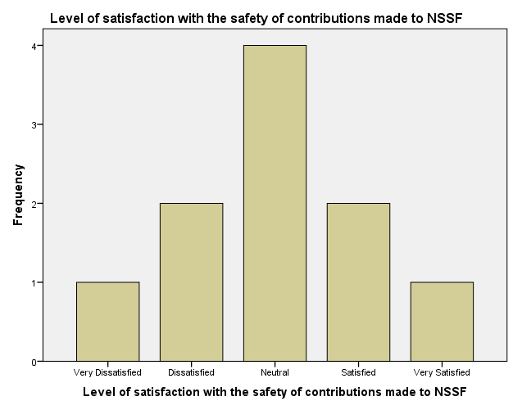

In regard to investments made by NSSF using contributions; a majority which is 30% of responses expressed a neutral level of satisfaction; a minority that is 10% being very satisfied; with other categories; satisfied, dissatisfied receiving 20% each respectively. There was also a 20% of responses that had no opinion on the concerned matter.

|  |  |  |  |  |  |
| --- | --- | --- | --- | --- | --- |
| **Level of satisfaction with the investments made by NSSF using contributions** | | | | | |
|  | | Frequency | Percent | Valid Percent | Cumulative Percent |
| Valid | Don't Know/Not Applicable | 2 | 20.0 | 20.0 | 20.0 |
| Dissatisfied | 2 | 20.0 | 20.0 | 40.0 |
| Neutral | 3 | 30.0 | 30.0 | 70.0 |
| Satisfied | 2 | 20.0 | 20.0 | 90.0 |
| Very Satisfied | 1 | 10.0 | 10.0 | 100.0 |
| Total | 10 | 100.0 | 100.0 |  |

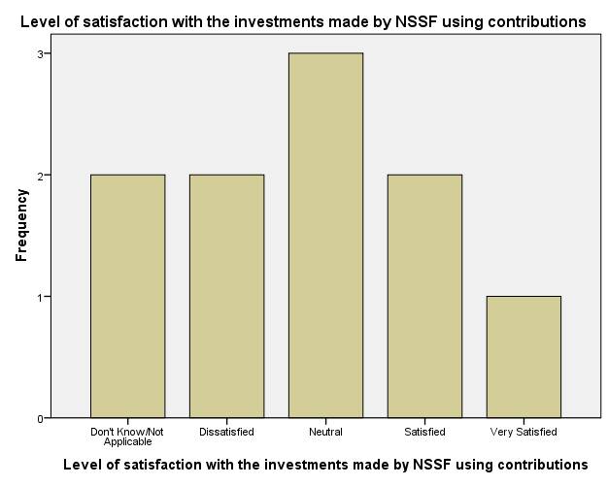

Respondents were also queried on how they view NSSF benefits as compared to competitors’ benefits. From the frequency table below; the majority (30%) of respondents were tied between neutral, satisfied and very satisfied each respectively, with a minority (10%) choosing the option of ‘Don’t Know/Not Applicable’.

|  |  |  |  |  |  |
| --- | --- | --- | --- | --- | --- |
| **Level of satisfaction with NSSF benefits as compared to competitors' benefits** | | | | | |
|  | | Frequency | Percent | Valid Percent | Cumulative Percent |
| Valid | Don't Know/Not Applicable | 1 | 10.0 | 10.0 | 10.0 |
| Neutral | 3 | 30.0 | 30.0 | 40.0 |
| Satisfied | 3 | 30.0 | 30.0 | 70.0 |
| Very Satisfied | 3 | 30.0 | 30.0 | 100.0 |
| Total | 10 | 100.0 | 100.0 |  |

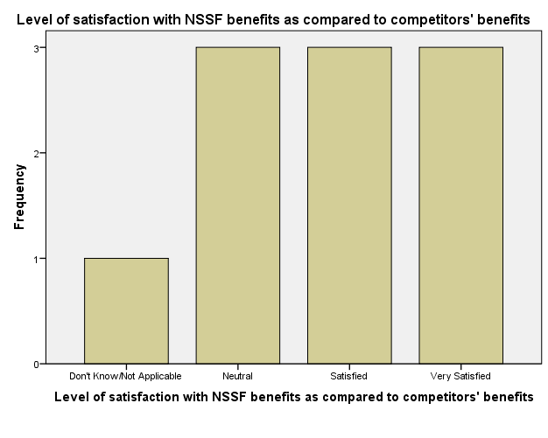

Respondents were queried on their level of satisfaction with the decisions and rules exercised by the NSSF staff. The frequency table below shows that; a majority of 40% were neutral, with a minority of 10% were tied between very dissatisfied and satisfied each respectively. The rest responded 20% to dissatisfied and very satisfied each respectively.

|  |  |  |  |  |  |
| --- | --- | --- | --- | --- | --- |
| **Level of satisfaction with decisions and rules exercised by NSSF staff** | | | | | |
|  | | Frequency | Percent | Valid Percent | Cumulative Percent |
| Valid | Very Dissatisfied | 1 | 10.0 | 10.0 | 10.0 |
| Dissatisfied | 2 | 20.0 | 20.0 | 30.0 |
| Neutral | 4 | 40.0 | 40.0 | 70.0 |
| Satisfied | 1 | 10.0 | 10.0 | 80.0 |
| Very Satisfied | 2 | 20.0 | 20.0 | 100.0 |
| Total | 10 | 100.0 | 100.0 |  |

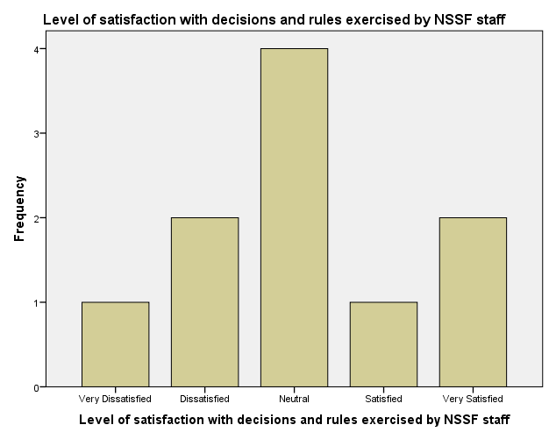

**Q3b: CORE VALUES**

The customer satisfaction survey also queries respondents as to what extent they agree with various items on the NSSF Core values as implemented or practiced by the staff. The statistics demonstrate a 100% valid response rate with no missing values.

|  |  |  |  |  |  |
| --- | --- | --- | --- | --- | --- |
| **Degree of acceptance of NSSF Core values Statistics** | | | | | |
|  | | NSSF non-tolerance to corrupt activities | Coming up with new or better ways of service delivery | Responsibility and openness of Staff in daily work | Staff working together when necessary to meet needs |
| N | Valid | 10 | 10 | 10 | 10 |
| Missing | 0 | 0 | 0 | 0 |

In the first part, the respondents were queried if they agree with the NSSF core value of non-tolerance to corrupt activities. 40% of the respondents which is the majority agree with this value; 30% neither agree nor disagree; 20% strongly agree; with a minority of 10% who disagree with this value as shown in the frequency table below.

|  |  |  |  |  |  |
| --- | --- | --- | --- | --- | --- |
| **Degree of acceptance with NSSF non-tolerance to corrupt activities** | | | | | |
|  | | Frequency | Percent | Valid Percent | Cumulative Percent |
| Valid | Disagree | 1 | 10.0 | 10.0 | 10.0 |
| Neither agree nor disagree | 3 | 30.0 | 30.0 | 40.0 |
| Agree | 4 | 40.0 | 40.0 | 80.0 |
| Strongly Agree | 2 | 20.0 | 20.0 | 100.0 |
| Total | 10 | 100.0 | 100.0 |  |

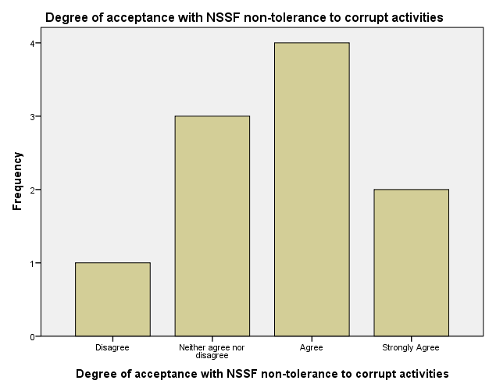

On the issue of NSSF core value of coming up with new or better ways of delivering service; 40% (the majority) neither agree nor disagree with this value; 20% were tied in strongly agree and agree each respectively; with a minority 10% responded in strongly disagree and disagree each respectively.

|  |  |  |  |  |  |
| --- | --- | --- | --- | --- | --- |
| **Degree of acceptance with NSSF core value of coming up with new or better ways of service delivery** | | | | | |
|  | | Frequency | Percent | Valid Percent | Cumulative Percent |
| Valid | Strongly Disagree | 1 | 10.0 | 10.0 | 10.0 |
| Disagree | 1 | 10.0 | 10.0 | 20.0 |
| Neither agree nor disagree | 4 | 40.0 | 40.0 | 60.0 |
| Agree | 2 | 20.0 | 20.0 | 80.0 |
| Strongly Agree | 2 | 20.0 | 20.0 | 100.0 |
| Total | 10 | 100.0 | 100.0 |  |

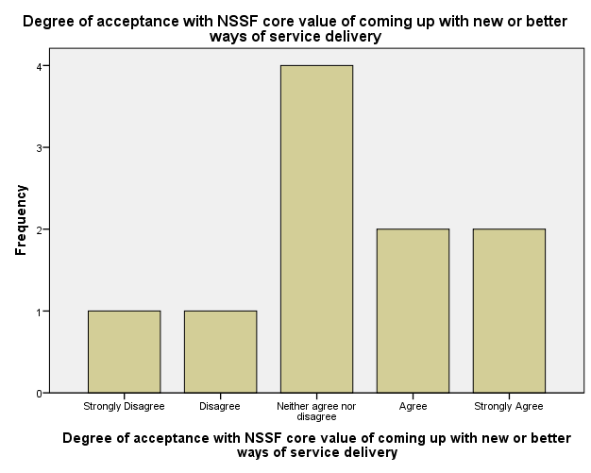

In regard to the core value of responsibility and openness of NSSF staff in their day-to-day work, the responses as in the frequency table below revealed a 40% majority with a ‘neither agree nor disagree with’; 20% strongly disagree and strongly agree each respectively; with a minority 10% disagree and agree each respectively.

|  |  |  |  |  |  |
| --- | --- | --- | --- | --- | --- |
| **Degree of acceptance with NSSF core value of responsibility and openness of Staff in daily work** | | | | | |
|  | | Frequency | Percent | Valid Percent | Cumulative Percent |
| Valid | Strongly Disagree | 2 | 20.0 | 20.0 | 20.0 |
| Disagree | 1 | 10.0 | 10.0 | 30.0 |
| Neither agree nor disagree | 4 | 40.0 | 40.0 | 70.0 |
| Agree | 1 | 10.0 | 10.0 | 80.0 |
| Strongly Agree | 2 | 20.0 | 20.0 | 100.0 |
| Total | 10 | 100.0 | 100.0 |  |

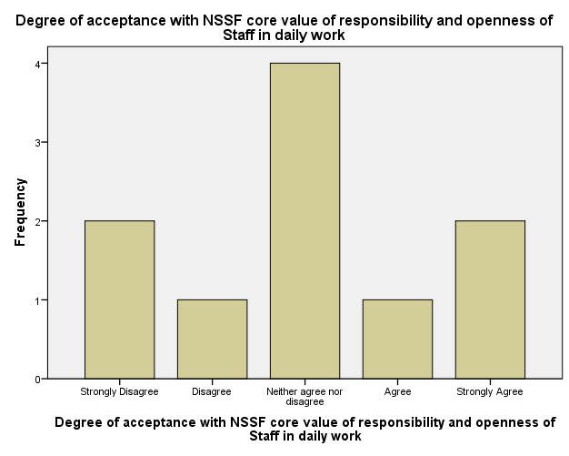

The last part dealt with the extent to which respondents agree with the core value of NSSF staff working together to meet their needs. The frequency table below shows; majority of 40% neither agree nor disagree; 30% disagree; 20% didn’t know/not applicable; and 10% which is the minority strongly agree.

|  |  |  |  |  |  |
| --- | --- | --- | --- | --- | --- |
| **Degree of acceptance with NSSF core value of staff working together when necessary to meet needs** | | | | | |
|  | | Frequency | Percent | Valid Percent | Cumulative Percent |
| Valid | Don't Know/Not Applicable | 2 | 20.0 | 20.0 | 20.0 |
| Disagree | 3 | 30.0 | 30.0 | 50.0 |
| Neither agree nor disagree | 4 | 40.0 | 40.0 | 90.0 |
| Strongly Agree | 1 | 10.0 | 10.0 | 100.0 |
| Total | 10 | 100.0 | 100.0 |  |

