

UGANDA INSTITUTE OF INFORMATION
AND
COMMUNICATION TECHNOLOGY
(UICT)
ICT DEPARTMENT
FIELD ATTACHMENT REPORT AT JINJA COMPUTER CENTRE
MUSIKA OWEN
2024/DCS/DAY/2020/G
DIPLOMA IN COMPUTER SCIENCE/YEAR 2
INDUSTRIAL TRAINING REPORT SUBMITTED TO UGANDA
INSTITUTE OF INFORMATION AND COMMUNICATION
TECHINOLOGY IN PARTIAL FULFILLMENT OF THE
AWARD OF
A DIPLOMA IN
COMPUTER SCIENCE
JANUARY/FEBURARY 2026

DECLARATION
I, Musika Owen do declare that the contents of this report are my original work and have never been submitted to any institution of any award.
Name: MUSIKA OWEN.
Date:
Signature:

APPROVAL
This industrial training report that has been submitted by MUSIKA OWEN, registration NO 2024/DCS/DAY/2020/G has been reviewed and approved by the undersigned academic supervisor and the field supervisor at work.
Field supervisor:
Signature:
Date:
Supervisor name:
Signature:
Date:

ACKNOWLEDGEMENT
I extend my sincere gratitude to the management and staff of Jinja Computer Centre for providing me with the internship opportunity, assistance and cooperation.
Special thanks to my reporting supervisors for their guidance, mentorship, and continuous support throughout my internship period. I also appreciate the academic support from the Uganda institute of information and communication technology.
Appreciation to my family and friends for their encouragement and support.

DEDICATION
This report is dedicated to my family for their love and support, and supervisors and instructors for their guidance throughout my industrial training.

LIST OF ACRONYMS.
Acronyms | In full
JCC | Jinja Computer Center
CBO | Community based organization
IT | Information Technology
LAN | Local Area Network
UTP | Unshielded Twist Pair
RAM | Random Access Memory
CPU | Central processing Unit
HDD | Hard disk drive

Table of contents
Contents
DECLARATION i
APPROVAL ii
ACKNOWLEDGEMENT iii
DEDICATION iv
LIST OF ACRONYMS. v
CHAPTER ONE 1
1.0 Introduction 1
1.1 Objectives of the organization 1
1.2 Background of Jinja Computer Centre. 1
1.2.1 Organizational structure. 1
1.3 vision 3
1.4 Mission 3
1.5 Goals 3
1.6 services offered. 3
CHAPTER TWO 4
2.1 Introduction 4
2.2 DESCRIPTION OF THE WORK CARRIED OUT BY THE ORGANIZATION 4
2.3 DUTIES AND RESPONSIBLITIES ASSIGNED 4
2.3.1 Graphics designing: 4
Key Tools and Techniques: 5
· Rectangular Marquee Tool 5
2.3.2 Networking: 6
Tools Used: 6
Step-by-Step Process: 8
3. Assembly: 9
Summary of Skills Gained 10
CHAPTER THREE 12
3.1 CHALLENGES, CONCLUSION AND RECOMMENDATIONS 12
3.0 Introduction 12
3.2 Achievements. 12
3.2.1 Swot Analysis 12
CHAPTER FOUR 13
4.1 INTRODUCTION 13
4.2.0 CHALLENGES 13
4.2.1 ORGANISATIONAL CHALLENGES 13
4.2.2 INDIVIDUAL CHALLENGES 14
4.3 RECOMMENDATIONS 14
4.3.1 TO THE INSTITUTION 14
4.3.2 TO THE ORGANIZATION 15
4.3.3 TO FELLOW INTERNEES 15
4.4 CONCLUSION 16
REFERENCES 16
Appendices 17

CHAPTER ONE
1.0 Introduction
This chapter highlights Name, Location, and background. Mission statement, vision, goals, motto, and objectives of Jinja Computer Center.
1.1 Objectives of the organization
To enhance the lives of youth through skill training in efforts to transform society and commodities.
To help youth to develop and gain skills.
To enhance and develop the youth through skill development, technology and moral rehabilitation.
1.2 Background of Jinja Computer Centre.
JCC is registered by the government as a Community Based Organization (CBO) with a certificate of registration.
Jinja Computer Center is located at Mutekanga building on the 2nd floor along Clive Road East Plot 18 Jinja.
JCC has both male and female youth executives. The basic pioneers include Ali Kidodo (manager) and Madam Barbra (instructor) at JCC.
Through its existence JCC has managed to train 200 youth in basic computer skills and educated 300 youths in HIV/AIDS from various commodities and higher institutions of learning.
JCC is registered by the Government as a Community Based Organization (CBO) with a certificate of registration.
1.2.1 Organizational structure.
Jinja Computer center is headed by Board of Directors, Programmers coordinators, Project support officers, Project officer health and sustainability, project officers, Education and skills Development, project assistant and drivers and cleaners.

Board of Directors

Programmer’s Coordinator

Project Support Officer

Project officer Education and Skill Development
Project Officer Health and Sustainability
Project Assistant

Drivers and Cleaners

1.3 vision
To provide and facilitate the delivery of quality, sustainable and customer-oriented services efficiently.
1.4 Mission
To provide computer solutions which enable customers to achieve excellent suitable competitive edge with emerging technologies in IT field.
1.5 Goals
To provide enough staff, qualified information and communication technologies to explode thanks to broad band initiatives like the fiber line.
To provide Computer Equipment, Job Training and Computer Education to the world’s citizens.
1.6 services offered.
The center provides superior consulting and training service in ICT, for both small and big sectors.
It has good innovation approach to consulting service acting as a liaison between the end user and the software provider.

CHAPTER TWO
2.1 Introduction
This chapter contains the training programs of the organization, activities carried out by the trainee, skills employed during the training, skills gained during the training, experiences gained/lessons learnt, relationship between theory in class and the practical in the field, impact of industrial training on the future career, challenges faced by the organization and the challenges faced by the trainee.
2.2 DESCRIPTION OF THE WORK CARRIED OUT BY THE ORGANIZATION
Internship programs
Certificate programs and video courses in Microsoft word, excel, access, photoshop and illustrator.
Graphics designing services e.g. calendars, business cards and identity card designs.
Offering of scholarships to driven, dedicated individuals
Computer/laptop repair and servicing
Camera installation and training services are also provided by the organization
2.3 DUTIES AND RESPONSIBLITIES ASSIGNED
2.3.1 Graphics designing:
In graphics I designed photos using adobe photoshop in which l managed to crop pictures using an elliptical marquee (cutting circular objects like buttons, inserting text, background color, regular marquee tool for cutting rectangular objects.
Objective: To enhance, edit, and create digital images for both organizational materials and client projects.
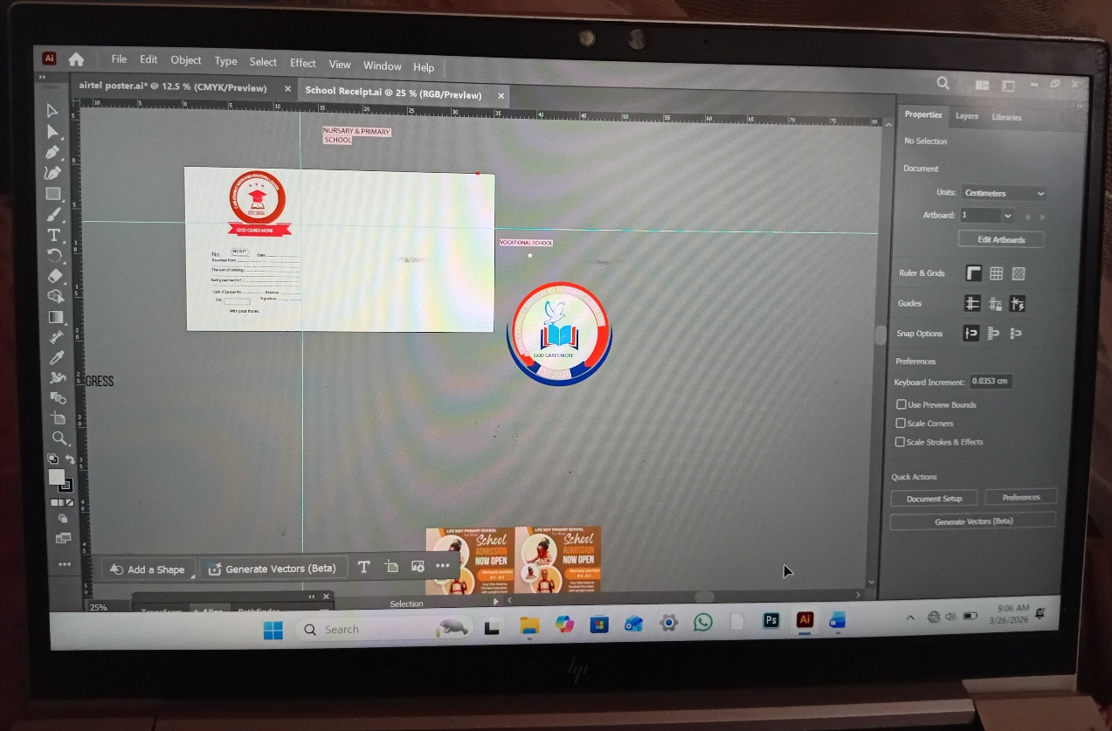

Key Tools and Techniques:

· Elliptical Marquee Tool
Purpose: Used to select circular or oval areas in an image.
Application: I used this tool to crop circular objects such as buttons, logos, or profile pictures from larger images. This allowed for precise extraction without distorting the shape.
· Rectangular Marquee Tool
Purpose: Used to select square or rectangular areas.
Application: I applied this to crop rectangular objects like ID cards, certificates, or sections of an image that required resizing or repositioning.
· Text Tool
Purpose: To insert and format text.
Application: I added names, titles, and organizational details to designs such as business cards and identity cards, ensuring proper font, size, and alignment.
· Background Color Adjustment
Purpose: To change or add background colors for visual appeal or branding consistency.
Application: I modified backgrounds to match client specifications, using the paint bucket tool and layer adjustments.

2.3.2 Networking:
In this field l was able to crip network cables using a crimping tool and terminate a straight through cable where l arranged them according to color coding white orange, orange, white blue and brown after l tested the cable to find out if the cable is working.
Objective: To prepare and terminate network cables for reliable internet and local area network (LAN) connectivity.

Tools Used:

· Crimping Tool – Used to attach RJ45 connectors to the ends of twisted-pair cables.
· Cable Tester – Used to verify continuity and correct pin configuration after termination.
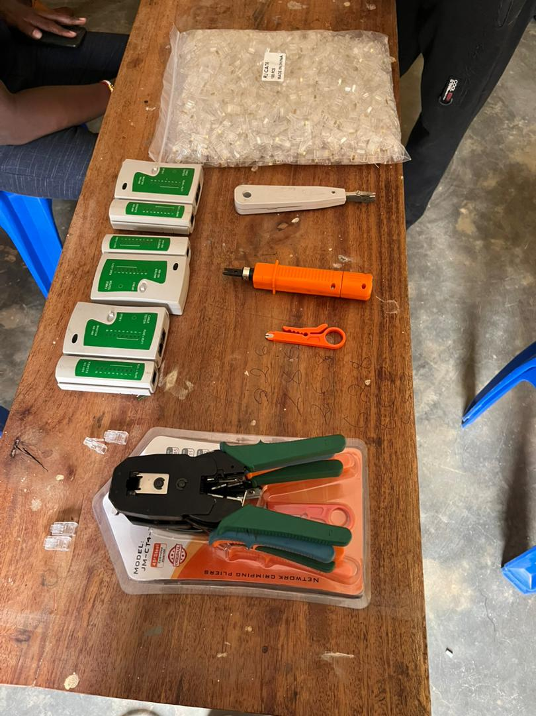

Process: Terminating a Straight-Through Cable

1. Cable Preparation: Stripped the outer jacket of the UTP (Unshielded Twisted Pair) cable to expose the inner twisted wires.
2. Wire Arrangement: Untwisted and arranged the wires according to the T568B standard (most common for straight-through cables):
· Pin 1: White Orange
· Pin 2: Orange
· Pin 3: White Green
· Pin 4: Blue
· Pin 5: White Blue
· Pin 6: Green
· Pin 7: White Brown
· Pin 8: Brown
3. Trimming: Cut the wires evenly to ensure they reached the end of the RJ45 connector.
4. Crimping: Inserted the wires into the RJ45 connector and used the crimping tool to secure them.
5. Testing: Used a cable tester to check for continuity and correct wiring. A successful test showed all eight pins lighting up in sequence on both the master and remote units.

Purpose of Straight-Through Cable: Used to connect different types of devices, such as a computer to a switch or router.
2.4 Maintenance and Repair (Laptop Disassembly and Assembly)

Objective: To understand the internal architecture of a laptop, identify key components, and practice safe handling for troubleshooting and repair.

Step-by-Step Process:

1. Disassembly:
· Removed the battery to ensure no power was flowing.
· Unscrewed the back panel carefully using appropriate screwdrivers.
· Used non-conductive tools to avoid static discharge.
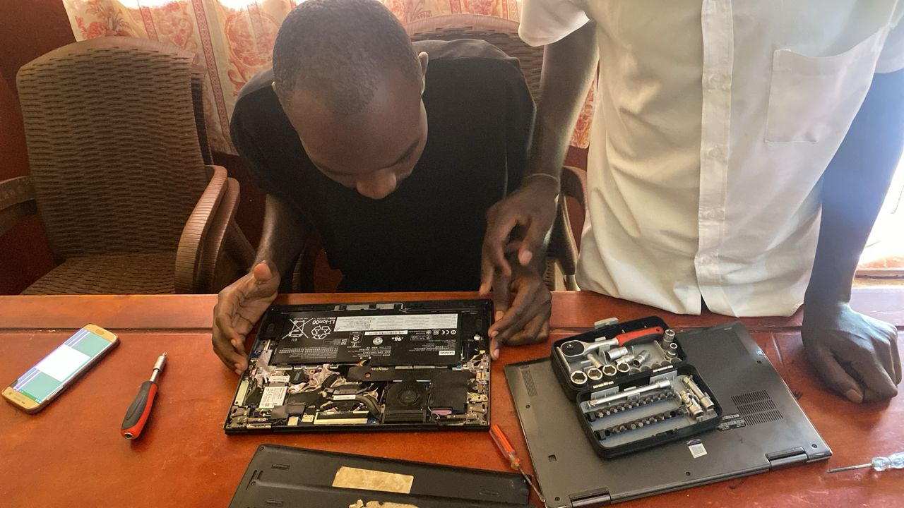
2. Identified Internal Components:
· RAM (Random Access Memory): Removable memory modules responsible for active processes. I learned how to unclip and reseat RAM to troubleshoot boot issues.
· HDD (Hard Disk Drive): The primary storage device. I observed how it connects via SATA interface and how to remove it for data recovery or replacement.
· CPU (Central Processing Unit): Located under a heat sink and fan assembly. I understood the importance of thermal paste and cooling in preventing overheating.
· Motherboard: The main circuit board connecting all components. I traced how power and data flow through it.
· Wi-Fi Card: A small removable card connected to antennas, responsible for wireless connectivity.
3. Assembly:
· Carefully reconnected all ribbon cables and components.
· Ensured screws were returned to their correct positions (some laptops use different screw lengths).
· Replaced the battery and powered on the laptop to confirm functionality.
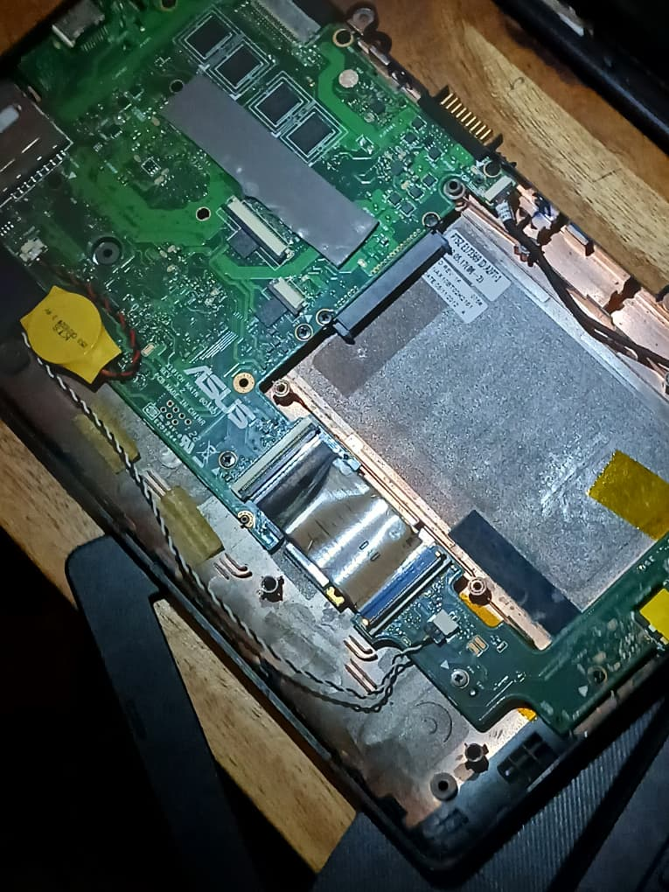
Summary of Skills Gained

Area Practical Skills
Graphics Image cropping, layer management, text insertion, color adjustment
Networking Cable stripping, color coding (T568B), crimping, cable testing
Hardware Laptop disassembly/assembly, component identification, basic troubleshooting

RELATIONSHIP WITH OTHER STUDENTS AND SUPERVISOR
My supervisor was very caring, available whenever l needed help and also submitting accomplished assignments and tasks thereby not causing struggles for me in searching for him.

CHAPTER THREE
3.1 CHALLENGES, CONCLUSION AND RECOMMENDATIONS
Introduction
This chapter is all about the overview and summary of key issues in this report and recommendations to different group of people to ensure positive and effective actions possible so that something of the value is got out of the field attachment.
3.2 Achievements.
I acquired knowledge and skills in various aspects of life and in the field of computer technology for example Screen technology, Generator, team work, Microsoft access, networking, printing and photo copying and installation of software on a computer. The skills are described below:
Microsoft access: My field supervisor used to give me assignments on access so l could create design and database views, assign primary key, create queries, forms, and reports.
Networking: I learnt so much about networking e.g. how to devices in networking for example crimping tool, cable tester, wireless router.
Generator: l learnt how to start a generator, how to check fuel and oil levels, how to refill the oil and fuel and how to connect a generator to a stabilizer.
Screen technology: l learnt about types of screens which include Light emitting diode, Liquid crystal display and Cathode ray tube.

3.2.1 Swot Analysis
Strengths:
- Practical ICT training
- Skilled instructors
Weaknesses:
- Limited equipment
- Power interruptions
Opportunities:
- Growing demand for ICT skills
- Expansion of services
Threats:
- Competition from other ICT centers
- Rising operational costs
CHAPTER FOUR
4.1 INTRODUCTION

4.2.0 CHALLENGES
4.2.1 ORGANISATIONAL CHALLENGES
Through JCC has achieved lot, it faces a lot of challenges and these include the following:
Funds
Like many small to medium sized ICT training centers, JCC often experiences financial constraints, limited funds affect the organization’s ability to purchase modern equipment and software licenses, maintain and upgrade existing infrastructure.
Taxation
Renting
Jinja computer center operates from a rented premise and renting comes with a lot of challenges such as rising rental costs over time, lack of control over the building modifications or expansions.
Power shortage
Inconsistent electricity supply is a common challenge in many regions. Power outrages disrupt daily operations at the center.
4.2.2 INDIVIDUAL CHALLENGES
As an intern, I also faced personal challenges while carrying out my duties
Power shortage
Frequent power outrages affected my ability to complete practical tasks such as graphics design, networking practice, and laptop repairs. On days when power was unavailable, for long periods, hands on training was significantly delayed.
Lack of enough equipment
The center had a limited number of computers, crimping tools, cable testers and laptops for disassembly practice. With multiple interns and students present, equipment had to be shared leading to reduced individual practice time, longer waiting periods before accessing tools.

HOW THEY WERE MANAGED
Lack of tools was managed by sharing
Power shortage was managed by use of a generator
4.3 RECOMMENDATIONS
4.3.1 TO THE INSTITUTION
The institution should send its supervisors more than one time to check on how the students are performing their duties.
The institution should introduce online supervision to cover those students in far areas.
The institution should ensure that students receive necessary equipment to use during the attachment when they are still at college.
4.3.2 TO THE ORGANIZATION
The organization should provide more tools
4.3.3 TO FELLOW INTERNEES
I recommend my fellow students to record their daily basis this helps a lot in report writing.
I recommend my fellow students attend on daily basis and always practice what they have learnt during their training

.

4.4 CONCLUSION
The field attachment exercise has been good for me during stay at Jinja Computer Center. This had made me eligible to acquire a variety of work and knowledge from different tasks undertaken. l was able to go gain knowledge through direct participation during the 6 weeks gained hands-on skills experience real life situations in the way that it changes my mind set especially during the career talks, guidance and counseling by our supervisor. I was able to learn team work and team building, good inter personal skill in the organization’s setting, getting exposed to the working world environment, ability to network and build contact with employers and other students and business community. Though on the other hand it has got some challenges such as limited facilities which needs to be addressed for the successful ongoing of the program.

REFERENCES
Computer Networking: A Top-Down Approach
Kurose, J. F., & Ross, K. W. (2017). Computer Networking: A Top-Down Approach (7th ed.). Pearson Education.

PC Hardware in a Nutshell
Mueller, S. (2003). PC Hardware in a Nutshell. O’Reilly Media.

Adobe Photoshop Classroom in a Book
Adobe Creative Team. (2020). Adobe Photoshop Classroom in a Book. Adobe Press.

Cisco Networking Academy
Cisco Networking Academy. (2024). Introduction to Networking. Retrieved from https://www.netacad.com

Microsoft Support
Microsoft. (2024). Microsoft Office Support and Training. Retrieved from https://support.microsoft.com

Appendices
INDUSTRIAL TRAINING SESSION INVOLVING LAPTOP ASSEMBLING, DISSEMBLE AND COMPUTER REPAIR AT CAEVA ORGANISATION

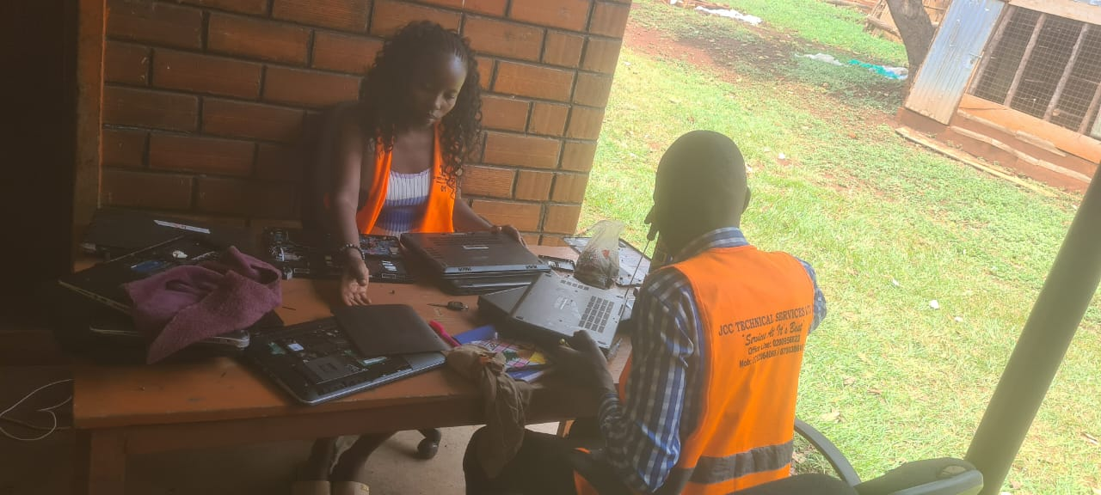

Team work
