C/C++ PI COMPUTATION LAB REPORT

1) Enter your name, student ID, platform (Mac or PC) and date
Name and StudentID: Brian Quintero 0842280
Class: CIS054 C/C++ Programming
Platform (Mac or PC): PC
Date: 2/21/17

OBJECTIVES:
Use a while loop to compute an approximate value of pi using 'n' terms of an infinite series.

PROJECT DESCRIPTION:
An approximate value of pi can be calculated using the series given below:
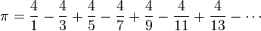
Write a C or C++ program that uses the successive approximation to compute pi. The program reads the number of terms for the calculation. Each term represents one of the fractions used in the computation. When pi has been computed, display the computed value of pi to 10 decimal places, the expected value, and the difference between the two values.
INPUTS | PROCESSING | OUTPUTS
Number of terms | Compute pi | Pi_computed  Pi_constant  The difference

LAB REPORT:
2) Fill in the TEST VALUES & ACTUAL RESULTS table
RUN | TERMS | EXPECTED RESULT  Computed values before  the program is run | ACTUAL RESULT  Fill in the output displayed by the program | DIFFERENCE  Between the expected result and the actual result
1 | 10 | 3.1415926536 | 3.0418396189 | .0997530347
2 | 100 | 3.1415926536 | 3.1315929036 | .0099997500
3 | 1,000 | 3.1415926536 | 3.1405926538 | .0009999997
4 | 10,000 | 3.1415926536 | 3.1414926536 | .0001000000
5 | 100,000 | 3.1415926536 | 3.1415826536 | .0000100000
NOTE: You cannot use a comma when entering numbers with cin or scanf.

DISCUSSION:
3) Complete the DISCUSSION section. It does not need to be long, but it needs to be complete.
3a) What did you do to develop the program? ("Followed the Directions" is not a complete description

I figured out how to make the loop subtract id odd and add if even, also figured out how to make the denominator and numerator constant to not complicate things further.I figure that my constant for M_Pi had to be typed out because the code. #define _USE_MATH_DEFINES was not working

3b) What problems did you have and how did you overcome the problems?
I had a problem for a while trying to figure out how to set up the loop to add and subtract.

PROGRAM OUTPUT:
4) Show five screen shots of the program. One for each of the runs (terms = 10, 100, 1000, 10000, 100000)

For the Mac, hold down command + shift + control keys and press the 3 key.
Use command+V to paste the clipboard into the lab report.

For Windows, There are two ways you can capture a screen shot of only your program:
- Use Microsoft's Snipping Tool by clicking on the Start icon and selecting "All Programs" then "Accessories". Use the mouse to select the area of the screen you want to save then click Ctrl-C or select the menu items Edit-Copy to save the image to the clipboard.
- Capture the active window to the clipboard by holding down the Alt key and tapping the PrintScreen key. NOTE: some notebook computers require that you hold down a [Fn] key and Alt keys to activate the PrintScreen function. NOTE: Do not click PrintScreen without the Alt key. This would capture the entire screen which would make your program output difficult to see.
Use Ctrl+V to paste the clipboard into the lab report.
Sample program output for 500 terms
How many terms do you want to compute Pi? 500
Computed Pi = 3.1395926556
Expected value = 3.1415926536
Difference = 0.0019999980

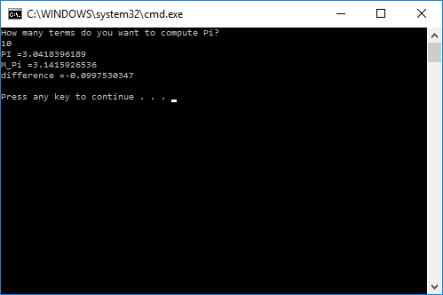
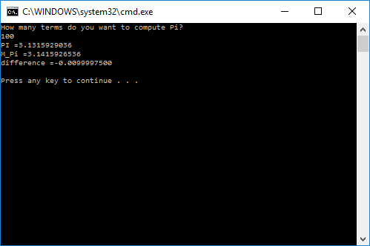
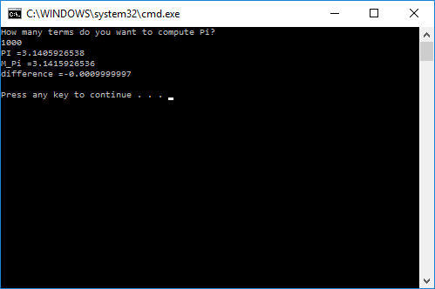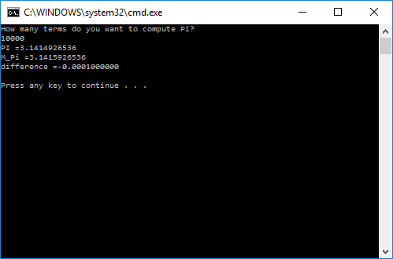
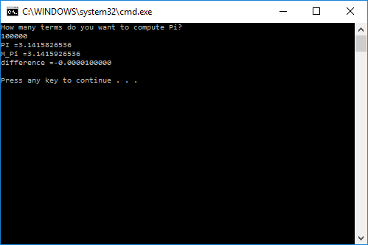
PROGRAM LISTING:
5) Copy and paste the code that YOU typed to make the program work. Your program should include a comment block at the top that shows the name of the program, date, version and your name.
//

#include "stdafx.h"
#include <iomanip>
#include <iostream>
#include <math.h>
#define _USE_MATH_DEFINES
using namespace std;

int main(int argc,char* argv[])
{
const double M_PI = 3.1415926535897932384626433832795;
double numerator = 4.0;
double denominator = 1.0;
double fraction = 1.0;
double pi = 0.0;
int terms;
int loopcount;

cout << "How many terms do you want to compute Pi?\n";
cin >> terms;

for (int loopcount = 1; loopcount <= terms; loopcount++)
{
fraction = numerator / denominator;
if (loopcount % 2) //determines if loop count is odd or even

pi += fraction;//adds if loop count is odd

else
pi -=fraction;//adds if loop count is even
denominator += 2;
}

cout << setiosflags(ios::fixed) << setiosflags(ios::showpoint) << setprecision(10);

cout << "PI =" << pi << endl;
cout << "M_Pi =" << M_PI << endl;
cout << "difference =" <<( pi - M_PI) << endl << endl;
system("PAUSE");// stop screen from dissapearing

return 0;
}

