C/C++ ELECTRIC BILL LAB REPORT

1) Enter your name, student ID, platform (Mac or PC) and date
Name and StudentID: Brian Quintero 0842280
Class: CIS054 C/C++ Programming
Platform (Mac or PC): PC
Date: 2/21/2017

OBJECTIVES:
Use if...else if...else statements to compare numeric values
Use Exception Handling in a C++ program to process unexpected or illegal inputs – Refer to the lecture

PROJECT DESCRIPTION:
Create a program that does the following:
1) Read the number of kWh used by the customer
2) compute the Electric Bill with a lower rate for the baseline kWh and a higher rate for kWh over the baseline
3) display the Electric Bill
C++ programs must use Exception Handling to process unexpected or illegal inputs – Refer to the lecture
INPUTS | PROCESSING | OUTPUTS
kWh | Input kWh from user, convert to double  Determine Base_kWh (up to 500)  Determine Extra_kWh (over 500)  Base_Bill = Base_kWh * 0.27  Extra_Bill = Extra_kWh * 0.55  Electric_Bill = Base_Bill + Extra_Bill  Display Electric_Bill | Electric_Bill

LAB REPORT:
2) Fill in the TEST VALUES & RESULTS table
Fill in the Test Data Values and Expected Results as shown on the lab assignment from Moodle.
Fill in the Actual Results after you have run and tested your program
TEST DATA VALUES  kwh | EXPECTED RESULT  Computed values before the program is run | ACTUAL RESULT  Fill in the output displayed  by the program
400 | $108.00 | $108.00
500 | $135.00 | $135.00
600 | $190.00 | $190.00

DISCUSSION:
3) Complete the DISCUSSION section. It does not need to be long, but it needs to be complete.
3a) What did you do to develop the program? ("Followed the Directions" is not a complete description)
-I figured out what my inputs were and what I need to be my outputs. For example my inputs for this project were 400kWh and my output should have been $108.00. I wrote out a program like the paycheck lab, just all converted to kwh with a different process and inputs/outputs since it was alike.

3b) What problems did you have and how did you overcome the problems?
-The problems I ran into were in my //Adding the Bills.When I was adding the bills I wasn’t writing it out clear. My addition was wrong and I wasn’t adding the right components for example I was adding my Extra_kWh wrong, I was doing Extra_kWh = base_kWh – 500.00
When it was supposed to be Extra_kWh= kWh - 500.00

PROGRAM OUTPUT:
4) Show four screen shots of the program execution.
- When kWh = 400
- When kWh = 500
- When kWh = 600
- When letters are entered for kWh instead of numbers

For the Mac, hold down command + shift + control keys and press the 3 key.
Use command+V to paste the clipboard into the lab report.

For Windows, There are two ways you can capture a screen shot of only your program:
- Use Microsoft's Snipping Tool by clicking on the Start icon and selecting "All Programs" then "Accessories". Use the mouse to select the area of the screen you want to save then click Ctrl-C or select the menu items Edit-Copy to save the image to the clipboard.
- Capture the active window to the clipboard by holding down the Alt key and tapping the PrintScreen key. NOTE: some notebook computers require that you hold down a [Fn] key and Alt keys to activate the PrintScreen function. NOTE: Do not click PrintScreen without the Alt key. This would capture the entire screen which would make your program output difficult to see.
Use Ctrl+V to paste the clipboard into the lab report.

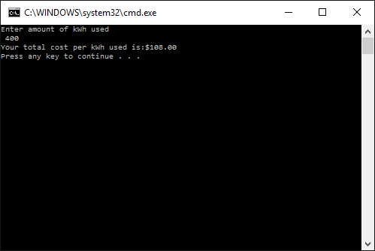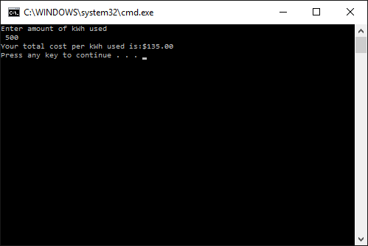
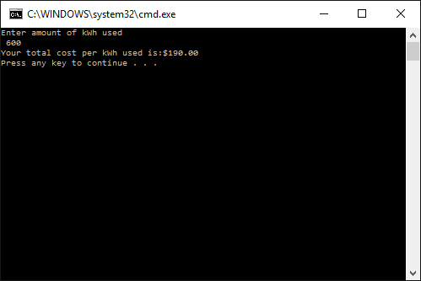

PROGRAM LISTING:
5) Copy and paste the code that YOU typed to make the program work. Your program should include a comment block at the top that shows the name of the program, date, version and your name.

// C++ Electric Bill
//Brian Quintero - june-28-2016
//CIS054 C/C++ Programming
//Inputs: kWh
//OUTPUTS: Electric Bill

#include "stdafx.h"
#include <iostream>
#include <iomanip>
using namespace std;

int _tmain(int argc, _TCHAR* argv[])
{
// declare the Variables

double kWh;
double Base_kWh;
double Extra_kWh;
double Base_Bill;
double Extra_Bill;
double Electric_Bill;

//INPUT kwh used

cout << "Enter amount of kWh used \n ";
cin >> kWh;

//Process

if (kWh <= 500.0) //only use numbers with decimal point and a 0 at the end to make sure double works
{
Base_kWh = kWh;
Extra_kWh = 0.0;

}

else

{
Base_kWh = 500.0;
Extra_kWh = kWh - 500.0; //anything over 500 kwh

}

// Adding the bills

Base_Bill = Base_kWh * .27;
Extra_Bill = Extra_kWh * .55;
Electric_Bill = Base_Bill + Extra_Bill;

//OUTPUT

cout << setiosflags(ios::fixed);
cout << setiosflags(ios::showpoint);
cout << "Your total cost per kWh used is:$" <<setprecision(2) << Electric_Bill << endl;

return 0;
}

