C/C++ FALAFEL LAB REPORT

1) Enter your name, student ID, platform (Mac or PC) and date
Name and Student ID: Brian Quintero 0842280
Class: CIS054 C/C++ Programming
Platform (Mac or PC): PC
Date: 3/26/2017

DESCRIPTION:
A falafel is a very popular Middle Eastern food. It is served as a sandwich stuffed in pita bread usually containing lettuce, tomatoes and some round balls of fried chickpeas. The fried balls of chickpeas look like meatballs but are green on the inside and are very nutritious.

Modify the Falafel program to do the following:
1) Create a counter for each type of item sold (Falafels, Sodas, Extras).
2) When the ‘T’ key is pressed for the total, display the count and subtotal for each item, the subtotal for all items, compute tax at 8.7%, display the amount of tax, and the final total for all items plus the tax.
3) Use a constant (const in C++, or #define in C) to define the tax rate.
4) Each display should contain two digits past the decimal point.
5) The program must process unexpected or illegal inputs. If the user enters a menu selection that is invalid, an error message must be displayed.
LAB REPORT:
2) Determine the Inputs, Processing and Outputs before creating the program
INPUTS | PROCESSING | OUTPUTS
F=Falafel  X=Extra  S=Soda | DisplayMenu();//shows menu so they can make their selection  price = 0;  cout << "Make your Selection (F,S,X,T): \n";// Falafel, Soda, Extra side, Total  cin >> selection;  switch (toupper(selection))//Makes any entry uppercase  {  case 'F':  price = 5.15;  break;  case 'S':  price = 2.24;  break;  case 'X':  price = 1.57;  break;  case'T':  break;  default:  cout << "Illegal enty, try again";//if they enter anything besides what is allowed they will recieve an error message  }  total = price + total;  } while (selection != 'T' && selection != 't');  cout << "the total is $" << total << endl; | T= total

3) Fill in the EXPECTED & ACTUAL RESULTS
TEST DATA VALUES  Provide several different examples of menu selections | EXPECTED RESULT  Computed values before the program is run | ACTUAL RESULT  Fill in the output displayed  by the program
F+S  F+X+X  F+X+S | $7.39  $8.29 | $7.39  $8.29

DISCUSSION:
4) Complete the DISCUSSION section. It does not need to be long, but it needs to be complete.
4a) What did you do to develop the program? ("Followed the Directions" is not a complete description)
I figured out what kind of loop I needed with endued up being the do-while loop. Then I figured out how I had to display the menu, which your instructions helped a lot for. Ran a program for to find the total of everything selected. Figured what should have been offered in the menu.

4b) What problems did you have and how did you overcome the problems?
The hardest part was figuring out how to setup the display for the menu. It was my first time displaying something under that format.

PROGRAM OUTPUT:
5) Show screen shots for at least TWO sample purchases of the program execution.
Refer to previous lab assignments for instructions on how to capture a screen or portions of a screen for either the PC or a Mac. Provide a screenshot into the lab report showing several items purchased. Provide another screenshot showing the result of an unexpected or illegal input.
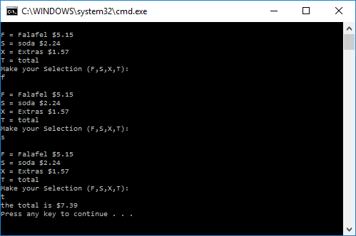
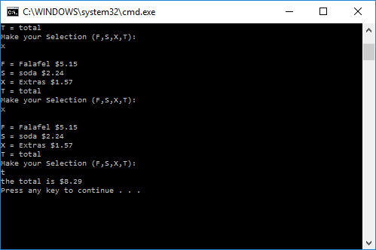
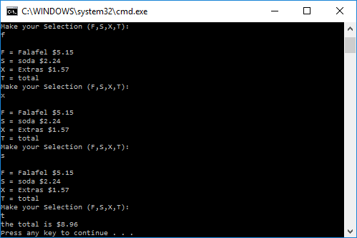

PROGRAM LISTING:
6) Copy and paste the code that YOU typed to make the program work. Your program should include a comment block at the top that shows the name of the program, date, version and your name.
// ConsoleApplication19.cpp : Defines the entry point for the console application.
//Brian Quintero- 3/6/2017
//CIS-54 C/C++ PORGRAMMING

#include "stdafx.h"
#include <iostream>
#include <cctype>
using namespace std;
void DisplayMenu(); //displays the menu

int main()
{
double total = 0.00;
double price;
char selection;

do
{

DisplayMenu();//shows menu so they can make their selection
price = 0;
cout << "Make your Selection (F,S,X,T): \n";// Falafel, Soda, Extra side, Total
cin >> selection;
switch (toupper(selection))//Makes any entry uppercase
{
case 'F':
price = 5.15;
break;
case 'S':
price = 2.24;
break;
case 'X':
price = 1.57;
break;
case'T':
break;
default:
cout << "Illegal enty, try again";//if they enter anything besides what is allowed they will recieve an error message

}

total = price + total;

} while (selection != 'T' && selection != 't');
cout << "the total is $" << total << endl;

return 0;
}

void DisplayMenu()//displays menu
{
cout << endl;//blnak line before menu
cout << "F = Falafel $5.15" << endl;
cout << "S = soda $2.24" << endl;
cout << "X = Extras $1.57" << endl;
cout << "T = total" << endl;
}

