C++ LENGTH OF LINE PROGRAM LAB REPORT

1) Enter your name, student ID, platform (Mac or PC) and date
Name and Student ID: Brian Quintero 0842280
Class: CIS054 C/C++ Programming
Platform (Mac or PC): PC
Date:
3/6/2017
DESCRIPTION:
Create a program that uses a function to determine the length of a line by inputting the X,Y coordinates of the line endpoints. Show the result with a precision of four decimal places. The function prototype is to be specified as follows:

double LengthOfLine (double X1, double Y1, double X2, double Y2); // returns length of line

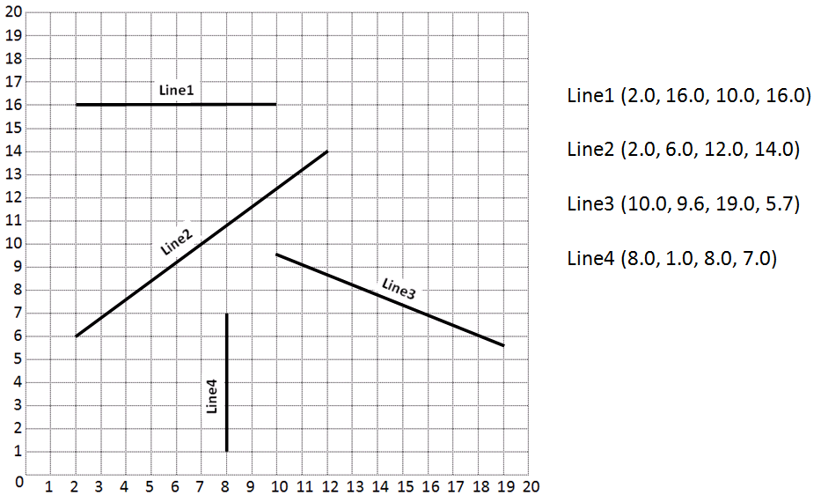

INPUTS | PROCESSING | OUTPUTS
X1  X2  Y1  Y2 | Input X1,X2,Y1,Y2 from user  Set the formula on how to convert for A,B,C  a=(X2-X1)  b=(Y2-Y1)  c=sqrt(a*a +b*b) | length
2) Determine the Inputs, Processing and Outputs before creating the program
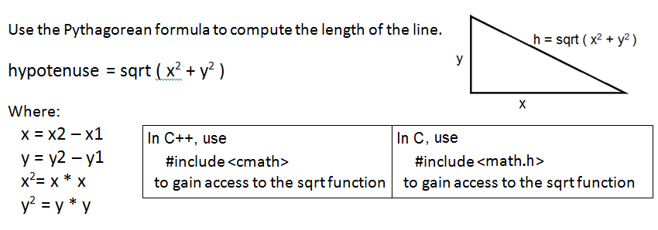

3) Fill in the EXPECTED & ACTUAL RESULTS
TEST DATA VALUES | EXPECTED RESULT  Computed values before the program is run | ACTUAL RESULT  Fill in the output displayed  by the program
2.0 16.0 10.0 16.0 | 8.000 | 8
2.0 6.0 12.0 14.0 | 12.8062 | 12.8062
10.0 9.6 19.0 5.7 | 9.8087 | 9.8087
8.0 1.0 8.0 7.0 | 6.0000 | 6

DISCUSSION:
4) Complete the DISCUSSION section. It does not need to be long, but it needs to be complete.
4a) What did you do to develop the program? ("Followed the Directions" is not a complete description)

First I had to figure out how to get the distances of the lines and how to add them together// basic math.
Then I had to figure out what formula I had to set up so the points would create a distance that I needed to compute.
After it was easy once I read a little deeper on how to set up the formulas.

4b) What problems did you have and how did you overcome the problems?
Setting up the formula for the length of the line was difficult for me, the format presented was different and figuring out why it was like that and remembering why it should be like that was the challenging part.

PROGRAM OUTPUT:
5) Show four screen shots, one for each of the TEST DATA VALUES in the above table.
Refer to previous lab assignments for instructions on how to capture a screen or portions of a screen for either the PC or a Mac
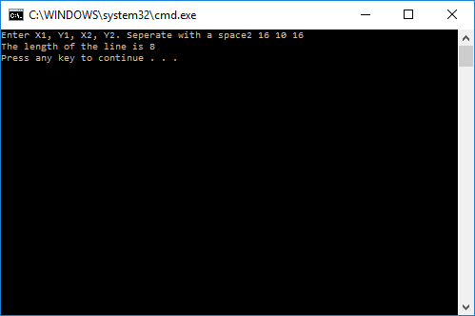
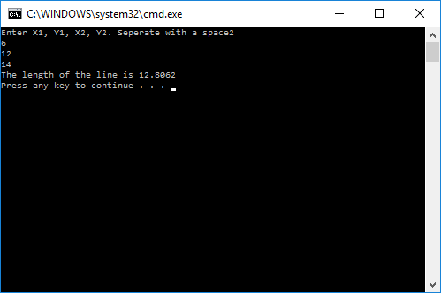
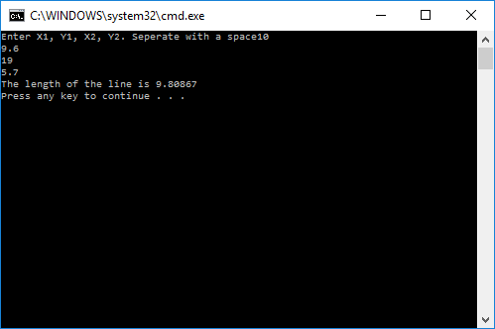
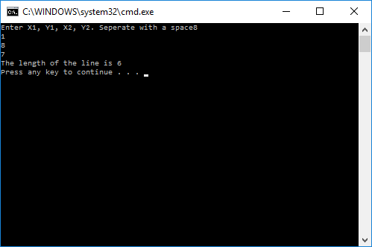
PROGRAM LISTING:
6) Copy and paste the code that YOU typed to make the program work. Your program should include a comment block at the top that shows the name of the program, date, version and your name.

// ConsoleApplication20.cpp : Defines the entry point for the console application.
//Brian Quinter - 3/26/2017
//CIS054 C/C++ PROGRAMMING
//INPUTS X1, X2, Y1, Y2

#include "stdafx.h"
#include <iomanip>
#include <iostream>
#include <math.h>
using namespace std;
double lengthofline(double X1, double Y1, double X2, double Y2);

int main()
{
double X1, Y1, X2, Y2, length; // variables declared
cout << "Enter X1, Y1, X2, Y2. Seperate with a space";
cin >> X1 >> Y1 >> X2 >> Y2;
length = lengthofline(X1, Y1, X2, Y2);
cout << "The length of the line is " << length << endl;

return 0;
}

double lengthofline(double X1, double Y1, double X2, double Y2)
{
double a, b, c;
a = X2 - X1;
b = Y2 - Y1;
c = sqrt(a*a + b*b);
return c;

}

