C/C++ LONG DISTANCE CALL LAB REPORT

1) Enter your name, student ID, platform (Mac or PC) and date
Name and Student ID: Brian QUintero
Class: CIS054 C/C++ Programming
Platform (Mac or PC): Pc
Date: 2/27/17

DESCRIPTION:
Chapter 3 Programming Project (#5 page 171 for the 8th Edition –or– #1 page 174 for the 9th Edition)
Write a program that computes the cost of a long-distance call. The cost of the call is determined according to the following rate schedule:
- Any call started between 8:00 am and 6:00 pm, Monday through Friday, is billed at a rate of $0.40 per minute.
- Any call starting before 8:00 am or after 6:00 pm, Monday through Friday, is charged at a rate of $0.25 per minute.
- Any call started on a Saturday or Sunday is charged at a rate of $0.15 per minute.
The input will consist of the day of the week, the time the call started, and the length of the call in minutes. The output will be the cost of the call. The time is to be input in 24-hour notation, so the time 1:30 pm is input as 13:30

The day of the week will be read as one of the following pairs of character values, which are stored in two variables of type char.
Mo Tu We Th Fr Sa Su

Be sure to allow the user to use either uppercase or lowercase letters or a combination of the two. The number of minutes will be input as a value of type int. (You can assume that the user rounds the input to a whole number of minutes.) Your program should include a loop that lets the user repeat this calculation until the user says she or he is done.

2) Determine the Inputs, Processing and Outputs before creating the program
INPUTS | PROCESSING | OUTPUTS
-Day of the week  -Hour  -Minute  -length of call | -input day of the week  -process the time in 24 hour notation and convert it to military time by ( TimeStarted = hour*100 + minutes)  -get the length of the call from user  -apply rate according to the day and time  For Weekend_Rate=.15; evening_rate=.25; day_rate=.40;  Then formulate my loop with  costOfBill = lengthOfCall * RateOfCall | CostOfBill

3) Fill in the EXPECTED & ACTUAL RESULTS
TEST DATA VALUES  Be sure to provide test values for all three possible conditions | EXPECTED RESULT  Computed values before the program is run | ACTUAL RESULT  Fill in the output displayed  by the program
1.Day=Mo, Time = 14:35, Minutes=20 | 1.Result E=$8 | 1.Actual Result= $8
Day=tues time =22:00  Minutes=20 | 5 | 5

DISCUSSION:
4) Complete the DISCUSSION section. It does not need to be long, but it needs to be complete.
4a) What did you do to develop the program? ("Followed the Directions" is not a complete description)

4b) What problems did you have and how did you overcome the problems?

PROGRAM OUTPUT:
5) Show three screen shots of the program execution.
- A call started between 8:00 am or after 6:00 pm, Monday through Friday, billed at a rate of $0.40 per minute. 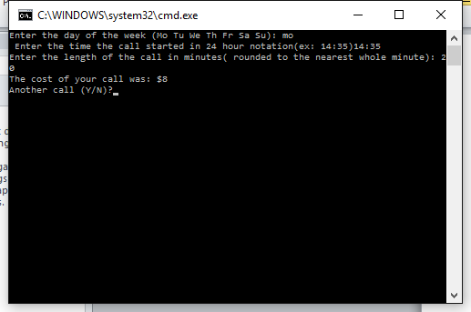
- A call starting before 8:00 am or after 6:00 pm, Monday through Friday, charged at a rate of
$0.25 per minute.
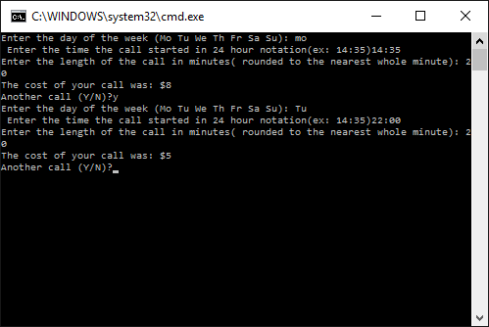
- A call started on a Saturday or Sunday charged at a rate of $0.15 per minute.

For the Mac, hold down command + shift + control keys and press the 3 key.
Use command+V to paste the clipboard into the lab report.

For Windows, There are two ways you can capture a screen shot of only your program:
- Use Microsoft's Snipping Tool by clicking on the Start icon and selecting "All Programs" then "Accessories". Use the mouse to select the area of the screen you want to save then click Ctrl-C or select the menu items Edit-Copy to save the image to the clipboard.
- Capture the active window to the clipboard by holding down the Alt key and tapping the PrintScreen key. NOTE: some notebook computers require that you hold down a [Fn] key and Alt keys to activate the PrintScreen function. NOTE: Do not click PrintScreen without the Alt key. This would capture the entire screen which would make your program output difficult to see.
Use Ctrl+V to paste the clipboard into the lab report.

PROGRAM LISTING:
6) Copy and paste the code that YOU typed to make the program work. Your program should include a comment block at the top that shows the name of the program, date, version and your name.

// ConsoleApplication15.cpp : Defines the entry point for the console application.
//

#include "stdafx.h"
#include <cstring>
#include <iomanip>
#include <string>
#include <iostream>
using namespace std;

char day1;
char day2;

char Mo, Tu, We, Th, Fr;
char Sa, Su;
int hour;
char separator;
int minute;
int timeStarted;
int lengthOfCall;
double costOfCall;
double billing_rate;
char again;

int _tmain(int argc, _TCHAR* argv[])
{

do
{

cout << "Enter the day of the week (Mo Tu We Th Fr Sa Su): ";
cin >> day1 >> day2;
day1 = toupper(day1);
day1 = toupper(day2);

cout << " Enter the time the call started in 24 hour notation(ex: 14:35)";
cin >> hour >> separator >> minute;
timeStarted = hour*100 + minute;

cout << "Enter the length of the call in minutes( rounded to the nearest whole minute): ";
cin >> lengthOfCall;

const double weekend_Rate=.15;// rate during the weekend
const double evening_Rate=.25;//rate during the evening of weekdays
const double day_Rate=.40;// rate during the day before evening on weekdays

//process for weekends
if (day1 == 'S' && day2 =='A')
billing_rate = weekend_Rate;

else if (day1 == 'S' && day2 =='U')
billing_rate = weekend_Rate;

else// exception to weekends
{
if (timeStarted >= 800 && timeStarted<=1800)
billing_rate = day_Rate;
else
billing_rate = evening_Rate;
}
costOfCall = lengthOfCall * billing_rate;

cout << "The cost of your call was: $" << costOfCall<< endl;

//loop control
cout << "Another call (Y/N)?";
cin >> again;
again = toupper(again);

}while (again=='Y');

return 0;
}

