MEDIAN OF A FILE LAB REPORT

1) Enter your name, student ID, platform (Mac or PC) and date
Name and Student ID: Brian Quintero
Class: CIS054 C/C++ Programming
Platform (Mac or PC): pc
Date: 3/13/2017

DESCRIPTION:
NOTE: The code for processing a disk file is very different between the C and C++ languages. There are separate code examples for C and C++. The code samples show how to read a disk file and skip records until you reach the location of the records that will contain the values to be used when computing the median value. You can verify that you have the correct results by opening the files with a spreadsheet program (Microsoft Excel, Apple Numbers or OpenOffice Calc), select the column with the balances and compute the median value with one of the statistical functions.

Two data files are provided for this lab. One file has an odd number of records and the other file has an even number of records. You need to run the program for each file and compute the median value for each file.

Sample code is given at the end of this lab assignment. Replace the cout that is inside the while loop with code to compute the total of all balances. After the while loop completes, display the total of all balances.

For Microsoft, the easiest place to put the data file is in the same folder as the source .CPP file. If you wish to place the data file on the desktop, enter the following for the filename:
Microsoft Windows (replace Dan with your login name):
char filename[ ] = "C:/Users/Dan/Desktop/File1.txt"; // filenames on the PC are not case sensitive
Mac OS/X (replace Dan with your login name):
char filename[ ] = "/Users/Dan/Desktop/File1.txt"; // filenames on the Mac are case sensitive

LAB REPORT:
2) Determine the Inputs, Processing and Outputs before creating the program.
INPUTS | PROCESSING | OUTPUTS
Filename | See if file is able to be open  If able to open total+=acctbal  If not meant to be added will go through another program  To determine median median=(median+acctbal)/2; | Median  recordstoskip

3) Fill in the EXPECTED & ACTUAL RESULTS.
TEST DATA VALUES | EXPECTED RESULT  Use a spreadsheet program to determine the expected median values | ACTUAL RESULT  Fill in the output displayed  by the program
Balances-1.txt  Balances-2.txt | 1151.03  1150.22 | 1151.03  1150.22

DISCUSSION:
4) Complete the DISCUSSION section. It does not need to be long, but it needs to be complete.
4a) What did you do to develop the program? ("Followed the Directions" is not a complete description)

Once I finished the first HW in module 6 I had a better understanding of how to complete the program. So I formatted the median, set the files to either Balances-1, Balances-2.
Then I had to figure out the 3rd code which was much like the first hw.

4b) What problems did you have and how did you overcome the problems?
The problems I had was just making sure my code was good to transmit both the balances with the right amount

PROGRAM OUTPUT:
5) Show two screen shots. One each for program execution of the two data files.
Refer to previous lab assignments for instructions on how to capture a screen or portions of a screen for either the PC or a Mac
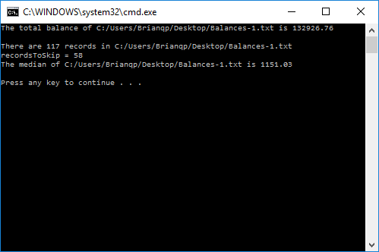
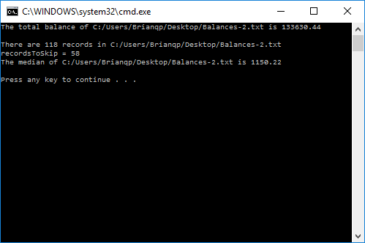

PROGRAM LISTING:
6) Copy and paste the code that YOU typed to make the program work. Your program should include a comment block at the top that shows the name of the program, date, version and your name.

//Brian Quintero 0842282
//CIS-054 C/C++ PROGRAMMING
//PC
//3/13/2017

#include "stdafx.h"
#include <iomanip>
#include <cstdlib>
#include <fstream>
#include <iostream>
using namespace std;

int main(int argc, char** argv)
{
// variables to control the disk file
ifstream infile;
char filename[200] = "C:/Users/Brianqp/Desktop/Balances-1.txt";
int recordCount = 0;
int recordsToSkip = 0;
int acctNo = 0;
char acctName[100] = "";
double acctBal = 0.0; // variable used to determine the median
double median = 0.0;
double total = 0.0;

// ---- PART 1, Count the number of records in the file and determine the mean
infile.open(filename);

if (infile.fail())
{
cerr << "Unable to open --" << filename << "--, first pass" << endl;
exit(1);
}

while (!infile.eof())
{
acctName[0] = 0; // initialize to 0 to test for empty records
infile >> acctNo >> acctName >> acctBal;

if (acctName[0] != 0)
{
total += acctBal;
recordCount++;
}

}

cout << setiosflags(ios::fixed);
cout << setiosflags(ios::showpoint);
cout << setprecision(2);

cout << "The total balance of " << filename << " is " << total << endl << endl;

infile.close();

cout << "There are " << recordCount << " records in " << filename << endl;

// ---- PART 2, Determine the number of records to skip
if (recordCount % 2 == 1) {
recordsToSkip = recordCount / 2; // Odd number of records
}
else {
recordsToSkip = recordCount / 2 - 1; // Even number of records
}

cout << "recordsToSkip = " << recordsToSkip << endl;

// ---- PART 3, open the file, skip leading records, determine the median
infile.open(filename);
if (infile.fail())
{
cerr << "Unable to open " << filename << ", second pass" << endl;
exit(1);
}

while (recordsToSkip != 0) {
infile >> acctNo >> acctName >> acctBal;
recordsToSkip--;
}

infile >> acctNo >> acctName >> acctBal;
if (recordCount % 2 == 1) {
median = acctBal;
}
else {
median = acctBal;
infile >> acctNo >> acctName >> acctBal;
median = (median + acctBal) / 2;
}

infile.close();

cout << "The median of " << filename << " is " << median << endl << endl;

return 0;
}

