C/C++ PAYCHECK PROGRAM LAB REPORT

1) Enter your name, student ID, platform (Mac or PC) and date
Name and Student ID: Brian Quintero
Class: CIS054 C/C++ Programming
Platform (Mac or PC): PC
Date: 2/6/2017

OBJECTIVES:
Enter and successfully run a C or C++ program
Use console input to read data from the keyboard
Calculate regular and overtime pay using if…else statements
Use console output to display data to the monitor

DESCRIPTION:
Design a C or C++ program that does the following: 1) Read the number of hours worked and the pay rate, 2) compute the pay including overtime at time-and-a-half 3) display the gross pay, not including taxes or any other deductions.
INPUTS | PROCESSING | OUTPUTS
Hours  PayRate | Read hours from the keyboard into a double  Read payRate from the keyboard into a double  Determine regularHours (up to 40)  Determine overtimeHours (hours over 40)  regularPay = regularHours * payRate  overtimePay = overtimeHours * payRate * 1.5  grossPay = regularPay + overtimePay  Display grossPay | GrossPay

LAB REPORT:
2) Fill in the TEST VALUES & RESULTS table
Fill in the Test Data Values and Expected Results as shown on the lab assignment from Moodle.
Fill in the Actual Results after you have run and tested your program
TEST DATA VALUES | EXPECTED RESULT  Computed values before  the program is run | ACTUAL RESULT  Fill in the output displayed  by the program
Hours = 39, PayRate = 20 | $780.00 | $780.00
Hours = 40, PayRate = 20 | $800.00 | $800.00
Hours = 41, PayRate = 20 | $830.00 | $830.00

DISCUSSION:
3) Complete the DISCUSSION section. It does not need to be long, but it needs to be complete.
3a) What did you do to develop the program? ("Followed the Directions" is not a complete description
-I first uploaded Visual studio, then I figured out what my output should be so I can enter my inputs. Then since I had a setup of what I had to code I began entering with leaving notes in between Paragraphs.

3b) what problems did you have and how did you overcome the problems?
-I ran into two errors.
One with (iostream : :fixed) I had typed it with a space between iostream and : and that’s where an error was.
The other error I had was I wasn’t pairing my pay rate, I was supposed to scroll down the list of and accept the match which I at first did not do.
PROGRAM OUTPUT:
4) Show three screen shots of the program.
- A paycheck computed when the hours worked is less than 40
- A paycheck computed when the hours worked is equal to 40
- A paycheck computed when the hours worked is greater than 40

For the Mac, hold down command + shift + control keys and press the 3 key.
Use command+V to paste the clipboard into the lab report.

For Windows, There are two ways you can capture a screen shot of only your program:
- Use Microsoft's Snipping Tool by clicking on the Start icon and selecting "All Programs" then "Accessories". Use the mouse to select the area of the screen you want to save then click Ctrl-C or select the menu items Edit-Copy to save the image to the clipboard.
- Capture the active window to the clipboard by holding down the Alt key and tapping the PrintScreen key. NOTE: some notebook computers require that you hold down a [Fn] key and Alt keys to activate the PrintScreen function. NOTE: Do not click PrintScreen without the Alt key. This would capture the entire screen which would make your program output difficult to see.
Use Ctrl+V to paste the clipboard into the lab report.

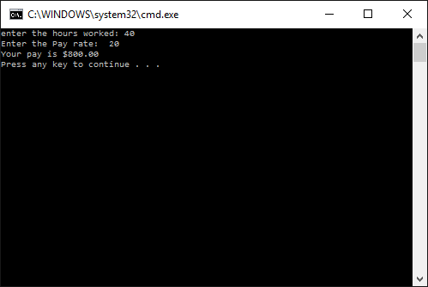
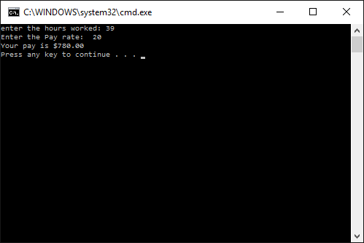
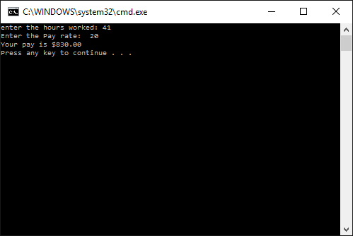

PROGRAM LISTING:
5) Copy and paste the code that YOU typed to make the program work. Your program should include a comment block at the top that shows the name of the program, date, version and your name.

//C++PaycheckV1.0.cpp : Defines the enry point for the console application
//Brian Quintero - 6/22/2016
//CIS-54 C/C++ Programming
//Inputs: Hours, Pay Rate
//Outputs: Paycheck

#include "stdafx.h" //ONly enter this lane when using visual studio
#include <iostream>
#include <iomanip>
using namespace std;

int main(int argc, char* argv[])
{
//Declare the variables
double Hours;
double PayRate;
double RegHours;
double OvertimeHours;
double RegPay;
double OvertimePay;
double PayCheck;

//Input the Hours and PayRate
cout << "enter the hours worked: "; //prompt
cin >> Hours;
cout << "Enter the Pay rate: ";
cin >> PayRate;

//Compute RegHours and OvertimeHours
//PROCESS the data and compute the paycheck

if (Hours <=40)
{
RegHours = Hours;
OvertimeHours = 0; //No over time if less than 40 hours
}
else
{
RegHours = 40;
OvertimeHours = Hours- 40; // anything over 40
}

//Compute paycheck

RegPay = RegHours * PayRate;
OvertimePay = OvertimeHours * PayRate * 1.5;
PayCheck = RegPay + OvertimePay;

//OUTPUT the paycheck with two digits past the decimal
cout << setiosflags(ios::fixed);
cout << setiosflags(ios::showpoint);
cout << "Your pay is $" << setprecision(2) << PayCheck << endl;

return 0;
}

