C/C++ PLAYERS ON A TEAM LAB REPORT

1) Enter your name, student ID, platform (Mac or PC) and date
Name and StudentID: Brian Quintero 0842280
Class: CIS054 C/C++ Programming
Platform (Mac or PC): PC
Date: 2/13/2017

OBJECTIVES:
Use if...else if...else statements to compare numeric values

PROJECT DESCRIPTION:
Design a C or C++ program that does the following: Determine whether a sports team manager needs to add more players to make a full team or cut players from the team if there are too many.
INPUTS | PROCESSING | OUTPUTS
teamSize  playersOnTeam | Read teamSize from the keyboard  Read playersOnTeam from the keyboard  If playersOnTeam <= teamSize Then  Display "There are not enough players" Compute how many more players are needed  Display "# more players are needed"  Else if playersOnTeam > teamSize  Display “There are too many players"  Compute how many more players need to be cut  Display "# players need to be eliminated"  Else  Display “You have the correct number of players” | Number of players needed to be added, cut, or indicate that the number is correct

LAB REPORT:
2) Fill in the TEST VALUES & RESULTS table
Fill in the Test Data Values and Expected Results as shown on the lab assignment from Moodle.
Fill in the Actual Results after you have run and tested your program
 | TEST DATA VALUES | EXPECTED RESULT  Computed values before the program is run | ACTUAL RESULT  Fill in the output displayed  by the program
Too High | Players that should be on the team 53;  Players on the team 65; | 12 players to be eliminated; | 12 players to be eliminated
Too Low | How many players should be on the team= 13  How many players on the team=10 | 3 more players needed | 3 more players are needed
Just Right | 25 players should be on the team  25 player are on the team | You have the correct number of players | You have the correct number of players

DISCUSSION:
3) Complete the DISCUSSION section. It does not need to be long, but it needs to be complete.
3a) What did you do to develop the program? ("Followed the Directions" is not a complete description)

I figured out what my input needed to be and what the process is and what I need to be my output. The input and output were east but trying to formulate the process on my own was a little challenging.
Still need to learn how to make what I want the computer do clear

3b) What problems did you have and how did you overcome the problems?
One of my main problems is I forget to add “ ; “ at the end of every statement . I tend to just go back and look over every lane. I also don’t understand why in “cout << ExtraPlayers<< " Players to be eliminated" << endl << endl;” there is two endl.

PROGRAM OUTPUT:
4) Show three screen shots of the program execution.
- Too many players on a team

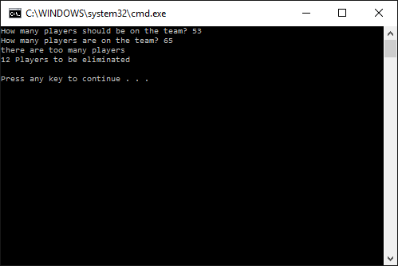
- Not enough players on a team
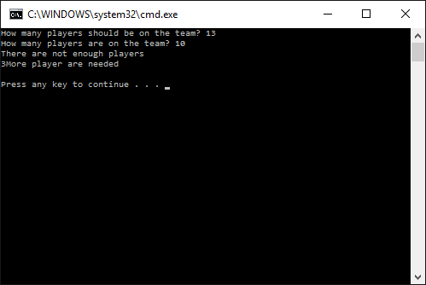
- The correct number of players on a team
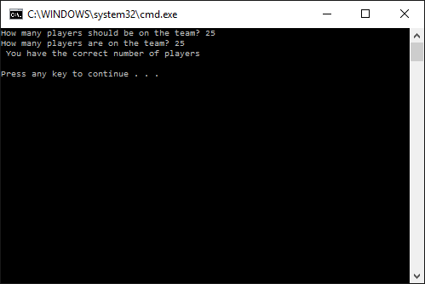

For the Mac, hold down command + shift + control keys and press the 3 key.
Use command+V to paste the clipboard into the lab report.

For Windows, There are two ways you can capture a screen shot of only your program:
- Use Microsoft's Snipping Tool by clicking on the Start icon and selecting "All Programs" then "Accessories". Use the mouse to select the area of the screen you want to save then click Ctrl-C or select the menu items Edit-Copy to save the image to the clipboard.
- Capture the active window to the clipboard by holding down the Alt key and tapping the PrintScreen key. NOTE: some notebook computers require that you hold down a [Fn] key and Alt keys to activate the PrintScreen function. NOTE: Do not click PrintScreen without the Alt key. This would capture the entire screen which would make your program output difficult to see.
Use Ctrl+V to paste the clipboard into the lab report.

PROGRAM LISTING:
5) Copy and paste the code that YOU typed to make the program work. Your program should include a comment block at the top that shows the name of the program, date, version and your name.

// C++PlayersOnTeam.cpp //C++ version of the program
//
//MaxPlayers - determine if there are not enough, too many
// or just right for the number of player on a team
//Brian Quintero
//CIS-054 C/C++ programming
//6-24-2016

#include "stdafx.h"
#include <iostream>
using namespace std;

int _tmain(int argc, _TCHAR* argv[])
{
int TeamSize;
int PlayersOnTeam;
int MorePlayersNeeded;
int ExtraPlayers;

//Input data

cout << "How many players should be on the team? ";
cin >> TeamSize;
cout << "How many players are on the team? ";
cin >> PlayersOnTeam;

// process and output

if (PlayersOnTeam < TeamSize )
{
cout<< "There are not enough players" << endl;
MorePlayersNeeded = TeamSize - PlayersOnTeam;
cout << MorePlayersNeeded << "More player are needed" << endl << endl;
}

else if (PlayersOnTeam > TeamSize)
{
cout << "there are too many players" << endl;
ExtraPlayers = PlayersOnTeam - TeamSize;
cout << ExtraPlayers<< " Players to be eliminated" << endl << endl;
}

else
{
cout << " You have the correct number of players" << endl << endl;
}

return 0;
}

