C++ READ A FILE LAB REPORT

1) Enter your name, student ID, platform (Mac or PC) and date
Name and Student ID: Brian Quintero
Class: CIS054 C/C++ Programming
Platform (Mac or PC): Pc
Date: 3/13/17

DESCRIPTION:
Read the Balances.txt text file. Compute the total of all balances and display the total.

Sample code is provided on the class website. Replace the cout that is inside the while loop with code to compute the total of all balances. After the while loop completes, display the total of all balances.

Use the following path/file name if you place the Balances.txt file on your desktop
Microsoft Windows (replace Dan with your login name):
char filename[ ] = "C:/Users/Dan/Desktop/Balances.txt"; // filenames on the PC are not case sensitive
Mac OS/X (replace Dan with your login name):
char filename[ ] = "/Users/Dan/Desktop/Balances.txt"; // filenames on the Mac are case sensitive

EXTRA CREDIT: 3 points – must be submitted at the same time as the original lab report
Display the average balance in addition to the total of all balances. Inside the loop, you will also need to count the number of customer records. After the loop completes and you have displayed the total of all balances, compute the average balance by dividing the total by the customer count. Then display the average balance.

2) Determine the Inputs, Processing and Outputs before creating the program
INPUTS | PROCESSING | OUTPUTS
Disk file  Balances.txt | Set up file to be accessed  Retrieve file  Set up the addition of files(toal+=bal)  Set up the average of all balances(avg=total/count) | total  avg

DISCUSSION:
3) Complete the DISCUSSION section. It does not need to be long, but it needs to be complete.
3a) What did you do to develop the program? ("Followed the Directions" is not a complete description)

The main thing I did was discover how to access the files, and set up the if else statements. But once that was set up the hardest part was accesing the files which I had to find through prorperties. I had a little help from a classmate, and even then It was stil hard

3b) What problems did you have and how did you overcome the problems?

The main problem I had was accessing my file , at one point I got the file to open and it didn’t add up the the total balance. Then i was able to formulate the balance once but when I closed it I could not get the program to run again. I figured out that my access file name was wrong and I found it in the properties of the folder.

PROGRAM OUTPUT:
4) Show a screen shot of the of the program execution.
Refer to previous lab assignments for instructions on how to capture a screen or portions of a screen for either the PC or a Mac
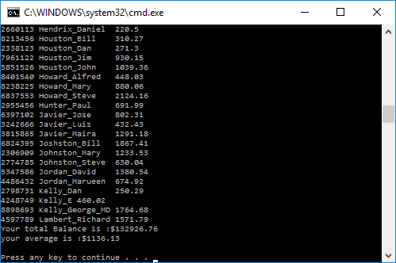

PROGRAM LISTING:
5) Copy and paste the code that YOU typed to make the program work. Your program should include a comment block at the top that shows the name of the program, date, version and your name.

//Brian Quintero 0842282
//CIS-054 C/C++ PROGRAMMING
//PC
//3/13/2017

#include "stdafx.h"
#include <iomanip>
#include <fstream>
#include <iostream>
using namespace std;

int main(int argc, char* argv[])
{

char filename[] = "C:/Users/Brianqp/Desktop/Balances.txt";
int acct;
char name[100];
double bal;
double total = 0;
double avg;
int count = 0;
ifstream infile(filename);

if (infile.fail())
{
cout << "unable to open" << filename << endl << endl;
system("PAUSE");
return 1;

}
infile >> acct >> name >> bal;
while (!infile.eof())
{
total += bal;
count++;
cout << acct << '\t' << name << '\t' << bal << endl;
infile >> acct >> name >> bal;

}
infile.close();

avg = total / count;
cout.setf(ios::fixed);
cout.setf(ios::showpoint);
cout.precision(2);
cout << "Your total Balance is :$" << total << endl;
cout << "your average is :$" << avg << endl << endl;

system("PAUSE");
return 0;

}

