C/C++ ROCK PAPER SCISSORS LAB REPORT

1) Enter your name, student ID, platform (Mac or PC) and date
Name and Student ID: Brian Quintero 0842280
Class: CIS054 C/C++ Programming
Platform (Mac or PC): Pc
Date:2/27/2017

OBJECTIVES:
Input player inputs using cout/cin (for C++) or printf/scanf (for C)
Use nested if/else if/else statements to determine the outcome of the game
Identify illegal inputs from the user and display an error message
Use a while loop to repeat the game

DESCRIPTION: Chapter 3 Programming Project #1 (page 170 8th Edition, page 172 9th Edition)
Write a program to score the rock-paper-scissor game. Each of two users types in either R,P, or S. The program then announces the winner as well as the basis for determining the winner: Paper covers rock, Rock breaks scissors, Scissors cut paper, or Nobody wins. Be sure to allow the user to use lowercase as well as uppercase letters. Your program should include a loop that lets the user play again until the user says she or he is done.

2) Determine the Inputs, Processing and Outputs before creating the program
INPUTS | PROCESSING | OUTPUTS
Player1 R,P,S  Player2 R,P,S | Input ROCK, PAPPER, OR SCICCORS from user.  Determine whos the winner for each input  R < P, P < S, S < R , P=P, R=R, S=S | Tie  Player 1 win  Player 2 win

3) Fill in the EXPECTED & ACTUAL RESULTS
TEST DATA VALUES | EXPECTED RESULT  Computed values before the program is run | ACTUAL RESULT  Fill in the output displayed  by the program
 | R-R=TIE  R-P=PLAYER 2  R-S=PLAYER 1  P-R=PLAYER1  P-P=TIE  P-S=PLAYER2  S-R=PLAYER2  S-P=PLAYER1  S-S=TIE | R-R=TIE  R-P=PLAYER2  R-S=PLAYER1  P-R=PLAYER 1  P-P=TIE  P-S=PLAYER2  S-R=PLAYER2  S-P=PLAYER1  S-S=TIE(BOTH OF YOU LOST IS WHAT MY TIE SAYS)
  Player 1 | Player 2
  R | R
  R | P
  R | S
  P | R
  P | P
  P | S
  S | R
  S | P
  S | S
  X | R
  R | X

PARTIAL SOLUTION:
4) You can use the code shown below as a reference to start your program, or you can create your own program from scratch. The program below shows only the solution when the first player enters the letter R to select rock.

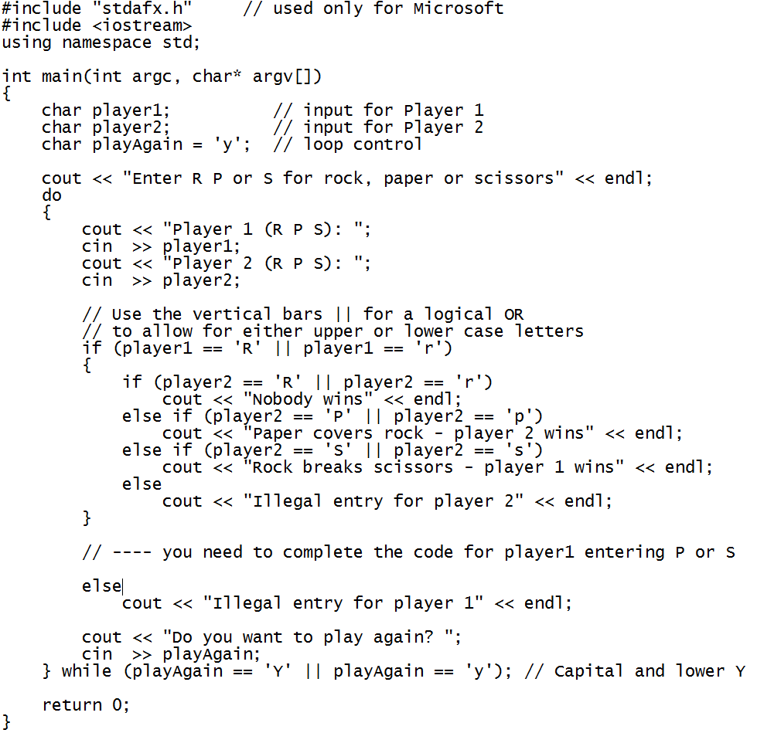

DISCUSSION:
Complete the DISCUSSION section. It does not need to be long, but it needs to be complete.
5a) What did you do to develop the program? ("Followed the Directions" is not a complete description)
I figured out what statement I wanted to use to make the program a little easier and I chose the If statement. And from their I just entered what would beat what.

5b) What problems did you have and how did you overcome the problems?
At first I couldn’t make the loop run
And I kept changing thinking it would run but It wouldn’t run at all after I fixed the loop.
Turns out I had another compiler running and the new program wouldn’t run since I had a different version up it took me 20 min to realize I had it opened and once I exited the program it ran with the loop in tact.

PROGRAM OUTPUT:
6) Show screen shots of the program.
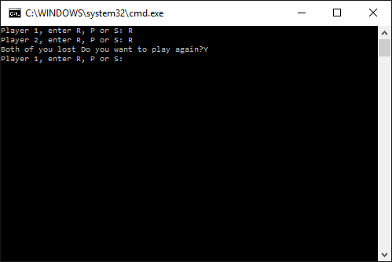
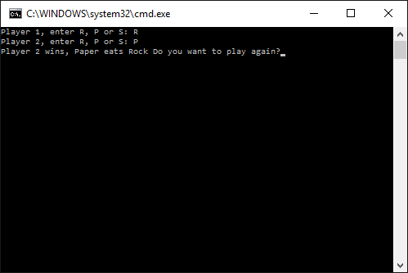
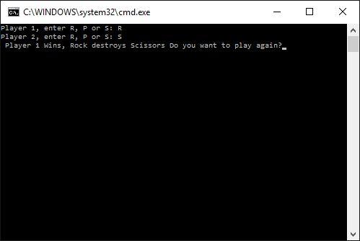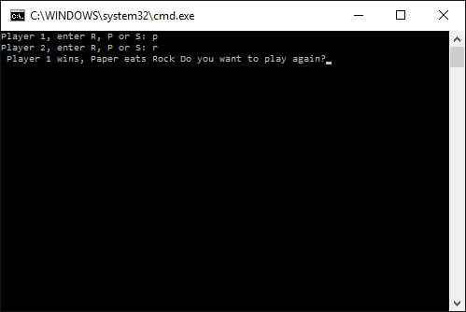
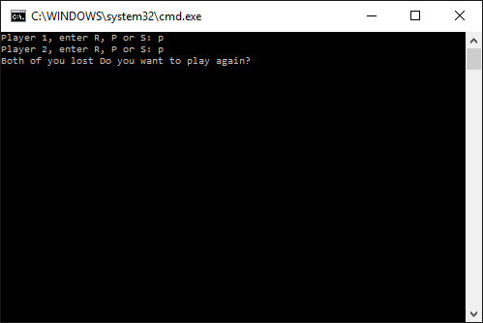
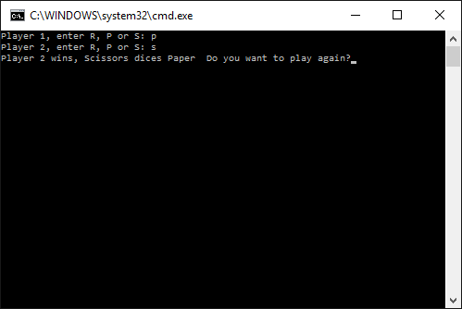
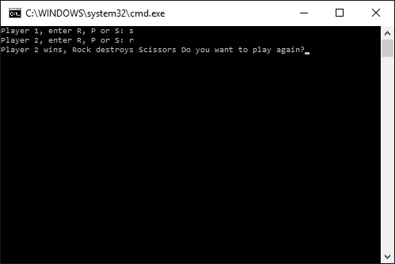
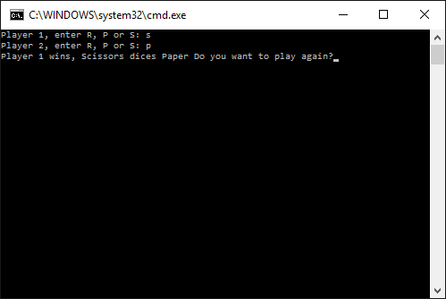
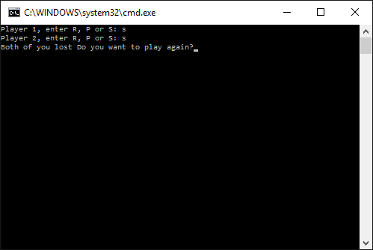
Show nine screen shots of the program AFTER the program has executed. Show screenshots of each of the winning possibilities.

For the Mac, hold down command + shift + control keys and press the 3 key.
Use command-V to paste the clipboard into the lab report.

For Windows, There are two ways you can capture a screen shot of only your program:
- Use Microsoft's Snipping Tool by clicking on the Start icon and selecting "All Programs" then "Accessories". Use the mouse to select the area of the screen you want to save then click Ctrl-C or select the menu items Edit-Copy to save the image to the clipboard.
- Capture the active window to the clipboard by holding down the Alt key and tapping the PrintScreen key. NOTE: some notebook computers require that you hold down a [Fn] key and Alt keys to activate the PrintScreen function. NOTE: Do not click PrintScreen without the Alt key. This would capture the entire screen which would make your program output difficult to see.
Use Ctrl+V to paste the clipboard into the lab report.

PROGRAM LISTING:
7) Copy and paste the code that YOU typed to make the program work. Your program should include a comment block at the top that shows the name of the program, date, version and your name.
// ConsoleApplication14.cpp : Defines the entry point for the console application.
//Brian Quintero
//c-c++
//CIS054 Computer Programming

#include "stdafx.h"
#include <iostream>
#include <cctype>
using namespace std;

int _tmain(int argc, _TCHAR* argv[])
{

//VARIABLE INPUT
char Player1;

char Player2;

char playAgain='y';

do
{
cout << "Player 1, enter R, P or S: ";
cin >> Player1;
Player1 = toupper(Player1);
cout << "Player 2, enter R, P or S: ";
cin >> Player2;
Player2 = toupper(Player2);

//Process

if (Player1 == 'R' && Player2 == 'R')
cout<< "Both of you lost";

else if ( Player1 == 'S' && Player2 == 'S')
cout << "Both of you lost";

else if (Player1 == 'P' && Player2 == 'P')
cout << "Both of you lost";

else if (Player1 == 'R' && Player2 == 'P')
cout << "Player 2 wins, Paper eats Rock";

else if (Player1 == 'R' && Player2 == 'S')
cout << " Player 1 Wins, Rock destroys Scissors";

else if (Player1 == 'P' && Player2 == 'R')
cout << " Player 1 wins, Paper eats Rock";

else if (Player1 == 'P' && Player2 == 'S')
cout << "Player 2 wins, Scissors dices Paper ";

else if (Player1 == 'S' && Player2 == 'R')
cout << "Player 2 wins, Rock destroys Scissors";

else if (Player1 == 'S' && Player2 == 'P')
cout << "Player 1 wins, Scissors dices Paper";

cout << " Do you want to play again?";
cin >> playAgain;

} while (playAgain =='Y' || playAgain=='y'); //LOOP

return 0;
}

