C/C++ SENTENCE FORMATTING LAB REPORT

1) Enter your name, student ID, platform (Mac or PC) and date
Name and Student ID: Brian Quintero
Class: CIS054 C/C++ Programming
Platform (Mac or PC): PC
Date: 5/2/17

DESCRIPTION:
The project is described in the textbook end of chapter 8 PROGRAMMING PROJECTS #1.
1) Change all whitespace characters to a space
2) Remove multiple spaces
3) Capitalize the first character of the sentence
4) Make all other characters lower-case

Example:
input --> this Is A tEst.
output -> This is a test.

LAB REPORT:
2) Determine the Inputs, Processing and Outputs before creating the program
INPUTS | PROCESSING | OUTPUTS
cout << "enter a sentence:" << endl;  cin.getline(sentence, 200); | for (i = 0; sentence[i]; i++)  {  if (isspace(sentence[i]))  sentence[i] = ' ';  }  i = 0;  while (sentence[i] != '\0')  {  if(sentence[i]==' '&& sentence[i+1]==' ')  for (int j = i; sentence[j]; j++)  {  sentence[j] = sentence[j + 1];  }  else i++;  }  sentence[0] = toupper(sentence[0]);  for (i = 1; sentence[i]; i++)  {  sentence[i] = tolower(sentence[i]);  } | cout << sentence << endl;

3) Fill in the EXPECTED & ACTUAL RESULTS
TEST DATA VALUES  Provide at least two different examples strings to format | EXPECTED RESULT  Computed values before the program is run | ACTUAL RESULT  Fill in the output displayed  by the program
this Is A tEST  iM Transfering to UCI | This is a test  Im transferring to uci | This is a test  Im transferring to uci

DISCUSSION:
4) Complete the DISCUSSION section. It does not need to be long, but it needs to be complete.
4a) What did you do to develop the program? ("Followed the Directions" is not a complete description)
I Figured out what I had to do to make the first letter capitol and the rest of the letters lowercase. After that I had to set the whitespaces to just a single space.

4b) What problems did you have and how did you overcome the problems?
The hardest part for me was just making all blank spaces in to a single space.

PROGRAM OUTPUT:
5) Show screen shots for at least TWO strings that were formatted.
Refer to previous lab assignments for instructions on how to capture a screen or portions of a screen for either the PC or a Mac
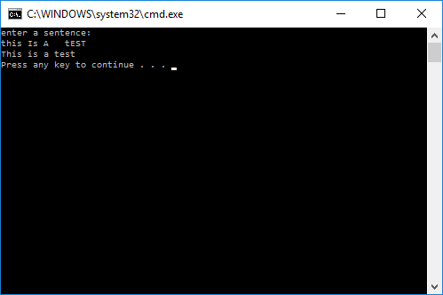
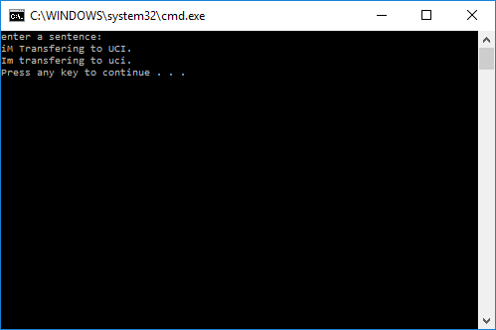

PROGRAM LISTING:
6) Copy and paste the code that YOU typed to make the program work. Your program should include a comment block at the top that shows the name of the program, date, version and your name.

// ConsoleApplication26.cpp : Defines the entry point for the console application.
//Brian Quintero
//CIS054 C/C++ PROGRAMMING
//PC
//5/2/17

#include "stdafx.h"
#include <iostream>
#include <cctype>
#include <iomanip>
using namespace std;

int main()
{

char sentence[200];
int i;

cout << "enter a sentence:" << endl;
cin.getline(sentence, 200);

for (i = 0; sentence[i]; i++)
{
if (isspace(sentence[i]))
sentence[i] = ' ';

}

i = 0;
while (sentence[i] != '\0')
{
if(sentence[i]==' '&& sentence[i+1]==' ')
for (int j = i; sentence[j]; j++)
{
sentence[j] = sentence[j + 1];
}
else i++;
}

sentence[0] = toupper(sentence[0]);

for (i = 1; sentence[i]; i++)
{
sentence[i] = tolower(sentence[i]);

}
cout << sentence << endl;

return 0;
}

