C/C++ STACK OF int DATA LAB REPORT

1) Enter your name, student ID, platform (Mac or PC) and date
Name and Student ID: Brian Quintero
Class: CIS054 C/C++ Programming
Platform (Mac or PC): Pc
Date: 5/11/2017

DESCRIPTION:
The textbook provides code to implement and test a stack that holds char data. The test program in the text asks the user to input a series of characters that are then pushed into the stack and then popped back out of the stack in reverse order. The code for the stack is provided on Canvas in two files:
stack.h - provides the header file for the definition of the stack holding char data
stack.cpp – provides the implementation of the stack for char data

A third file is provided on Canvas that is used to test a stack that holds int data. It is your job to modify the code for the stack of char data so that it will hold int data and test the modified stack code using the TestStackLab.cpp file.

When the program is run, it asks the user to input several integers, each separated by a space and ended with a -1. The program is then to display each integer in reverse order on a separate line. The only thing that needs to be done is to modify the stack.h and stack.cpp files to process int data instead of char data. The program output should be similar to:
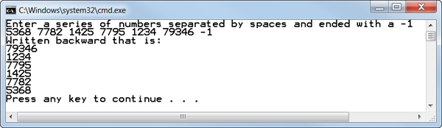

LAB REPORT:
2) Determine the Inputs, Processing and Outputs before creating the program
INPUTS | PROCESSING | OUTPUTS
int number;  cout << "Enter a series of numbers separated by spaces and ended with a -1" << endl;  cin >> number; | if (a_stack.top == NULL)  top = NULL;  else  {  StackFramePtr temp = a_stack.top; // moves from top to bottom of a_stack  StackFramePtr end; // point to end of new stack  end = new StackFrame;  end->data = temp->data;  top = end;  temp = temp->link;  while (temp != NULL)  {  end->link = new StackFrame;  end = end->link;  end->data = temp->data;  temp = temp->link;  }  end->link = NULL;  }  }  Stack::~Stack()  {  int next;  while (!empty())  next = pop();//pop calls delete.  }  //Uses cstddef:  bool Stack::empty() const  {  return (top == NULL);  }  void Stack::push(int the_symbol)  {  StackFramePtr temp_ptr;  temp_ptr = new StackFrame;  temp_ptr->data = the_symbol;  temp_ptr->link = top;  top = temp_ptr;  }  int Stack::pop()  {  if (empty())  {  cout << "Error: popping an empty stack.\n";  exit(1);  }  int result = top->data;  StackFramePtr temp_ptr;  temp_ptr = top;  top = top->link;  delete temp_ptr;  return result;  } | cout << "Written backward that is: " << endl;  while (!s.empty())  cout << s.pop() << endl;

DISCUSSION:
3) Complete the DISCUSSION section. It does not need to be long, but it needs to be complete.
3a) What did you do to develop the program? ("Followed the Directions" is not a complete description)
I had to change every int into char, once I did that most of the problems were solved I just had to make sure everything was changed as needed to adjust to the char.

3b) What problems did you have and how did you overcome the problems?

I didn’t know about the ctrl-h change I could make so I had to rewrite somethings so I can change it all to int.

PROGRAM OUTPUT:
4) Show one or more screen shots showing that the program successfully processed int data
Refer to previous lab assignments for instructions on how to capture a screen or portions of a screen for either the PC or a Mac
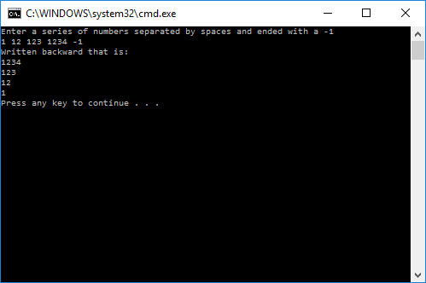

PROGRAM LISTING:
5) Copy and paste the code that YOU typed to make the program work. Your program should include a comment block at the top that shows the name of the program, date, version and your name.

#pragma once
//DISPLAY 13.17 Interface File for a Stack Class
//This is the header file stack.h. This is the interface for the class Stack,
//which is a class for a stack of symbols.

#ifndef STACK_H // prevent the Stack.h file from being compiled more than one time
#define STACK_H

#include "stdafx.h"

struct StackFrame
{
int data;
StackFrame *link;
};

typedef StackFrame* StackFramePtr;

class Stack
{
public:
Stack();
//Initializes the object to an empty stack.

Stack(const Stack& a_stack);
//Copy constructor.

~Stack();
//Destroys the stack and returns all the memory to the freestore.

void push(int the_symbol);
//Postcondition: the_symbol has been added to the stack.

int pop();
//Precondition: The stack is not empty.
//Returns the top symbol on the stack and removes that
//top symbol from the stack.

bool empty() const;
//Returns true if the stack is empty. Returns false otherwise.
private:
StackFramePtr top;
};

#endif //STACK_H
//DISPLAY 13.19 Implementation of the Stack Class
//This is the implementation file stack.cpp.
//This is the implementation of the class Stack.
//The interface for the class Stack is in the header file stack.h.

#include "stdafx.h"
#include <iostream>
#include <cstddef>
#include "stack.h"
using namespace std;

//Uses cstddef:
Stack::Stack() : top(NULL)
{
//Body intentionally empty.
}

Stack::Stack(const Stack& a_stack)
{
if (a_stack.top == NULL)
top = NULL;
else
{
StackFramePtr temp = a_stack.top; // moves from top to bottom of a_stack
StackFramePtr end; // point to end of new stack
end = new StackFrame;
end->data = temp->data;
top = end;

temp = temp->link;
while (temp != NULL)
{
end->link = new StackFrame;
end = end->link;
end->data = temp->data;
temp = temp->link;
}
end->link = NULL;
}
}

Stack::~Stack()
{
int next;
while (!empty())
next = pop();//pop calls delete.
}

//Uses cstddef:
bool Stack::empty() const
{
return (top == NULL);
}

void Stack::push(int the_symbol)
{
StackFramePtr temp_ptr;
temp_ptr = new StackFrame;
temp_ptr->data = the_symbol;
temp_ptr->link = top;
top = temp_ptr;
}

int Stack::pop()
{
if (empty())
{
cout << "Error: popping an empty stack.\n";

exit(1);
}

int result = top->data;

StackFramePtr temp_ptr;
temp_ptr = top;
top = top->link;

delete temp_ptr;

return result;
}
//Program to demonstrate use of the Stack class.
#include "stdafx.h"
#include <iostream>
#include "stack.h"
using namespace std;

int main()
{
Stack s;

int number;

cout << "Enter a series of numbers separated by spaces and ended with a -1" << endl;
cin >> number;
while (number != -1)
{
s.push(number);
cin >> number;
}

cout << "Written backward that is: " << endl;
while (!s.empty())
cout << s.pop() << endl;

return 0;
}

