C/C++ TIC-TAC-TOE LAB REPORT

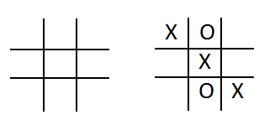
1) Enter your name, student ID, platform (Mac or PC) and date
Name and Student ID: Brian Quintero 0842280
Class: CIS054 C/C++ Programming
Platform (Mac or PC): pc
Date: 3/20/17

DESCRIPTION
Create a program using a two dimension array and functions that lets two players play the tic-tac-toe game. The program is to read a number from 1 to 9 from the keyboard alternating between the X and the O. Ask which square the X player wants, and then ask which square the O player wants. Continue until the game is won by either player, or all the squares have been filled. (Called a Cat's Game or a Tie Game)

A function must be used to display the tic-tac-toe game board, and a function must be used that determines if the game has been won. You can create the program on your own, or start with the sample code provided.

EXTRA CREDIT (3 points)
Modify the DisplayTicTacToe( ) function using the | and – characters to draw lines for the tic-tac-toe display.

LAB REPORT
2) Determine the Inputs, Processing and Outputs before creating the program
INPUTS | PROCESSING | OUTPUTS
1,2,3,4,5,6,7,8,9. | char player;  // check going across the top row to see if all squares are the same  player = board[0][0];  if (board[0][1] == player && board[0][2] == player) return player;  player = board[1][0];  if (board[1][1] == player&& board[1][2] == player)return player;//mid row  player = board[2][0];  if (board[2][1] == player&&board[2][2] == player)return player;//bot row  player = board[0][0];  if (board[1][0] == player&&board[2][0] == player)return player;//first column  player = board[0][1];  if (board[1][1] == player&&board[2][1] == player)return player;//2nd column  player = board[0][2];  if (board[1][2] == player&&board[2][2] == player)return player;//3rd column  player = board[0][0];  if (board[1][1] == player&&board[2][2] == player)return player;  player = board[0][2];  if (board[1][1] == player&&board[2][0] == player)return player;  return '-'; // if there is no winner | Winner X or O

DISCUSSION
3) Complete the DISCUSSION section. It does not need to be long, but it needs to be complete.
3a) What did you do to develop the program? ("Followed the Directions" is not a complete description)
I had to figure out how to sort the code for the test for the files. To know what files to write down so I could test to see who the winner was like player=board[0][0] //etc…, I read most of the program to understand it im having a hard times with arrays and voids so im going to spend this week catching up on those since ive caught up on the reading

3b) What problems did you have and how did you overcome the problems?
My main problem I think is learning how to set up the code myself im having good understanding of the structure once I read it, I just need to learn how to formulate it for myself.

PROGRAM OUTPUT
4) Show screen shots for at least FOUR sample games: 1) a win going across, 2) a win going down, 3) a win going at a diagonal, 4) a tie game in which there was no winner.
Refer to previous lab assignments for instructions on how to capture a screen or portions of a screen for either the PC or a Mac
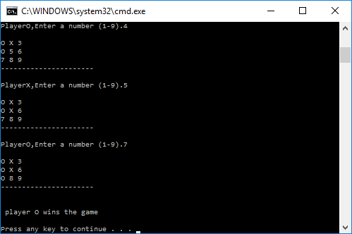
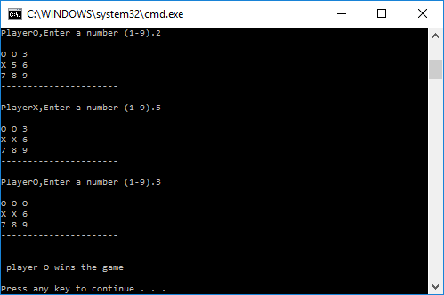
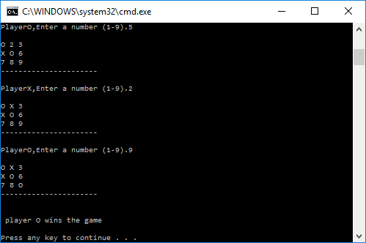
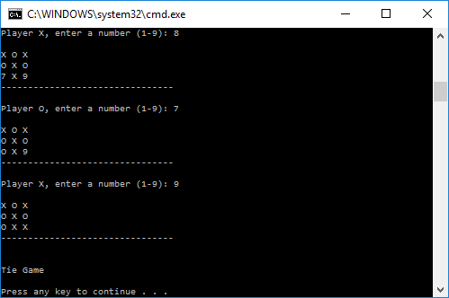

PROGRAM LISTIN
6) Copy and paste the code that YOU typed to make the program work. Your program should include a comment block at the top that shows the name of the program, date, version and your name.
// Program Name: TicTacToe.cpp
// Programmer: Brian Quintero
// Class: CIS054 C/C++ Programming
// Date: 3/19/2017

#include "stdafx.h" // Only for Microsoft Visual C++
#include <iostream> // needed for cin and cout
#include <cstdlib> // needed by srand() and srand()
#include <ctime> // needed for the time() function
using namespace std;

// function prototypes
void DisplayTicTacToe(char board[3][3]);
char CheckForWinningGame(char board[3][3]);

int main(int argc, char* argv[])
{
char board[3][3] = { // index for positions in the array
{ '1', '2', '3' }, // [0][0] [0][1] [0][2]
{ '4', '5', '6' }, // [1][0] [1][1] [1][2]
{ '7', '8', '9' } // [2][0] [2][1] [2][2]
};

int squareCounter = 0; // count how many squares are used
char gameWinner = '-'; // winner of the game ('X' or 'O')
char inputCharacter; // input from the user (should be '1' to '9')
int choice; // input converted to integer 0 to 8 (start from 0)
char player; // current player, set to either an 'X' or an 'O'

// select the starting player
srand((unsigned int)time(NULL)); // seed the random number generator
if (rand() % 2 == 1)
player = 'X';
else
player = 'O';

// starting instructions
cout << "Enter a 1 though 9 to select a square." << endl;

// Ask for a 1-9 until all squares are filled or the game has been won
while (squareCounter < 9 && gameWinner != 'X' && gameWinner != 'O')
{
DisplayTicTacToe(board);
cout << "Player " << player << ", enter a number (1-9): ";
cin >> inputCharacter;

// Arrays start counting from index 0
// convert inputCharacter from ASCII ('1' to '9') to integer (0 to 8)
// to select the row and column index for the 3x3 array
choice = inputCharacter - '1'; // now the inputs are 0,1,2,3,4,5,6,7,8
int row = choice / 3; // row will be 0 (for 0,1,2), 1 (for 3,4,5), 2 for (6,7,8)
int col = choice % 3; // col will be 0 (for 0,3,6), 1 (for 1,4,7), 2 for (2,5,8)

if (choice < 0 || choice > 8) // see if the input is below 1 or greater than 0
cout << "Illegal value, try again" << endl;
else if (board[row][col] == 'X' || board[row][col] == 'O')
cout << "This space has already been used, try again" << endl;
else
{
board[row][col] = player; // put in an 'X' or an 'O'
squareCounter++; // count the number of squares completed
// select the next player
if (player == 'X')
player = 'O'; // switch from 'X' to 'O' for next move
else
player = 'X'; // switch from 'O' to 'X' for next move
}
gameWinner = CheckForWinningGame(board); // returns 'X' or 'O' if the game is won
}
if (squareCounter == 9)
{
DisplayTicTacToe(board);
cout << endl << "Tie Game" << endl << endl;
}
else if (gameWinner == 'X' || gameWinner == 'O')
{
DisplayTicTacToe(board);
cout << endl << "Player " << gameWinner << " wins the game" << endl << endl;
}
return 0;
}

// ------ Display the Tic Tac Toe board
void DisplayTicTacToe(char board[3][3])
{
cout << endl;
for (int row = 0; row<3; row++) // display three rows
{
for (int col = 0; col<3; col++) // display three columns each row
cout << board[row][col] << ' ';
cout << endl; // end of row
}
cout << "--------------------------------" << endl << endl;;
}

// ------ Check all eight possible combinations for a win.
// returns the player ('X' or 'O') if the game has been won
// returns '-' if there is currently no winner
char CheckForWinningGame(char board[3][3])
{
char player;

// check going across the top row to see if all squares are the same
player = board[0][0];
if (board[0][1] == player && board[0][2] == player) return player;

player = board[1][0];
if (board[1][1] == player&& board[1][2] == player)return player;//mid row

player = board[2][0];
if (board[2][1] == player&&board[2][2] == player)return player;//bot row

player = board[0][0];
if (board[1][0] == player&&board[2][0] == player)return player;//first column

player = board[0][1];
if (board[1][1] == player&&board[2][1] == player)return player;//2nd column

player = board[0][2];
if (board[1][2] == player&&board[2][2] == player)return player;//3rd column

player = board[0][0];
if (board[1][1] == player&&board[2][2] == player)return player;

player = board[0][2];
if (board[1][1] == player&&board[2][0] == player)return player;

return '-'; // if there is no winner
}

