Module 3
Brian Rusk
26/05/2020

R Markdown
This is an R Markdown document. Markdown is a simple formatting syntax for authoring HTML, PDF, and MS Word documents. For more details on using R Markdown see http://rmarkdown.rstudio.com.
When you click the Knit button a document will be generated that includes both content as well as the output of any embedded R code chunks within the document. You can embed an R code chunk like this:
plot(cars)
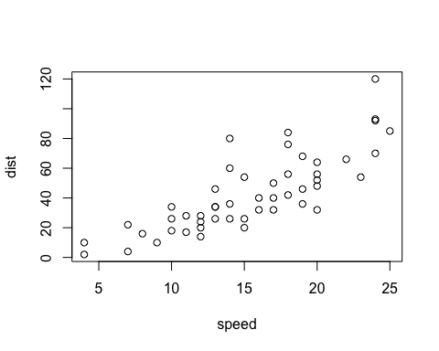

Including Plots
You can also embed plots, for example:
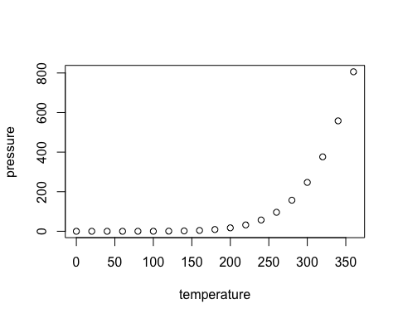
Note that the echo = FALSE parameter was added to the code chunk to prevent printing of the R code that generated the plot.

A Short List
- Apple
- Banana
- Cherries

A Simple Equation

Plot of the Pressure Dataset
plot(pressure)

