Module 3 Word Document

Brian Rusk

27/05/2020

## R Markdown

This is an R Markdown document. Markdown is a simple formatting syntax for authoring HTML, PDF, and MS Word documents. For more details on using R Markdown see <http://rmarkdown.rstudio.com>.

When you click the **Knit** button a document will be generated that includes both content as well as the output of any embedded R code chunks within the document. You can embed an R code chunk like this:

knitr::kable(summary(cars))

|  |  |  |
| --- | --- | --- |
|  | speed | dist |
|  | Min. : 4.0 | Min. : 2.00 |
|  | 1st Qu.:12.0 | 1st Qu.: 26.00 |
|  | Median :15.0 | Median : 36.00 |
|  | Mean :15.4 | Mean : 42.98 |
|  | 3rd Qu.:19.0 | 3rd Qu.: 56.00 |
|  | Max. :25.0 | Max. :120.00 |

## Including Plots

You can also embed plots, for example:

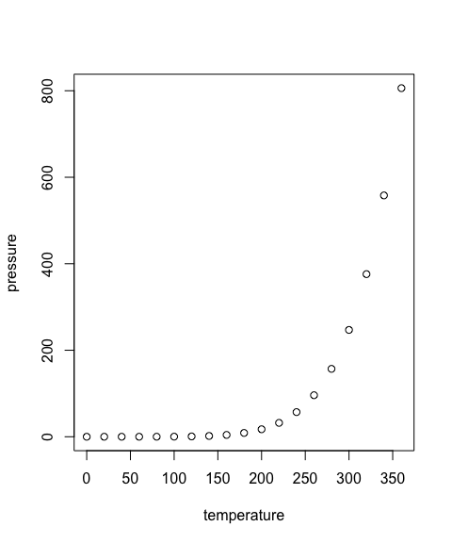

Note that the echo = FALSE parameter was added to the code chunk to prevent printing of the R code that generated the plot.

head(cars)

|  |  |
| --- | --- |
| speed | dist |
| 4 | 2 |
| 4 | 10 |
| 7 | 4 |
| 7 | 22 |
| 8 | 16 |
| 9 | 10 |

head(iris)

|  |  |  |  |  |
| --- | --- | --- | --- | --- |
| Sepal.Length | Sepal.Width | Petal.Length | Petal.Width | Species |
| 5.1 | 3.5 | 1.4 | 0.2 | setosa |
| 4.9 | 3.0 | 1.4 | 0.2 | setosa |
| 4.7 | 3.2 | 1.3 | 0.2 | setosa |
| 4.6 | 3.1 | 1.5 | 0.2 | setosa |
| 5.0 | 3.6 | 1.4 | 0.2 | setosa |
| 5.4 | 3.9 | 1.7 | 0.4 | setosa |