MILO – Instruction Manual

Introduction
Meet MILO (MIDI Intelligent Logic Operator). OK, that’s a mouthful, but I needed to turn MILO into an acronym, because I like the name Milo.
It’s a smart (micro controller powered) platform that can be programmed to control any device that uses MIDI (Commands or System Exclusive). The platform can be loaded with dedicated or generic firmware to control various musical devices.

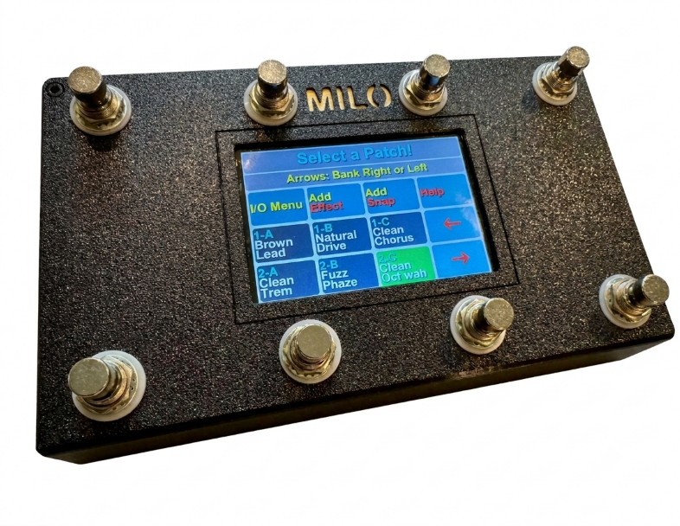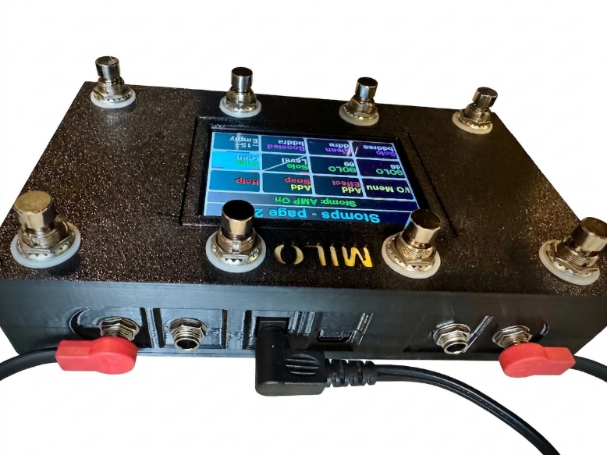
Left: top view – 8 footswitches and 4” touch screen to program MILO (shown with Katana GO firmware)
Right: front panel – includes: USB-C (power, new firmware, backups), 9V power jack, 4 TRS jacks for expression pedals or MIDI device connection
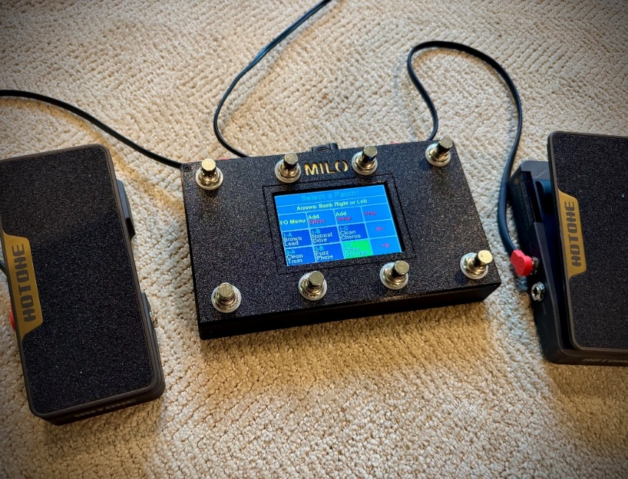
Expression Pedals – plug in up to 4 expression pedals

MILO Platform
Hardware:
- ESP32 micro controller (processor, memory, wifi, Bluetooth)
- 4” capacitive touch display (programmable with touch or online (for MIDI pedal only currently).
- 8 footswitches
- 4 TRS jacks – expression pedals or wired MIDI connections.
- 9V power jack – center negative.
MILO Website (in progress) firmware download and programming app to setup generic MILO firmware.
- Download new firmware -updates and new device versions such as:
- Dedicated:
- Boss Katana GO - complete
- Boss GX-1 (could do other GX’s) – in progress
- Boss Gen3: 50 and 100 – in progress
- Boss Mk2: 50 and 100 - in progress
- Generic MIDI - in progress:
- Any device that can be controlled with a MIDI connection (Bluetooth or wired).
- Examples:
  - Boss RC500 looper and rhythm (configure RC500 to desired functions)
  - Boss RC-10R looper and rhythm

Operational Description
Katana GO firmware
- Patch selection – bank through 30 patches with left/right arrows.
- Preset effect control & on/off footswitches – turn a patch’s 8 effects on and off with footswitches.
- User configured Stomp Effects (up to 16) – this could be extended to 24 or 36… Stomps are configured using the touchscreen. Stomps are accessible from all patches.
  - Effects – save extra effects (Mod, FX, Boost, Pdfx, etc to be loaded over any preset)
  - Snapshots (Snaps) – save effect on/off states to be enabled with one footswitch. Example: One footswitch that turns on both delays, reverb and solo effects, turns off other effects, add custom name.
  - Expression pedal effects – Set up any of the 4 TRS jacks to allow realtime control of nearly any effect parameter with an expression pedal. Up to 4 used in parallel. 4 byte parameters aren’t controllable, such as delay time, unfortunately.
  - System EQ – save extra system EQ sets to be turned on/off with a footswitch.

At startup: Select Bass or Guitar Mode

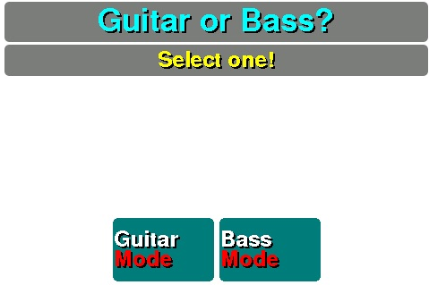
If your Katana Go is in Bass mode, hit the “Bass Mode” button or footswitch, or guitar. This allows MILO to read data from the right memory map internal the Katana Go. If you switch from Guitar to Bass, or Bass to Guitar, then your saved patches are most likely wrong. If that’s true, go to the I/O Menu and hit “Sync & save” (below).

FIRST: Sync Katana GO (select I/O Menu, then Sync)
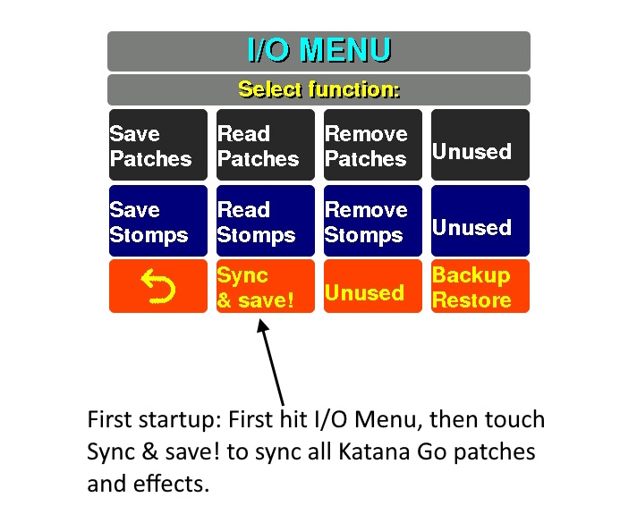

Realtime Patches, Effects and Stomps (live usage)
Page through and select the desired patch; turn effects on/off; use custom Stomps.
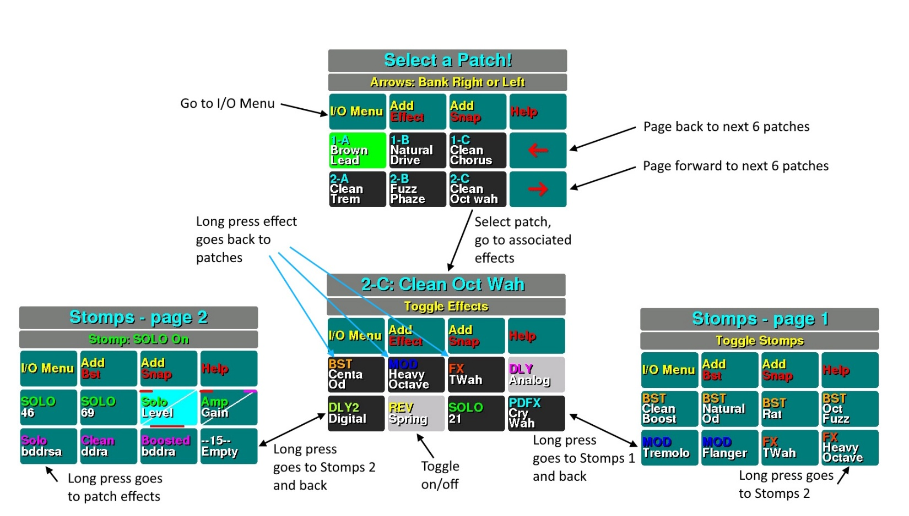

Add your own Stomp Effects & Snaps
Add extra effects, expression pedals, Snaps, and System EQ settings through the touchscreen; go to I/O menu to save Stomps to SD.
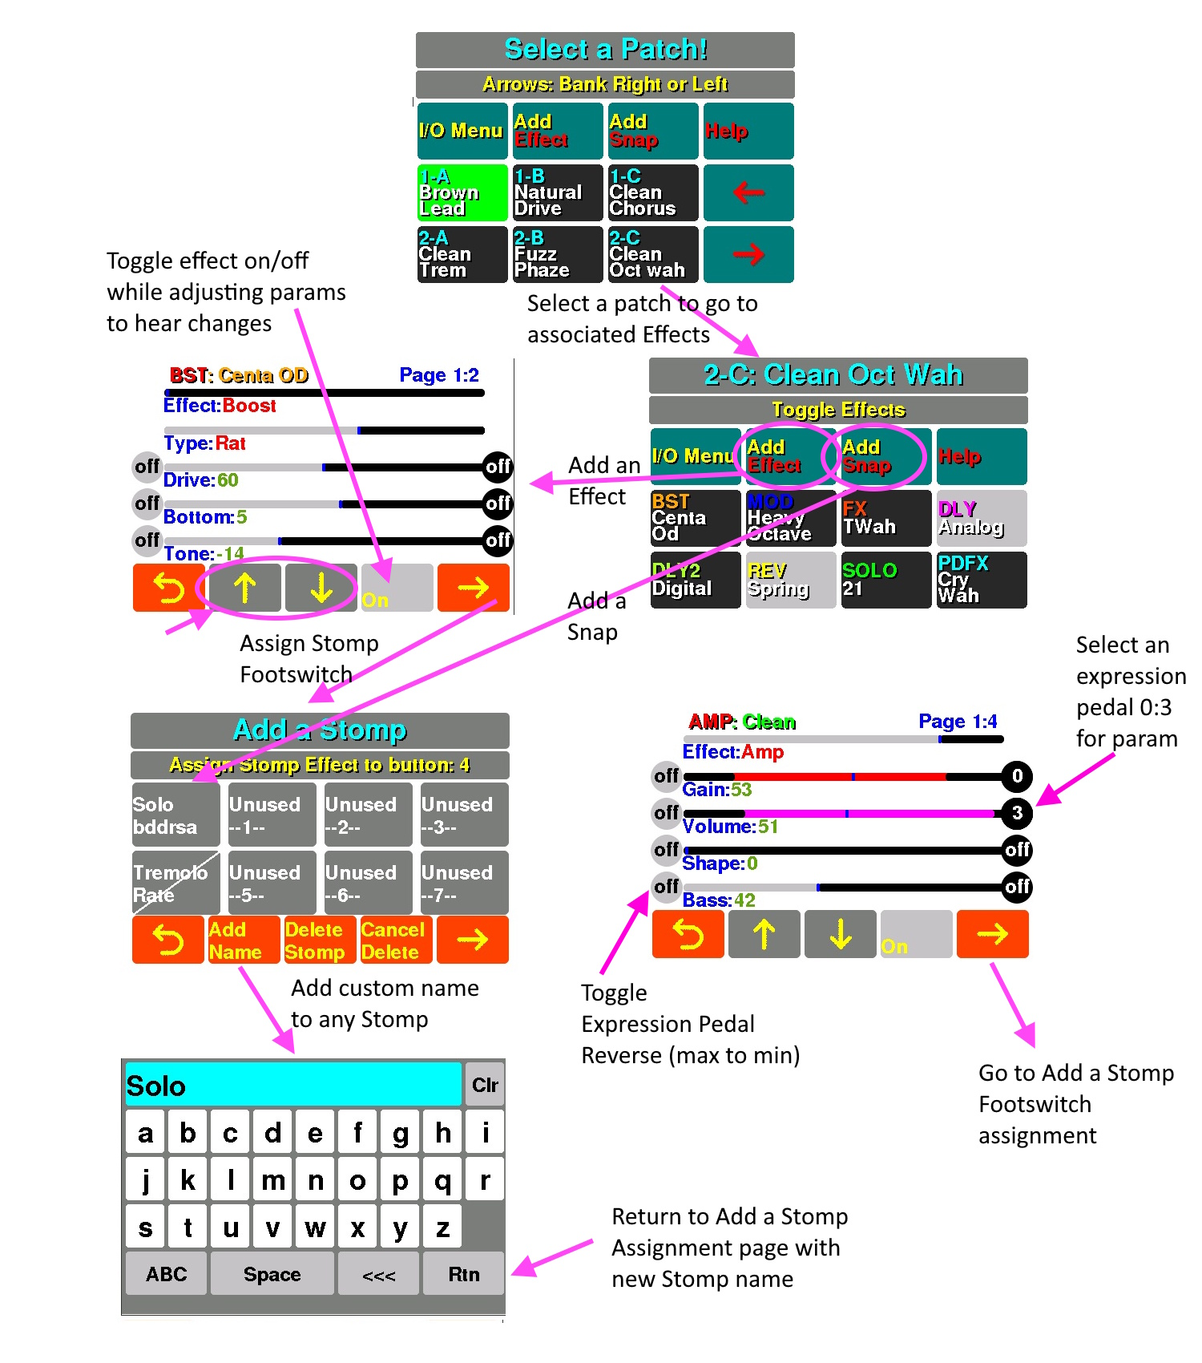

Backup and Restore Configuration files
To backup and/or restore configuration files, you first touch: I/O Menu from first screen. Then hit Backup Restore button. Then you need to connect to MILO’s WIFI hotspot: MILO-net. There is no password needed. If it asks for one, just hit return. Then, as instructed, in your browser URL address input line, type: http://192.168.4.1. You should then see the browser screen below. When your done, hit Return on MILO’s “Connect to: MILO-net” screen.
Using MILO’s backup and restore:
There are 2 configuration files saved by MILO:
patches_json.txt – saves all the Katana Go patch, effect, names, and miscellaneous MILO data.
stomps_json.txt – saves all the custom Stomps: effects, snaps, etc data.
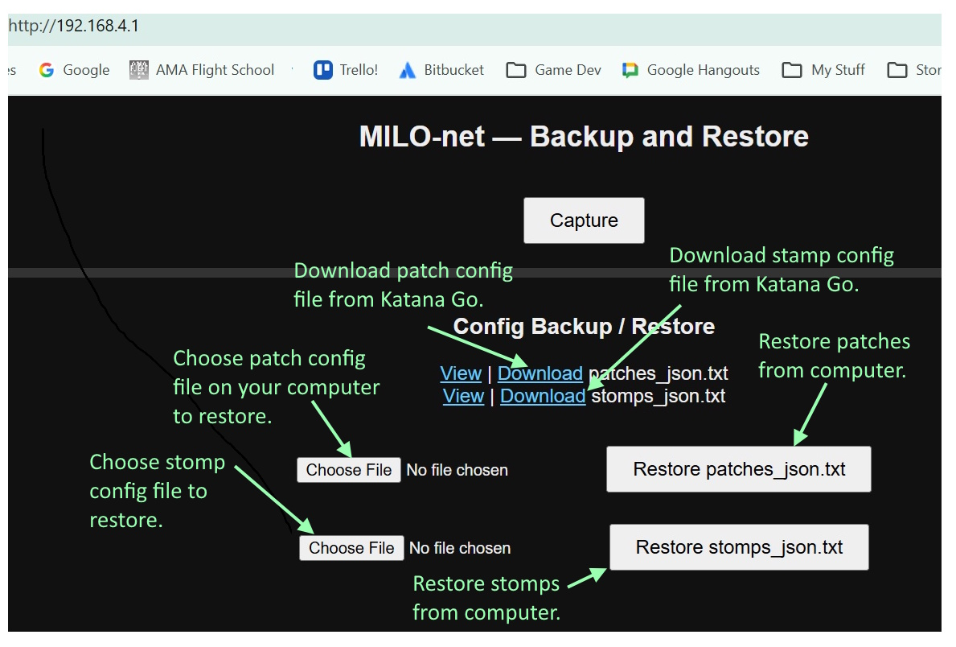
After you download a configuration file from Katana Go, it will go in your downloads folder. Move it to where you want it. Rename it, if you want. But when you restore a config file, IT MUST BE NAMED AS SHOWN ABOVE FOR MILO TO USE IT. The capture screenshot will not be useful to you as it only currently works while on that screen. I’ll add this in the future, if it’s requested.

Flashing new firmware
- Insert the 3 firmware files in your desired folder so you can browse to them from the web flashing app.
- Click this URL to load web flashing app:
https://adafruit.github.io/Adafruit_WebSerial_ESPTool/
- Plug MILO into USB port on your PC.
This (below) should come up. Hit the “Connect” button.
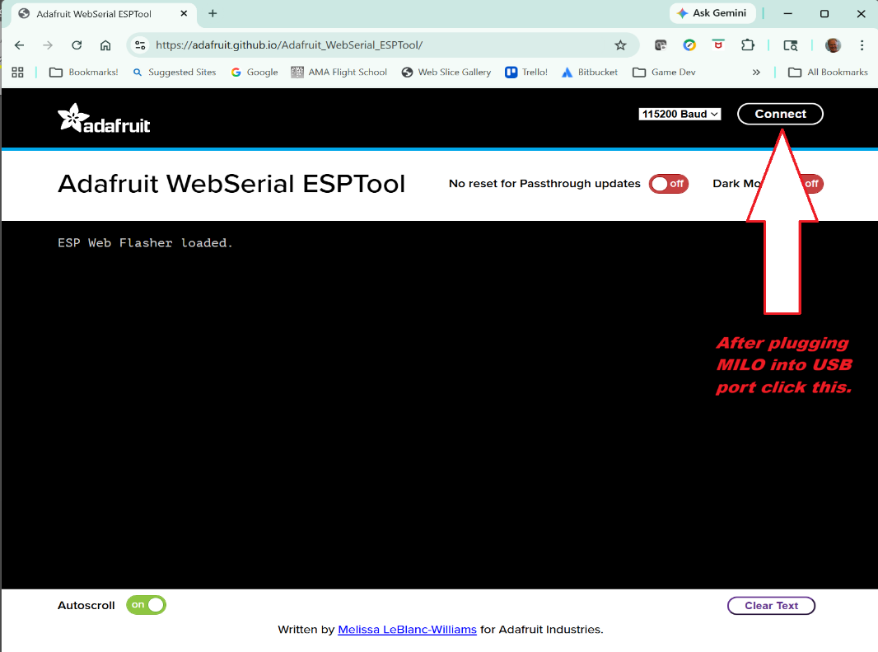
After hitting Connect, should see below:
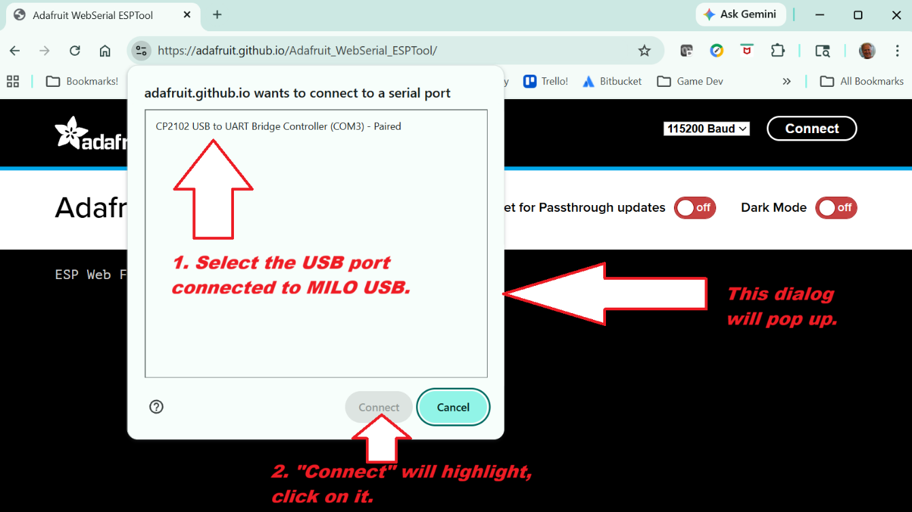
- Select USB port connected to MILO.
- Hit Connect!
This screen will come up:
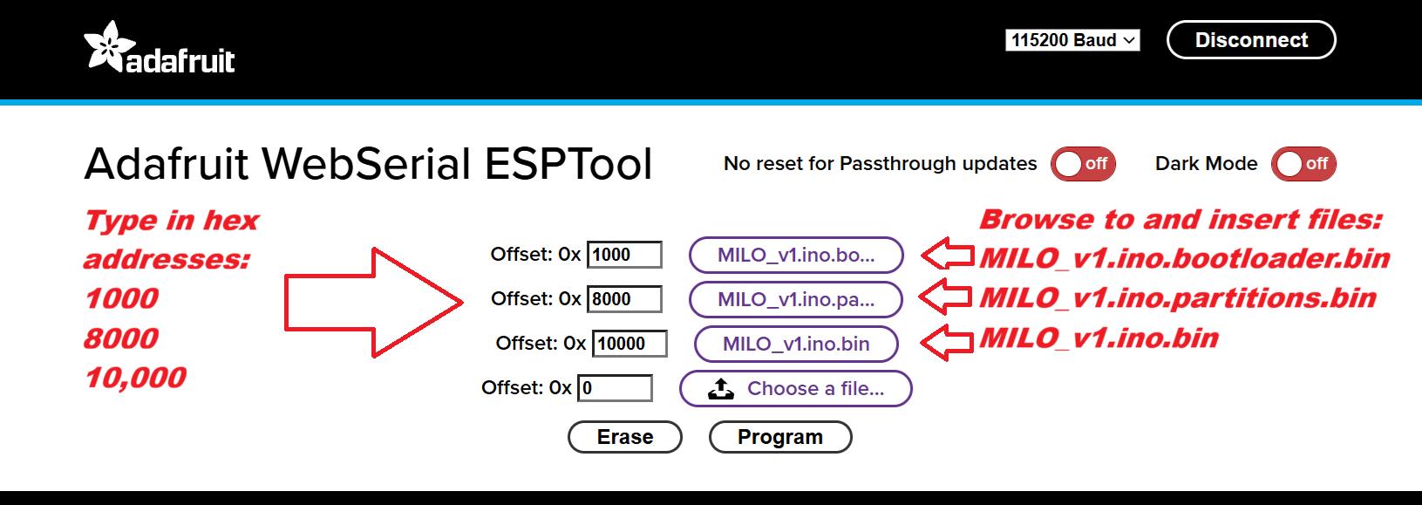
- Click each of the 3 “Choose a file”, and browse to your MILO firmware folder, select each file and insert in the 3 File slots as directed above (in that specific order!). Then type in the 3 hex addresses for where the files load: 1000, 8000, 10,000.
- Click the “Program” button.

- After the 3 green bars fill up (a few minutes), it will say (in the bottom black console area): “To run the new firmware, please reset your device.” So, unplug and replug the USB (power) and all should be set!

Questions
Brian Soderberg
Soderberg.brian@gmail.com
Round2Games

