MILO Mini
A small controller to provide Live control of any MIDI controllable gear from any Laptop, tablet, or mobile device. Features 4 TRS jacks for any combination of MIDI out & expression pedals in. Edit your device MIDI config files, save to MILO’s flash memory. You can save configurations for multiple devices, for example: Boss Katana Go, Boss GX-1, Boss Katana Gen 3 amps, RC500 Looper / Rhythm. It will read all patch & effect settings from these Boss devices and save them for fast load and Live use. See Live Mode Views below.
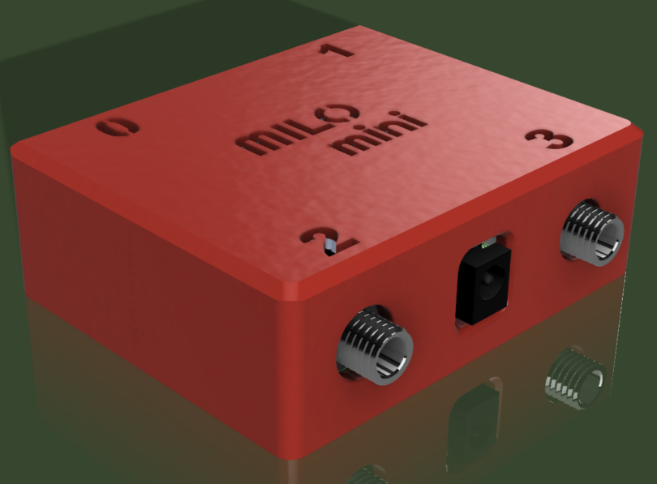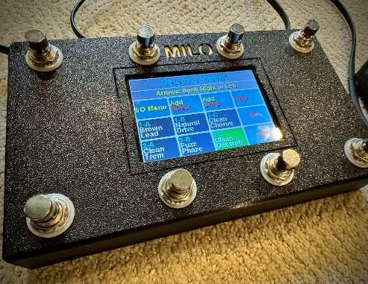
MILO Mini Design with 3D printed enclosure. Full size MILO

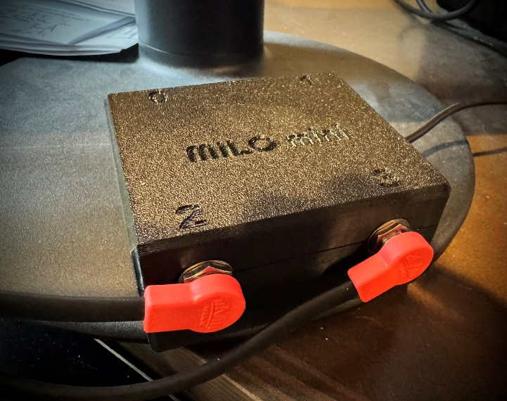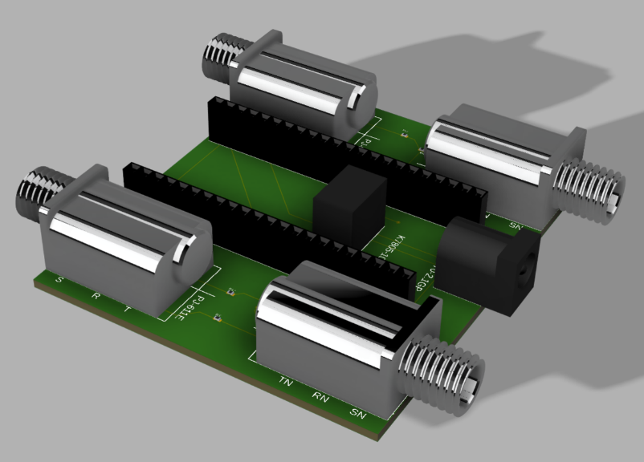
Fully functional prototype. PCB 3D design.
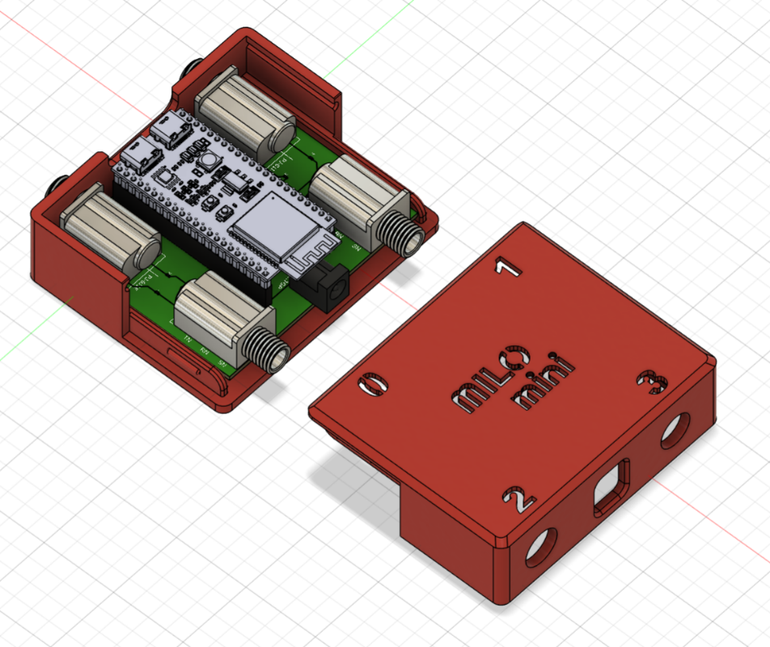
Entire design – Shows the processor: ESP32S3, 9V Jack (standard 9V gear power), 2 USB C in/out firmware updates and power if preferred to 9V.
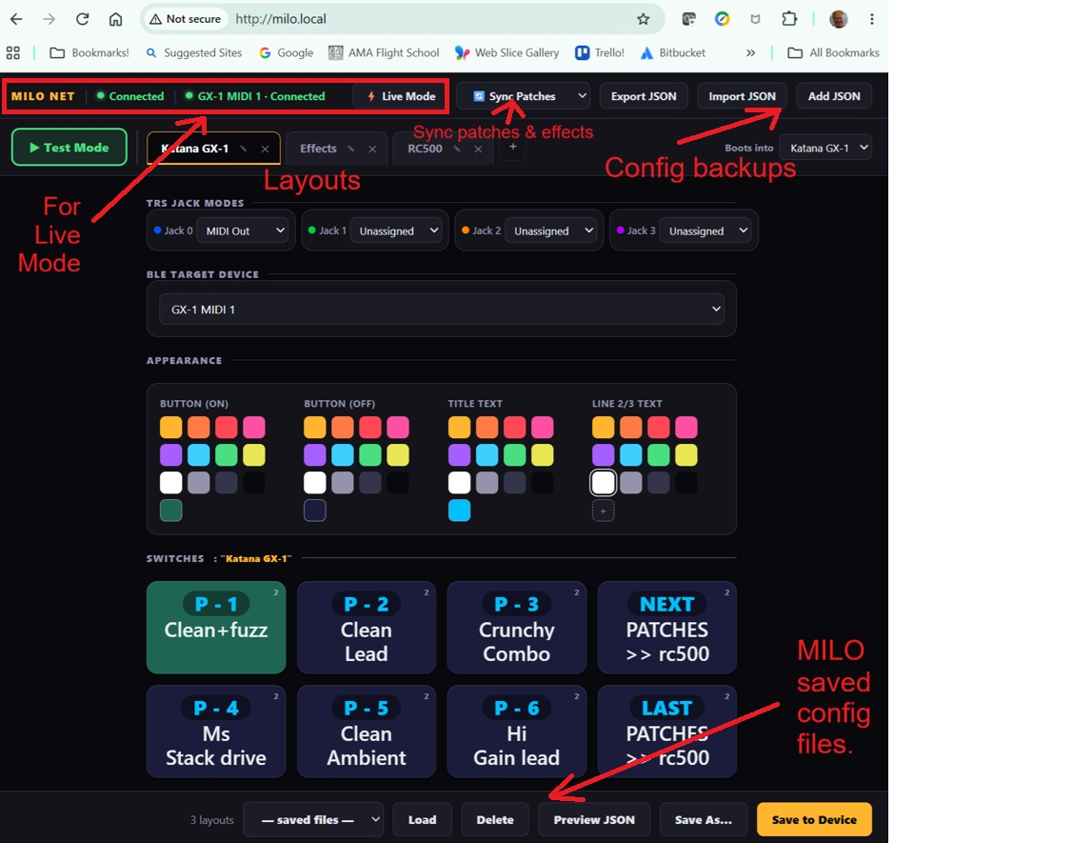
Edit screen (laptop, table, mobile). Boss GX1 config shown.
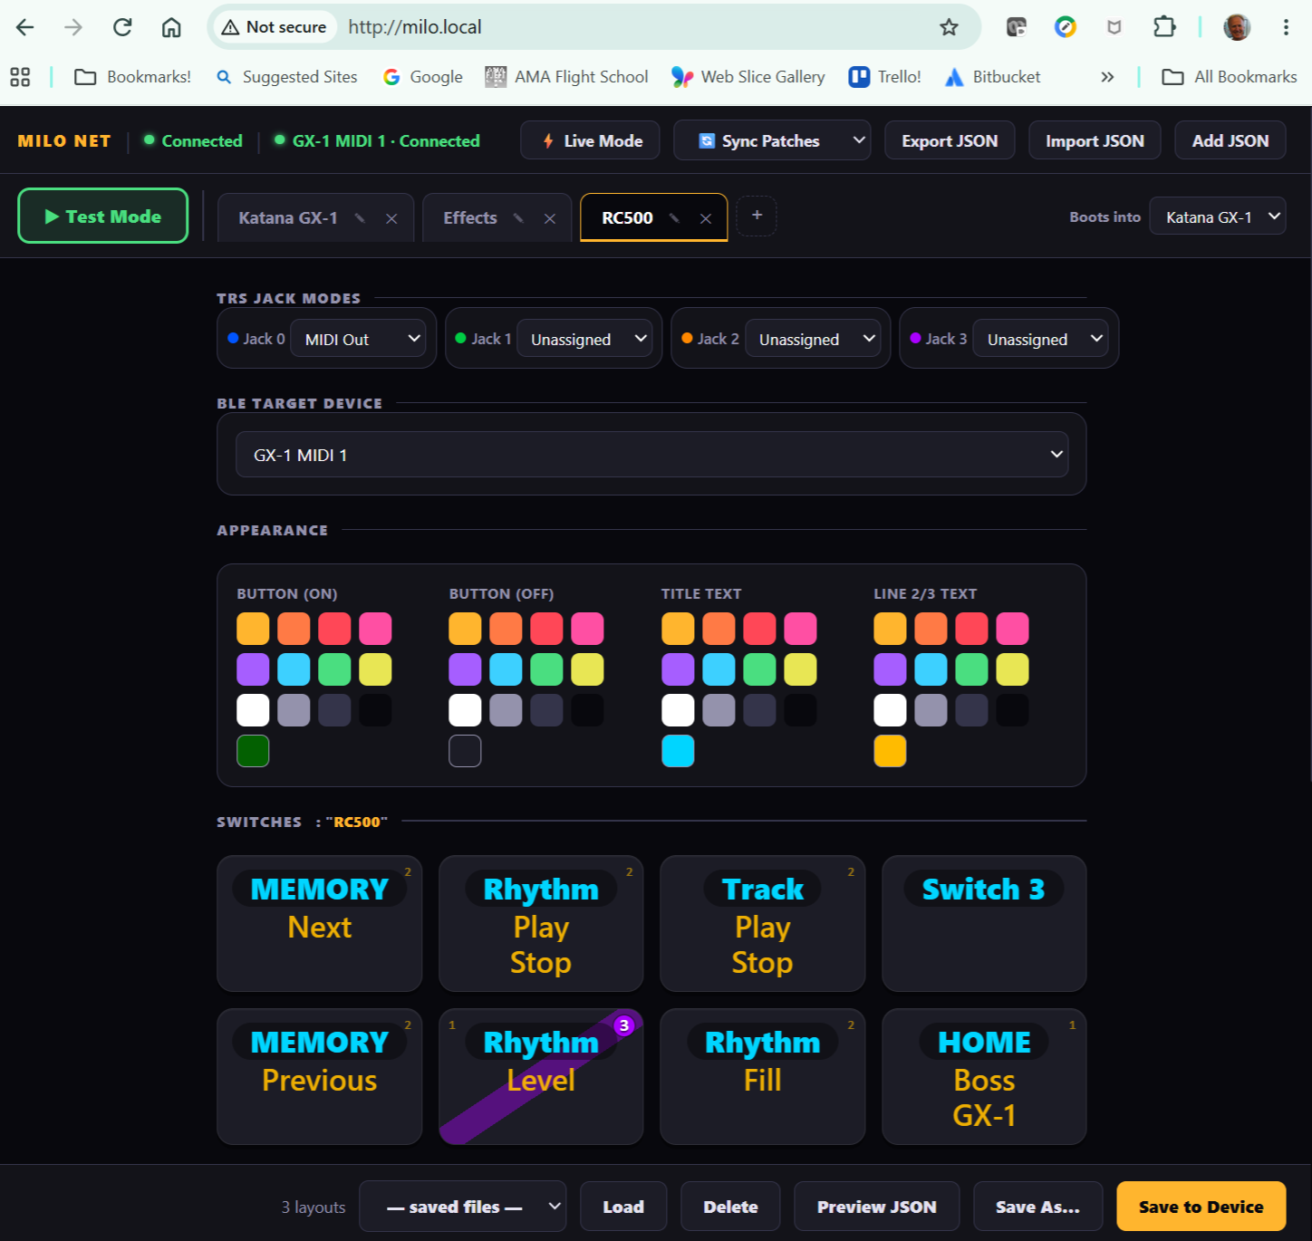
RC500 Looper / Rhythm pedal (jump to this from GX-1 switch layout), for example.
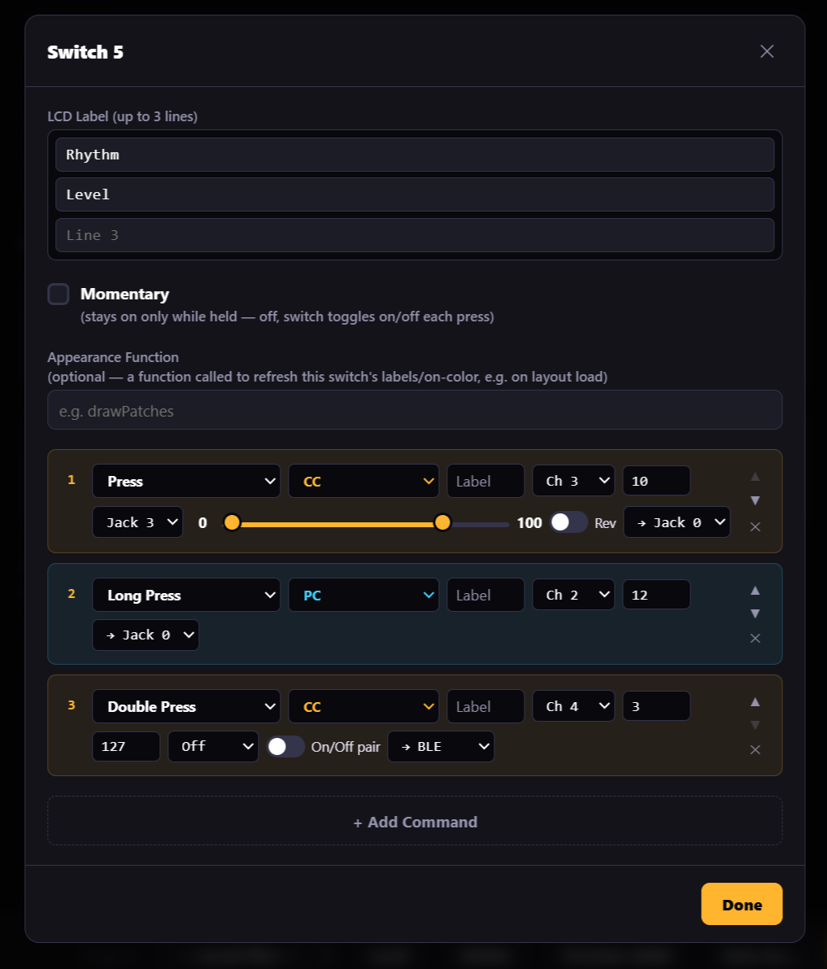
Switch: Midi command editing example.
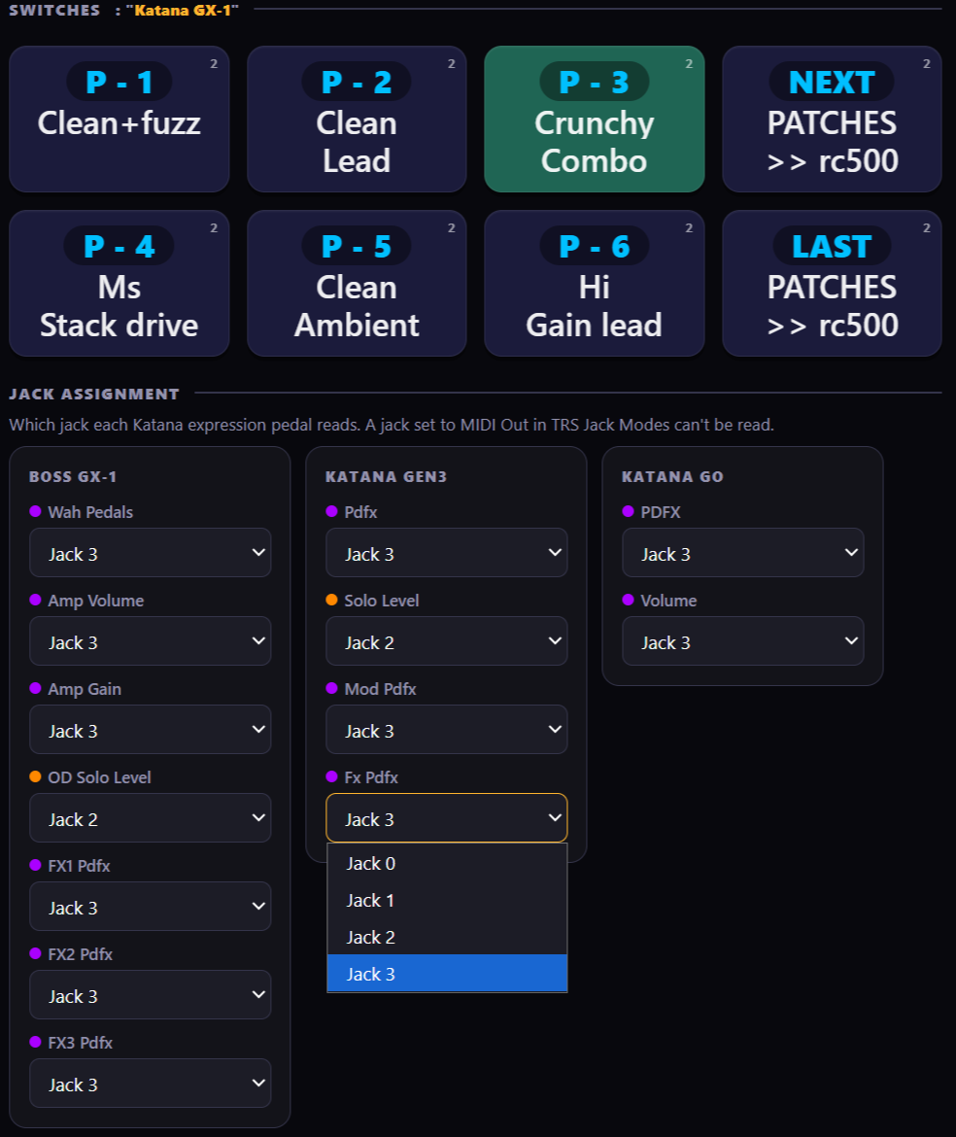
Jack assignment for expression pedals.
Example Live Mode views (from laptop, mobile, or tablet):
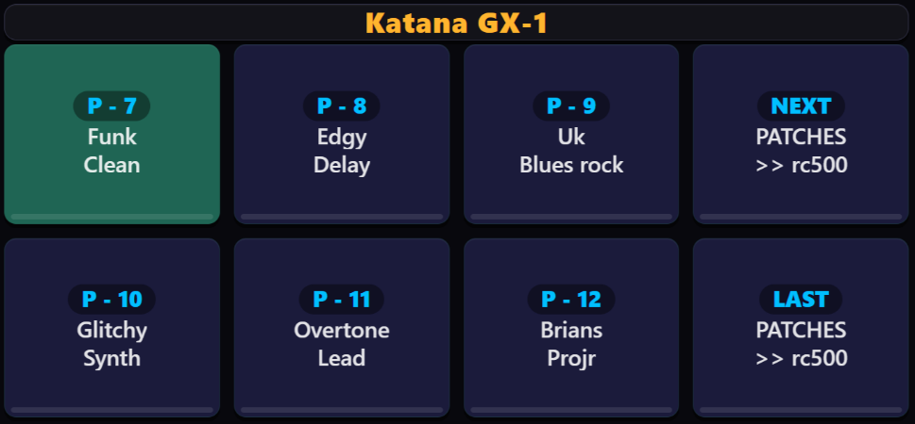
Boss GX-1 Patch selection (automatically read into MILO and saved).
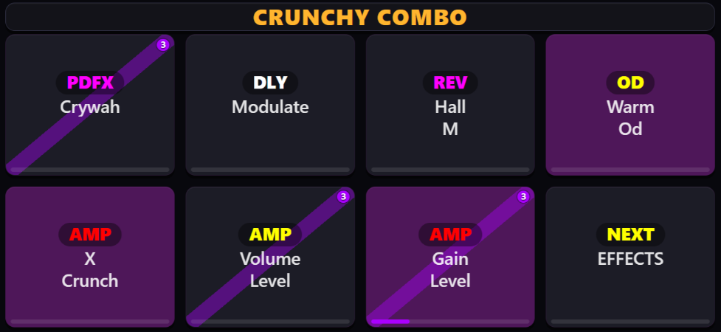
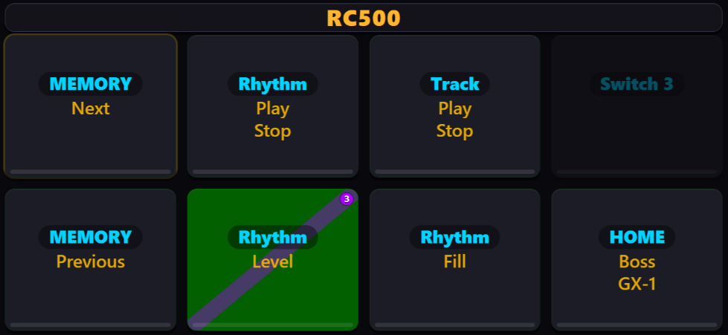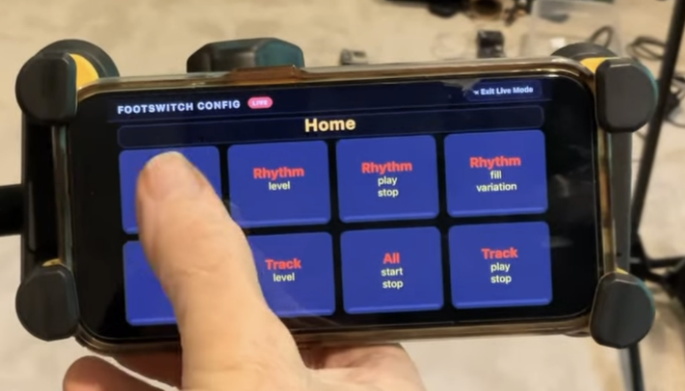
Example using MILO control over mobile…

