STRUCTURE

**Information Architecture (IA)**

A basic tree structure layout .

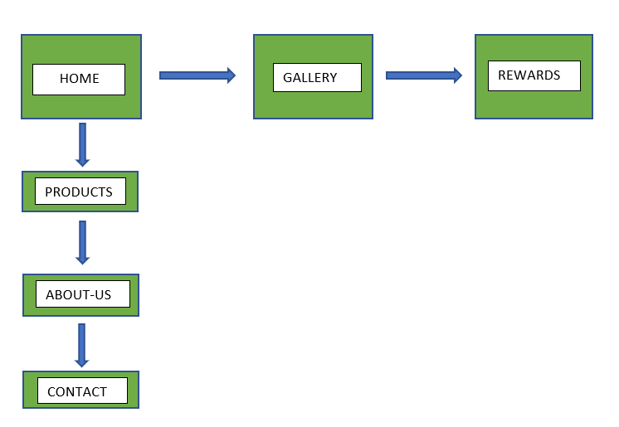

**Interaction Design (IXD)**

The first area the user will encounter is the Home page, where the navigation bar is located at the top right of the page. The navigation bar is found at the top of all the pages of the website. Each link in the main navigation bar is clearly marked out with a hover feature so the user can clearly see which items they are selecting.

An additional hamburger icon navigation menu is fixed to the screen in the upper right corner, which is hidden behind the main navigation bar when at the top of the page, so as to not confuse the user, but on scrolling down the page it reveals itself and remains in place allowing the user to navigate to anywhere in the website without restricting the viewport height allowing for a more pleasurable experience. When the user hovers their mouse over the hamburger menu on larger screens a dropdown menu appears allowing the user to navigate to the area of their liking.

On mobile devices the main navigation bar disappears, and the hamburger menu comes forward to sit above the header and is always in full sight of the user. It is located to the top-right of the screen in the same position as it is found on larger screens. This when pressed drops the navigation menu so the user can select their destination within the website. Each link is clearly marked out with a hover feature so the user can clearly see which link is being selected.

On desktop each navigation link has a gentle hover to show that the area is active and the active page has an underline indicating which page the user is currently on. Once clicked or pressed the link will smoothly take the user to whichever section they desire.

The gallery and video areas are close together for easy access to jump from one to another. The media player will play clips of videos on you tube which directly relate to the sourcing of the products for the shop. An audio file has been included thanking the user for visiting the website and requests that the user visit the shop. The user has control over the play, pause rewind, fast-forward and volume functions.

The site includes hyperlinks to external sources on Wikipedia for additional information which relates to the content found in this website.

The site also incorporates a rewards page which includes a sign up form which gathers data via the input fields and submits the data to the code institute database and returns a table of the contents gathered. The sign up form also includes a clear button which clears all the data fields.

Each social media link also has a hover effect so the user knows the link is active and it will take the user to the relevant platform requested.