Raw signal
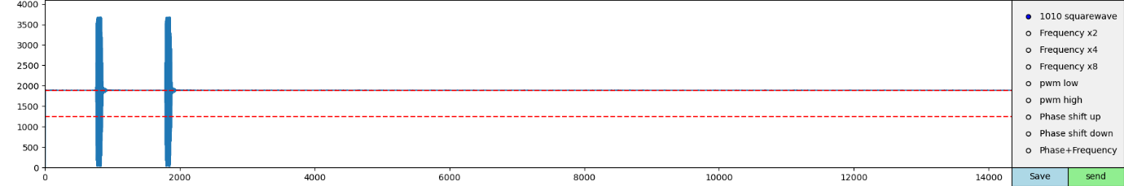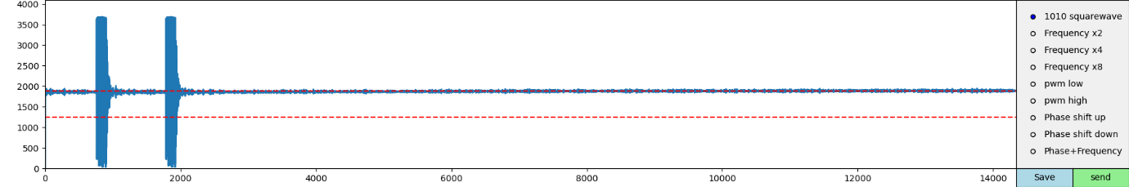
Tank
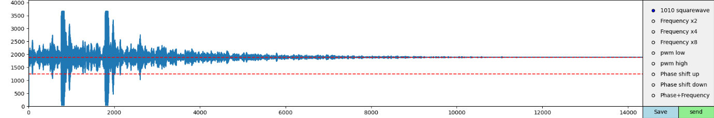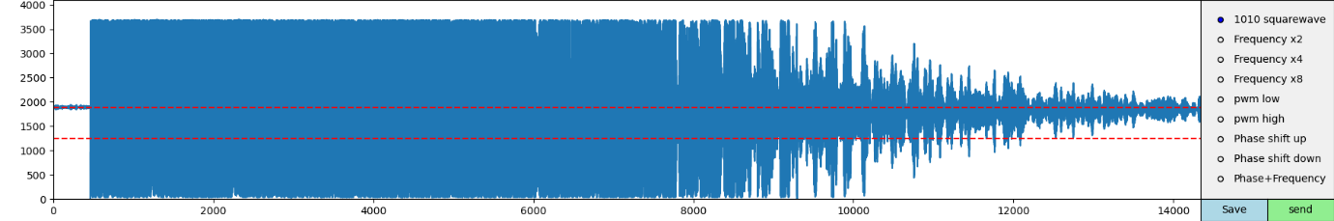

Fountain
