1. Introduction

The AgeStructureNe GUI interface offers a user interface to allow easy access to simuPOP-based simulations and the LDNe2-based Nb estimations provided by Tiago Antao's python program, AgeStrucureNe, available at https://github.com/tiagoantao/AgeStructureNe.git. We also offer an interface for plotting Nb estimations, and regressions based on the estimations. The original analyses based on Tiagos code, with their applications to many species are available in several publications, including [refs to AgeStructure Ne - based pubs].

The interface is divided into three parts, simulation, Nb estimation, and visualization. The output from a simulation can be loaded into an Nb estimation, and in turn, the output from an Nb estimation can be loaded into a visualization interface.

1. Installation

The program can be downloaded from <https://www.github.com/popgengui/negui>. Click on the button labeled “clone or download”. You can keep the program in any directory to which it can be written. For dependency details and other installation advice, see the README.md file provided with the program files.

1. Starting the program

The program is launched using python 2.7 or python 3.6, invoking the negui.py module. Please see the README.md file for details on different ways to start the program.

1. Loading interfaces

To load one or more of the three interfaces for performing simulations, Nb/Ne estimations, or plotting programs, from the main menu click on the “New” menu (fig. 1). You can load an number of interfaces and run them simultaneously, though running too many at once can tax your computers cpu and/or memory capacity.

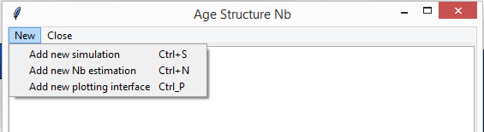

Figure 1 Adding an interface

1. Running a simulation. Load a simulation interface with the add menu (fig. 1), and set the paramaters with the provided controls. Steps for preparing the interface to run a simulation follow.
   * 1. Load a configuration file. The initial simulation interface requires the user to load a configuration file (fig. 2). The user can load a configuration file provided with the program, found inside the configuration/simulation directory inside the main program directory. Note that you can open one of these files and change the parameters manually, if you prefer it to setting them in the interface
     2. Adjust the simulation parameters. With a configuration file loaded (fig. 3) you can change the values in the editable controls. These are detailed below in the “Simulation parameters” section.
     3. Click the button labeled “run simulation,” and the simulation will start. The button’s text now changes to say “cancel simulation,” and next to it a new label notes that a simulation is in progress. While the simulation is in progress, the parameter controls are disabled.
2. Simulation Input. The simulation inter face has 5 subframes that divide the parameters by category.
   1. The Load/Run (fig. 2) section of the Simulation interface offers the following parameters.

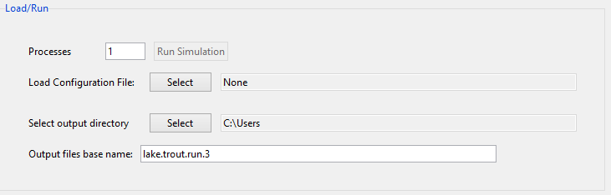

Figure Simulation interface, Load/Run section.

* + 1. *Processes*, with valid values between 1 and the total number of virtual cores in your computer. Multiple processes are only useful if you have set the “Replicates” parameter (see the Simulation subframe details below) to a value greather than one.
    2. *Configuration File*. Press the Select button next to the label, *Load Configuration file* to load a configuration file into the interface. We have included configuration files for many species. These can be found in the “configuration_files/simulation” path inside the main program folder.
    3. *Output directory.*  Press the select button next to the label, *Select output directory*, select a folder for the output files written by the simulation
    4. *Output files base name.* You can type in a base name for the simulation output files. The simulation will prepend this to the *.genepop, *.conf, *_age_totals.tsv and *_nb_values.tsv output files (see the “Simulation Output” section below).
  1. Configuration Info (fig. 3). This group if for information only and has no settable parameters.

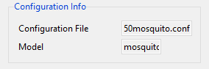Figure 3 Simulation interface, Configuration info

* + 1. *Configuration File.* This gives the file name of the loaded configuration file.
    2. *Model.* This gives the name of the model parameterized by the configuration file. In our example configuration files, the model name is usually a species common name.
  1. 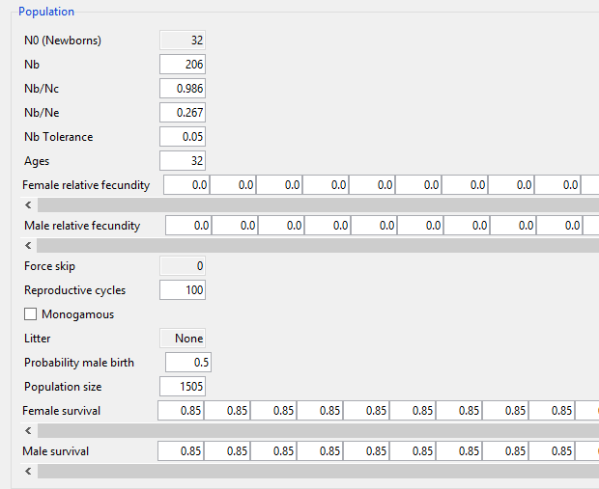The Population section (fig. 4) offers the following parameters.

Figure , Simulation interface, population section

* + 1. *N0 (Newborns)*. This gives the number of newborns added at each simulated reproductive cycle. This value is not editable directly, but is calculated using several values, all of which are editable. These including Nb, Nb/Nc, survival rates, and the probability of male birth. The N0 is recalculated whenever any of these values changes, using the following procedure:
       1. Assign an Nc value, as Nb divided by Nb/Nc.
       2. Assign a current_male_proportion equal to the probability of male birth.
       3. Assign a current_female_proportion equal to 1 – the probability of male birth.
       4. Assign a cumulative_proportion=1.
       5. For each age value age_val giving a male and female survival rate:
          1. Update, current_male_proportion=current_male_proportion x male_survival at age_val.
          2. Update, current_female=current_remale x female_survival at age_val.
          3. Update cumulative_proportion =cumulative_proportion + current_male_proportion.
          4. Update cumulative_proportion=cumulative_proportion + current_female_proportion.
       6. Set N0=Nc/cumulative_proportion, rounding it to the nearest integer.
    2. *Nb/Nc* is the effective number of breeders in one reproductive cycle divided by the number of cohort size (?).
    3. *Nb/Ne* is the ratio of the effective number of breeders in one reproductive cycle to the effective population size per generation. This value is not used in the simulation itself, but is written to the output genepop file, and can be used in the Nb estimation interface to make a bias correction in the LDNe estimation of Nb (see the section “Nb estimation input,” below).
    4. *Nb* is the effective number of breeders in one reproductive cycle.
  1. *Nb Tolerance* is the proportion of the *Nb* parameter by which a new population is added to the simulation after at each reproductive cycle. For example, if the *Nb* is set at 600, and the *Nb Tolerance* is set at 0.02 then populations created at each reproductive cycle (after the burn-in period, explained below), must have an *Nb*  value, as calculated using the parentage analysis without parents (PwoP) procedure[1].
  2. *Ages* gives the number of age classes for the population to be simulated. Note that this is disabled, and that the length of the lists for *Fecundity* and *Survival* values (see below) are set to length *Ages* minus one for the former and *Ages* minus two for the latter. The age value and changes in these lists, therefore, need to be edited in either a life table or configuration file (see the section “Manually editing life tables and configuration files.”

1. Robin S. Waples and Ryan K. Waples, “Inbreeding Effective Population Size and Parentage Analysis without Parents,” *Molecular Ecology Resources* 11 (March 1, 2011): 162–71, doi:10.1111/j.1755-0998.2010.02942.x.