**AgeStrucNe**

**USER MANUAL**

Version: 1.0

Updated: 06/05/2017

Authors:

Ted Cosart, Brian Hand, Brian Tretheway (?), Others?

Introduction 2

Installation 3

Starting the program 3

Loading interfaces 3

Running a simulation 4

Simulation Input 4

a. The Load/Run section 4

b. Configuration Info section 5

c. The Population section 6

d. The Genome section 8

e. The Simulation section 8

Simulation output 9

1. The conf file 10

2. The age counts file 10

3. The Nb values file 10

4. The genepop file 10

Running an Nb or Ne Estimation 11

Nb/Ne Estimations input 11

a. The Load/Run section 11

b. The Genepop Files Loaded section 12

c. The Parameters section 12

b. Pop sampling parameters section 14

c. Loci sampling parameters section 15

Nb estimation output 15

a. Messages file 15

b. Estimates table file 15

Visualization Input 15

a. Load/Run section 15

b. Tsv file loaded section 15

c. Viz type section 15

d. Regresssion plotting section 15

e. Subsample plotting section 15

# Introduction

The AgeStrucNe GUI interface offers a user interface to allow easy access to simuPOP-based simulations (Peng and Kimmel 2005). and the LDNe-based Nb and Ne estimations (Waples and Do 2008) as implemented in Tiago Antao's python program, AgeStrucureNe, available at <https://github.com/tiagoantao/AgeStructureNe.git>. We also offer an interface for plotting Nb and Ne estimations, and regressions based on the estimations. The original analyses based on Tiago’s code, with their applications to many species, are available in several publications, including [refs to AgeStructureNe - based pubs].

Our program offers a separate interface to perform three functions: population simulation, Nb and Ne estimation, and estimate visualization. The genepop file output from a simulation can be loaded into an Nb estimation interface, and in turn, the output from an Nb estimation can be loaded into a visualization interface. The Nb estimation interface can also use any genepop file for input.

# Installation

The program can be downloaded from <https://www.github.com/popgengui/negui>. Click on the button labeled “clone or download”. You can keep the program in any directory to which it can be written. For dependency details and other installation advice, see the README.md file provided with the program files.

# Starting the program

The program is launched using a python 2.7 or python 3.6 executable, invoking the negui.py module. Please see the README.md file for details on different ways to start the program.

# Loading interfaces

To load one or more of the three interfaces for performing simulations, Nb/Ne estimations, or plotting programs, from the main menu click on the “New” menu (fig. 1). You can load any number of interfaces and run them simultaneously, though running too many at once can tax your computers cpu and/or memory capacity to a standstill.

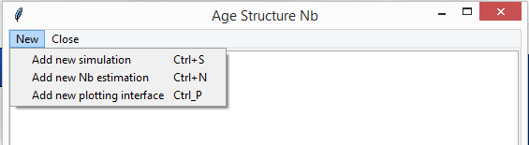

Figure Adding an interface

# Running a simulation

* 1. Load a simulation interface with the add menu (Figure 1), and set the parameters with the provided controls. Steps for preparing the interface to run a simulation follow.
  2. Load a configuration file. The initial simulation interface requires the user to load a configuration file (Figure 2). The user can load a configuration file provided with the program, found inside the configuration/simulation directory inside the main program directory, or load their own configuration (see premade configuration files for a formatted example and also see the section “Manually editing life tables and configuration files”). Note that you can also open these files and change the parameters manually, if you prefer it to setting them in the interface
  3. Adjust the simulation parameters. With a configuration file loaded (Figure 3) you can change the values in the editable controls. These are detailed below in the “Simulation Input” section.
  4. Click the button labeled “run simulation,” and the simulation will start. The button’s text now changes to say “cancel simulation,” and next to it a new label notes that a simulation is in progress. While the simulation is in progress, the parameter controls are disabled.

# Simulation Input

The simulation interface has 5 subframes that divide the parameters by category.

1. The Load/Run section (Figure 2) of the Simulation interface offers parameters related to input and output files.

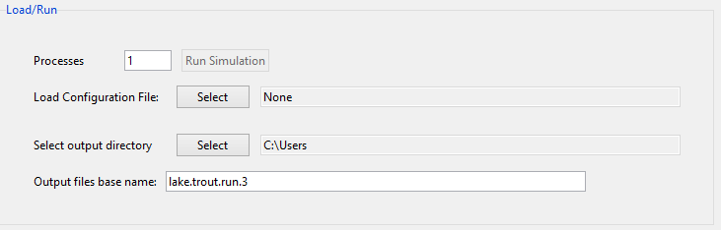

Figure Simulation interface, Load/Run section.

* + 1. Processes, with valid values between 1 and the total number of virtual cores in your computer. Multiple processes are only useful if you have set the “Replicates” parameter (see the Simulation subframe details below) to a value greater than one.
    2. Configuration File. Press the Select button next to the label, *Load Configuration file* to load a configuration file into the interface. We have included configuration files for many species. These can be found in the “configuration_files/simulation” path inside the main program folder.
    3. Output directory*.*  Press the select button next to the label, *Select output directory*, select a folder for the output files written by the simulation
    4. Output files base name*.* You can type in a base name for the simulation output files. The simulation will prepend this to the *.genepop, *.conf, *_age_totals.tsv and *_nb_values.tsv output files (see the “Simulation Output” section below).

1. 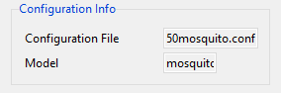Configuration Info section (Figure 3). This group simply shows you the input file information and has no settable parameters.

Figure Simulation interface, Configuration info

1. Configuration File Name*.* This gives the file name of the loaded configuration file.
2. Model Name*.* This gives the name of the model parameterized by the configuration file. In our example configuration files, the model name is usually a species’ common name. Note that the model name connects a configuration file to a life table, found in the “resources” subdirectory. The program automatically loads these life tables and, if the configuration file lacks a parameter, it looks for the parameter and its value in the life table file that has a matching model name. As noted, our program will output configuration file that includes all parameters used in the simulation, so that it can be reused and the program will not require a life table file.
3. The Population section (Figure 4) offers many parameter settings that characterize the population’s size and fecundity.

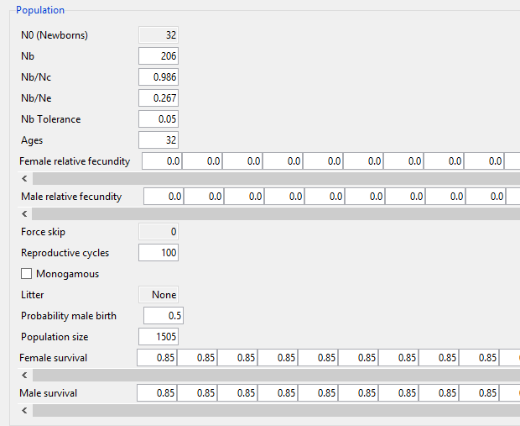

Figure , Simulation interface, population section

1. N0 (Newborns). This gives the number of newborns added at each simulated reproductive cycle. This value is not editable directly, but is calculated using several values, all of which are editable. These including Nb, Nb/Nc , Female, Male Survival, and the probability of male birth. The N0 is recalculated whenever any of these values changes, using the following procedure:
   * + 1. Assign an Nc value, as Nb divided by Nb/Nc .
       2. Assign a current_male_proportion equal to the Probability of male birth .
       3. Assign a current_female_proportion equal to 1 – the Probability of male birth .
       4. Assign a cumulative_proportion=1.
       5. For each age value age_val giving a male and female survival rate:
          1. Update, current_male_proportion=current_male_proportion x male_survival at age_val.
          2. Update, current_female=current_remale x female_survival at age_val.
          3. Update cumulative_proportion =cumulative_proportion + current_male_proportion.
          4. Update cumulative_proportion=cumulative_proportion + current_female_proportion.
       6. Set N0=Nc/cumulative_proportion, rounding it to the nearest integer.
2. Nb/Nc is the effective number of breeders in one reproductive cycle divided by the census size.
3. Nb/Ne is the ratio of the effective number of breeders in one reproductive cycle to the effective population size per generation. This value is not used in the simulation itself, but is written to the output genepop file, and can be used in the Nb estimation interface to make a bias correction in the LDNe estimation of Nb (see the section “Nb estimation input,” below).
4. Nb is the target effective number of breeders in the simulated population.
5. Nb Tolerancedetermines the threshold for allowable "true" Nb values for simulated populations calculated using the parentage analysis without parents (PWoP) procedure (Waples and Waples 2011). For example, if the Nbis set at 600, and the Nb Toleranceis set at 0.02, allowable Nb values would be in the range from 588-612 for simulated populations using PWoP.
6. Agesgives the number of age classes for the population to be simulated. Note that this is disabled, and that the length of the lists for Female, Male Fecundityand Female, Male Survivalvalues (see below) are set to length Agesminus one for the former and Agesminus two for the latter. The age value and changes in these lists, therefore, need to be edited in either a life table or configuration file (see the section “Manually editing life tables and configuration files”).
7. Female, Male Survivalare lists whose *i*th item gives the probability of survival for an individual of the *i*th age category.
8. Female, Male Fecundityare lists whose *i*th item gives the probability of reproducing for individuals of the *i*th age category.
9. Force Skip gives a probability, for each non-zero value, *f_a*, in the female fecundity list, that during a given reproductive cycle *r*, the value will be replaced with zero. Such replacement means that females belonging to the age class *a*, given by *f_a*, for cycle *r*, are infertile. This parameter is set (assigned a non-zero value) in only a few of the configuration files we copied from the AgeStructureNe program, and we have not made it editable in our interface. In your own custom configuration files you can set it to any value 0 through 100 (the value shown in the interface will be the file’s value divided by 100).
10. Litter, if not a “None” value, will be a list of integers, affecting litter sizes. Note that we do not allow interface editing of these parameters, but note that, as above for the Force Skip setting, you can inter this parameter value in a configuration file. This should be a list, and can have one of 2 valid configurations:
    1. The list can have a single value *l*, and *l* < 0, then at each reproductive cycle the maximum possible number of offspring available to each reproducing female is given by *l* * -1.
    2. Otherwise, the list should have (positive) integers. In this case these integers proportionally allot litter sizes, as given by their indices in the list. In particular, at each reproductive cycle, as a female is chosen to mate:
       1. An age *a* is chosen randomly.
       2. A female *f­_a* is chosen randomly from the females of age *a*.
       3. A list index *i* (i.e. one of 1,2,3…n , where *n* is the number of items in the *litter* list), is selected by weighted probability, proportionally according to the ratio of each list value to the sum of the list values.
       4. Female *f_a* is then the mother of the next *i* offspring (i.e. the female selection steps are skipped for the next *i* parings, since *f_a* is the female of the pair.). Thus, she will parent the next *i* offspring, unless the *jth* of her offspring assignments produces the maximum total offspring for the cycle (i.e. N0is reached), and *j* < *i*.
11. Reproductive cycles shows the total number of reproductive cycles that will be simulated.
12. Monogamous, when checked, tells the simulation to enforce monogamy.
13. Probability of male birth is used during reproductive cycles to determine the sex of new individuals. As noted above in the description of the *N0*, it is used also in the N0 calculation, and so the latter is recalculated when this value is changed. When the Cull method is set to *equal_sex_ratio*, this parameter is automatically set to 0.5, and its entry box is disabled.
14. Population size shows the number of individuals that will be created in the simulation’s initial population. Thereafter the size will change according to the reproductive parameters, notably *N0*.
15. 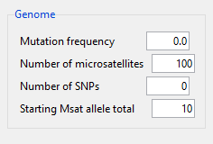The Genome section (Figure 5) parameters determine the simulated individuals’ allelic content.

Figure Simulation interface, genome section

* 1. Mutation frequency, if non-zero, is applied to microsatellites (not to SNPs). It will be used to set the simuPOP simulation StepwiseMutater’s rate parameter.
  2. Number of microsatellites, simulated as diploid. Note that in cases in which you specify both *n* microsatellites and *m* SNPs, in the output genepop file, the first *n* loci are the microsatellites and the last *m* loci are the SNPs.
  3. Number of SNPs, simulated as diploid.
  4. 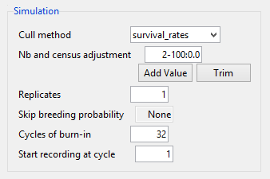Starting Msat allele total gives the initial number of microsatellite alleles present in each microsatellite in the initial population. For each microsatellite, the initial genotype frequencies are drawn from the Dirichlet distribution. With Number of microsatellites set to 10, for example, each microsatellite will have 10 alleles with frequencies given by the Dirichlet distribution of order 10, with alpha’s uniformly set to 1.0. The maximum allowed number of alleles is 100.

Figure , Simulation interface, simulation section

1. The Simulation section (Figure 6) parameters determine several per-cycle behaviours:
   1. Cull method indicates one of two possible per-cycle methods whereby individuals are removed from the population.
   2. Replicates sets the number of independent simulations run with the current parameter set. These can be run in parallel if you specify more than one process in the Processesparameter.
   3. Nb and census adjustment offers one or more specifications that will change the target Nb and the number of individuals in the population by a fixed rate and at a range of cycles (one or more). Entries are of the form min-max:rate, specifying a change in Nb and census size applied at cycle numbers min through max. The values conform to min <= 2 <= max, and rate >= 0.0. No adjustment is made with rate = 0.0. For example, to reduce the Nb and the total number of individuals by a tenth at cycle 3 (remaining in effect for the remaining cycles, unless another adjustment is added to the list), you would edit the entry to read, 3-3:0.1. The adjustments are different, depending whether the rate is less than or greater than 1.0.
      1. If the rate is less than 1.0, the target *Nb* value, and each age class in the current census is reduced by the proportion given by rate. Note that the change in *Nb* will result in a change to *N0* as described above the Population section’s description of *N0*.
      2. If the rate is more than 1.0, the target Nb value will be multiplied by the rate, with a resulting recalculation of *N0.* No change will be made to the current census.
   4. Skip breeding probability, if its value is not “None,” should be a list of percentages. It effects the number of available females of a given age at a given cycle number *c*. The *ith* percent *p_i*  gives the probability (*p*/100) that a female of age=*i*, is not able to breed in cycle *c.* Like the Litter and Force Skip parameters, this parameter is not settable in the interface, but can be included in your configuration file.
   5. Cycles of burn-in, give an integer *n* in the range 1 <= *n <= r*, with *r* giving the total Reproductive cycles . This value tells simulation that the Nb tolerance test (see the Nb Toleranceparameter description) should not be performed for the first *n* cycles. The default value for this parameter equals the number of Agesin the model to allow any individuals of the initial population to cycle out of the population.
   6. Start recording at cycle number *c* will result in the genepop file containing only the populations of cycles c through *r*, where *r* = total Reproductive cycles *.* This can greatly reduce the size of the output genepop file, when you are interested only in the last *r-c* cycles, but want to simulate many cycles before recording, and when you have large populations and many loci to simulate.

# Manually editing life tables and configuration files

Directly editing a *conf file can sometimes be more convenient than using the GUI interface to change simulation parameters. If you open one of the supplied configuration files in the subdirectory, configuration_files/simulation, and life table files (in the resources subdirectory), you’ll see the parameter=value pairs, each below a section header inside square brackets. If you need to create several configuration files based on the same model, you can create a life table for the model, and then several configuration files that have your desired parameter changes. See the supplied life table files and configuration files for examples.

Some of the parameter names differ from their functional equivalents in the interface:

|  |  |
| --- | --- |
| To set this value as shown in interface | Set this value in the configuration file |
|  |  |

# Simulation output

When a simulation is complete the message “simulation in progress” will disappear from the interface and editable entry boxes will no longer be grayed-out. A completed simulation delivers a genepop file for each replicate, named using the output files base nameparameter shown in the load/Run section of the simulation input. The base name is extended with a replicate number *n* and a “genepop” extension, so that, for example, if your simulation output base name is bulltrout, and you specified 3 replicates, the output file for the 3rd replicate would be named“bulltrout.r3.genepop.” Also, there are three files produced during the first replicate only, all prefixed with the *output base name*. One with the extension “conf,” lists the parameter settings for the simulation (and, hence, for all replicates), another has extension “_age_counts_by_gen.tsv,” and a third file has extension “_nb_values_calc_by_gen.tsv”. Details on the output files follow.

1. The conf file shows the parameter settings used in the simulation (except the number of replicates, which it always sets to one). This file can be loaded into another instance of the Simulation Input (see the *Load/Run* parameter) and another simulation with matching parameters can be run. Conveniently, if it represents many customized settings on a former configuration file, small changes to it can be made to run a simulation similar, but without having to re-enter all of the settings used to create it.
2. The age counts file is a table with tab-delimited fields that gives a count of total individuals for each age class, for each reproductive cycle. The first line in the file gives column headers, the first “generation,” referring to reproductive cycle number, a zero-based count of reproductive cycles, and the rest listing age classes simply as 1,2,3…*t*, *t =* total age classes. This file is created only for the first simulation replicate.
3. The Nb values file is a table with tab-delimited fields giving the PWoP­3 Nb values calculated during the simulation, and used to compare to the target Nbvalue +/- the Nb Tolerancevalue. The first column gives the zero based reproductive cycle number and the second the PWoP-based Nb value that passed the tolerance test, and represents the accepted population for that cycle. This file is created only for the first simulation replicate.
4. The genepop file conforms to the genepop file standards given at <http://genepop.curtin.edu.au/help_input.html>. The header line notes the name of the *.gen file it came from, which simply names an intermediate file from which it derived it’s population information. It also gives the value of Nb/Ne. It the value is non-zero, it can be loaded automatically into the *Nb/Ne estimation interface* (see the *Parameters section* of the *Nb/Ne Estimation* interface description. The second line of the genepop file gives the name of the first loci, which is simply “l0.” Each consecutive loci, l0, l1,l2…*L*-1 (where *L* gives the total number of microsatellites plus the total number of SNPs) is listed on a separate line. Note that the first *M* loci will represent the microsatellites, and the last *S* loci will represent the SNPs, with *M* and *S* the totals given in the *Genome* section of the Simulation Input*.* Thereafter the file consists of separate “pop” sections, each representing a reproductive cycle. The first *n* cycles (as numbered 1,2,3…*n*) will not be in the file if the *Start at cycle number* parameter is set to *n* + 1. The population for each cycle is listed, in order of cycle number. Each is demarked by a line with “pop” as its sole entry. Individuals, one to a line, follow each “pop” entry. Each individual as an ID with multiple fields delimited by a semicolon, giving, <individual id number>;<sex (1 = male, 2 = female )>;<id of father>;<id of mother>;<age class>. These are followed by a comma, and then a space-delimited set of alleles for each locus named in the lines 2 – total number of loci. Note that these allele entries represent diploidy, and use 3-digit allele numbering so that, for each loci, allele one is named by the first 3 digits, and allele 2 by the last 3.

# Running an Nb or Ne Estimation

Figure Nb/Ne estimations interface, Load/Run section

The Nb (and Ne) estimation interface performs and LDNe2 based Nb or Ne estimation from genepop file input as supplied by the user. While it was developed in concert with the simuPOP-based simulation output from our program’s interface, it will perform estimations on any genepop file input. To run estimations:

.

* 1. Load a “new nb interface” with the add menu (Figure 7), and set the parameters with the provided controls.
  2. Load a genepop file as described in the *Simulation output* section.
  3. Adjust the estimation parameters. The parameters are detailed in the *Nb/Ne estimations input* section below.
  4. Click the button labeled “Run Nb Estimation,” and the computations will start. The button’s text now changes to say “cancel simulation,” and next to it a new label will note that “estimations in progress". As in the other interfaces, while the estimations are in progress, the parameter controls are disabled.

# Nb/Ne Estimations input

The interface provides for multiple subsampling schemes of both individuals and loci within the input genepop file pop sections. The sub-sections of the interface follow.

1. The Load/Run section (Figure 7) offers an interface to load input and name the output files.
   1. Total processes. The program will run estimations on the individual “pop” sections in parallel using the number of processes set here. It is usually advisable, unless your computer has many process already running, to use most if not all of your available (virtual) processing cores, to speed up the estimation run parameter.
   2. The Load genepop files button offers a file loading interface to locate and load one or more genepop file(s). Note that when you load multiple genepop files, the parameter settings will be applied to all. In particular, activating an Nb bias adjustment will apply it to all the files, so that only data with which it is compatible should be loaded. This also applies to other parameters, such as population number range [bookmark] and loci number range [bookmark].
   3. Select output directory. By clicking on the button and choosing your preferred folder you select where the estimation output files will be written. Note that this will also be used as a temporary directory in which intermediate files will be written inside new directories with the “tmp” prefix, ending in random characters. These files will be removed on completion of the simulation. Sometimes, if the estimation run is cancelled or otherwise is interrupted, they will not be removed, but can be manually deleted from your directory.
   4. Output files base name. The text entered here will become the prefix for the output files [bookmark].
2. The Genepop Files Loaded section (Figure 8) has a single box that shows you the names of the loaded genepop files. It is not an editable section.

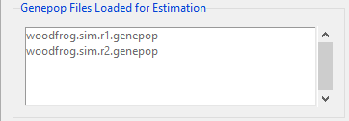

Figure , Nb estimation interface, genepop files loaded section

1. The Parameters section gives the main parameters, including the choice of subsampling in pop sections and/or loci.

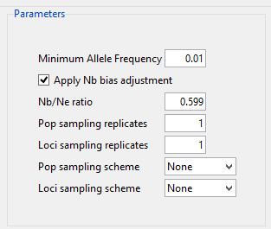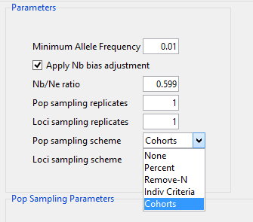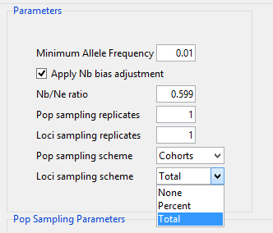

a

b

c

Figure , Nb estimations interface, parameters section. Subfigure a shows the section with no subsampling selected. Subfigure b shows the types of subsampling available for pop sections, and subfigure c shows those available for the loci.

* 1. Minimum allele frequency sets the threshold below which the LDNe program will ignore an allele in its LDNe calculation. The interface defaults to 0.05, as a value that is commonly used, and which reduces upward bias (Waples and Do 2008, 2010).
  2. Nb bias adjustment check box allows you to apply a bias adjustment to the estimations. Note that when you load a genepop file generated by the simulation interface, and you check the box labeled “applyNb bias adjustment”, the program will load the Nb/Ne value as set in the simulation interface. You can accept it or enter another value. If no value is available in the genepop file, then you will need to enter a non-zero value to make any bias adjustment.
  3. Nb/Ne ratio is the value used for the bias adjustment, when it is checked. A zero value or an un-checked box means no bias adjustment will be done.
  4. Pop sampling replicates. When set to *n*, for each estimate, for each pop sampling parameter, the estimate is repeated *n* times. While you can set this to any value for any subsampling scheme, note that it is sensible only when your subsampling parameter involves a random sample of individuals (see [bookmarks] schemes), or you have more than 1 loci subsampling parameter (see [bookmarks] loci subsampling schemes, or both. If there is no random subsampling, the replicates will be performed, with identical results.
  5. Loci sampling replicates. When set to *n*, for each pop sampling replicate, for each loci subsampling parameter value, the estimate is repeated *n* times. As with the Pop sampling replicates parameter, if the loci subsampling scheme has no randomized subsample (see [bookmarks]), then the estimates will be identical.
  6. Pop sampling scheme. This drop-down box offers the following subsampling schemes (Figure 9b).
     1. None. This scheme uses all individuals with the pop section for the Nb or Ne estimation, unless the value for indiv max per pop reduces the pop size to *m* randomly selected individuals. If the pop section has fewer individuals than the value given by indiv min per pop , the pop section is skipped, with a message written to the messages file.
     2. Percent. When you select this scheme the [bookmark for pop sampling parameters] shows a “percent” box with two buttons below it (Figure 10b), “Add Value,” and “Trim.” You can edit any box currently in the list. Clicking “Add Value” will append a box to the list, its default value taken from its nearest neighbor. For each percentage *p* in the list, each pop section will be reduced to *p* percent of its total individuals, unless its census is not in the range in [indiv min per pop , indiv max per pop], in which case the population will be skipped, and a message written to the messages file. For each subsample the individuals are randomly selected. Note that any multiple loci subsampling values and/or pop and loci replicates will result in an estimate for each percentage value, repeated for each of the loci subsampling and replicate values.
     3. Remove-N. This scheme also offers an editable list, which behaves as described for the Percent scheme. For this scheme, when you enter an integer *N*, the pop subsample will be that given by its total minus *N*, the removed *N* individuals randomly selected except in the case of *N* = 1, in which case each of the remove-1 cases will be estimated (i.e. there will be *t* estimations for a pop section with *t* individuals. Pop sections are skipped if the total individuals in the population are not in the range [indiv min per pop , indiv max per pop]. Note, as with the Percent scheme, estimates for each N value will be repeated for loci sample values and pop and loci sampling replicates.
     4. Cohorts. Because this scheme selects individuals by age, it requires input genepop files produced by the Simulation output. If your input is empirical data and you wish to calculate Nb, it is assumed that each pop in the Genepop file is a single cohort and all individuals should be used in the Nb calculation. When Cohorts is selected the interface shows, besides its usual pop number and min/max pop size parameters, an entry labelled “Indiv max age” (Figure 10). For each population, individuals outside the ages given by [0.0, max age] are excluded. However, because the simulations produce genepop files with no individuals aged less than 1.0, the interval is effectively [1.0, max age]. For each pop, and for each percentage value in the list, subsampling steps are:
        1. For each age value in [0.0, max age], count the total individuals in the age group.
        2. Find the smallest of the age group totals, *t,* from (1).
        3. Randomly subsample *t* individuals from each age group to get total sample size *s*.
        4. If *s* is within [indiv min per pop, indiv max per pop] then, for each percentage *p* in the percentage list, randomly select *p* percent of the collected individuals. If *s* is outside the range an error occurs and the analysis is terminated.
        5. Individual Criteria. This scheme allows you to select a range of cohorts by contiguous age group. Like the Cohorts scheme, it requires your input to genepop files produced by the simulation output. When Individual Criteria is selected the interface shows, besides it’s the pop number and min/max pop size parameters, two entries for a minimum and maximum age” (Figure 10e). The program pools all individuals within the minimum and maximum age range (inclusive), and calculates the estimation using the pool. If the total polled individualsis outside the range given by [indiv min per pop, indiv max per pop], an error is thrown and the analysis is terminated.
  7. Loci sampling scheme.
     1. None. Figure 11a. All loci will be used in the estimations, from the *ith* to the *jth,* *i*  and *j* given by the loci number start and loci number end. If the total loci in the range is less than the value in min loci count, then the program [check behavior]. If the max loci count *m* is less than the total loci, then *m* loci will be randomly selected.
     2. Percent. For each percentage *p* listed in the “percentages” boxes (Figure 11b), an estimation is calculated using a random selection of *p* loci from those within the range given by loci number start to loci number end.
     3. Total. [description]

1. Pop sampling parameters section. In this section (Figure 10) you set the pop section sampling parameters, which are presented according to the scheme selected in the Pop sampling scheme parameter.

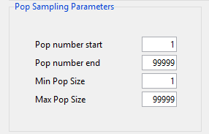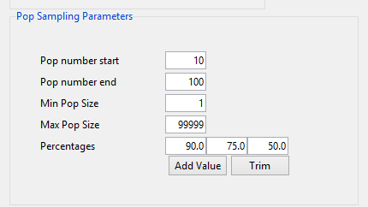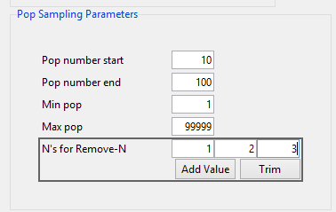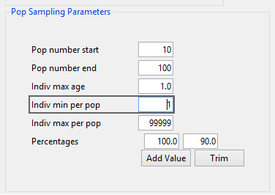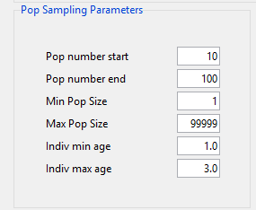

a

b

c

d

e

Figure , pop sampling parameters section, as presented for. (a) the None scheme, (b) the Percent scheme, (c) Remove-N, (d) Cohorts, and (e) Individual Criteria.

* 1. Pop number start. When this is set to integer *n,* the estimates will skip pop section numbers (asordered in the genepop file) in the range [1, *n* – 1].
  2. Pop number end. If the genepop file has *t* total pop sections, then, when this parameter is set to integer *n*, the estimates will skip pop section numbers in the range [ *n* + 1, *t*].
  3. Indiv min per pop For the None, Percent, and Remove-N sampling schemes, a pop section must contain at least this many individuals, or it will be skipped. Skipped populations will be noted in the messages file. For the Cohorts and Individual Criteria sampling schemes, the total cohort sample must meet or exceed this minimum, or an error occurs and the estimation run is terminated.
  4. Indiv max per pop. For the None sampling scheme, if total individuals in a pop section exceed this value *i_max*, than *i_max* individuals will be randomly selected from the pop. For the Percent and Remove-N schemes, pop sections with individuals totaling more than this value will be skipped, with a message written to the messages file. For the Cohorts scheme, if sample size exceeds this value, then an error occurs and the estimation run is terminated; for the Individual Criteria scheme, the sample is reduced to the the value by random selection of individuals.
  5. Scheme-specific parameters. See the descriptions in the section, Pop sampling scheme.

1. Loci sampling parameters section. [description]

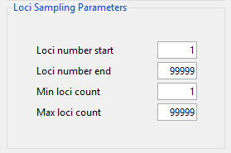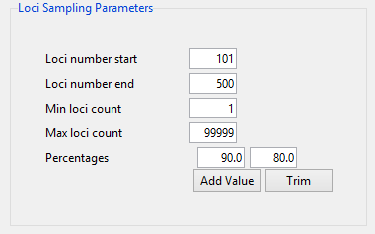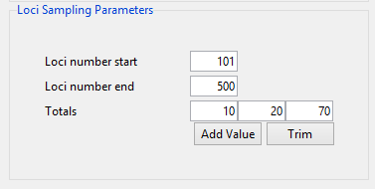

a

b

c

Figure , locii sampling parameters section, as presented for the schemes (a) None, (b) Percent, (c) Total.

* 1. Loci number start. Loci used in the estimation will be drawn from the *i*th to the *jth* Loci as ordered in the genepop file. This value gives the *ith*. Note that this range allows you, for example, to run a simulation in which the first *m*  loci are microsatellites and the last *s* loci are SNPs, and then use the same genepop file in two different estimations, one based on microsatellites using loci range 1 thru *m*, and the second based on SNPs using range loci *m*+1 to *m+s*.
  2. Loci number end. This value gives the *jth* loci in the range as described for loci number start.
  3. Min Loci count. This sets a minimum for the total loci to be used in the estimation. If the loci sample in the genepop file is less than this value, the program generates and error message and the run is terminated.
  4. Max Loci count. This sets a maximum value *m* on the number of loci to be used in the estimation. If the range gives a larger total, then *m* loci will be randomly selected from those in the range, loci number start to loci number end.
  5. Scheme specific parameters. See the descriptions in the section, Loci sampling scheme.

# Nb estimation output

1. Messages file (*.msgs) [description]
2. Estimates table file (*.tsv) [description]

# Visualization Input

1. Load/Run section. [description]
2. Tsv file loaded section. [description]
3. Viz type section. [description]
4. Regresssion plotting section. [description]
5. Subsample plotting section. [description]

## References

Peng, Bo, and Marek Kimmel. 2005. “SimuPOP: A Forward-Time Population Genetics Simulation Environment.” *Bioinformatics* 21 (18): 3686–87. doi:10.1093/bioinformatics/bti584.

Waples, Robin S., and Chi Do. 2008. “Ldne: A Program for Estimating Effective Population Size from Data on Linkage Disequilibrium.” *Molecular Ecology Resources* 8 (4): 753–56. doi:10.1111/j.1755-0998.2007.02061.x.

———. 2010. “Linkage Disequilibrium Estimates of Contemporary Ne Using Highly Variable Genetic Markers: A Largely Untapped Resource for Applied Conservation and Evolution.” *Evolutionary Applications* 3 (3): 244–62. doi:10.1111/j.1752-4571.2009.00104.x.

Waples, Robin S., and Ryan K. Waples. 2011. “Inbreeding Effective Population Size and Parentage Analysis without Parents.” *Molecular Ecology Resources* 11 (March): 162–71. doi:10.1111/j.1755-0998.2010.02942.x.