Computer-Use Benchmark Landscape
Shortlist of 6 benchmarks for our shared-canvas benchmark
Working document - benchmark planning - October 2026

1. Executive summary
This document narrows the surveyed landscape to 6 benchmarks under consideration - PSBench, CANVAS, ProSoftArena, PPT-Eval, OSWorld and ScratchWorld - totalling 2,206 tasks. For each, we identify which tasks fit a multi-agent shared-canvas workflow, show real example tasks with their real artifacts for a qualitative sanity check, and summarize how they would compose into our own benchmark.
Note: GUIDE was considered but excluded - it benchmarks intention understanding from screen recordings (behavior-state detection, intent prediction, help prediction), not computer-use task execution, so it is out of scope for an execution-based shared-canvas benchmark.

2. Scale of the landscape
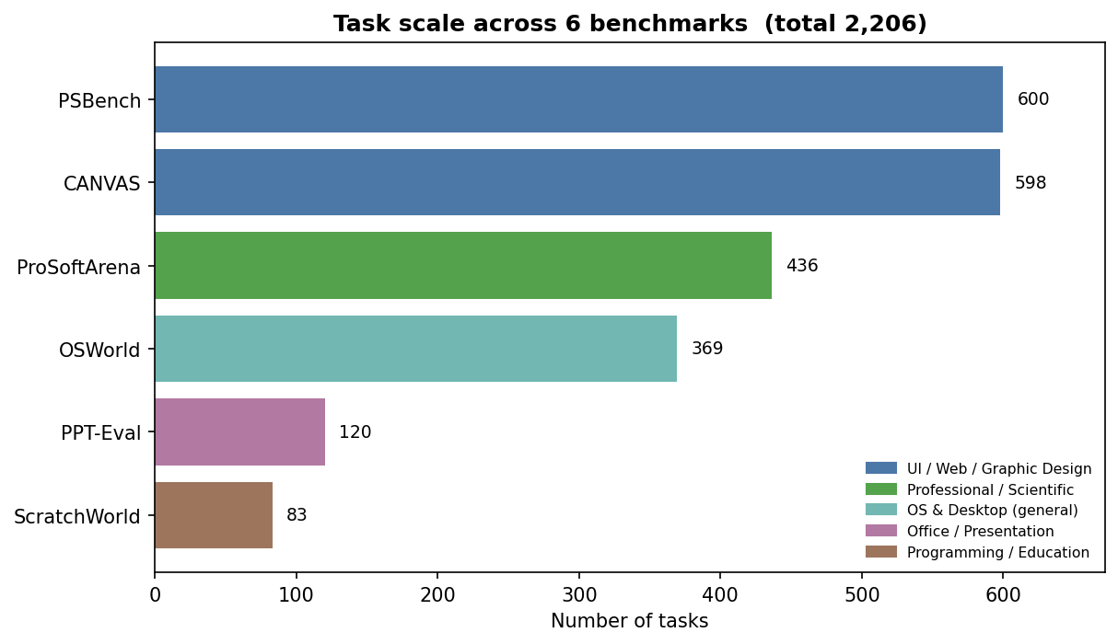
Figure 1. Task count per benchmark, colored by domain category (6 benchmarks, 2,206 tasks).

3. Benchmarks at a glance
Benchmark | Domain | Tasks | Key software | Main function / use | Shared-canvas
PSBench | UI / Web / Graphic Design | 600 | Adobe Photoshop | Image editing: 600 Photoshop tasks (flip, resize, color, filters, compositing), each with a start image, reference output, and grading rubric. | 24 High
CANVAS | UI / Web / Graphic Design | 598 | Figma | UI/UX design: replicate a reference UI, or modify a base design to a target (edits + component insertion). Ships design node JSON, SVG and PNG renders. | 23 High
ProSoftArena | Professional / Scientific | 436 | ANSYS, ArcGIS, AutoCAD, SolidWorks, ChemDraw, Excel, R, NVivo, Illustrator, Photoshop, ImageJ, MultiSim, VS Code | Hierarchical professional-software benchmark (L1 Operation -> L4 Creative) over 13 domain-expert apps and 6 disciplines. Execution-based + human-in-the-loop. (Data not yet released; representative rows.) | 78 High
PPT-Eval | Office / Presentation | 120 | Microsoft PowerPoint Online | PowerPoint Online editing tasks (easy/medium/hard) across 12 source decks, rubric-graded. | User-reviewed
OSWorld | OS & Desktop (general) | 369 | Ubuntu + LibreOffice, Chrome, GIMP, VLC, Thunderbird, VS Code (14 apps) | Real-computer daily tasks in a Linux VM across files, office, browser and media. Each task downloads a starting file and is execution-checked. | 14 High
ScratchWorld | Programming / Education | 83 | MIT Scratch | Block-based programming: build and modify Scratch projects from an initial project file. | 6 High

4. Domain coverage
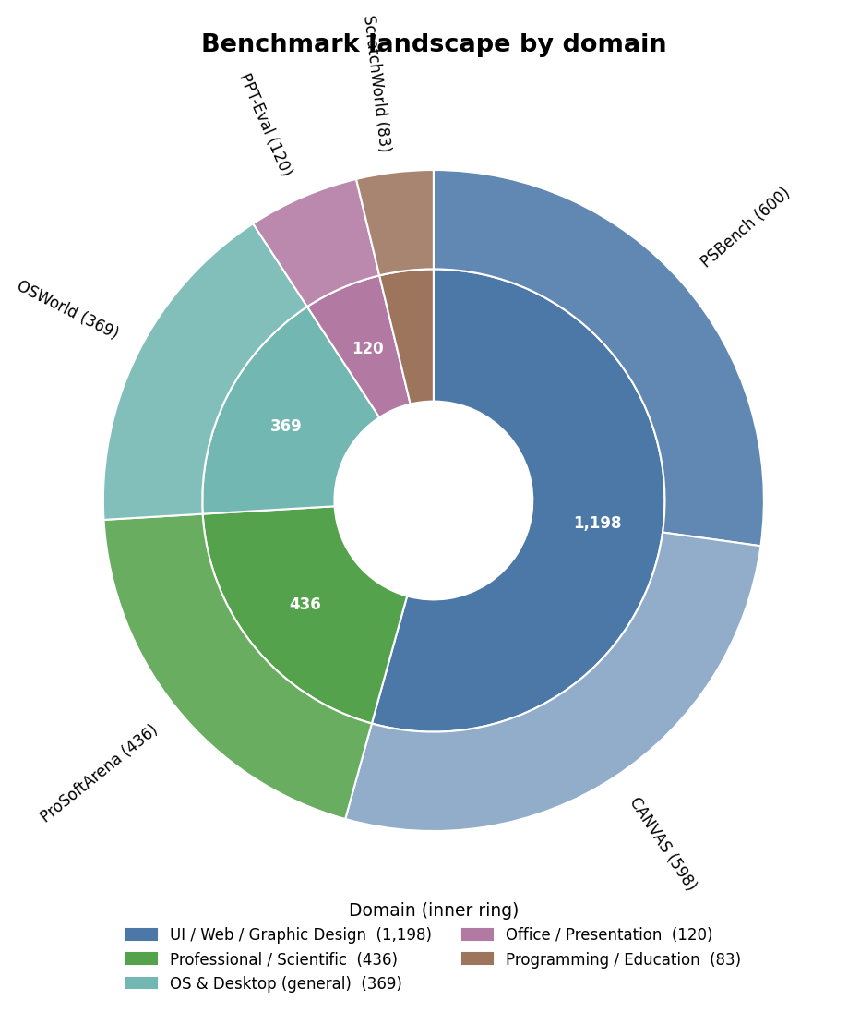
Figure 2. The 6-benchmark shortlist by domain. Inner ring: domain category; outer ring: benchmark sized by task count.

5. Operation types (hierarchical example)
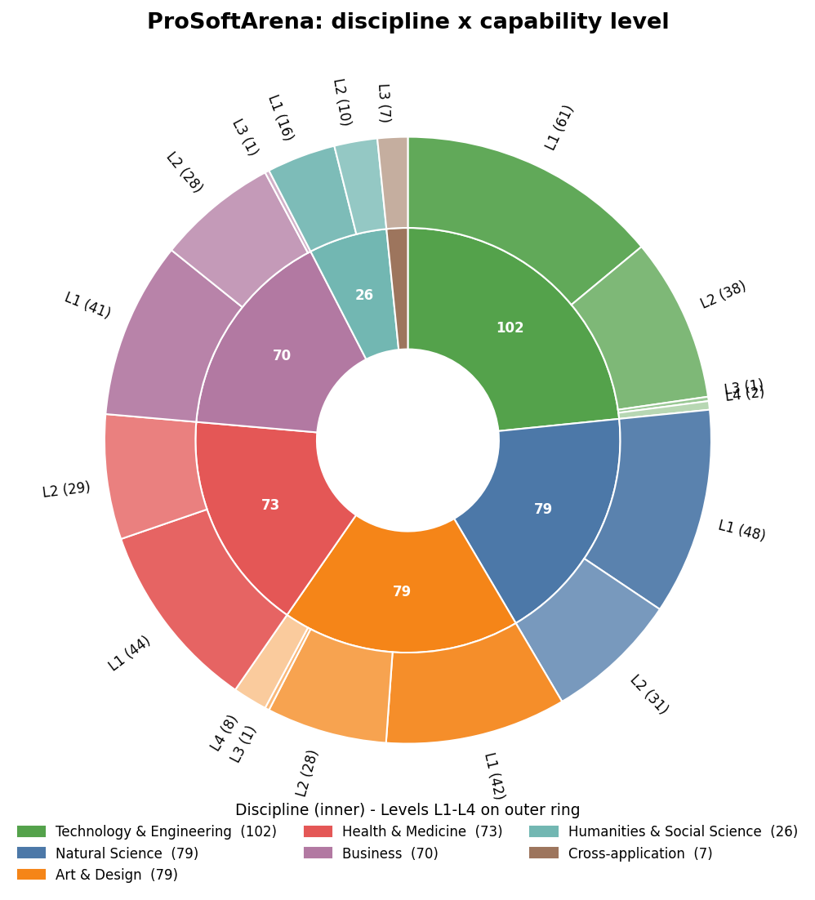
Figure 3. Operation types within ProSoftArena - inner ring: discipline; outer ring: capability level (L1-L4). Mirrors the domain x operation view used for OSWorld.

6. Shared-canvas suitability
A task fits the shared-canvas model when it decomposes into two or more concurrent regions, layers, views or components of one shared artifact, while still requiring global visual/spatial/temporal coherence.
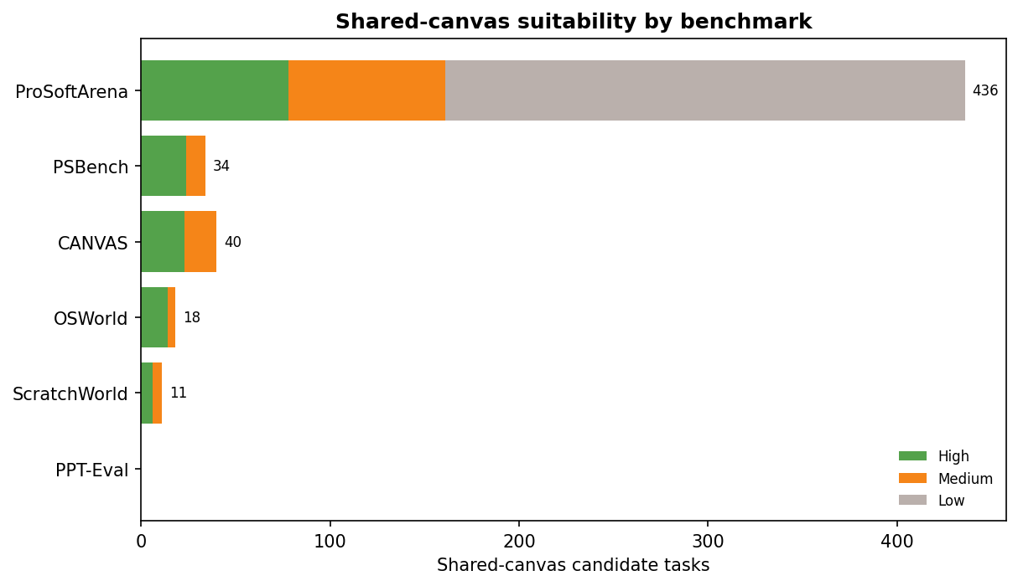
Figure 4. Shared-canvas candidate tasks per benchmark (High / Medium / Low confidence).

Best-fit software for shared-canvas tasks
Benchmark | Software used in shared-canvas-suitable tasks
PPT-Eval | PowerPoint Online
CANVAS | Figma
PSBench | Photoshop
ScratchWorld | MIT Scratch
ProSoftArena | Photoshop, Illustrator, SolidWorks, AutoCAD (L2/L4)
OSWorld | LibreOffice Calc/Impress, GIMP

7. Real example tasks + artifacts (qualitative review)
For each benchmark we show real tasks and the real artifact the agent works with, so we can judge whether these are genuinely good shared-canvas tasks. The 'shared-canvas read' states how each task decomposes into concurrent regions on one artifact.

7.1 PPT-Eval (PowerPoint Online)
Already reviewed by the team. Each task edits one shared deck; the source deck (.pptx) opens in the browser viewer, and a rubric defines success.
Task: "On slide 3, Add a fourth vCPU circle (vCPU4) next to the existing three circles using a different color and also add vCPU4 to the time-sharing diagram"
Artifact: View slides ↗ · View rubric ↗
Task: "Change the color tone of the figure on slide 4 to blue by adding a shape on top of the figure and increasing it's transparency"
Artifact: View slides ↗ · View rubric ↗

7.2 CANVAS (Figma)
Modify a base UI design to a target. The before/after renders below show the exact regions that change - several icons/components on one mobile screen, each ownable by a different agent.
Task: "Apply the following changes to the design. - Profile status indicator: Change from green to blue. - Settings gear icon..."
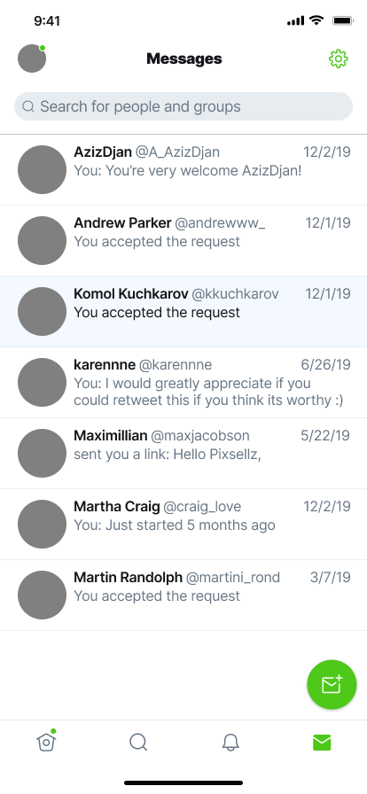  Base (starting design) | 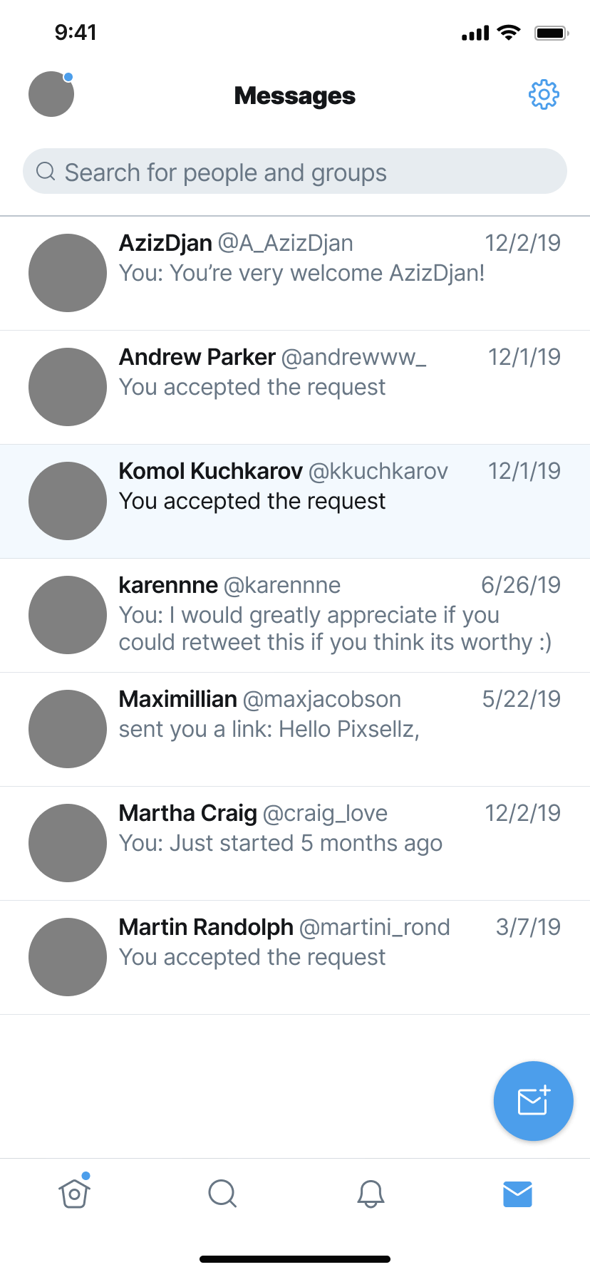  Target (goal design)
Source design: Figma community file ↗
Shared-canvas read: 4 regions on one artifact - profile status indicator; settings icon; compose-message button; bottom navigation icons.
Task: "Apply the following changes to the design. - Back arrow: Change from pink to blue. - Call icon: Change from pink to bl..."
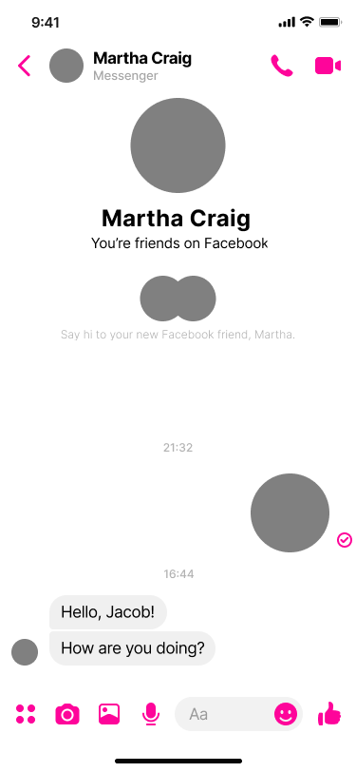  Base (starting design) | 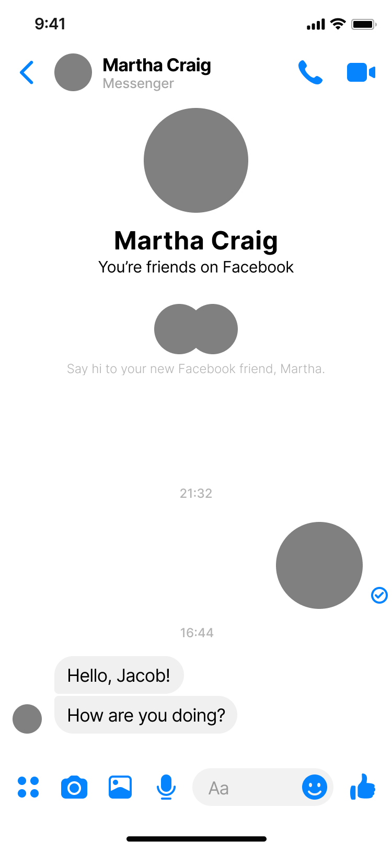  Target (goal design)
Source design: Figma community file ↗
Shared-canvas read: 4 regions on one artifact - top-bar back/call/video icons; sent-message checkmark; bottom composer tool icons; emoji and like controls.

7.3 PSBench (Photoshop)
Edit one image to match a reference. The input and reference-output below make the multi-region structure concrete (e.g., sky vs. lights vs. local glow).
Task: "Transform the panda image into a magical night scene with a deep blue star-filled sky, a large glowing moon, and decorative leaves in the lower-left foreground. Add warm glow to the bamboo held by the panda and selected nearby accents while keeping the panda clearly visible as the main subject."
  Input (starting image) |   Reference output (goal)
Shared-canvas read: 3 regions on one artifact - deep-blue star sky and moon; lower-left decorative leaves; panda and warm glowing bamboo accents.
Task: "Transform the daytime street into a convincing night scene with a deep blue sky and darker buildings. Make the windows and street lamps glow warm yellow-orange, add soft halos and local light spill, and retain enough shadow detail to recognize the architecture."
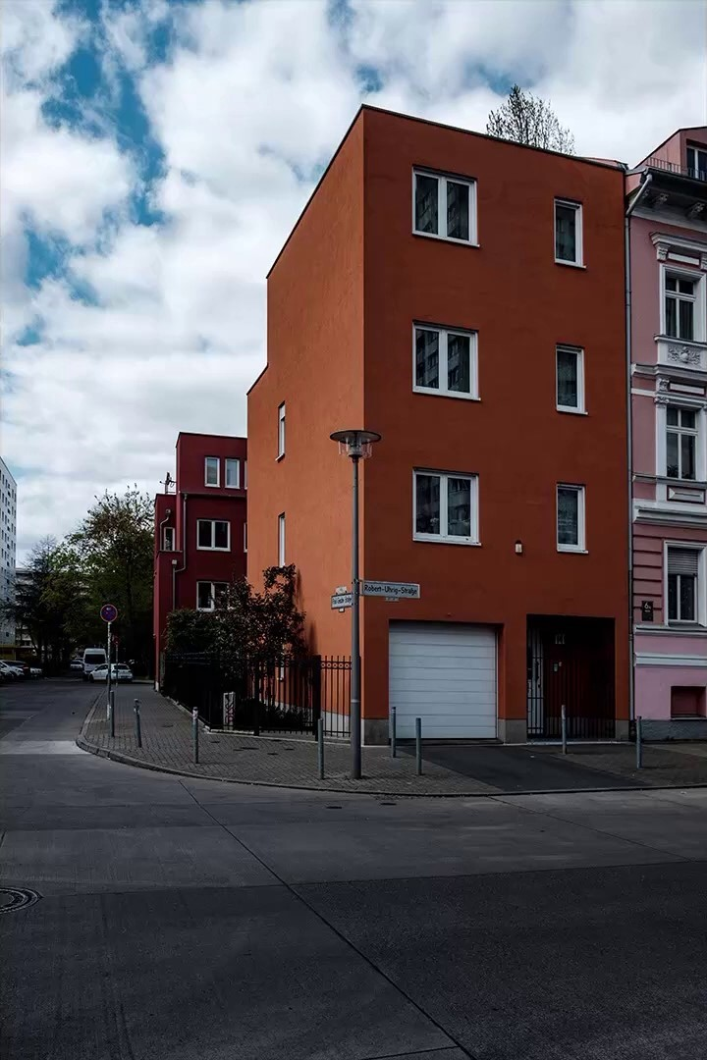  Input (starting image) | 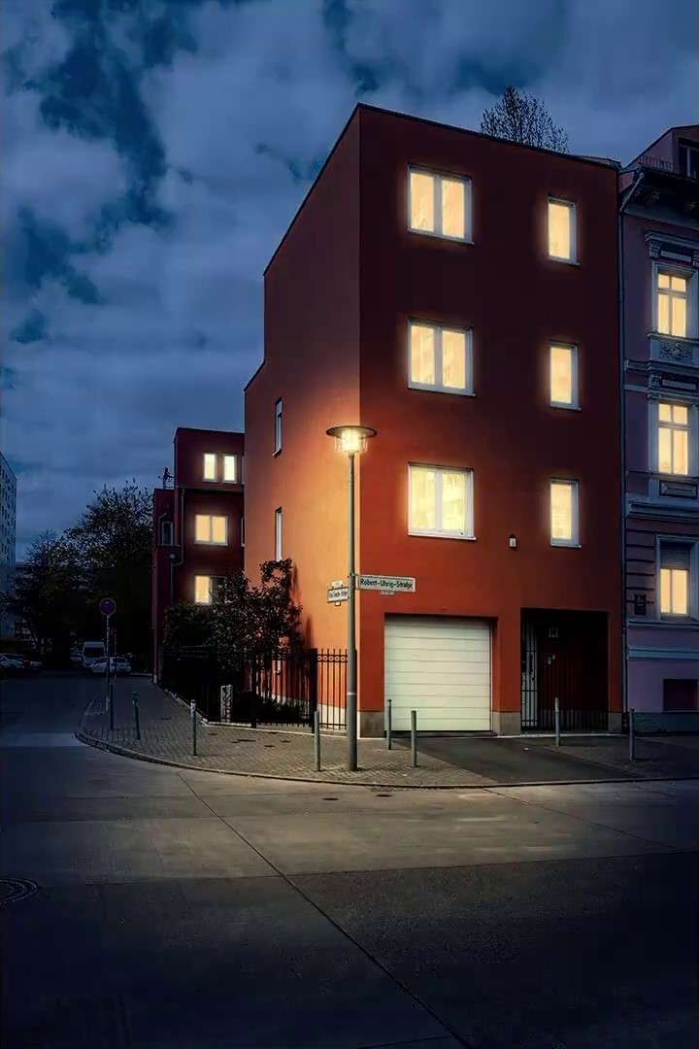  Reference output (goal)
Shared-canvas read: 3 regions on one artifact - sky and darkened architecture; windows and street lamps; local halos and light spill.

7.4 ScratchWorld (MIT Scratch)
Extend one shared Scratch project. Regions map cleanly to sprites/stage/scripts, so agents can own different sprites on the same project.
Task: "Add a score system that increases over time/distance and gradually speeds up the Buildings to raise difficulty."
Artifact: Task definition (.json) ↗ - Starts from make_it_fly.sb3; agents extend/modify one shared project.
Shared-canvas read: 3 regions on one artifact - Score module: initialize and increment visible score every second; Buildings sprite: derive decreasing glide duration and preserve endless scrolling; Integration: shared difficulty state and restart initialization.
Task: "Introduce multi-level progression using multiple backdrops. Upon reaching the goal, switch to the next level and reset player position."
Artifact: Task definition (.json) ↗ - Starts from maze_starter_multi_level_maze_progression_modify.sb3; agents extend/modify one shared project.
Shared-canvas read: 3 regions on one artifact - Goal sprite: detect completion, advance level, and signal final win; Stage: initialize currentLevel and switch among three existing backdrops; Ball sprite: reset to the common start position on each level transition.

7.5 ProSoftArena (professional software)
Example L2/L4 tasks on one document/canvas. Per-task files are not yet released (paper only), so there is no artifact to preview - a gap to flag before relying on it.
Task: "Model the floor plan of a single room with walls, a door, and a window, fully dimensioned."
Software: AutoCAD · Artifact: not yet released (paper ↗)
Shared-canvas read: 4 regions on one artifact - Model the floor plan of a single room with walls; door; window; fully dimensioned.
Task: "Apply a fixed support and a 500 N load, mesh the body, and solve for equivalent stress."
Software: ANSYS · Artifact: not yet released (paper ↗)
Shared-canvas read: 4 regions on one artifact - Apply a fixed support; 500 N load; mesh the body; solve for equivalent stress.

7.6 OSWorld (Ubuntu / LibreOffice)
Each task downloads one starting file into the VM. The examples below touch several regions of that single file (merged header + per-field pivots; three textboxes on a slide).
Task: "Please create a new sheet. Keep its sheet name as "Sheet2". Merge cells A1:C1 in the new sheet and write "Demographic Profile" with blue (#0000ff) f..."
Artifact: Starting file: DemographicProfile.xlsx (view in browser) ↗
Shared-canvas read: 4 regions on one artifact - summary header — merged A1:C1 Demographic Profile heading; sex pivot — percentage summary for Sex; civil-status pivot — percentage summary for Civil Status; education pivot — percentage summary for Highest Educational Attainment.
Task: "Change the text color in the textboxes to on slide 1 yellow, red, and green, respectively, in top-to-bottom order. Use exactly these colors—no varia..."
Artifact: Starting file: 45_2.pptx (view in browser) ↗
Shared-canvas read: 3 regions on one artifact - top textbox — yellow text; middle textbox — red text; bottom textbox — green text.

8. Projected benchmark composition
Across the 6 benchmarks, the shared-canvas candidate pool is 539 tasks (145 high, 119 medium, 275 low). Taking the top 5 per benchmark gives a seed of 25 tasks; scaling to every High-confidence task gives 145 tasks. (PPT-Eval contributes 0 here because it was reviewed separately.) Breakdowns by domain, benchmark and software follow.

8.1 By domain
Domain | Seed (top-5) | High-conf pool
UI / Web / Graphic Design | 10 | 47
OS & Desktop (general) | 5 | 14
Professional / Scientific | 5 | 78
Programming / Education | 5 | 6
Total | 25 | 145

8.2 By benchmark
Benchmark | Seed (top-5) | High-conf pool
PSBench | 5 | 24
CANVAS | 5 | 23
ProSoftArena | 5 | 78
OSWorld | 5 | 14
ScratchWorld | 5 | 6
Total | 25 | 145

8.3 By software
Software | Seed (top-5) | High-conf pool
Adobe Photoshop | 5 | 32
Figma | 5 | 23
SolidWorks | 2 | 14
ChemDraw | 0 | 10
LibreOffice Impress | 4 | 9
AutoCAD | 2 | 9
R (RGui) | 0 | 9
NVivo | 0 | 7
MIT Scratch | 5 | 6
ImageJ | 0 | 6
Microsoft Excel | 0 | 5
VSCode | 0 | 4
Adobe Illustrator | 0 | 4
LibreOffice Calc | 1 | 3
ANSYS | 1 | 2
LibreOffice Writer | 0 | 1
GIMP | 0 | 1
Ubuntu Desktop | 0 | 1
Total | 25 | 146

9. Benchmark details

PSBench - UI / Web / Graphic Design (600 tasks)
Main function: Image editing: 600 Photoshop tasks (flip, resize, color, filters, compositing), each with a start image, reference output, and grading rubric.
Software: Adobe Photoshop
Shared-canvas fit: 24 High. Multiple independent regions on one image (e.g., glowing subject vs. monochrome background).

CANVAS - UI / Web / Graphic Design (598 tasks)
Main function: UI/UX design: replicate a reference UI, or modify a base design to a target (edits + component insertion). Ships design node JSON, SVG and PNG renders.
Software: Figma
Shared-canvas fit: 23 High. Several regions/components on one shared design canvas, edited concurrently.

ProSoftArena - Professional / Scientific (436 tasks)
Main function: Hierarchical professional-software benchmark (L1 Operation -> L4 Creative) over 13 domain-expert apps and 6 disciplines. Execution-based + human-in-the-loop. (Data not yet released; representative rows.)
Software: ANSYS, ArcGIS, AutoCAD, SolidWorks, ChemDraw, Excel, R, NVivo, Illustrator, Photoshop, ImageJ, MultiSim, VS Code
Shared-canvas fit: 78 High. L2 multi-step tasks on one document and L4 creative designs on one canvas. L1 (atomic) and L3 (cross-app) are weak fits.

PPT-Eval - Office / Presentation (120 tasks)
Main function: PowerPoint Online editing tasks (easy/medium/hard) across 12 source decks, rubric-graded.
Software: Microsoft PowerPoint Online
Shared-canvas fit: User-reviewed. Slide/deck regions; excluded from auto-flagging because already reviewed.

OSWorld - OS & Desktop (general) (369 tasks)
Main function: Real-computer daily tasks in a Linux VM across files, office, browser and media. Each task downloads a starting file and is execution-checked.
Software: Ubuntu + LibreOffice, Chrome, GIMP, VLC, Thunderbird, VS Code (14 apps)
Shared-canvas fit: 14 High. Tasks touching 2+ regions of one artifact (e.g., slide 3 image size + slide 6 fonts in one deck).

ScratchWorld - Programming / Education (83 tasks)
Main function: Block-based programming: build and modify Scratch projects from an initial project file.
Software: MIT Scratch
Shared-canvas fit: 6 High. Sprites / scripts that can be owned by different agents on one project.

10. Main concerns
- Licensed / proprietary software is hard to test at scale. PSBench (Photoshop) and parts of ProSoftArena rely on commercial apps - Photoshop, Illustrator, SolidWorks, ANSYS, ArcGIS, ChemDraw. Without licenses these tasks cannot be executed or reproduced, blocking both running and verification.
- Released data is uneven. CANVAS, PSBench and OSWorld are fully public with per-task artifacts; ProSoftArena is not yet released (paper only, representative rows). This limits what we can run today.
- No shared operation vocabulary. Capability levels (ProSoftArena), generation/edit/repair, difficulty tiers (PPT-Eval) and app-domain families (OSWorld) differ, so cross-benchmark comparison needs manual normalization.
- Environment heterogeneity. Online apps (PPT-Eval, CANVAS/Figma), Ubuntu VMs (OSWorld), Windows VMs (ProSoftArena) and the Scratch runtime each need a different harness.
- Shared-canvas coverage is concentrated. High-confidence tasks cluster in image/design (PSBench, CANVAS) and ProSoftArena; OSWorld and ScratchWorld contribute fewer, so a balanced benchmark must deliberately pull from the smaller sources.

11. Next steps
- Finalize our task list. Curate from the High-confidence candidates across these 6 benchmarks, deliberately spanning domains and software rather than over-indexing on image/design.
- Prioritize open, license-free software where possible (Figma free tier, GIMP vs. Photoshop, LibreOffice, Scratch) and explicitly flag any license-required task.
- Define one normalized operation taxonomy (domain x operation type) for our benchmark - the OSWorld-style sunburst is a good template.
- Specify the shared-canvas protocol: region-to-agent assignment, concurrent-edit merging, and evaluation of the combined artifact for local correctness and global coherence.
- Resolve data access: track ProSoftArena's release; stage work on the already-public CANVAS / PSBench / OSWorld / ScratchWorld tasks first.
- Review and approve the candidate list in the shared-canvas tab (High first), then export the approved set as the seed.

