# How to use Mainframe Report 2 PDF

This document can be used to process several Trips Reports into PDF format with bookmarks.

## Install Mf2PDF

Use the Supplied Setup.exe program to install Mainframe Report 2 PDF (MF2PDF) on your PC. Double click setup.exe and follow the prompts. When the installation is done, start MF2PDF from the TDO Applications menu from the Start Button.

## Start MF2PDF

After running the Installer MF2PDF can be found in the Start Menu along with this document.

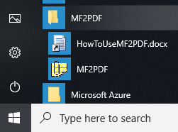

When the app starts the screen will show a table of parameters for existing Jobs. You will need to update the inFileName and outFileName paths as needed for the current year set of logs. Adding new rows is possible at the bottom of the screen, or just update an existing row if that works for you.

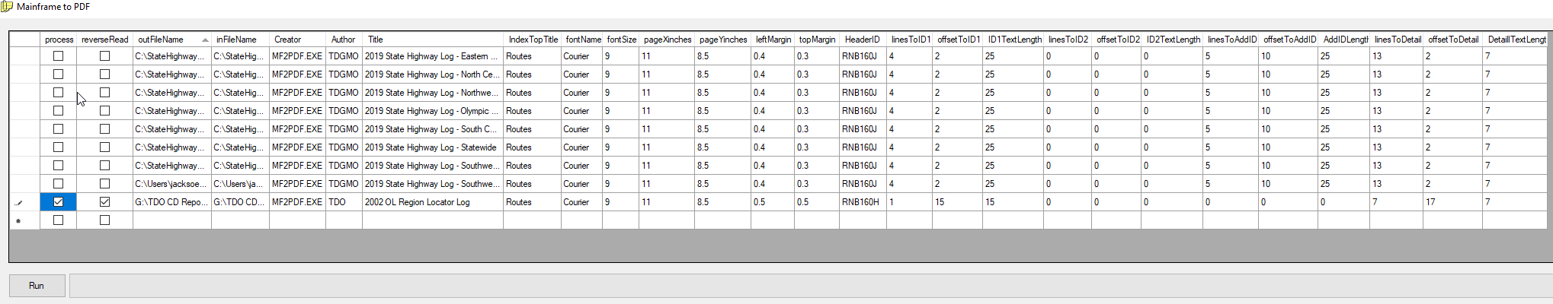

## Setting the Parameters

MF2PDF uses a number of parameters to process each mainframe text file.

**Process**: Create PDF for this row when “Run” is clicked.

**reverseRead**: Used for Locator log. Causes mf2pdf to read the file from the bottom up.

**outFileName**: Output file location and name, ends with .pdf.

**inFileName**: Input text file downloaded from the the mainframe

**Creator**: always MF2PDF.EXE

**Author**: varies, most recently our group is called TDGMO

**Title**: Appropriate title. This column must be unique

**IndexTopTitle**: Name to use for Bookmark groups in PDF. Normally “Routes”.

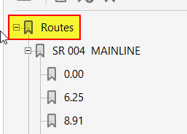

**fontName**: Courier

**fontSize**: 9

**pageXinches**: 11

**pageYinches** 8.5

**leftMargin**: .5

**topMargin**: .5

**HeaderID**: Depends on the report, RNB160J for Highway Log, RNB160H for Locator Log.



linesToID1 through DetailTextLength: See annotated screen capture below for State Highway Log settings.

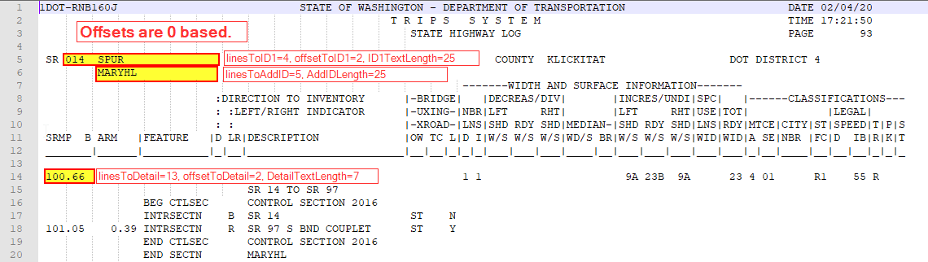

**linesToID1** through **DetailTextLength**: See annotated screen capture below for State Locator Log settings. Remember this log is designed to be read from the bottom of the page up.

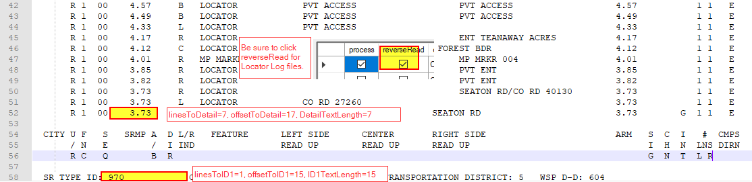

**linesToID2:** ID2 can be used to nest bookmarks below ID1. In the case of the PTR report there are several possible directional breaks for each site. These are identified on the same line as the site ID, see below:

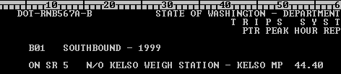

Nest a bookmark on the directional change.

The result would be as below, nested bookmarks below the site ID.

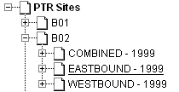

**OffsetToID2:** Number of positions over from left side.

**ID2textLength:** Length of additional identifier.

**ID2TextLength:** Length of ID2 text.

**Lines2Detail:** To create further nested bookmarks at the detail level (often the milepost at the beginning of each page) use Lines2Detail. This would be the lines from HeaderID to first detail row. HR VOL for PTR, example below.

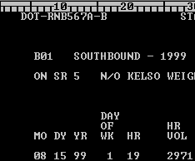

Detail for the PTR report is the HR VOL column, first row. IT is down 14 lines from HeaderID, over 23 from left, length 7.

**Offset2Detail:** Number of positions over from left side to detail.

**DetailTextLength:** Length of detail item to capture for the bookmark text.