# **Mainframe Report to PDF Converter**

## Glossary

* addID: Used in the conversion of state highway log to define the modifier for the state route ID name such as KELSO, COUPLET etc. in the bookmarks.
* addIDLength: Used in the conversion of state highway log to define the length of the addID.
* Author: Author of the PDF, used in PDF metadata.
* Creator: Creator of the PDF, used in the PDF metadata.
* detailText: The SRMP milepost used under in the addID (SRID) bookmark.
* detailTextLength: The length of the SRMP milepost value.
* fontName: The font used in the PDF.
* fontSize: The size of the PDF Font.
* headerID: The term used to define the start of a new page (ex. RNB160J)
* IDText: The SRID (005, 101, etc.) used in the bookmarks.
* IDTextLength: The length of the IDText.
* indexTopTitle: Title of the first-level bookmark, usually “Routes”
* leftMargin: The left margin width used in the PDF.
* linesToAddID: Number of lines from the top of the page to the addID, on each page that the addID occurs on.
* linesToDetail: Number of lines from the top of the page to the detailText, on each page that the detailText occurs on.
* linesToID: Number of lines from the top of the page to the IDText, on each page that the IDText occurs on.
* offsetToAddID: Number of characters that precede the addID on the line where the addID occurs.
* offsetToDetail: Number of characters that precede the detailText on the line where the detailText occurs.
* offsetToID: Number of characters that precede the idText on the line where the idText occurs.
* pageXinches: Width of the PDF pages in inches.
* pageYinches: Height of the PDF pages in inches.
* topMargin: The top margin width used in the PDF.

## Introduction

The Mainframe to PDF converter creates bookmarked PDF reports using either Locator Log or State Highway Log mainframe reports. It creates bookmarks based on a set of predefined parameters to make navigation of the output report simple.

## Installation

Copy Mainframe to PDF Converter folder to user’s C: drive and create a shortcut to the Mainframe to PDF converter.exe file.

## Start MF2PDF

When the app starts the screen will show an empty window with five buttons: 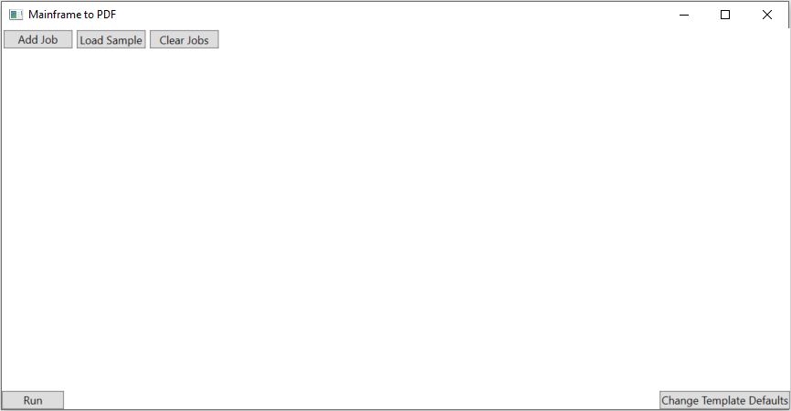

First, click the “Change Template Defaults” button to review the default parameters used in the app (see glossary above). 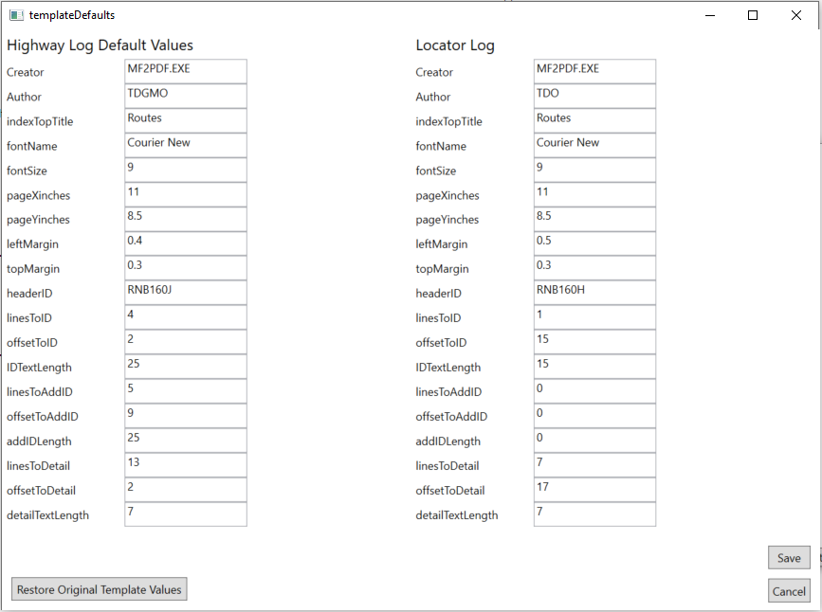

This menu should be the first troubleshooting step in a circumstance where the formatting of a PDF created by the application doesn’t match the user’s expectations. These values can be restored to their initial state at any time using the “Restore Original Template Defaults” button. The following illustrations depict the formatting changes defined by each value and how to assign them. Let’s see how offset, length, and lines are used to identify the text used to define bookmarks in the document, using the State Highway Log mainframe report as an example.

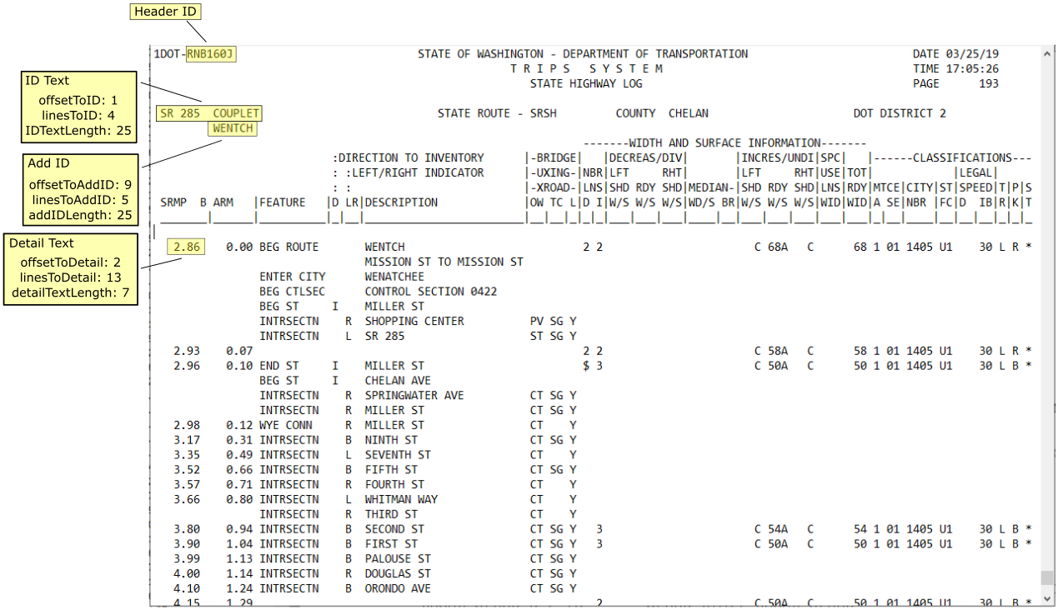

* HeaderID: The header ID is the text block that, when identified on a line in the mainframe report, triggers the beginning of a new page.
* ID Text:
  + linesToID: The ID text in this report occurs on the fifth line from the top of the page (the line where the HeaderID is found). This value is given as a 0-based index value in the default parameters, so the index of 4.
  + offsetToID: The ID text in this report begins at the second character on the fifth line of this document. This value is given as a 0-based index value in the default parameters, so the index of 1.
  + IDTextLength: The ID text in this example (SR 285 COUPLET) is only 15 characters long, however there might be longer ID’s in the document. To account for this variability, a value larger than that is used, and the term that is found with that length is trimmed of any leading or trailing white space by the program.
* Add ID:
  + linesToAddID: The Add ID for this ID occurs on the sixth line from the top of the page (the line where the HeaderID is found). This value is given as a 0-based index value in the default parameters, so the index of 5.
  + offsetToAddID: The Add ID for this ID begins at the tenth character on the fifth line of this document. This value is given as a 0-based index value in the default parameters, so the index of 9.
  + addIDTextLength: : The Add ID for this ID (WENTCH) is only 6 characters long, however there might be longer ID’s in the document. To account for this variability, a value larger than that is used, and the term that is found with that length is trimmed of any leading or trailing white space by the program.
* Detail:
  + linesToDetail: The detail on this page occurs on the sixth line from the top of the page (the line where the HeaderID is found). This value is given as a 0-based index value in the default parameters, so the index of 5.
  + offsetToDetail: The Add ID in this report begins at the tenth character on the fifth line of this document. This value is given as a 0-based index value in the default parameters, so the index of 9.
  + detailTextLength: The Add ID in this example (WENTCH) is only 6 characters long, however there might be longer ID’s in the document. To account for this variability, a value larger than that is used, and the term that is found with that length is trimmed of any leading or trailing white space by the program.

**HeaderID**: Depends on the report, RNB160J for Highway Log, RNB160H for Locator Log.



linesToID1 through DetailTextLength: See annotated screen capture below for State Highway Log settings.

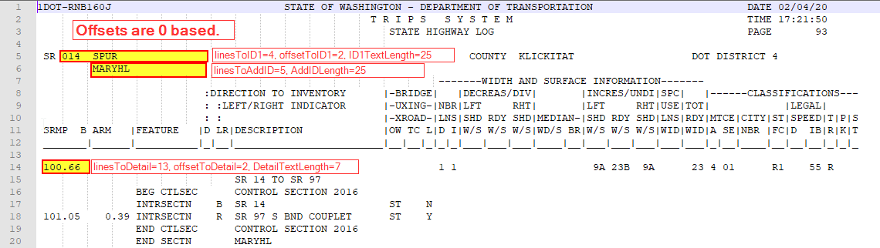

**linesToID1** through **DetailTextLength**: See annotated screen capture below for State Locator Log settings. Remember this log is designed to be read from the bottom of the page up.

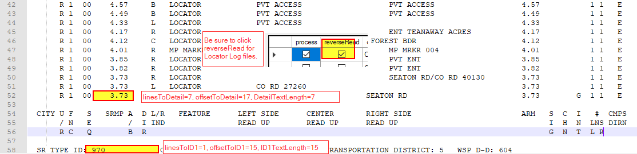

**linesToID2:** ID2 can be used to nest bookmarks below ID1. In the case of the PTR report there are several possible directional breaks for each site. These are identified on the same line as the site ID, see below:

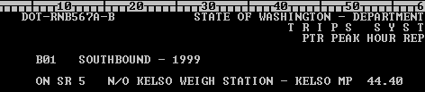

Nest a bookmark on the directional change.

The result would be as below, nested bookmarks below the site ID.

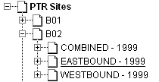

**OffsetToID2:** Number of positions over from left side.

**ID2textLength:** Length of additional identifier.

**ID2TextLength:** Length of ID2 text.

**Lines2Detail:** To create further nested bookmarks at the detail level (often the milepost at the beginning of each page) use Lines2Detail. This would be the lines from HeaderID to first detail row. HR VOL for PTR, example below.

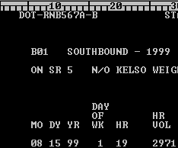

Detail for the PTR report is the HR VOL column, first row. IT is down 14 lines from HeaderID, over 23 from left, length 7.

**Offset2Detail:** Number of positions over from left side to detail.

**DetailTextLength:** Length of detail item to capture for the bookmark text.