# Code

/******************************************************************************************************************

Week 4 iLab Assignment

Developed By: Brian Whitelaw

Prepared For: Prof. Michael Brown

DeVry University Online

Program Name: Quick Fast Car Care

Nature and Necessity: The owner of Quick Fast Car Care wants to enhance customer experience. This application

should be created to streamline the process for customers by calculating services offered. The application

needs to calculate the cost of an oil change, car wash, or both.

******************************************************************************************************************/

// Import libraries

**import** javax.swing.*;

**import** java.awt.event.*;

**import** java.text.DecimalFormat;

**public** **class** CarCare **extends** JFrame **implements** ActionListener

{

// Set main

**public** **static** **void** main(String[] args)

{

// Create application window at 333 pixels^2

// Call CarCare method

CarCare cc = **new** CarCare();

cc.setTitle("Quick Fast Car Care");

cc.setSize(333,333);

cc.setVisible(**true**);

} // End of main

// Declare variables

Double cost = 0.00;

String oil;

String wash;

// Set format of decimal format

DecimalFormat df = **new** DecimalFormat("$#,###.00");

// Call objects

JMenuBar jmb = **new** JMenuBar();

JMenu oilMenu = **new** JMenu("Oil Change"); // Cannot simply be oil to avoid duplication of variables

JMenu washMenu = **new** JMenu("Car Wash"); // Cannot simply be wash to avoid duplication of variables

JMenu tot = **new** JMenu("Total/Clear/Exit");

// Set menu items for menus

JMenuItem bronze = **new** JMenuItem("Bronze");

JMenuItem silver = **new** JMenuItem("Silver");

JMenuItem gold = **new** JMenuItem("Gold");

JMenuItem basic = **new** JMenuItem("Basic");

JMenuItem better = **new** JMenuItem("Better");

JMenuItem best = **new** JMenuItem("Best");

JMenuItem totItems = **new** JMenuItem("Totals");

JMenuItem clrItem = **new** JMenuItem("Clear");

JMenuItem exitItem = **new** JMenuItem("Exit");

// Create Window and add objects

**public** CarCare ()

{

**this**.setJMenuBar(jmb);

jmb.add(oilMenu);

jmb.add(washMenu);

jmb.add(tot);

// Add options to oil change button

oilMenu.add(bronze);

oilMenu.add(silver);

oilMenu.add(gold);

// Add options to wash button

washMenu.add(basic);

washMenu.add(better);

washMenu.add(best);

// Add options to totals button

tot.add(totItems);

tot.add(clrItem);

tot.add(exitItem);

// Implement listeners for oil options

bronze.addActionListener(**this**);

silver.addActionListener(**this**);

gold.addActionListener(**this**);

// Implement listeners for wash options

basic.addActionListener(**this**);

better.addActionListener(**this**);

best.addActionListener(**this**);

// Implement listeners for totals button

totItems.addActionListener(**this**);

clrItem.addActionListener(**this**);

exitItem.addActionListener(**this**);

// All listeners reference "this" particular instance of occurence

} // End of method

// Implement response to Action Event

**public** **void** actionPerformed(ActionEvent e)

{

// if else statements to make decisions with accumulators

// Set oil package to bronze with cost of $20

**if** (e.getSource() == bronze)

{

cost += 20;

oil = "Bronze";

}

// Set oil package to silver with cost of $25

**else** **if** (e.getSource() == silver)

{

cost += 25;

oil = "Silver";

}

// Set oil package to gold with cost of $30

**else** **if** (e.getSource() == gold)

{

cost += 30;

oil = "Gold";

}

// Set wash package to basic with cost of $5

**else** **if** (e.getSource() == basic)

{

cost += 5;

wash = "Basic";

}

// Set wash package to better with cost of $10

**else** **if** (e.getSource() == better)

{

cost += 10;

wash = "Better";

}

// Set wash package to better with cost of $15

**else** **if** (e.getSource() == best)

{

cost += 15;

wash = "Best";

}

// Display totals

**else** **if** (e.getSource() == totItems)

{

JOptionPane.*showMessageDialog*(**null**, "Oil Change: " + oil + "\nCar Wash: " + wash + "\nTotal Cost: " + df.format(cost), "Your Options and Total", JOptionPane.***INFORMATION_MESSAGE***);

}

// Clears an item

**else** **if** (e.getSource() == clrItem)

{

cost = 0.00; // Sets cost to zero

oil = ""; // Sets oil package to selection

wash = ""; // Sets wash package to selection

}

// Allows for exit

**else** **if** (e.getSource() == exitItem)

{

System.*exit*(0);

}

} // End of action event

} // End of class

# Screenshots – Windows have been resized on this document to conserve space.

Selected Bronze, Better, and Total. The total should be $30.

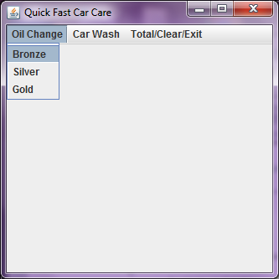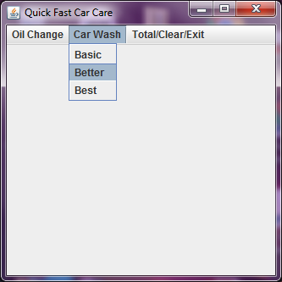 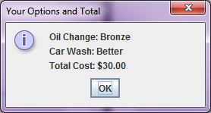

Selected Gold, Best, and Total without clearing previous entries or closing window. Result should be $75.

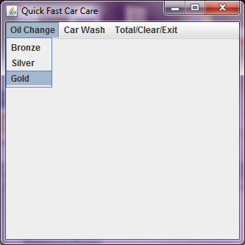 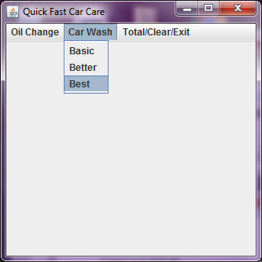

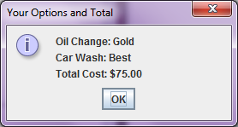

Again, I selected Gold and Best but this time I hit “Clear” first. Total amount should be $45.

