/******************************************************************************

CIS_355A_Week6_iLab

Developed By: Brian Whitelaw

Prepared For: Professor Michael Brown

DeVry University Online

Program Name: Java Pizza

Nature and Necessity: Use JTabbedPane for an application that allows users to

place an order for pizza. There should be four tabs total that include

an order summary page that displays all information relevant to that order.

**************************************************************************** */

// Import Libraries

**import** javax.swing.JFrame;

**public** **class** JavaPizza

{

**public** **static** **void** main(String[] args)

{

Tab tab = **new** Tab();

tab.setDefaultCloseOperation(JFrame.***EXIT_ON_CLOSE***);

} // End of main

} // End of class

// Import Libraries

**import** java.awt.event.*;

**import** javax.swing.*;

**import** java.text.DecimalFormat;

**public** **class** Tab **extends** JFrame **implements** ActionListener

{

// Create text fields

JTextField tName = **new** JTextField(13);

JTextField tPhone = **new** JTextField(13);

JTextField tTotal = **new** JTextField(13);

// Create buttons

JRadioButton jrbs = **new** JRadioButton("Small");

JRadioButton jrbm = **new** JRadioButton("Medium");

JRadioButton jrbl = **new** JRadioButton("Large");

JButton jb1 = **new** JButton("Order Summary");

// Create checkbox

JCheckBox tops [] = **new** JCheckBox[12];

**public** Tab()

{

// Call super

**super**("Java Pizza");

// Build panels

JTabbedPane tab = **new** JTabbedPane();

// Set tab title for first tab

JLabel lbl1 = **new** JLabel("Welcome to Java Pizza", SwingConstants.***CENTER***);

// First panel

JPanel p1 = **new** JPanel();

p1.add(lbl1);

p1.add(**new** JLabel("Please Enter Your Name"));

p1.add(tName);

p1.add(**new** JLabel("Please Enter Your Phone Number"));

p1.add(tPhone);

tab.addTab("Customer", **null**, p1, "Customer Information");

// Set tab title for second tab

JLabel lbl2 = **new** JLabel("What Size Would You Like?", SwingConstants.***CENTER***);

// Second panel

JPanel p2 = **new** JPanel();

p2.add(lbl2);

p2.add(jrbs);

p2.add(jrbm);

p2.add(jrbl);

tab.addTab("Size", **null**, p2, "What Size?");

// Set tab title for third tab

JLabel lbl3 = **new** JLabel("What Toppings Would You Like?", SwingConstants.***CENTER***);

// Third panel

JPanel p3 = **new** JPanel();

p3.add(lbl3);

// for loop to process toppings array

**for** (**int** i = 0; i<12; i++)

{

tops[i] = **new** JCheckBox();

p3.add(tops[i]);

} // End for

tab.addTab("Toppings", **null**, p3, "What Toppings Would You Like?");

// List of toppings available

tops[0].setText("Pepperoni");

tops[1].setText("Sausage");

tops[2].setText("Canadian Bacon");

tops[3].setText("Breakfast Bacon");

tops[4].setText("Hamburger");

tops[5].setText("Mushrooms");

tops[6].setText("Black Olives");

tops[7].setText("Onions");

tops[8].setText("Pineapple");

tops[9].setText("Extra Cheese");

tops[10].setText("Extra Sauce");

tops[11].setText("Anchovies");

// Set tab title for fourth tab

JLabel lbl4 = **new** JLabel ("Total Amount Due", SwingConstants.***CENTER***);

// Fourth panel

JPanel p4 = **new** JPanel();

p4.add(lbl4);

p4.add(tTotal);

p4.add(jb1);

tab.addTab("Total", **null**, p4, "Amount Due: ");

// Implememt JTabbedPane

getContentPane().add(tab);

setSize(213,333);

setVisible(**true**);

jb1.addActionListener(**this**);

}

// Add ActionEvent

**public** **void** actionPerformed(ActionEvent e)

{

// Declare variables

String name = "";

String phone = "";

String size = "";

String toppings = "";

Double total = 0.00;

// Set Decimal Format

DecimalFormat df = **new** DecimalFormat("$00.00");

// Gather Inputs

name = tName.getText();

phone = tPhone.getText();

// if else statement to process size selections

**if** (jrbs.isSelected())

{

size = "Small";

total += 8;

}

**else** **if** (jrbm.isSelected())

{

size = "Medium";

total += 10;

}

**else**

{

size = "Large";

total += 12;

}

// Accumulator for topping selection using a for loop

**for** (**int** i = 0; i<12; i++)

{

**if** (tops[i].isSelected())

{

total += 2;

toppings += tops[i].getText();

toppings += "";

} // End if

} // End for

// Get totals

tTotal.setText(String.*valueOf*(df.format(total)));

OrderSummary ords = **new** OrderSummary(name, phone, size, toppings, total);

} // End actionEvent

**public** **class** OrderSummary **extends** JFrame

{

**public** OrderSummary(String n, String p, String s, String t, **double** total){

**super**("Order Summary");

// Set Decimal Format

DecimalFormat df = **new** DecimalFormat("$00.00");

// Set panel

JPanel p1 = **new** JPanel();

**this**.add(p1);

JTextArea jta = **new** JTextArea(13,27);

p1.add(jta);

jta.setText("Customer Name: " + n + "\nPhone Number: " + p + "\nSize Ordered: " + s + "\nToppings Desired: " + t + "\nAmount Due: " + (df.format(total)));

setSize(423,333);

setVisible(**true**);

}

} // End of class

} // End of class

# Screenshots

I selected 3 toppings at $2 each, and a large pizza at $12. Total should be $18.00

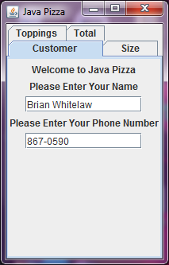 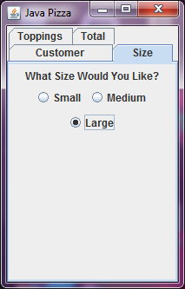 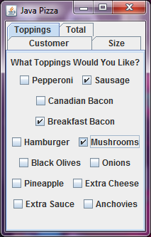 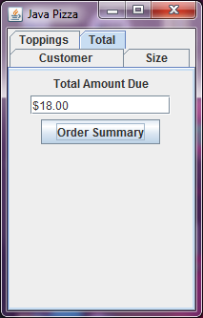

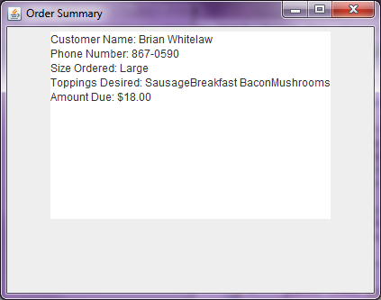

Here I selected 1 topping for $2, and did not select a pizza size (should default to large at $12). Total should be $14.

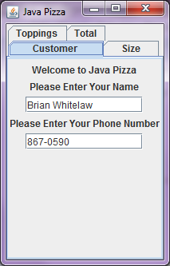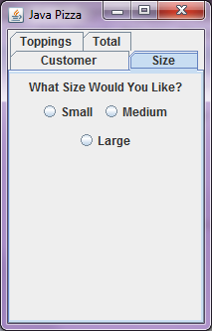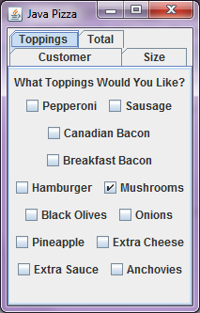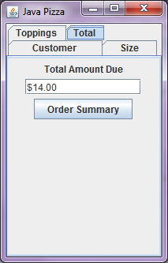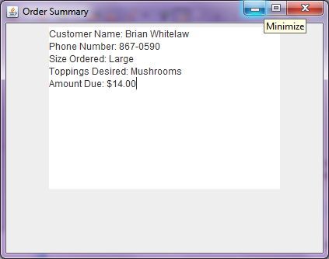

In this case, I chose a small pizza at $8 with two toppings at $2 each. Total should be $12.

