**Goal: Find a relationship between DATA and PRICE**

1. Subjective Judgement of factors
2. Use Regression Model to prove correlations between data

**Focus on Technology Sector:**

Companies showing strong correlation (R > 0.7):

1. MSFT
2. **NVDA**
3. CSCO
4. ORCL
5. CRM
6. **GOOG**
7. AMZN
8. FB
9. NFLX

**Use Macro factors to see the big picture:**

1. Price of crude oil:

After plotting the 1 / Opening Price of Crude Oil against the Opening Price of S&P 500 on the period 1/3 to 2/25, I realized that the Price of crude oil is inversely related to the price of the S&P 500. With R = 0.7841, a relatively strong correlation.

1. Interest Rates

Higher interest rates tend to negatively affect earnings and stock prices

1. Inflation

Value stocks perform better in high inflation periods and growth stocks perform better when inflation is low. Stocks tend to be more **volatile** when inflation is elevated.

1. Unemployment rate

A rise in unemployment typically signals a **decline in interest rates**, which is good news for stocks, as well as a decline in future corporate earnings and dividends, which is bad news for stocks theoretically. In the graph below, we can see that **S&P 500** is most likely **inversely related to the unemployment rate.**

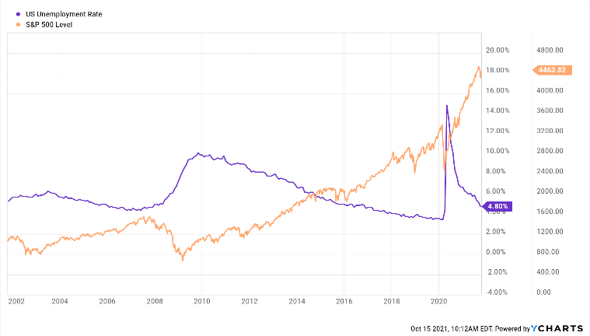

**Use Financial Factors to see correlation:**

1. P/E Ratio:

Using yesterday’s P/E ratio to predict today’s stock price.

However, need to take more data from other companies to further reinforce such correlation.

One interesting finding is that the P/E ratio and stock price have a higher correlation when the company’s stock price has a higher correlation with S&P 500.

NVDA:

GOOG: