<https://www.sciencedirect.com/science/article/pii/S1877050911005035>

<https://www.hvst.com/posts/r-squared-to-measure-a-stocks-performance-pattern-with-the-s-p-500-index-XD9TApYG>

<https://www.zoonova.com/>

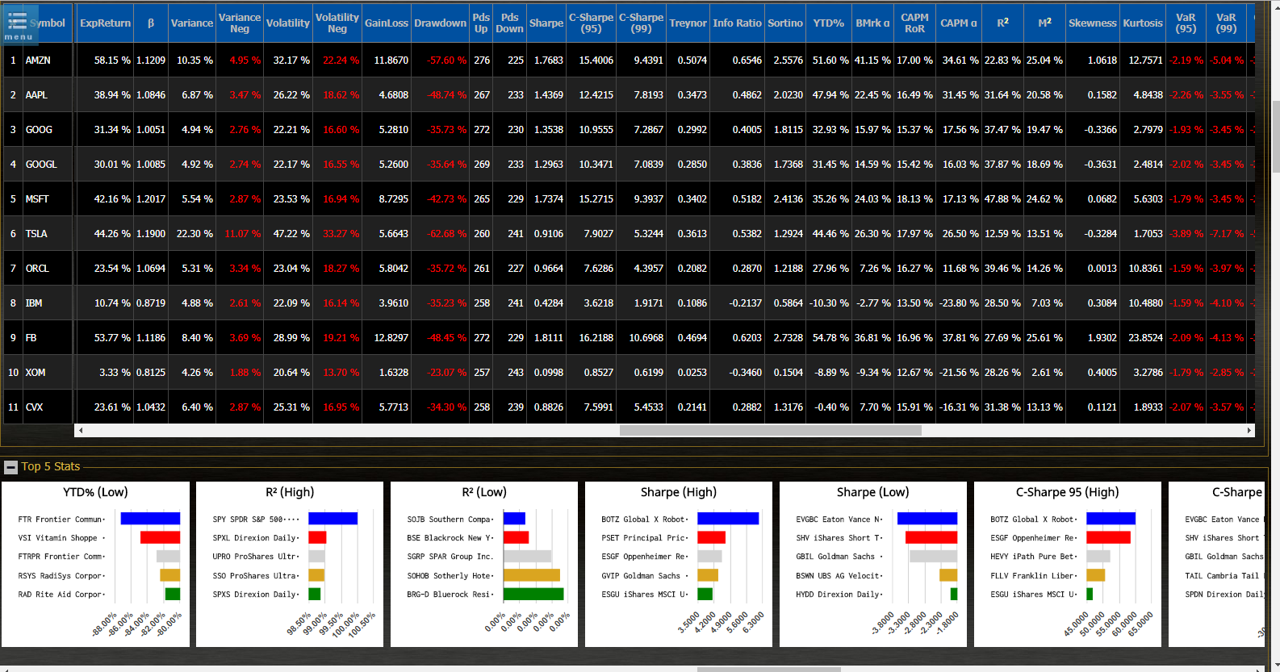

GOOG

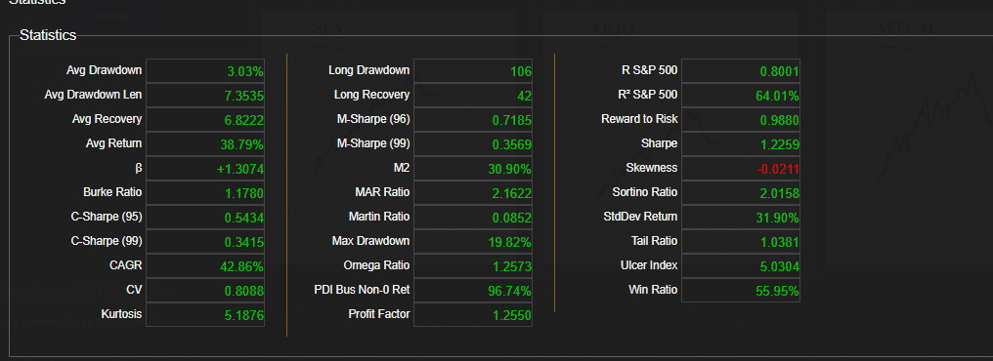

AAPL

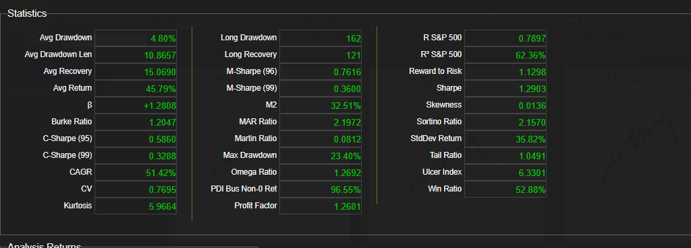

MA

