Correlation Coefficient: possibly valuable to check to which extent a stock is correlated with the s&p 500

Basically linear regression w the s&p 500

<https://www.investopedia.com/ask/answers/051315/how-can-i-use-correlation-coefficient-predict-returns-stock-market.asp>

We could check the correlation coefficient between the stock and s&p 500 to make our prediction

Example:

Google vs s&p 500

correlation coefficient = 0.81

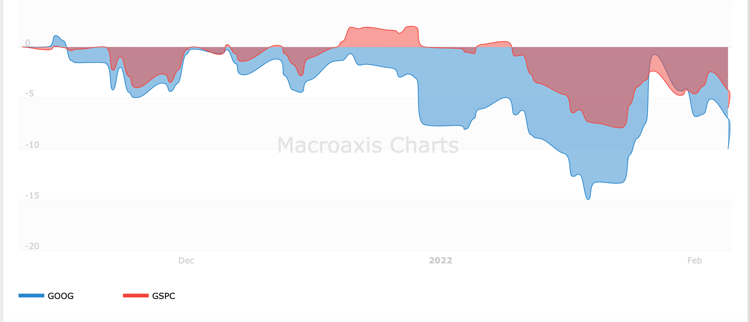

<https://www.macroaxis.com/invest/pair-correlation/GOOG/%5EGSPC/Alphabet-vs-SP-500>

Example:

Facebook

<https://www.macroaxis.com/invest/market/%5EGSPC--compareProfile--FB>

Correlation coefficient 0.72

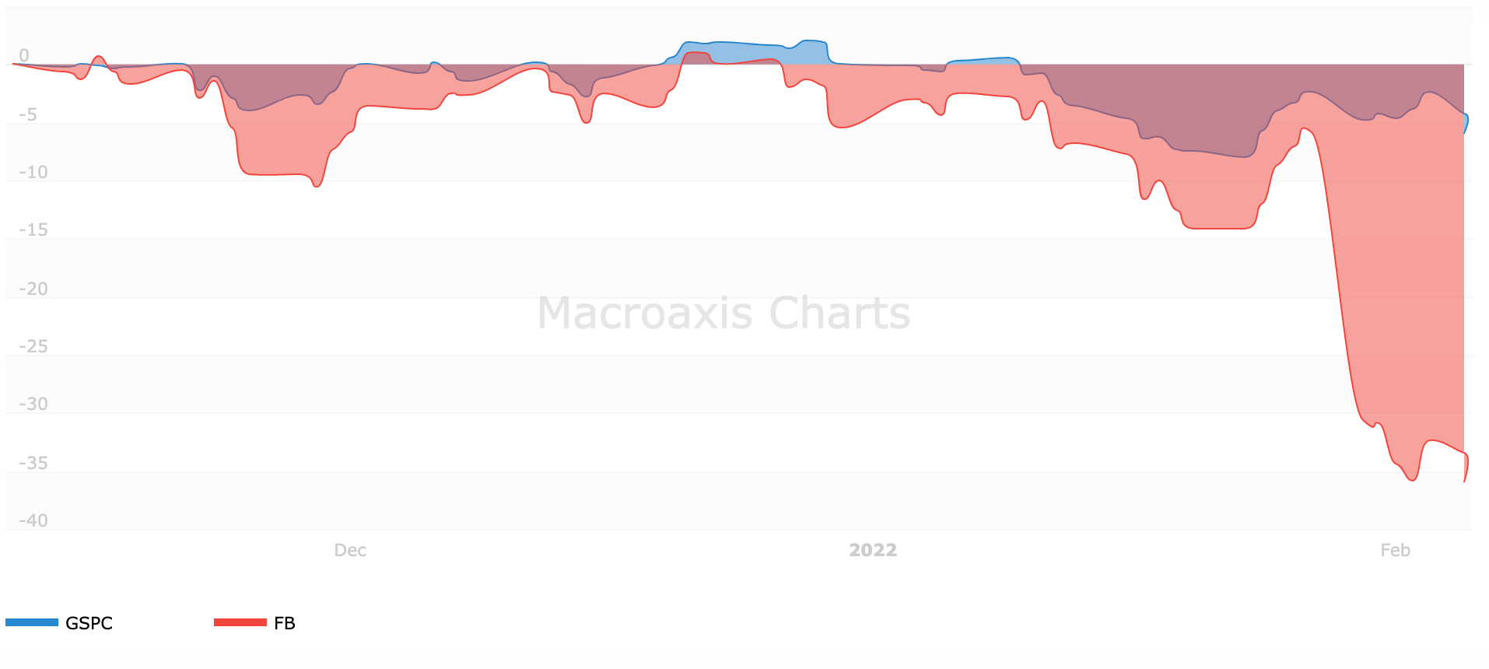

Apple and s&p 500 have a very weak correlation so maybe not so reliable

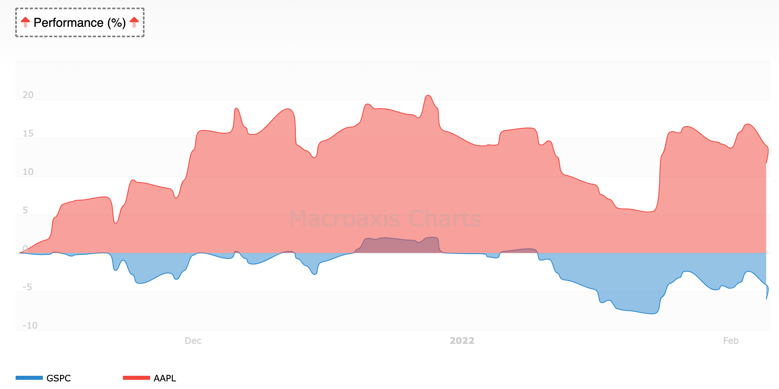

<https://www.macroaxis.com/invest/market/%5EGSPC--compareProfile--AAPL>

CPI PPI and S&P500

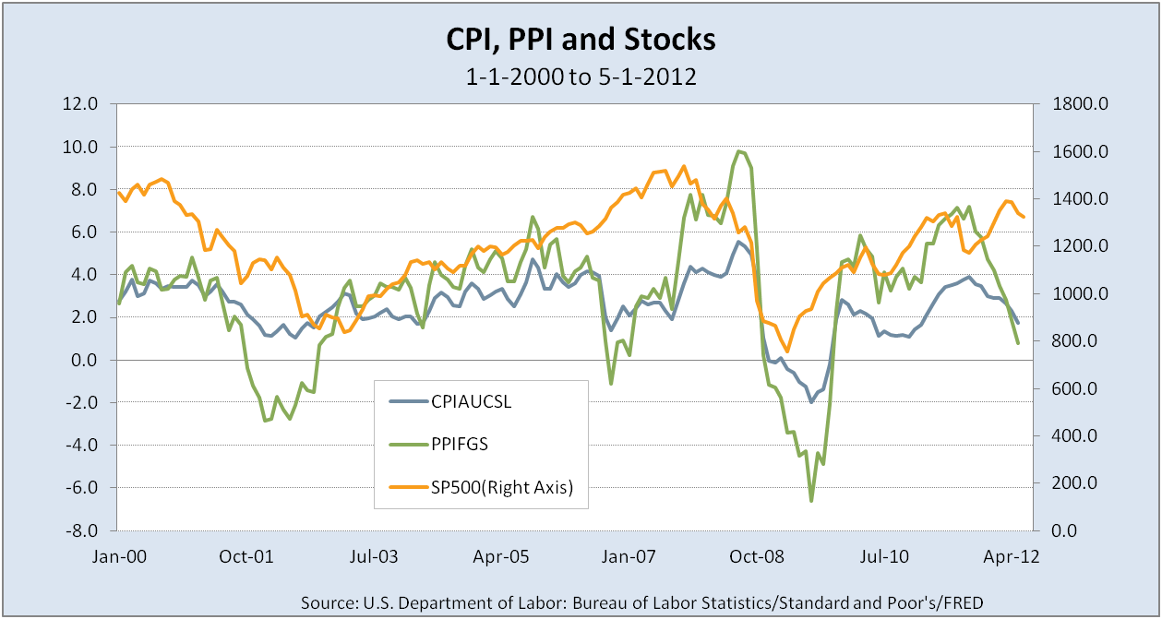

CPI & PPI have very strong correlation, correlation coefficient around 0.86

<https://www.forbes.com/sites/mikepatton/2012/07/16/consumer-prices-producer-prices-and-stock-performance-a-unique-perspective/>

Inflation rate is normally very negatively correlated with the stock market

Except for certain cases, easily calculated with cpi

<https://www.up.ac.za/media/shared/61/WP/wp_2016_05.zp77509.pdf>

Basically no correlation w the housing market

<http://smiller.faculty.unlv.edu/REAL_ESTATE_STOCK_MARKETS_WAVLETS.pdf>