Carpio, Briane A. Progcon

TM/HRO – 191 October 11, 2019

A1. FLOW CHARTS AND PSEUDCODES

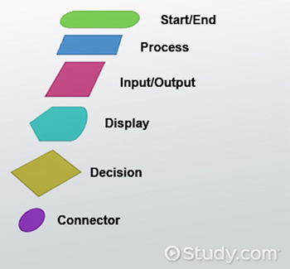 What is a flowchart in Programming?

A flowchart is a type of diagram that represents an algorithm, workflow or process. The flowchart shows the steps as boxes of various kinds, and their order by connecting the boxes with arrows. This diagrammatic representation illustrates a solution model to a given problem. Flowcharts are used in analyzing, designing, documenting or managing a process or program in various fields.

Flowcharts display the steps in code as shapes connected together with arrows. The main goal is to create a rough draft of a solution to a coding problem. The type of shapes seen in the flowchart depends on what statements the programmer wants to create.

Importance of flowchart in Programming.

flowcharts are a useful tool in visualizing a module's flow of execution before writing any code. This allows developers to do three things: verify the algorithm's correctness before writing code, visualize how the code will ultimately be written, and communicate and document the algorithm with other developers and even non-developers. Flowcharts may be used in conjunction with other tools, such as pseudo-code, or may be used by itself to communicate a module's ultimate design, depending on the level of detail of the flowchart. Flow charts are an important tool for the improvement of processes. By providing a graphical representation, they help project teams to identify the different elements of a process and understand the interrelationships among the various steps. Flow charts may also be used to gather information and data about a process as an aid to decision making or performance evaluation.

What is Pseudocode?

Pseudocode (pronounced SOO-doh-kohd) is a detailed yet readable description of what a computer program or algorithm must do, expressed in a formally-styled natural language rather than in a programming language. Pseudocode is sometimes used as a detailed step in the process of developing a program. It allows designers or lead programmers to express the design in great detail and provides programmers a detailed [template](https://whatis.techtarget.com/definition/template) for the next step of writing code in a specific programming language.

<https://en.wikibooks.org/wiki/Programming_Fundamentals/Flowcharts>

<https://www.inc.com/encyclopedia/flow-charts.html>

<https://www.google.com/search?q=flowchart+symbols+in+programming&rlz=1C1CHBF_enPH866PH866&sxsrf=ACYBGNQ5TLPe9RJJb6icU8-DCa3hktPwaA:1570858305054&source=lnms&tbm=isch&sa=X&ved=0ahUKEwjUl4-a_5XlAhUNHXAKHZBxBW8Q_AUIEigB&biw=1920&bih=969#imgrc=2CahOZ-Fv3VY7M:>