Briane A. Carpio Progcon

TM/HRO-191 Activity #4

Flowgorithm Exercies Discussion

M1.

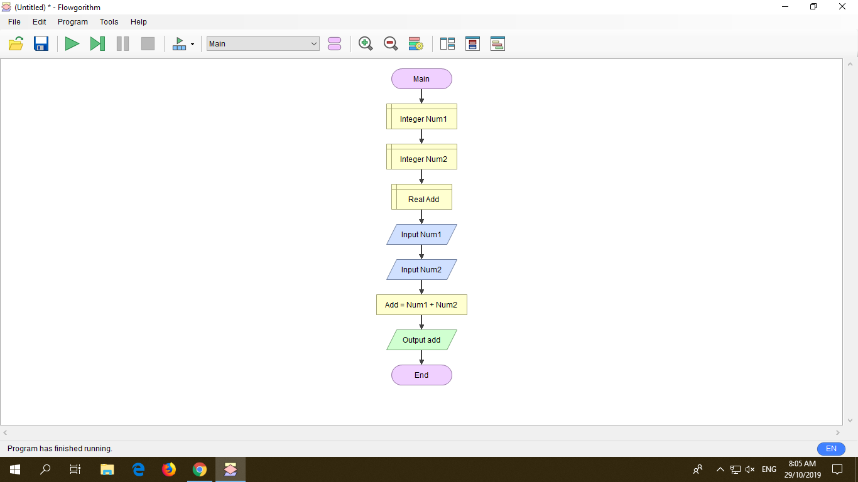

Discussion: In doing my flowchart by adding two numbers, I first put declare to give the integer Number 1 and Number 2, next is I put the Real add then put the input Number 1 and Number 2. And add the sum Number 1 and Num 2 and output and after you get the answer, it will end.

M2.

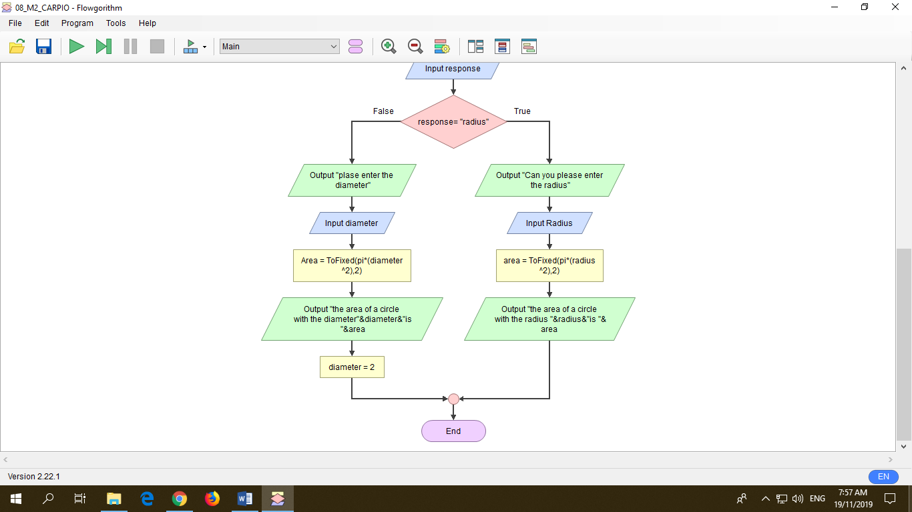

Discussion: In solving the area of a circle using Radius and Diameter, First I insert declare and Real Radius, Real Variable, Real Diameter, and Real Answer. After that I Insert declare and put String Response and String yes. Next is insert Output and ask if “do you have a value of radius and diameter?” and after that insert Input Response. And next is create a decision if it is true or if it is false. If it is false you will have to use the diameter and if it is true you have to use Radius and you will go into some progress and you will be getting the output, and that will be the end.