Today at Canyons

The Dining-Room Group

6/22/2018

## This morning

gf_point(Height ~ Age, data = NHANES, color = ~ Gender)

## Warning: Removed 353 rows containing missing values (geom_point).

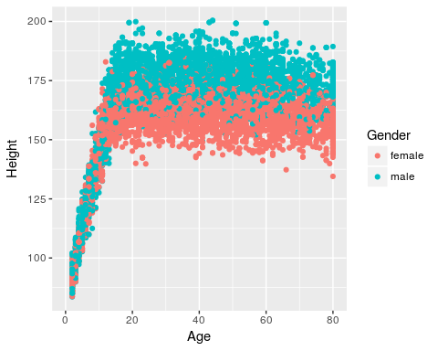

We started at 9am by telling people to go to the [workshop schedule](http://statprep.org/Workshop) and solved

$$\int_{0}^{∞}{\frac{1}{x}}dx$$

The things we did …

1. The first thing
   * part A
   * part B
2. The second thing

## Ronald Fisher

He looks like this …

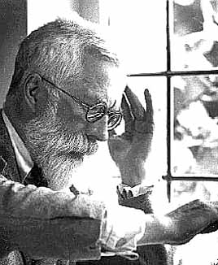

Fisher