Dedan Kimathi University of Technology

Quadrature Term Paper

Brian Manoti Okinyi

C026-01-1210/2016

Scientific Computing - ICS 2207

Mr. Daniel Kihuga

October 2, 2017

Integration

Numerical integration covers several different things, including numerical evaluation of integrals and solutions to ordinary differential equations. In this section, we will talk about numerical evaluation of the definite integrals which will refer to as quadrature.

For f : R ! R, definite integral over interval [a; b]

Z b

I(f) = f(x) dx

a

is defined by limit of Riemann sums

n

X

Rn = (xi+1 xi) f( i)

i=1

 Riemann integral exists provided integrand f is bounded and continuous almost everywhere

 Absolute condition number of integration with respect to perturbations in integrand is b a

 Integration is inherently well-conditioned because of its smoothing effect

**Numerical Quadrature**

* Quadrature rule is weighted sum of finite number of sample values of integrand function

 To obtain desired level of accuracy at low cost,

How should sample points be chosen?

How should their contributions be weighted?

 Computational work is measured by number of evaluations of integrand function required

**Adaptive quadrature**

A functions, *f(x)*, which is a real-valued function of a real variable, defined in a finite interval between *a* to *b* has an integral of this form:

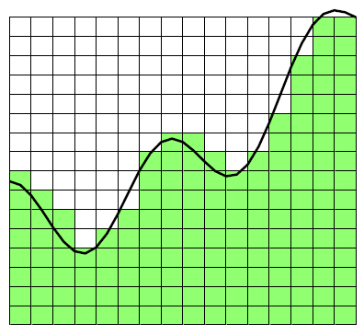Adaptive quadrature involves careful selection of the points where we sample values for f(x). The goal is evaluate the integral at as many points as it is possible, to gain better accuracy. A fundamental property of definite integral is that it is the basis for adaptive quadrature.





Basic Quadrature Rules



 

***Example:***



***Example: Quadrature Rules***

Example:  Exact solution = (1/3)*(1^3 – 0^3) = 1/3



= h*f(0.5) =

= h*0.5^2 = (1/4)

= 0.25



= h*(f(0)+f(1))/2

= h*(0+1)/2 = (1/2)

= 0.5



*Absolute error for M = (1/3-1/4) = (1/12) = 0.083333*

*Absolute error for T = (1/3-1/2) = (-1/6) = -0.166667*

In the previous example we had a smooth function, and the Midpoint method was twice as accurate as the Trapezoid method.

A new rule, called *Simpson’s Rule*, is usually more accurate than either one of the two and is defined as:

S = (2/3) M + (1/3) T with an additional point c given as: *c = (a+b)/2*.









Even better, take the midpoints *d = (a+c)/2* and *e = (c+b)/2* and apply the Simpson’s Rule to get a new rule called *Composite Quadrature Rule*.







This and the Simpson’s Rule are on the same interval, so we can find an estimate of the absolute error by subtracting these two.

MATLAB function *quad.* Other functions*:*  *quadtx* and *quadgui.*



**Specifying Integrals**

To specify an integral, first we need to define the function either by using the @ or a .m file.

Example: > f = @(x) 1./(1+x^2)

> Q = quadtx(f, 0, 1)

Example:

> f = @(x) sin(x)./x

> Q = quadtx(f, 0, pi)

The problem here is division by 0 at the x = 0. So we can get around this problem using:

> Q = quadtx(f, realmin, pi)

**Performance**

Let’s look at an example: 

The first evaluation when a = 0 and b = 1 using Extrapolated Simpson’s Rule.

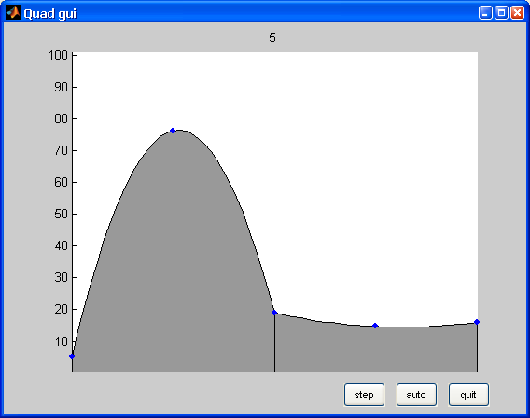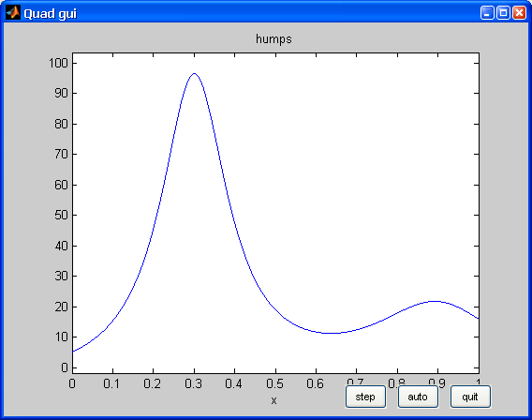

Actual plot of the function

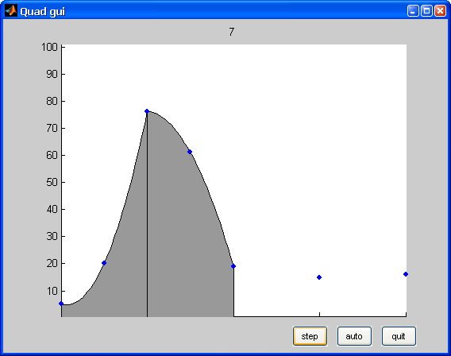**Steps**

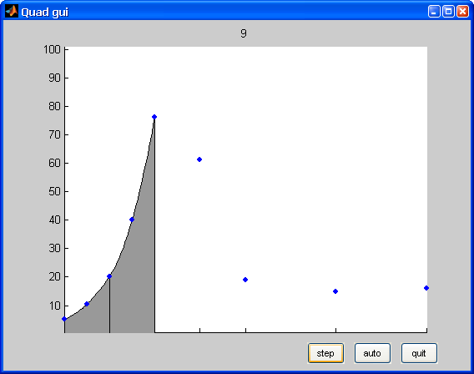

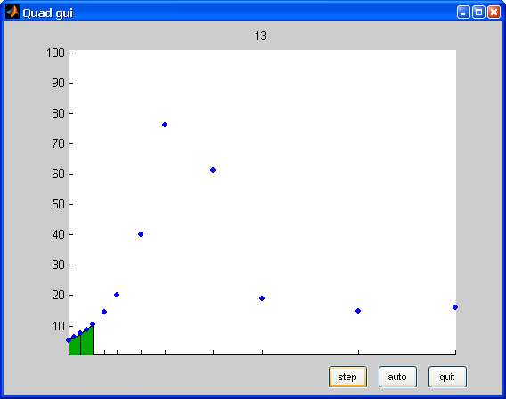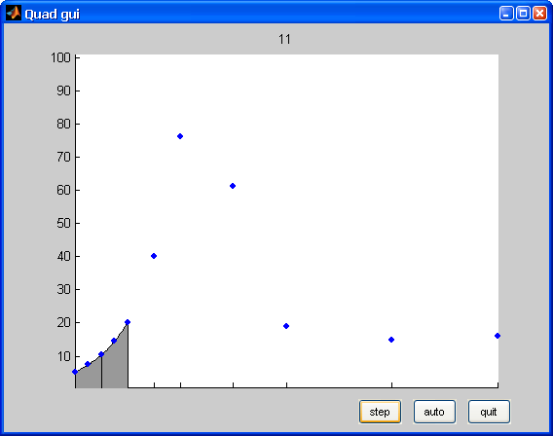

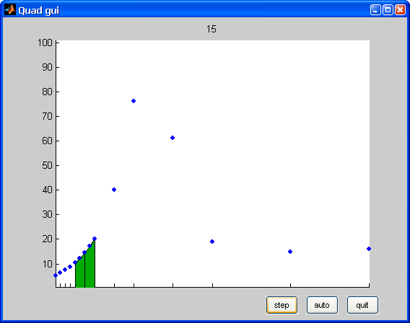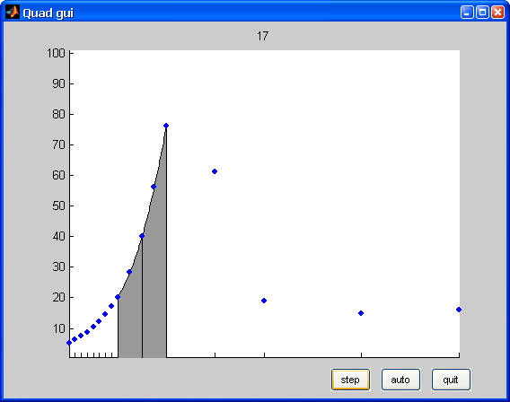

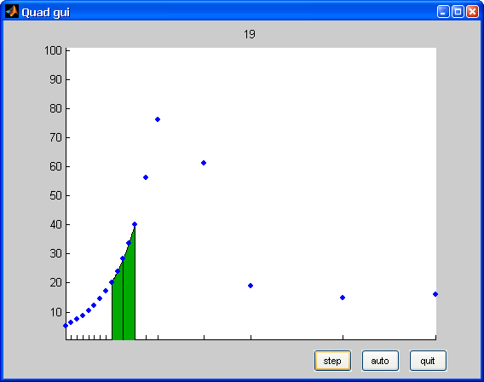

 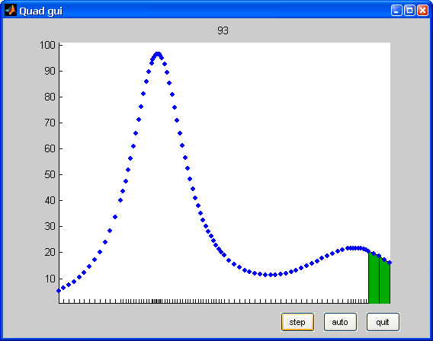

The effort required by the program to find an estimate of the integral within a specific accuracy can be measured by the number of times the integrand is evaluated.

The exact answer to the function in the previous example is:

*D = 5*atan(16/13)+10*pi-6*

*% This program tabulates the count and error.*

for k = 1:12

tol = 10^(-k);

[Q,fcount] = quadtx(@humps,0,1,tol);

err = Q - Qexact;

ratio = err/tol;

fprintf('%8.0e %21.14f %7d %13.3e %9.3f\n', ...

tol,Q,fcount,err,ratio)

end

**Integrating Discrete Data**

So far we have been concerned with computing an approximation to the definite integral of a specified function. We have assumed the existence of a MATLAB program that can evaluate the integrand at any point in a given interval.

However, in many situations, the function is only known at a finite set of points, say (*xk; yk*)*; k* = *1; …; n*. Assume the *x*'s are sorted in increasing order, with

*a* = *x*1 *< x*2 *< … < xn* = *b*

An integral of the form: can be evaluated.

Since it is not possible to evaluate *y* = *f*(*x*) at any other points, the adaptive methods we have described are not applicable.

The most obvious approach is to integrate the piecewise linear function that interpolates the data. This leads to the *composite trapezoid rule*.



where *hk* = *xk*+1 *- xk*. The trapezoid rule can be implemented with on eline of code:

>> T = sum(diff(x).*(y(1:end-1)+y(2:end))/2)