**Homework 1 Report 1**

Notice : Because writing two searches in the same program, so it should comment one and run the other to get the answer.

**Linear Search**

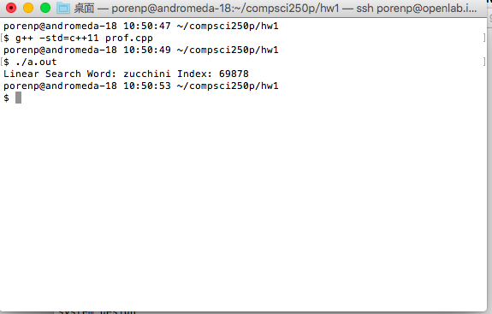

*Figure 1: The compile and execution of the linear search*

**Perf analysis**

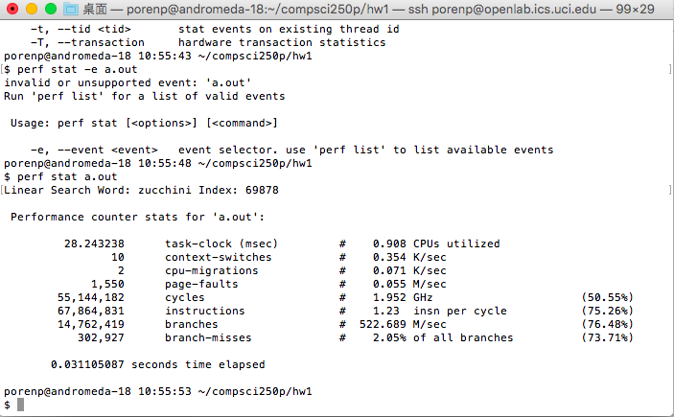

*Figure 2: The result of perf for linear search*

**Binary Search**

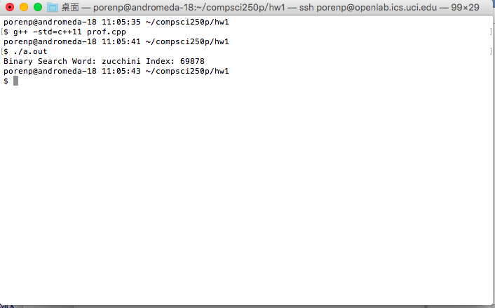

*Figure 3: The compile and execution of the binary search*

**Perf analysis**

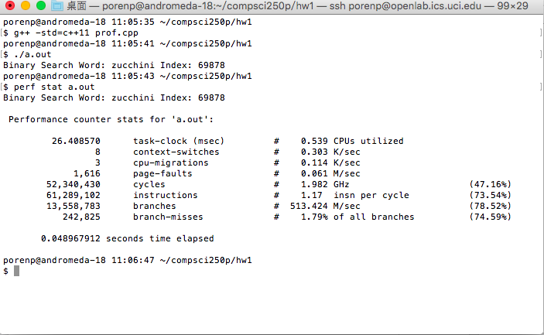

*Figure 4: The result of perf for binary search*

**Term explanation**

Use *Figure 4* as an example

* Context-Switches : In figure 4, there is 8 context switches and 0.303K/sec in binary search.

The term called context switches means the switches of the CPU from one process or thread to another. The context switches performs the following steps:

1. Suspend progression of current process/thread, store the state for that process/thread to the memory
2. Retrieve the context of next process/thread from the memory and store them to the register.
3. Return the location and resume the state of the next process/thread.

* Page Faults: In figure 4, it shows 1,616 page faults and 0.061M/sec in binary search.

The term called page faults means that when a program doesn’t find its’ data or instruction in virtual memory. Then, it should go to physical memory to fetch them.

* IPC(Instructions Per Cycle): The IPC for binary search is 1.17 which can be derived from instructions/cycles. The IPC highly relates the speed of execution. That’s because CPU has its’ own clock speed. We can take 4GHz CPU as an example. It runs 4*10^9 cycles per second. In other words, when IPC value raises, CPU can run more instructions in a second. Hence, the efficiency would be better than before.
* Branch Misses: The binary search has 242,825 branch misses. That is about 1.79% of all branches. Branch Misses will happen when CPU mispredict the next instruction to execute. The reason why CPU would predict the next instruction to execute is to make pipeline efficiently and speed up the execution.