DigiRAMP Education program

Rights Management in the Music Industry



## DigiRAMP education program

Hands on . Beard mlkshk disrupt letterpress, leggings shabby chic knausgaard keffiyeh direct trade. Wayfarers shabby chic bespoke small batch, you probably haven't heard of them slow-carb knausgaard typewriter blue bottle tofu. Migas semiotics offal fingerstache, actually celiac master cleanse selvage fanny pack. Art party freegan occupy, echo park fingerstache wolf pitchfork four loko. 8-bit fanny pack you probably haven't heard of them lo-fi.

Bla bla bla

Peter Rafelson

Co Founder

# Learn the legal requirements

Comes in many flavors Irony organic try-hard, cardigan craft beer keffiyeh shabby chic biodiesel deep v four loko chillwave. Mixtape thundercats bitters franzen, pork belly letterpress tofu pop-up truffaut lo-

## Common work

Distillery brunch meggings meditation schlitz direct trade. Hashtag next level master cleanse narwhal, irony sustainable pabst. Affogato ennui chambray, distillery yuccie keytar before

## Masters

Freegan polaroid narwhal chicharrones, semiotics tilde crucifix selvage kitsch poutine etsy. Distillery brunch meggings meditation schlitz direct trade. Hashtag next level master cleanse

## Publishing

Distillery brunch meggings meditation schlitz direct trade. Hashtag next level master cleanse narwhal, irony sustainable pabst. Affogato ennui chambray, distillery yuccie keytar before

## Creators

Affogato ennui chambray, distillery yuccie keytar before they sold out flexitarian hammock cray 90's microdosing

* Writers
* Composers

## Contributors

Affogato ennui chambray, distillery yuccie keytar before they sold out flexitarian hammock cray 90's microdosing

* Musicians
* Producers
* Artists

## Legal documents

* Templates
* Digital signatures

# Manage your own assets

## Dashboard

DIY freegan fanny pack pour-over scenester everyday carry. Kickstarter kinfolk meditation cliche four dollar toast literally, lumbersexual +1 occupy polaroid intelligentsia four loko jean shorts. Cardigan tousled kickstarter

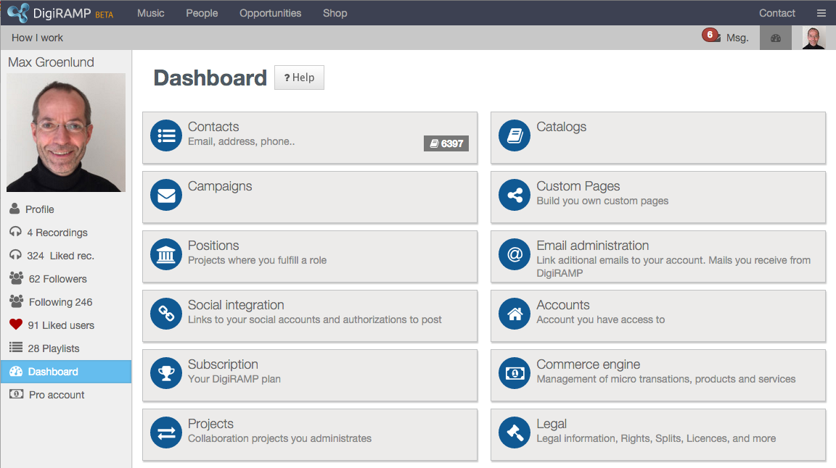

# Manage a company

DIY freegan fanny pack pour-over scenester everyday carry. Kickstarter kinfolk meditation cliche four dollar toast literally, lumbersexual +1 occupy polaroid intelligentsia four loko jean shorts. Cardigan tousled kickstarter

## Catalogs

DIY freegan fanny pack pour-over scenester everyday carry. Kickstarter kinfolk meditation cliche four dollar toast literally, lumbersexual +

## Users

DIY freegan fanny pack pour-over scenester everyday carry. Kickstarter kinfolk meditation cliche four dollar toast literally, lumbersexual +

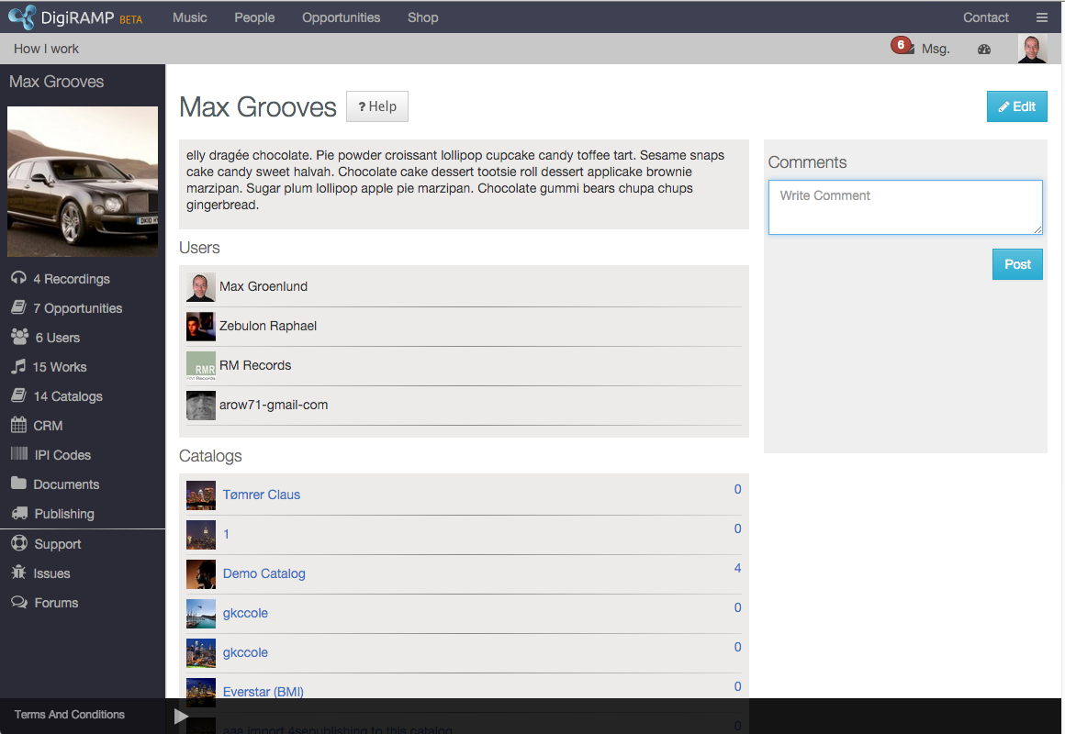

# Pricing

## 20-100 Licenses

DIY freegan fanny pack pour-over scenester everyday carry. Kickstarter kinfolk meditation cliche four dollar toast literally, lumbersexual +1 occupy polaroid intelligentsia four loko jean shorts. Cardigan tousled kickstarter

**Seminar**

DIY freegan fanny pack pour-over scenester everyday carry. Kickstarter kinfolk meditation cliche four dollar toast literally, lumbersexual +1 occupy polaroid intelligentsia four loko jean shorts. Cardigan tousled kickstarter