**ABSTRACT**

As we all know Zomato and Swiggy are very popular food delivery apps in the market right now, we got our inspiration from these apps and decided that we would make a food delivery app with highly customizable graphical food customization which no other apps have implemented, the app will also consist of a bill generation and a payment system. Below are some images that represent our idea for the app

**FOR PIZZA:-**

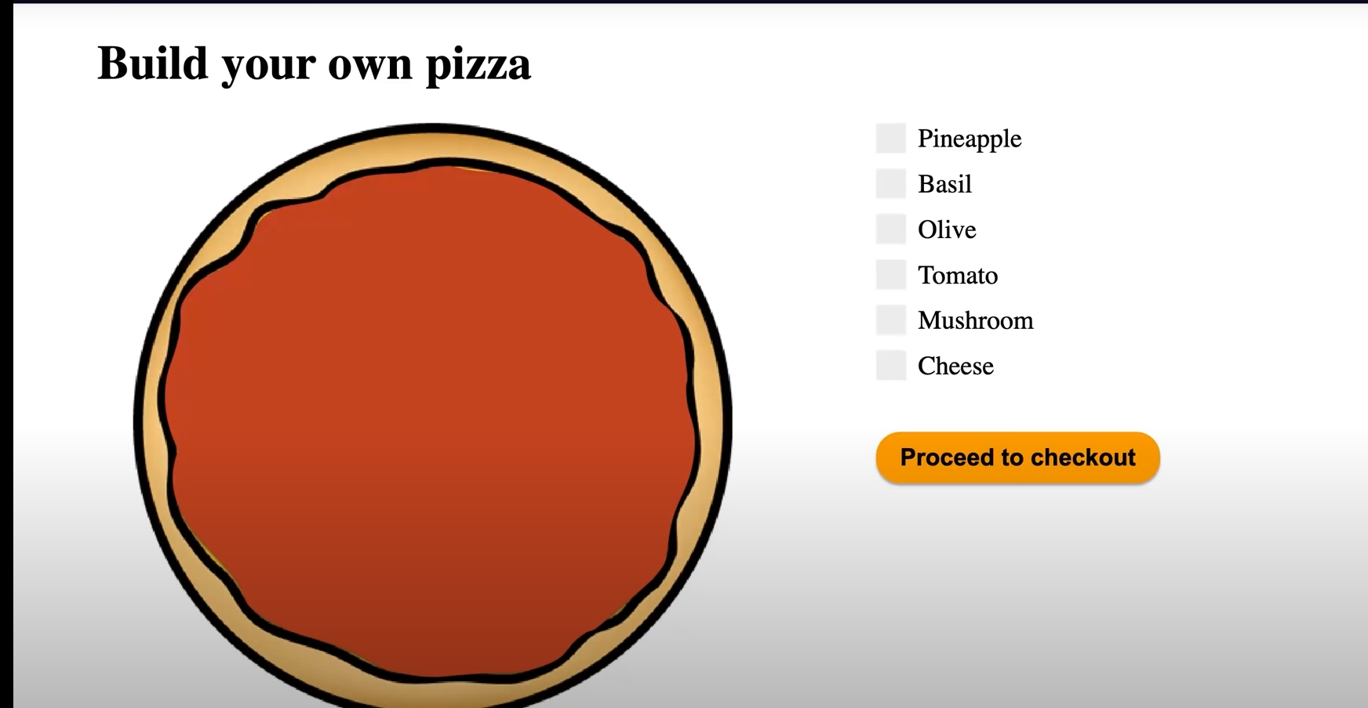

**FOR BURGER:-**

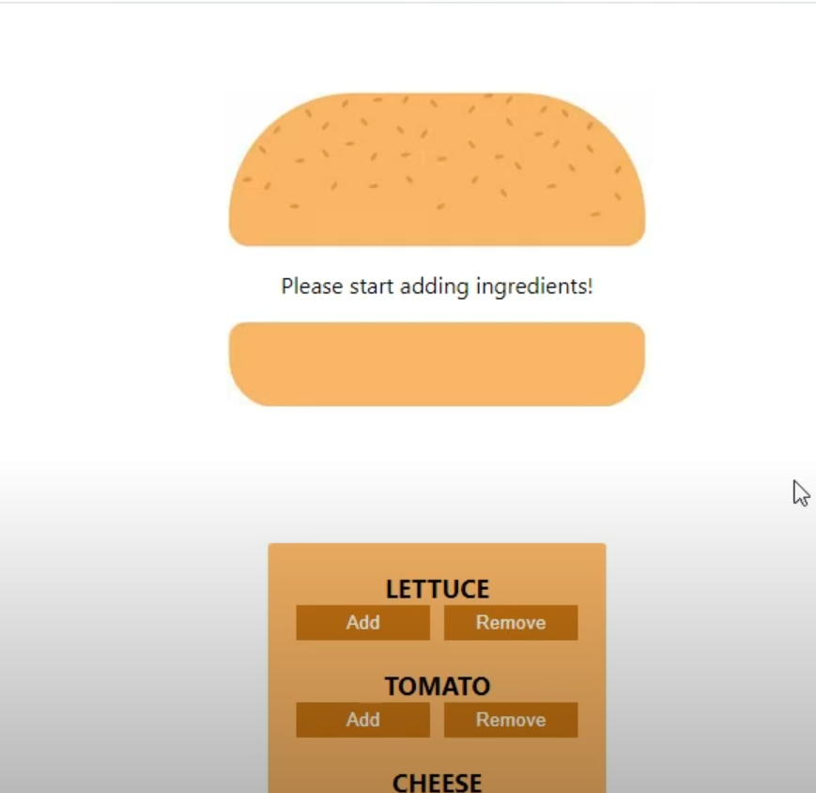

We will add the customization to many different food item as well.