Refinery CMS

CPS530 Web Systems Development

Term Project Report

Ryerson University

Rahul Bilimoria - 500569144

Tenzin Nyendak - 500573810

Brian Turner - 500565237

Ivanna Francesca Rasay - 500557962

Charlene Landayan - 500563295

November 24, 2016

## Framework/CMS

The Refinery CMS is an extendable Ruby on Rails CMS created for users to design their own content on their own website. It uses jQuery as the javascript library and is an open source content manager that supports Rails 4.2+ and embraces the same conventions used in Rails.

#### Popularity

The Refinery CMS is the most popular Ruby on Rails CMS with over 200 contributors and active users extending the application with different engines for a more flexible and stronger use.

#### Technical Information

As stated, the Refinery CMS is an open source content management that uses jQuery and supports Rails 4.2+. It extends different applications with different engines for better ease of use.

##### Strengths

Refinery CMS has a user friendly interface that focuses on simplicity. Developers can efficiently add functionality and make changes to the front end. Web pages are easily customizable to match any business. It is a web based interface where users can login to access their content. The CMS provides visual content editing for users who like to view changes as they are being made.

##### Weaknesses

While the CMS is easy to use and focuses on simplicity, installing it can be quite problematic if several programs are not installed in the system; these programs include Ruby, ImageMagick and SQL.

#### Type of Users

The type of users that use this CMS are people who do not know how to program to rapidly create a flexible website that still follows the conventions of the Ruby on Rails framework. Users that are familiar with the Rails framework can adapt to Refinery CMS with ease.

#### Type of Websites

The type of websites that users use the Refinery CMS for are personal websites as well as business related websites to make them “simple, clean and understandable”.

# Installation

The installation of the Refiner CMS is simple and easy, as long as the user’s system has a working installment of Ruby, ImageMagick, and either SQLite, MySQL, or PostgreSQL. With all of this set up, open a terminal and follow the steps below:

* **Install ExecJS**

|  |
| --- |
| gem install execjs |

* **Install Rails**

|  |
| --- |
| gem install rails --version 4.2.6 |

* **Generate an Application**

|  |
| --- |
| rails new my_new_application -m http://refinerycms.com/t/3-0-stable |

- After running this snippet, it will create a new Refinery ready Rails application, just install the dependencies using Bundler and set up the database.

* **Start up your site**

|  |
| --- |
| cd my_new_application  rails server |

- Now visit http://localhost:3000/refinery in your browser and you should see your Refinery CMS site and be prompted to set up your first user.

# Design

#### Creating Text

Using the editor several options are available to add text to the web page. Text can be added by directly typing into the textbox of the editor, the default setting is paragraph text. This can be changed by highlighting the text and selecting one of the options in the toolbar.

#### Adding Images

Images can be added just as simply as creating text by selecting the ‘Add Image’ option in the toolbar. Selecting the option will prompt a modal that asks the user to select the image along with size options

#### Adding Style

Styling can be introduced to a project by making changes to the application’s style sheet found by opening app/assets/stylesheet/application.css.scss. It allows the ability to style their content using SASS, a pre-processor for CSS.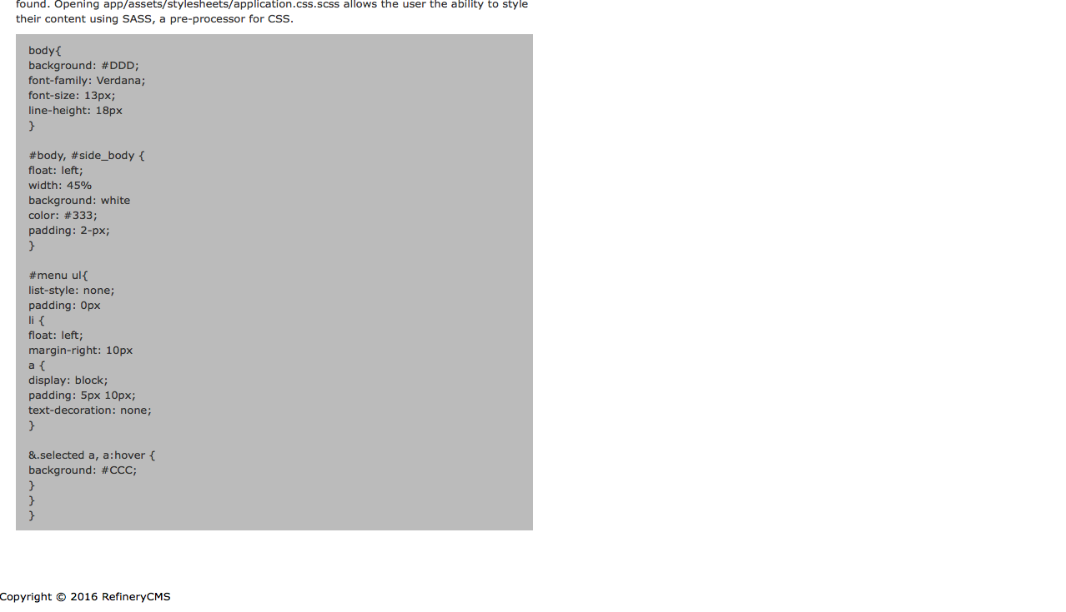

# Conclusion

In conclusion, we rate this experience as a 7 out of 10. We expected the framework to be slightly more easier to use but after playing around with the program we were used to the conventions. Installing the program was a bit troublesome since three other programs need to be installed for Refinery to work but the actual installation was simple since we were used to using terminal and terminal commands. The page was relatively easy to create since Refinery provides all the tools to create fast websites with ruby. Compared with regular HTML/CSS, this was a bit more difficult to learn since it is similar to ruby. If we could change some things up, we wouldn’t change anything because we liked the outcome of our work. No we did not regret our choice of CMS.

# Credits

#### **Members:**

Rahul Bilimoria - Site Developer

Tenzin Nyendak - Site Developer

Brian Turner - Site Developer

Ivanna Francesca Rasay - Report/Content Writing

Charlene Landayan - Report/Content Writing

#### **References:**

http://refinerycms.com/

https://en.wikipedia.org/wiki/Refinery_CMS

https://github.com/refinery/refinerycms