Keypasco Proxy Installation Guide

V1.5

權利專有聲明

本文件包含來毅數位科技股份有限公司的機密與專有資訊，它僅供您作為評估是否採用本文件所述之服務之用。未經來毅數位科技股份有限公司明示的書面同意，上述資訊的一部或全部，不得影印、使用、重製、上載、刊登、改作、或揭露予任何第三人作為任何其他目的之用。

Proprietary Statement

This Document contains the confidential and proprietary information of Lydsec Digital Technology Co., Ltd., which is only for your evaluation of whether to use the services described in this document. Without the express written consent of Lydsec Digital Technology Co., Ltd., part or all of the above information may not be photocopied, used, reproduced, uploaded, published, modified, or disclosed to any third party for any other purpose.

Reversion history
ISSUE | DATE | AUTHOR | COMMENT
V1.2 | 2025-02-08 | Brian Chen | - Modify to support create self-signed certificate automatically.  - Simplify the installation process
V1.3 | 2025-02-26 | Brian Chen | - Add Bypass Borgen server information section  - Add Keypasco Proxy testing steps
V1.4 | 2025-03-18 | Brian Chen | - Auto add FQDN or localhost and password for pfx  - Auto search Lydsecmfa.zip file  - Set default log path  - Set default local user “kpadmin”  - Auto open Microsoft edge and show url at the end of powershell
V1.5 | 2025-03-29 | Brian Chen | - Add ClientApi setting

Table of Contents
1 Introduction 4
1.1 Scope 4
1.2 Knowledge Prerequisites 4
2 Keypasco Proxy Prerequisites 5
2.1 Hardware Requirements 5
2.2 Supported Operating Systems 5
2.3 Supported Database 5
3 Installation Overview 6
4 Installing Keypasco Proxy on Windows 7
4.1 Pre-request: 7
4.2 Provided by Lydsec 7
4.3 Running Steps for Proxy Install 7
4.4 Bypass Borgen server information 9
4.5 Testing 10
4.6 Problems 16

Introduction

Scope
This document is intended for users installing and configuring the Keypasco Proxy.

Knowledge Prerequisites
- Basic understanding of Windows Server

Keypasco Proxy Prerequisites
This chapter lists the requirements and supports environment for installing Keypasco Proxy.

Hardware Requirements
- 4 cores CPU
- 8G RAM
- 50G Hard Disk

Supported Operating Systems
- Windows Server 2019/2022

Supported Database
- SQlite -- default
- PostgreSQL
- MS SQL

Installation Overview

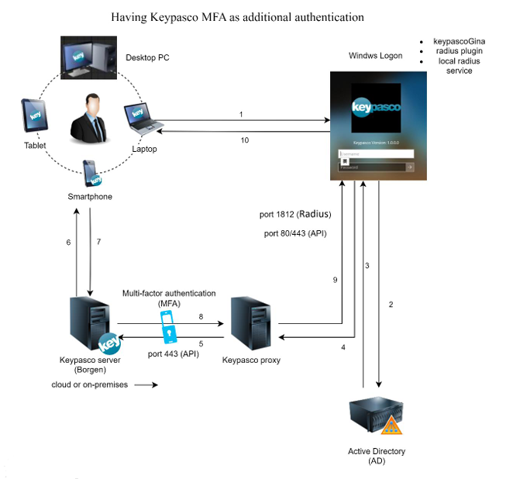

Installing Keypasco Proxy on Windows

Pre-request:
- Need KeypascoProxyInstall_V1.x.zip which is the installing script for Keypasco Proxy
- Get the Keypasco proxy install package Lydsecmfa-V1.016.xx-1.43.zip and copy to KeypascoProxyInstaller_V1.0x folder
- Prepare SSL certificate (.pfx) and password (Suggested)
- Revise the “P12Path” in the .\files\ iniData.json of the package
(Please refer 4.4 Bypass Borgen Server Information for detailing information)
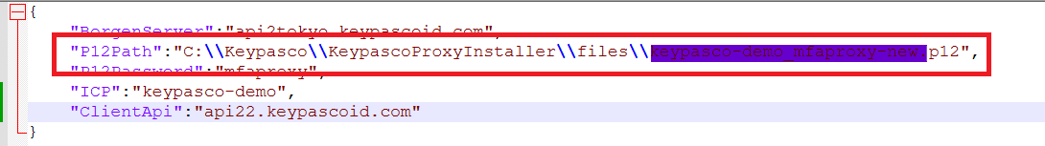

Provided by Lydsec
- Keypasco Borgen certificate (.p12) and password
- FQDN of Borgen server
- ICP
(This information might be pre-defined in iniData.json by Lydsec)

Running Steps for Proxy Install
- Unzip KeypascoProxyInstall_V1.x.zip to any working folder
- Copy Lydsecmfa-V1.016.xx-1.43.zip to the unzipped folder KeypascoProxyInstall
- Check the contents of iniData.json in KeypascoProxyInstall\files

Case1: use your own SSL certification(.pfx)
- Copy SSL certificate(.pfx) to KeypascoProxyInstall\files and type pfx password in KeypascoProxyInstall\files \pfx.pwd

Case2: use self-signed SSL certification
- Please make sure there is no .pfx file in KeypascoProxyInstall\files

Start Install
- Open PowerShell by Administrator
- Run .\Unblock.bat
- Run .\KProxySetting.ps1 in Powershell under KeypascoProxyInstall folder

Parameters Description:
- Restore Web.config: [Y]es/[N]o to restore the backup Web.config file if the backup file exists (Default: Yes)
- Restore initConfig.ini: [Y]es/[N]o to restore the backup initConfig.ini file if the backup file exists (Default: Yes)
- Use PostpgrSQL: [Y]es/[N]o to use PostpgrSQL (Default: No)
- PostgreSql Server [Example: 10.0.1.xxx]: PostgreSQL server url
- PostgreSql DB name: DB name
- PostgreSql user name: DB user name
- PostgreSql user password: DB user password
- Borgen server FQDN: FQDN of Borgen server
- Certificate(P12) full path: full path of certificate file
- Certificate(P12) password: password of certificate file
- Customer ID(ICP): ICP of Borgen server
- AD Domain: AD domain

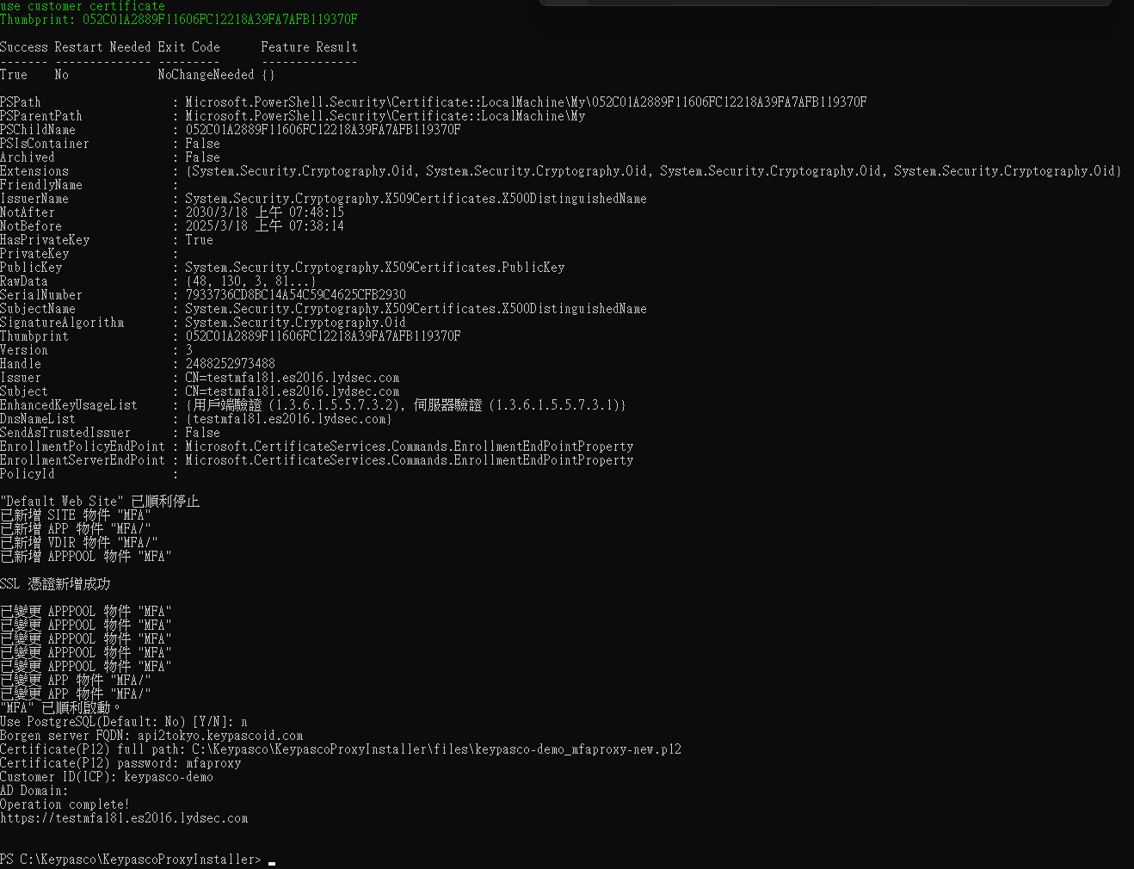

Bypass Borgen server information
Create a JSON file name iniData.json in KeypascoProxyInstaller_V1.0x\files\ folder and input the correct Borgen information. The KProxySetting.ps1 will load this file to process the installation.

Example:
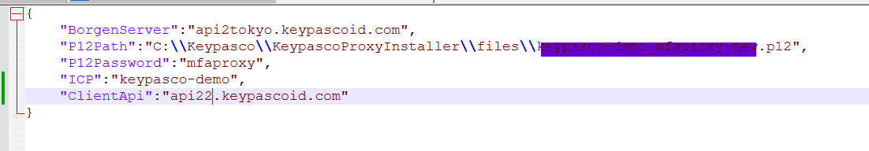
Parameters Description:
- BorgenServer: FQDN of Borgen server
- P12Path: full path of certificate file
- P12Password: password of certificate file
- ICP: ICP of Borgen server
- ClientApi: Client API url

Testing
- Open browser and enter: https://localhost or FQDN
- Login with the local user “kpadmin” with P12 password
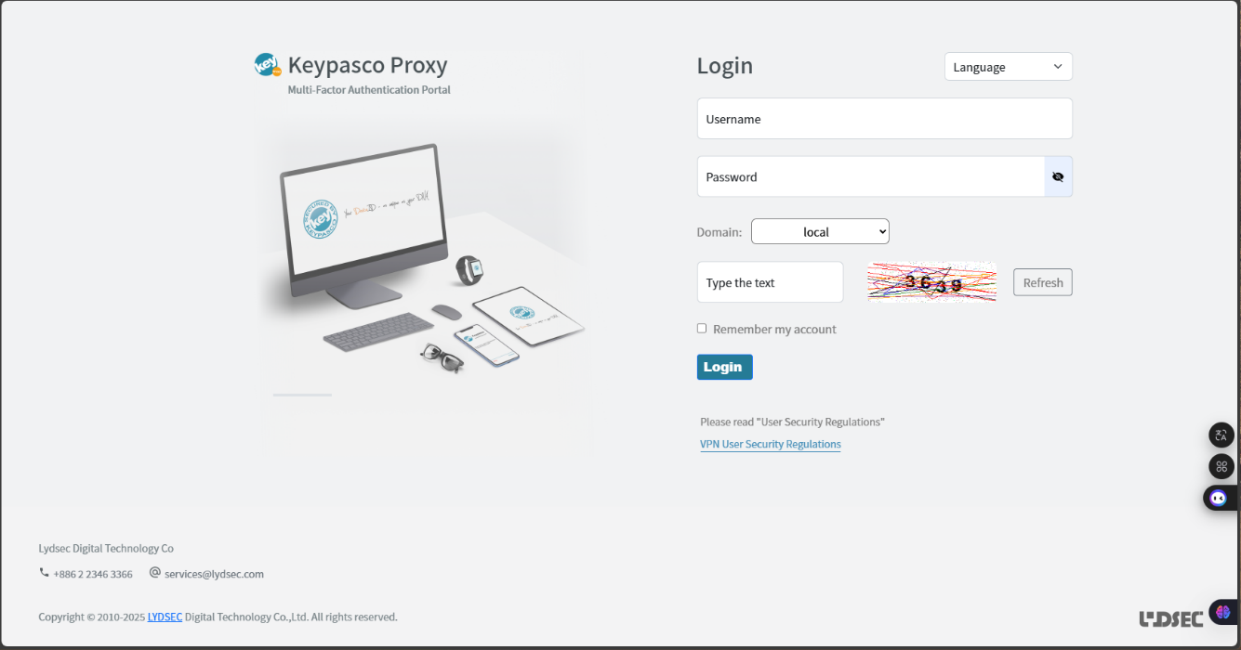
Kpadmin

- Click “Add Device” to bind device
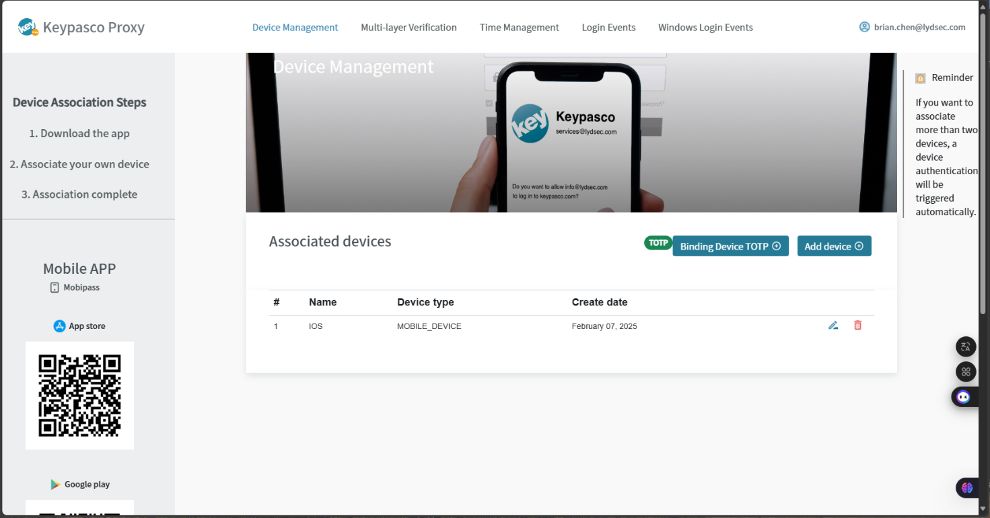

- Select “Mobile Device”
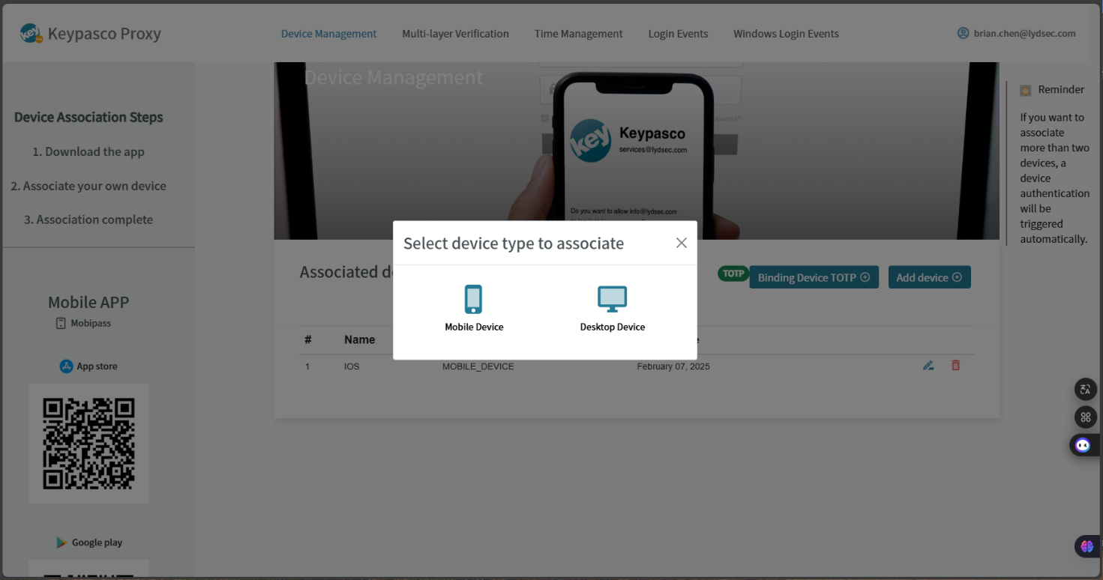

- The QRcode opened for mobile device binding
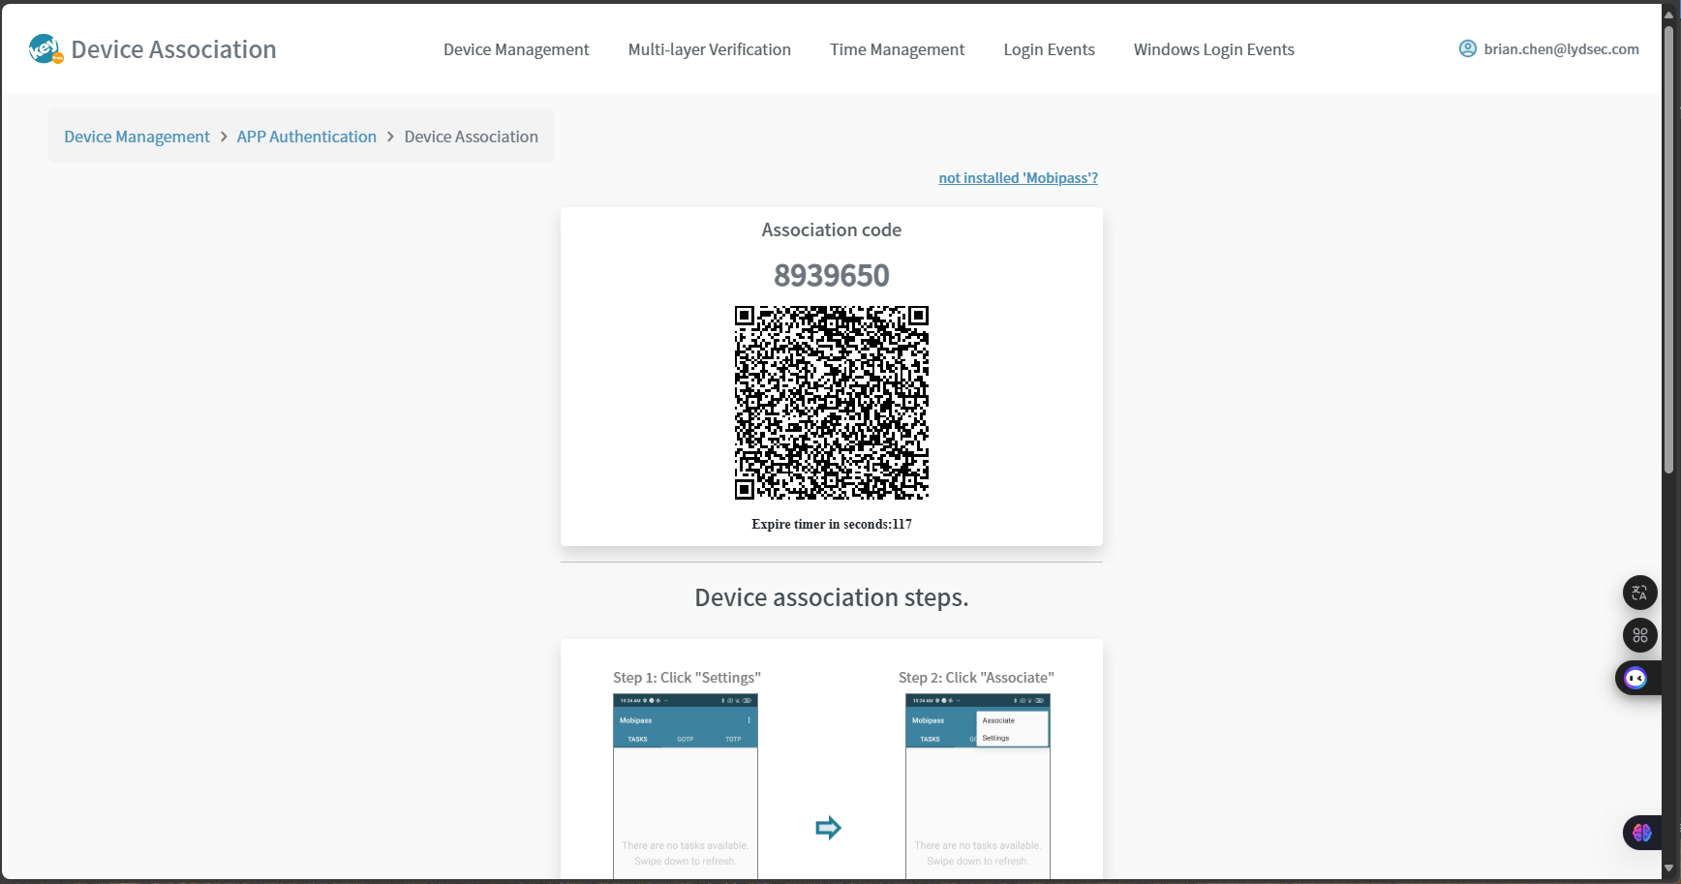

- Install Android/iOS application “Mobipass”
- Open it and scan QRcode to bind your device
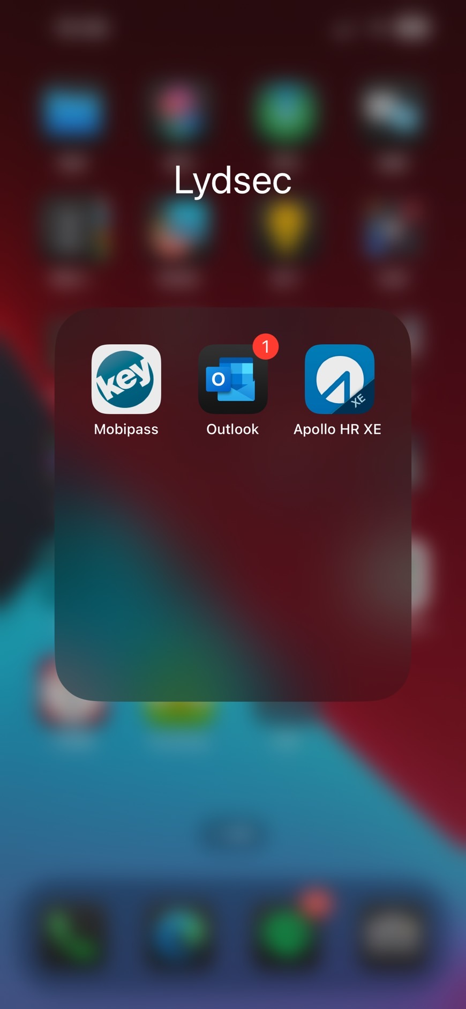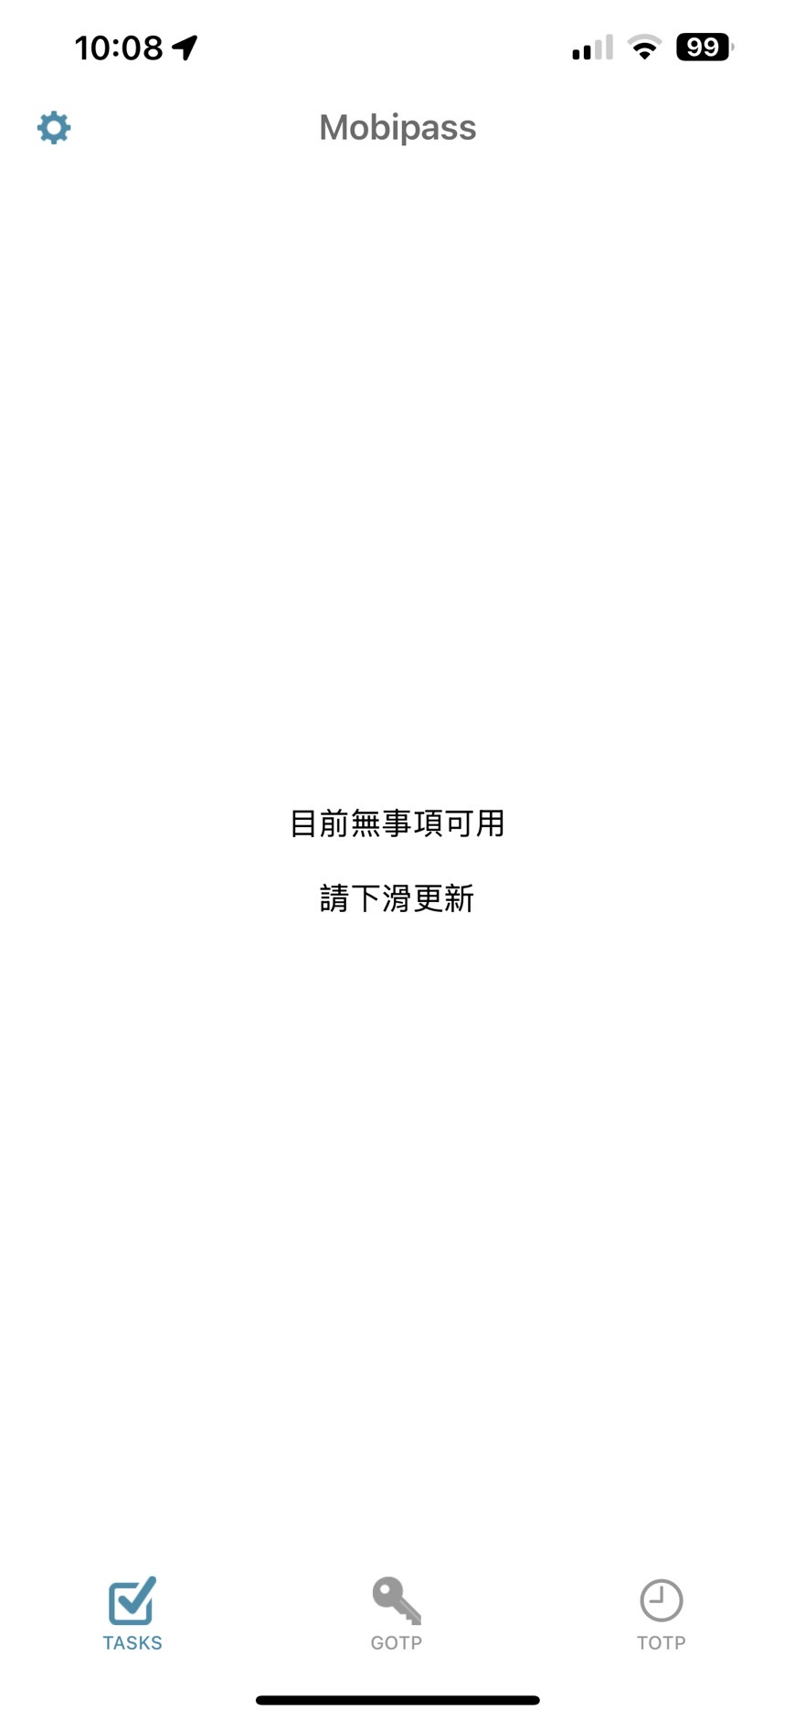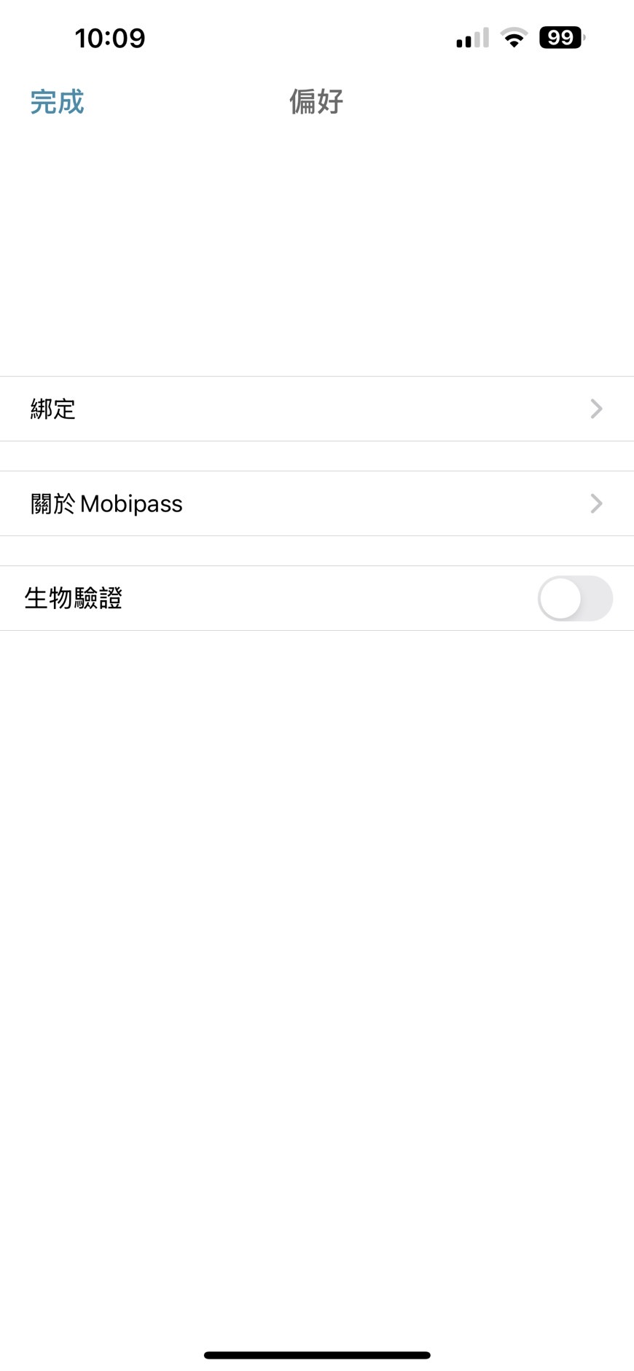
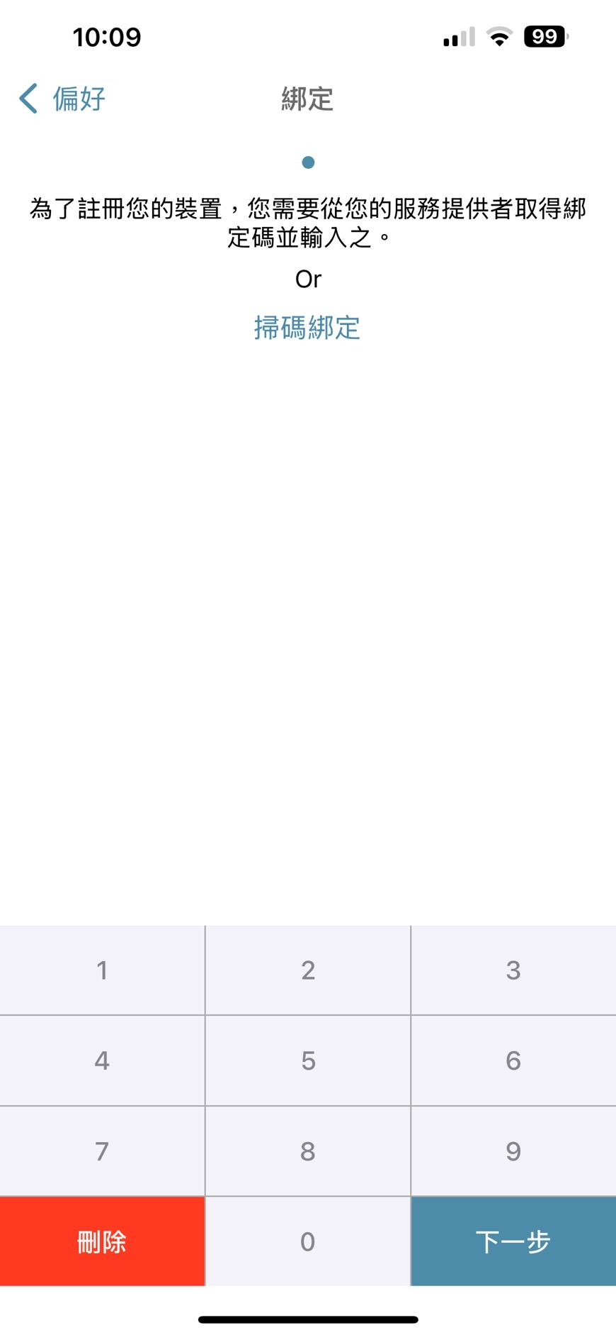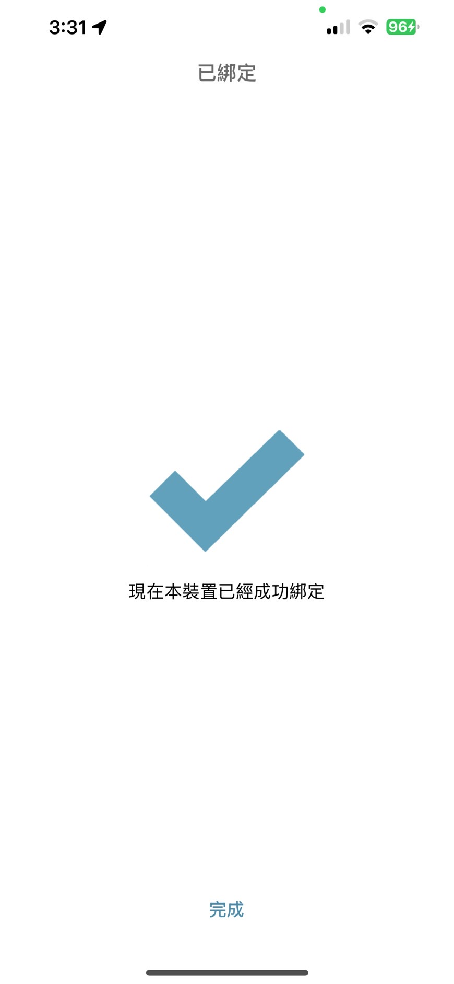
- Show binding device information
- Click “Modify Device Name”
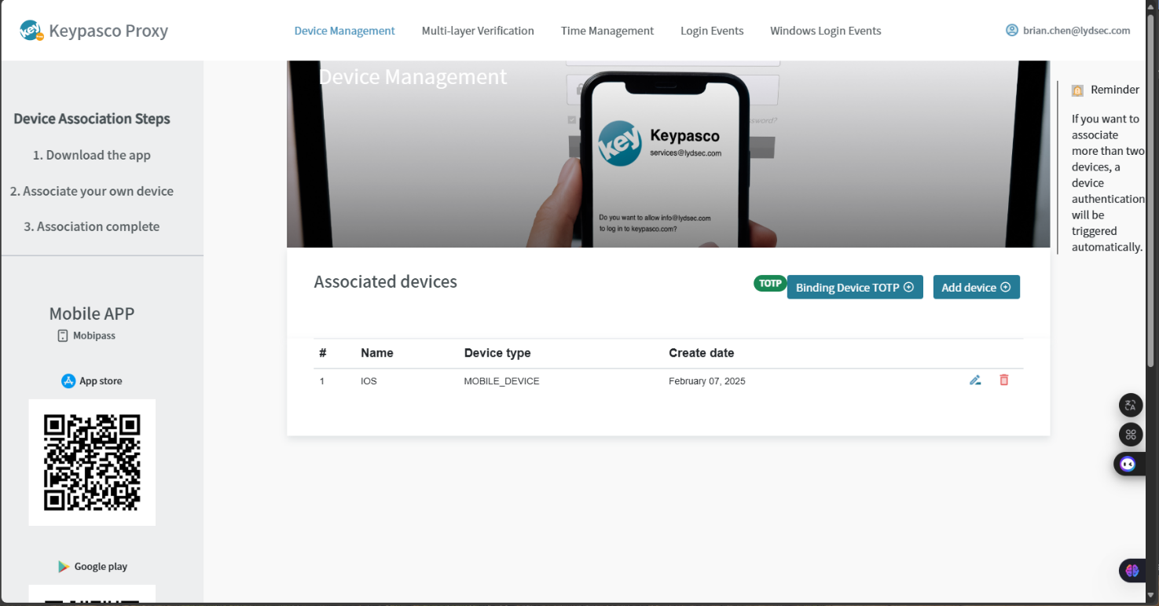

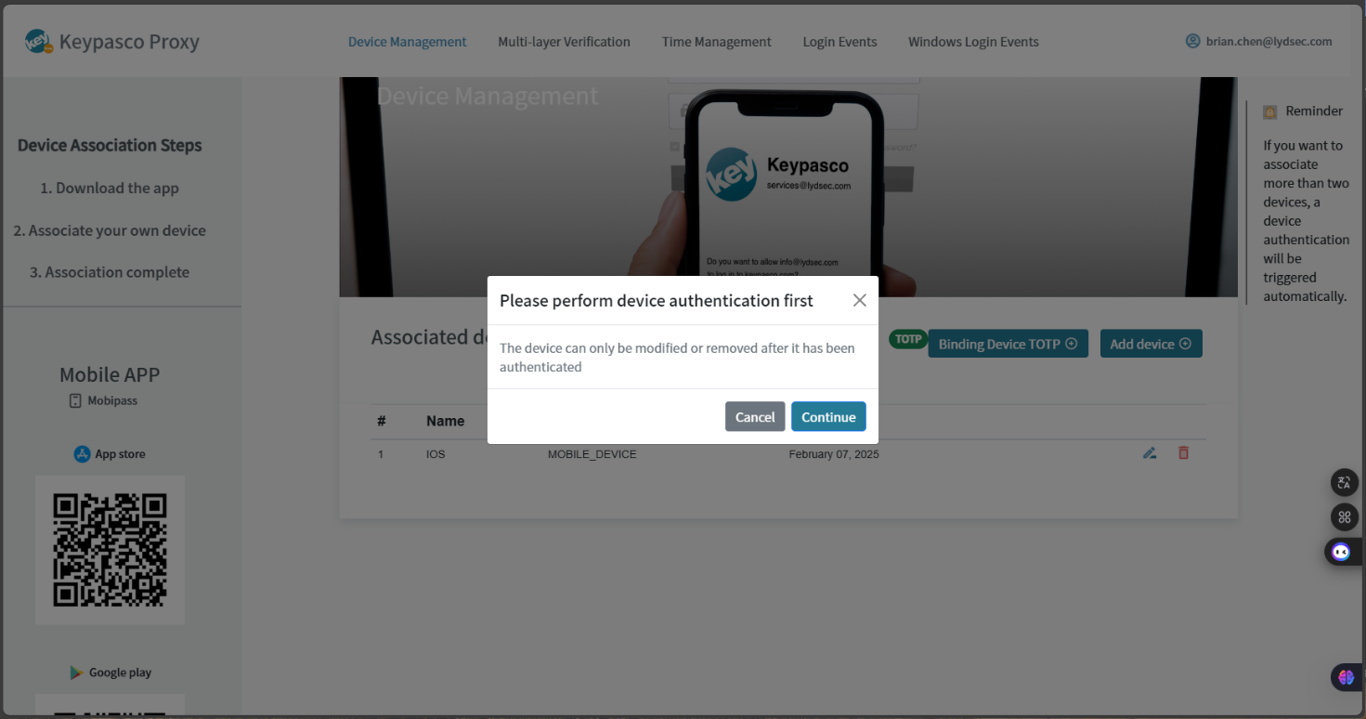

- Select “App Authentication”
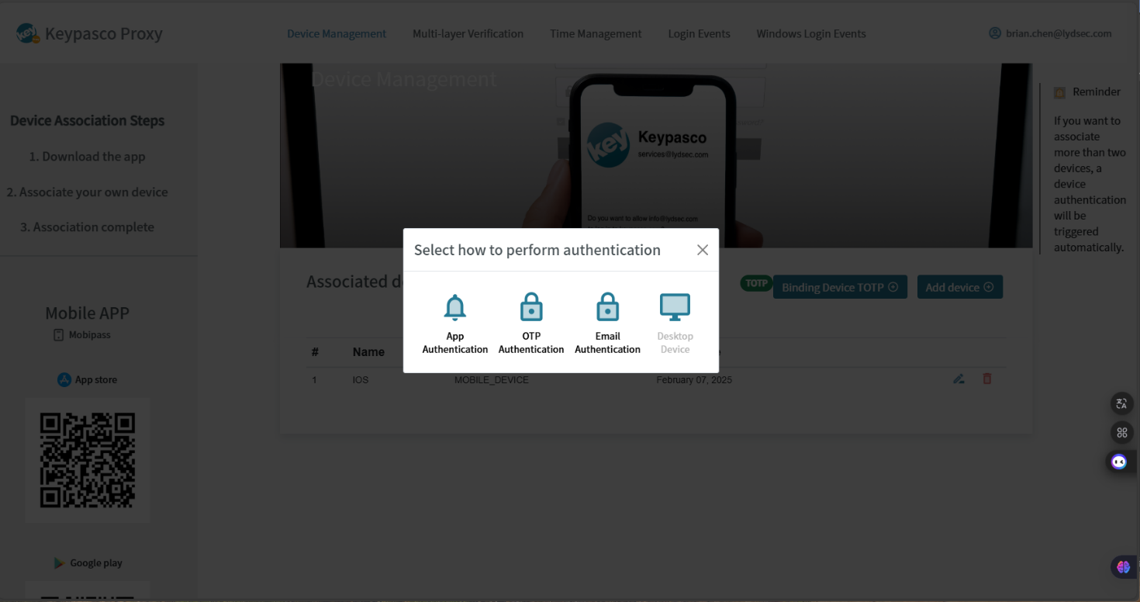

- Click “Authenticate”
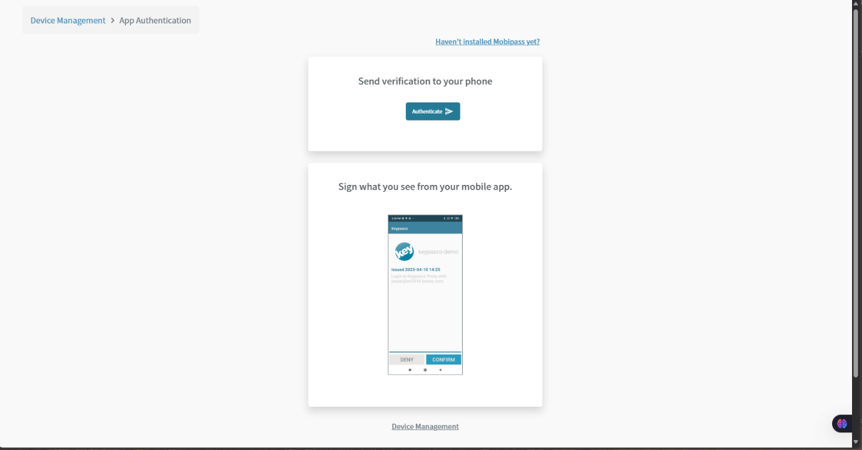

- The binding device will receive the push message
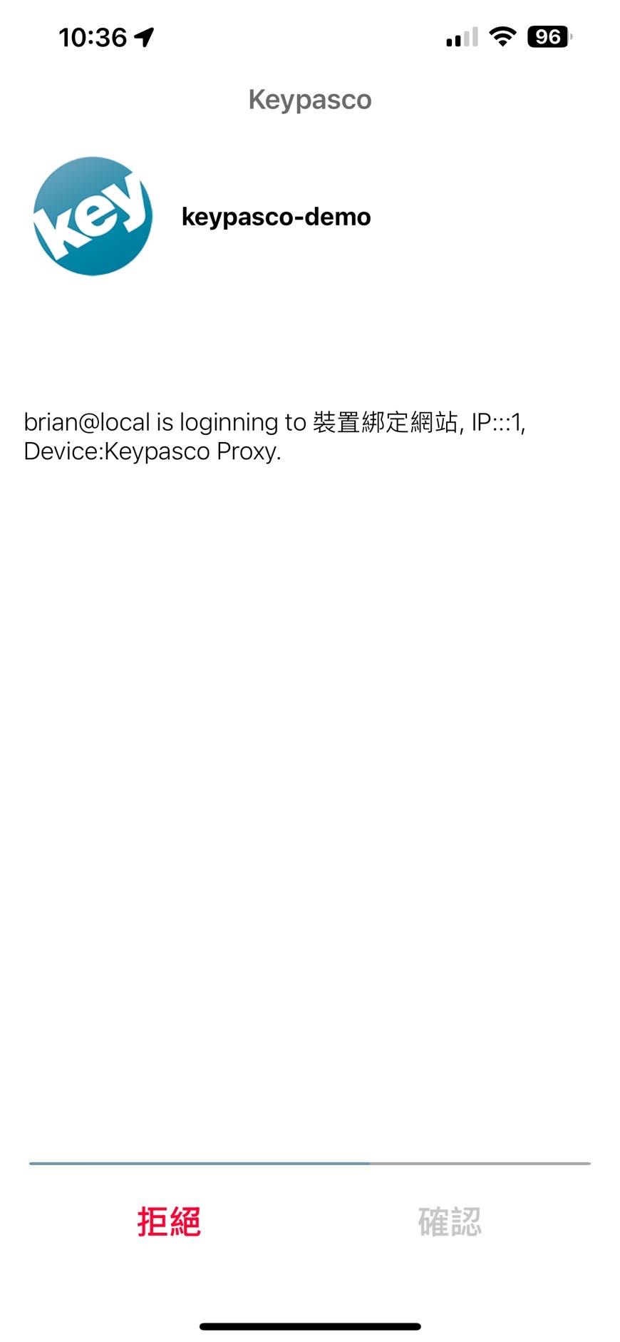

Problems
- If the problem “xxx.ps1 cannot be loaded because the execution of scripts is disabled on this system.” run follow command to get the permission.
>Set-ExecutionPolicy Unrestricted
or
>Unblock-File -Path "C:\Path\To\ KProxySetting.ps1"

