Database Management Systems

Project 1

By: Dustin Cook

Brian Brunner

# Entity-Relationship Diagram

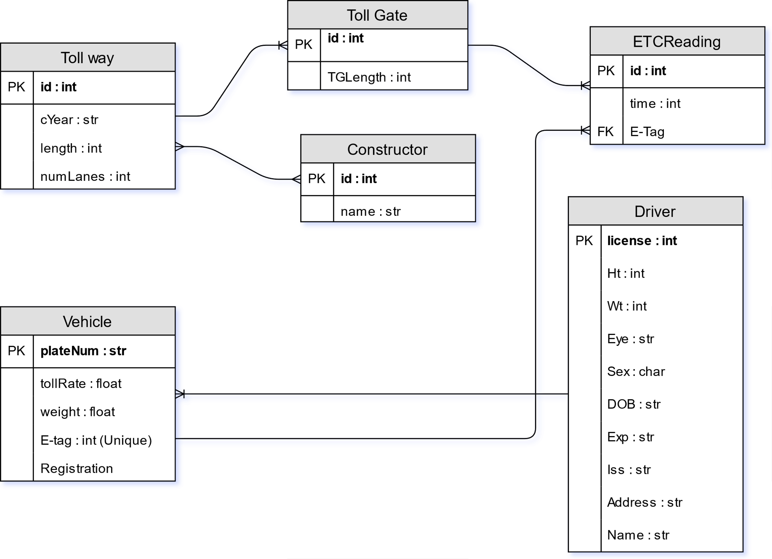

# Schemas

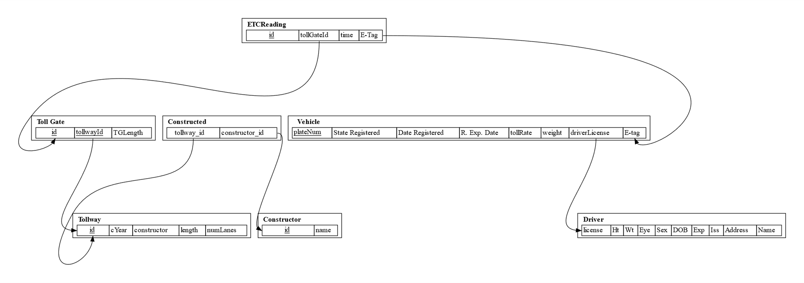

# SQL: Create Table Statements

**CREATE** **TABLE** Driver **(**

License **INT** **NOT** **NULL,**

Ht **FLOAT** **NOT** **NULL,**

Wt **FLOAT** **NOT** **NULL,**

Eye **VARCHAR(**30**)** **NOT** **NULL,**

Sex **CHAR(**1**)** **NOT** **NULL,**

DOB **DATETIME** **NOT** **NULL,**

Expiration **DATE** **NOT** **NULL,**

Issued **DATE** **NOT** **NULL,**

HomeAddress **VARCHAR(**30**)** **NOT** **NULL,**

FullName **VARCHAR(**30**)** **NOT** **NULL,**

**CHECK** **(**Expiration **>** Issued**),**

**PRIMARY** **KEY** **(**License**),**

**);**

**CREATE** **TABLE** Tollway **(**

ID **INT** **UNIQUE,**

CYear **INT** **NOT** **NULL,**

TWLength **INT** **NOT** **NULL,**

NumLanes **INT** **NOT** **NULL,**

**PRIMARY** **KEY** **(**ID**),**

**);**

**CREATE** **TABLE** TollGate **(**

ID **INT** **UNIQUE,**

TWID **INT,**

TGLength **INT** **NOT** **NULL,**

**FOREIGN** **KEY** **(**TWID**)** **REFERENCES** TollWay**(**ID**),**

**PRIMARY** **KEY** **(**ID**),**

**);**

**CREATE** **TABLE** Vehicle **(**

PlateNumber **VARCHAR(**10**)** **UNIQUE,**

StateRegistered **CHAR(**2**)** **NOT** **NULL,**

DateRegistered **DATETIME** **NOT** **NULL,**

RegisteredExpDate **DATETIME** **NOT** **NULL,**

TollRate MONEY**,**

VehicleWeight **FLOAT** **NOT** **NULL,**

License **INT** **NOT** **NULL,**

ETag **INT** **UNIQUE** **NOT** **NULL,**

**FOREIGN** **KEY** **(**License**)** **REFERENCES** Driver**(**License**),**

**CHECK** **(**DateRegistered **<** RegisteredExpDate**),**

**PRIMARY** **KEY** **(**PlateNumber**),**

**);**

**CREATE** **TABLE** ETCReading **(**

ID **INT** **UNIQUE** **NOT** **NULL,**

TGID **INT** **NOT** **NULL,**

DTime **DATETIME** **NOT** **NULL,**

ETag **INT** **NOT** **NULL,**

**FOREIGN** **KEY** **(**TGID**)** **REFERENCES** TollGate**(**ID**),**

**FOREIGN** **KEY** **(**ETag**)** **REFERENCES** Vehicle**(**ETag**),**

**PRIMARY** **KEY** **(**ID**),**

**);**

**CREATE** **TABLE** Constructor **(**

ID **INT** **NOT** **NULL,**

FullName **VARCHAR(**30**)** **NOT** **NULL,**

**PRIMARY** **KEY** **(**ID**),**

**);**

**CREATE** **TABLE** Constructed **(**

TWID **INT** **UNIQUE** **NOT** **NULL,**

CID **INT** **UNIQUE** **NOT** **NULL,**

**FOREIGN** **KEY** **(**TWID**)** **REFERENCES** TollWay**(**ID**),**

**FOREIGN** **KEY** **(**CID**)** **REFERENCES** Constructor**(**ID**),**

**PRIMARY** **KEY** **(**TWID**,** CID**),**

**);**

# SQL: Database Population. Examples of insert statements into each table

Constructed:

**insert** **into** Constructed **(**TWID**,** CID**)** **values** **(**1**,** 1**);**

Constructor**:**

**insert** **into** Constructor **(**ID**,** FullName**)** **values** **(**1**,** 'Zerk Sillett'**);**

Driver**:**

**insert** **into** Driver **(**license**,** Ht**,** Wt**,** Eye**,** Sex**,** DOB**,** Expiration**,** Issued**,** HomeAddress**,** FullName**)** **values** **(**1**,** 10.52**,** 86.41**,** 'Crimson'**,** 'M'**,** '2003-01-16 17:09:03'**,** '2015-06-09'**,** '2014-02-03'**,** '9606 Westerfield Avenue'**,** 'Gunner Thecham'**);**

ETCReading**:**

**insert** **into** ETCReading **(**ID**,** TGID**,** DTime**,** ETag**)** **values** **(**1**,** 90**,** '2018-03-18 17:52:17'**,** 6**);**

TollGate**:**

**insert** **into** TollGate **(**ID**,** TWID**,** TGLength**)** **values** **(**1**,** 10**,** 5**);**

Tollway:

**insert** **into** Tollway **(**ID**,** CYear**,** TWLength**,** NumLanes**)** **values** **(**1**,** 1996**,** 445**,** 9**);**

Vehicle:

**insert** **into** Vehicle **(**PlateNumber**,** StateRegistered**,** DateRegistered**,** RegisteredExpDate**,** TollRate**,** VehicleWeight**,** License**,** ETag**)** **values** **(**1**,** 'FL'**,** '2012-02-22 01:25:08'**,** '2015-03-21 22:30:39'**,** '$3.23'**,** 9.88**,** 63**,** 1**);**

# SQL: Given Queries

/* 1 */

**SELECT** ID**,** TWLength **FROM** Tollway

**WHERE** CYear **<** 1990**;**

/* 2 */

**SELECT** D**.**FullName**,** D**.**License **From** Driver D

**WHERE** **(**

**SELECT** **COUNT(** **\*** **)**

**FROM** Vehicle

**WHERE** license **=** D**.**License

**)** **>=** 2**;**

/* 3 */

**SELECT** TollGate**.**TGLength**,** TollGate**.**ID **FROM** TollGate

**WHERE** TollGate**.**ID **in**

**(SELECT** TOP 3 TGID

**FROM** ETCReading

**GROUP** **BY** TGID

**ORDER** **BY** **Count(**TGID**)** **DESC);**

/* 4 */

**SELECT** License **FROM** Vehicle **WHERE** Vehicle**.**ETag **in**

**(SELECT** ETag **FROM** ETCReading **WHERE** ETCReading**.**TGID **in**

**(SELECT** ID **FROM** TollGate **WHERE** TollGate**.**TWID **=** 1**)**

**GROUP** **BY** ETCReading**.**ETag

**HAVING** **COUNT** **(**ETCReading**.**ETag**)** **>** 2**);**

/* 5 */

**SELECT**

Vehicle**.**TollRate **\***

**(SELECT** **Count(** **\*** **)** **FROM** ETCReading

**WHERE** **Year(**DTime**)** **=** 2018 **and** ETCReading**.**ETag **=** Vehicle**.**ETag **and** Vehicle**.**License **=** Driver**.**License

**)** **as** spent**,**

Driver**.**FullName **FROM** Vehicle**,** Driver

**WHERE** Vehicle**.**License **=** Driver**.**License

**ORDER** **BY** **(**spent**)** **DESC;**

# SQL: Additional Queries