C:\Projects\CentralParks\cplogo-3-2.png

# Project Introduction

The CentralParks Middleware Platform offers clients a cost efficient and easy way to quickly deploy iPhone and Android Apps and keep them updated in a simple web-based tool.

## Target Clients:

Park districts are special government entities that provide for recreation facilities and park space as well as cultural enrichment activities and community events. Districts vary widely in size and complexity and are not necessarily bound by city or county borders.

CentralParks is a effort to allow for a park district to economically provide Android and Apple apps with consistently updated information in their community. Quick and inexpensive development combined with a rich set of middleware tools to keep the apps updated are the key selling points and focus of this project. To allow for varying complexity and budget of the park district entity, the app must be easily scalable and quickly deployable.

## New Client Development Process:

The typical on boarding experience for a client, after sales, would be for a client manager to initiate a project within the middleware and select the options that have been agreed to. All of this will be done within the middleware by Links staff. A district will then have its app submitted to developers based on its middleware settings and content for development. The end user, “client administrator”, will be allowed access to the dynamic data portion of the middleware and be able to bring their data to the app via this mechanism. The client will be able to provide their data in three ways.

1. RSS feeds with their field map to the middleware feeds.
2. CSV file import
3. Manual entry through the middleware site.

Once an app is developed, and a client has approved it. It will be sent through the Apple store and Google play store for their approvals and to be launched

## Ongoing Maintenance and upgrading:

Clients will be able to continue to maintain their project via the middleware and may request customizations or expansions of their apps, requiring new binary builds, via a request form within the middleware. New builds will be formally requested via Links Staff on a regular interval as coordinated with the developers and the end clients.

# CentralParks Middleware Site Map

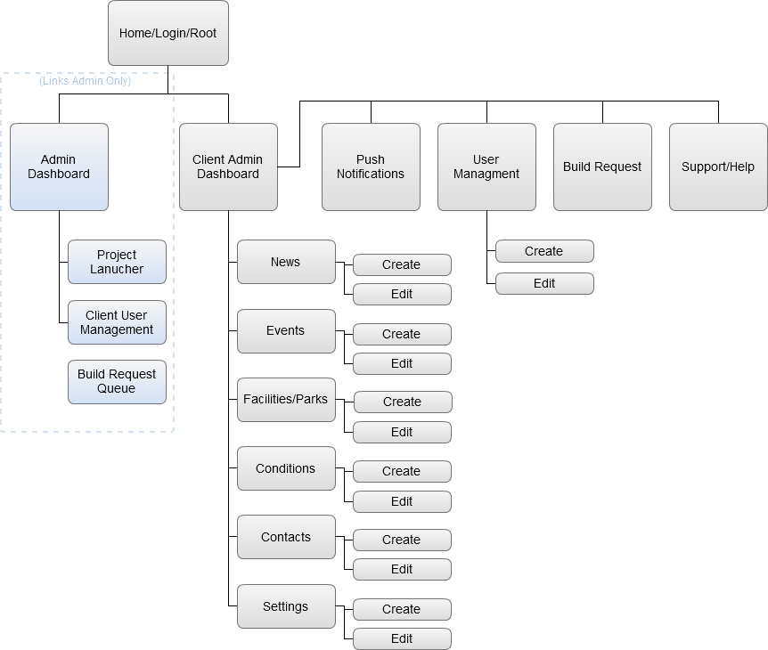

* Site Home / [Login](http://briceshatzer.github.io/central_parks-Admin_UI/login.html) / Root
* Admin Dashboard
  + [Project Launcher](http://briceshatzer.github.io/central_parks-Admin_UI/project_launcher.html)
  + Client User Management
  + Build Request Queue
* [Client Admin Dashboard](http://briceshatzer.github.io/central_parks-Admin_UI/data_management-home.html)  
  *(Data Management Home)*
  + [News](http://briceshatzer.github.io/central_parks-Admin_UI/data_management-news.html)
    - [Create](http://briceshatzer.github.io/central_parks-Admin_UI/create-edit_news.html) / [Edit](http://briceshatzer.github.io/central_parks-Admin_UI/create-edit_news.html?id=fall_food_drive_was_a_huge_success)
  + [Events](http://briceshatzer.github.io/central_parks-Admin_UI/data_management-events.html)
    - [Create](http://briceshatzer.github.io/central_parks-Admin_UI/create-edit_events.html) / [Edit](http://briceshatzer.github.io/central_parks-Admin_UI/create-edit_events.html?id=santa_to_visit_rec_center)
  + [Facilities/Parks](http://briceshatzer.github.io/central_parks-Admin_UI/data_management-facilities_parks.html)
    - [Create](http://briceshatzer.github.io/central_parks-Admin_UI/create-edit_facilities-park.html) / [Edit](http://briceshatzer.github.io/central_parks-Admin_UI/create-edit_facilities-park.html?id=central_park)
  + [Conditions](http://briceshatzer.github.io/central_parks-Admin_UI/data_management-conditions.html)
    - [Create](http://briceshatzer.github.io/central_parks-Admin_UI/create-edit_conditions.html) / [Edit](http://briceshatzer.github.io/central_parks-Admin_UI/create-edit_conditions.html?id=olympic_fields_field_3)
  + [Contacts](http://briceshatzer.github.io/central_parks-Admin_UI/data_management-contacts.html)
    - [Create](http://briceshatzer.github.io/central_parks-Admin_UI/create-edit_contact.html) / [Edit](http://briceshatzer.github.io/central_parks-Admin_UI/create-edit_contact.html?id=office_of_park_services)
  + [Settings](http://briceshatzer.github.io/central_parks-Admin_UI/data_management-settings.html)
* [Push Notifications](http://briceshatzer.github.io/central_parks-Admin_UI/push_notifications.html)
* [User Management](http://briceshatzer.github.io/central_parks-Admin_UI/user_management.html)
* [Create](http://briceshatzer.github.io/central_parks-Admin_UI/create-edit_user.html) / [Edit User](http://briceshatzer.github.io/central_parks-Admin_UI/create-edit_user.html?id=john_doe)
* [Build Request](http://briceshatzer.github.io/central_parks-Admin_UI/build_request.html)
* [404.html](http://briceshatzer.github.io/central_parks-Admin_UI/404.html)
* Support/Help

# CentralParks Middleware Requirements

## Site Home / [Login](http://briceshatzer.github.io/central_parks-Admin_UI/login.html) / Root

Not yet complete

## Admin Dashboard

Not yet complete

## Project Launcher

Not yet complete

## Client User Management

Not yet complete

## Build Request Queue

Not yet complete

## Client Admin Dashboard

### Featured Items

This controls which slides show up in what order.

* Only News and Events Items may be Featured
* An item must be marked as “featured” AND have a publish date of today or in the past, and not yet expired.
* If an event, the event must be today or in the future.

### Analytics

Pull Stats of last 30 days Sessions vs. Screen Views and other metrics shown via Google Analytics

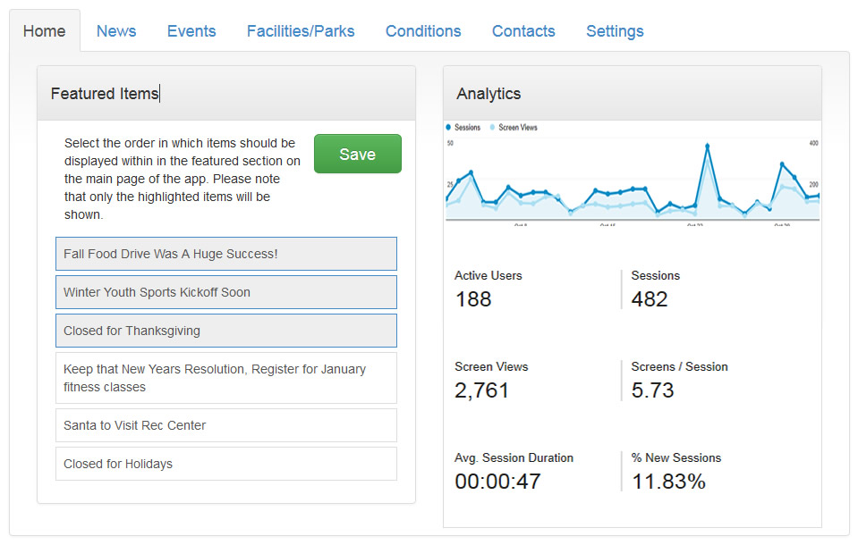 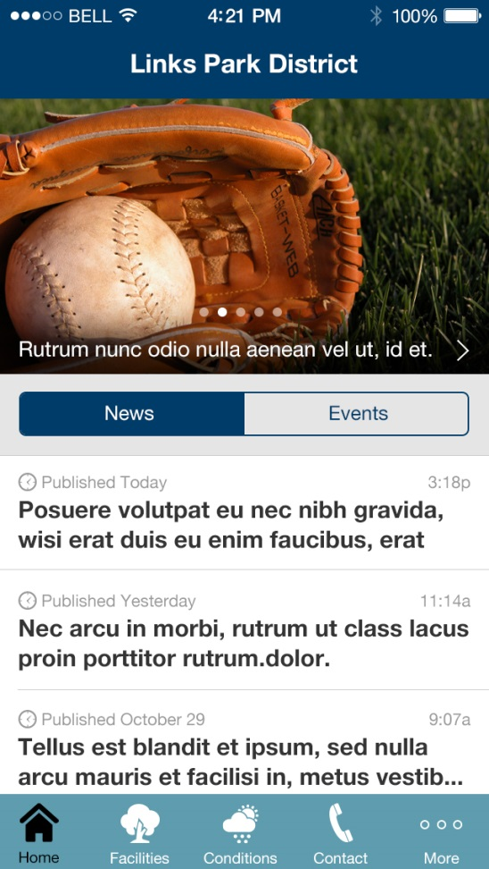

## Data Management: News

News Items have a list view and create/edit view.

* The list view has no actions other than edit or delete. Delete should provide a confirmation pop up.
* Create/Edit view allows for content, metadata and image upload.

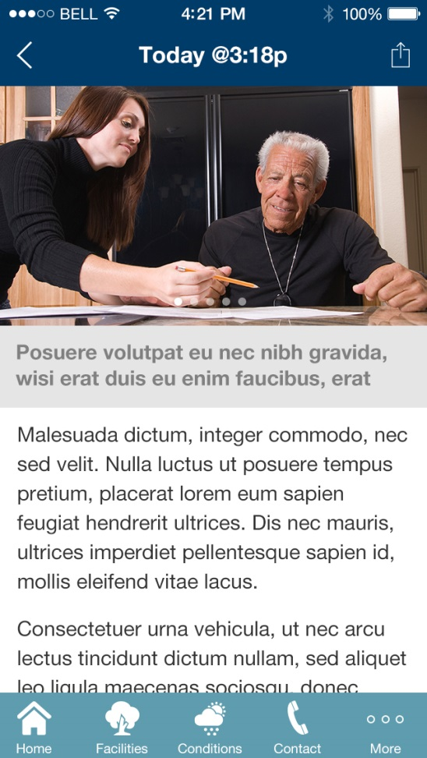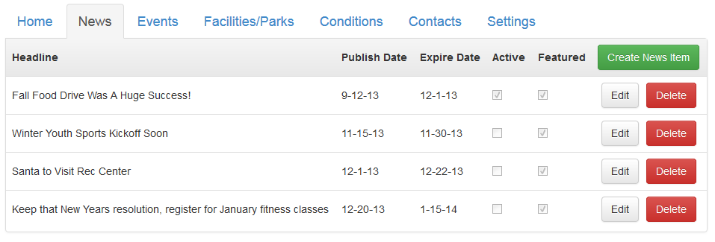

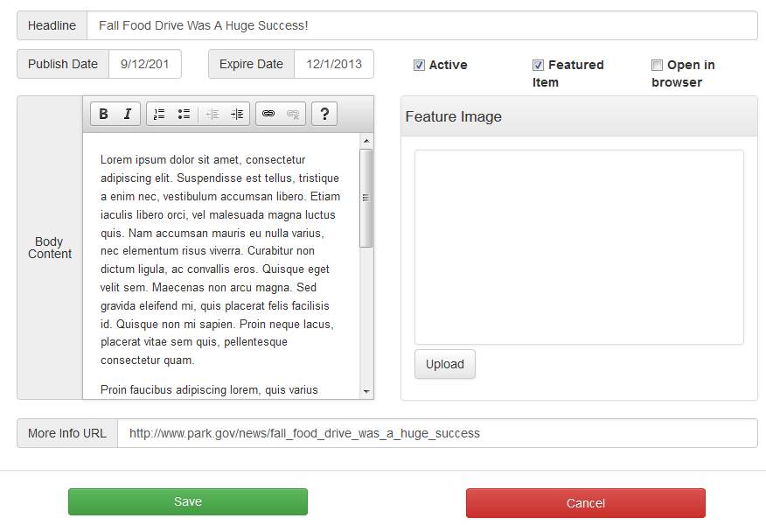

## Data Management: Events

Event Items have a list view and create/edit view.

* The list view has no actions other than edit or delete. Delete should provide a confirmation pop up.
* 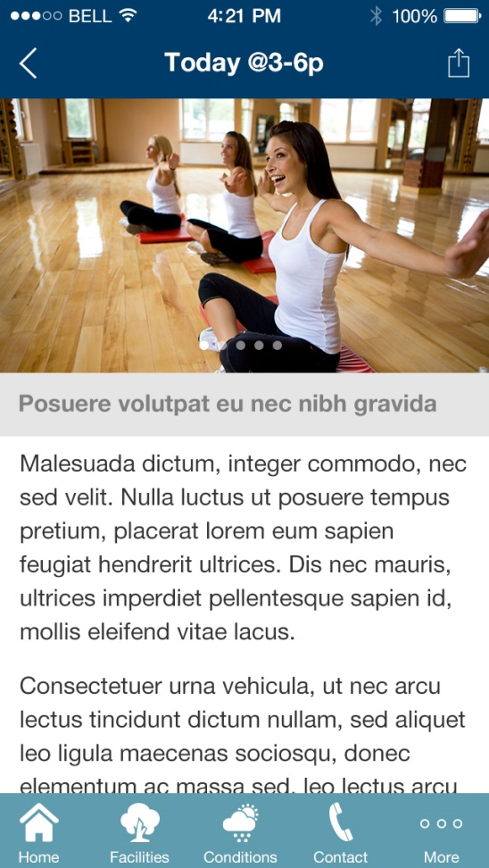Create/Edit view allows for content, metadata and image upload.

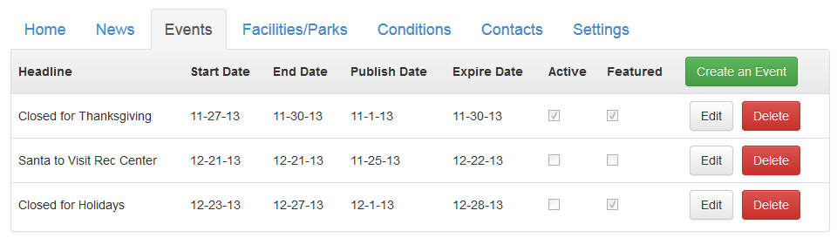

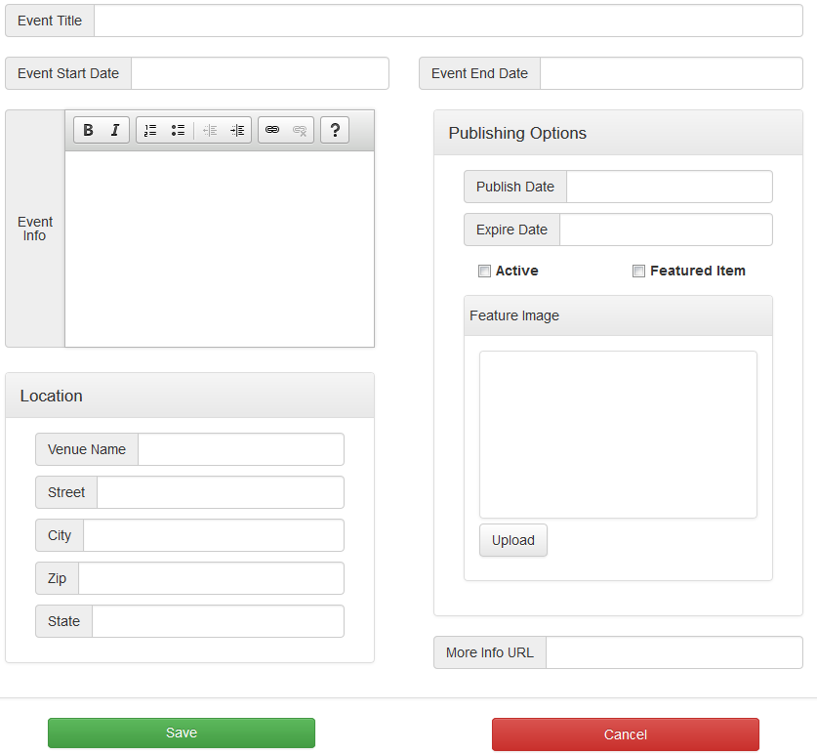

## \\LTS04\Developers\Clients\Central Parks\Facilities.jpgData Management: Facilities/Parks

Event Items have a list view and create/edit view.

* The list view has no actions other than edit or delete. Delete should provide a confirmation pop up.
* Create/Edit view allows for content, metadata, classification, attributes and multiple image upload.
* Image upload MAY need to be disabled until the record is “Saved” then be enabled, so the user doesn’t lose form data because of bad file upload on initial record creation.

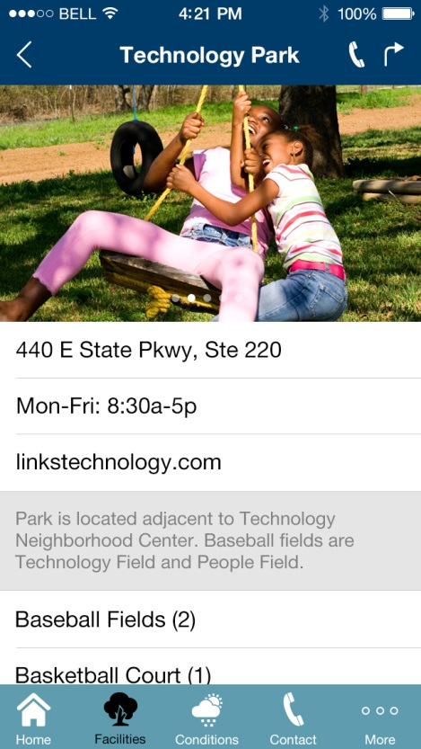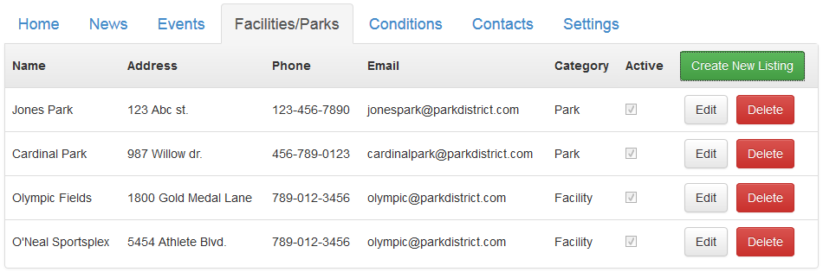

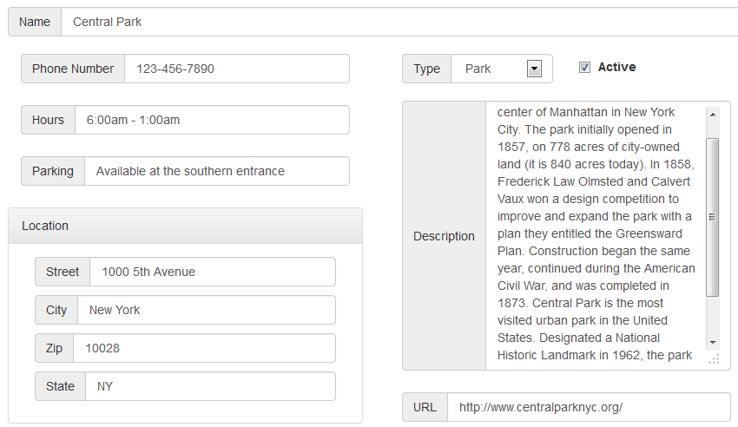

*(Facilities Edit/Create Continued)*  
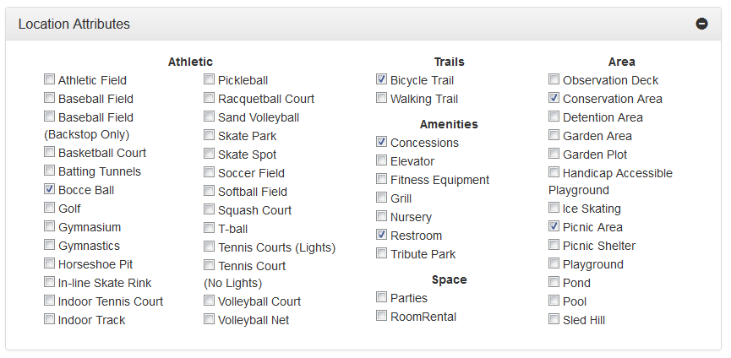

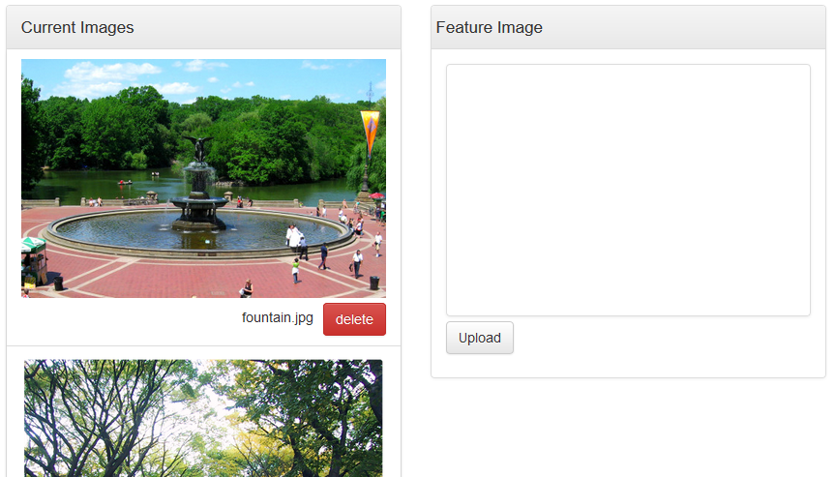

## \\LTS04\Developers\Clients\Central Parks\Conditions.jpgData Management: Conditions

Conditions items list out their status and allow for editing/creation of an item. A group condition management  
panel allows for the closing of whole groups of items. Notifications can also be initiated from here.

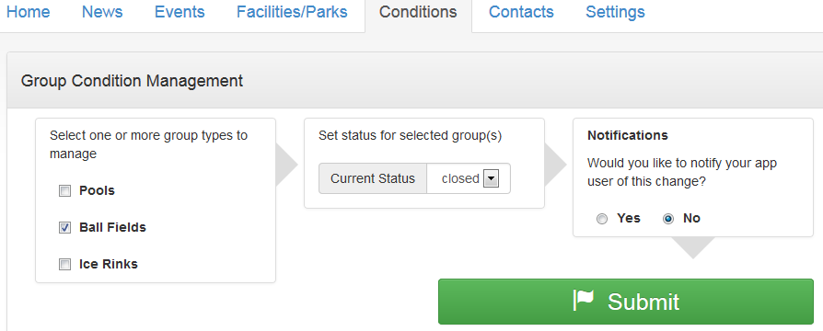

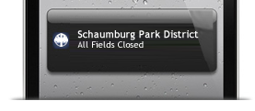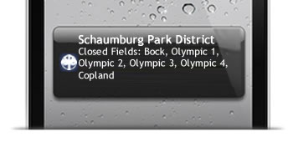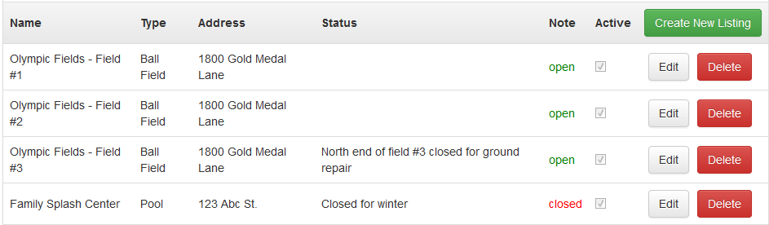

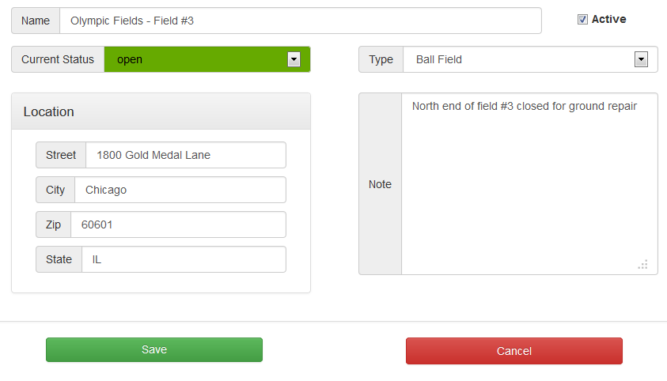

## Data Management: Contacts

Allows for editing and creating contacts for contact list in app. In app, tapping an item calls that item by phone number. Currently location/email is extraneous data not shown in app.

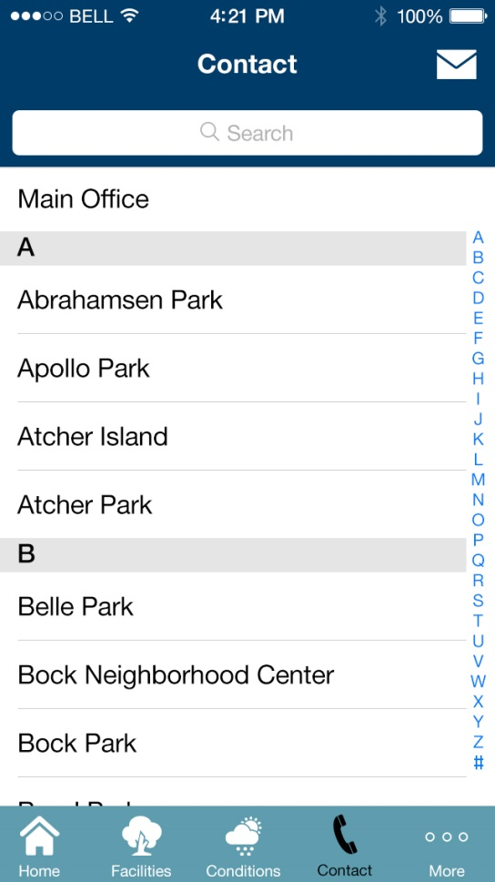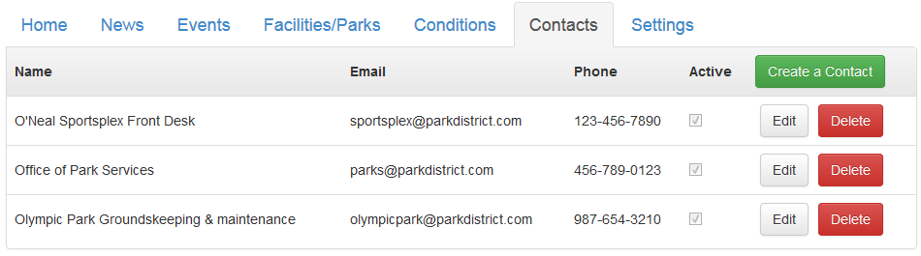

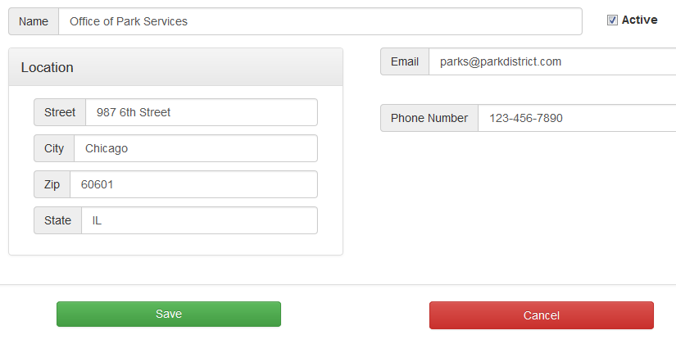

## Data Management: Settings

### Import Data

* This allows the upload of correctly formatted CSV files of content that will add the data to the selected area.

### Controllable Text Areas

In the App, there are a handful of text blocks that can draw from this list for their content.

* Welcome Message inserts on the splash page below the logo
* Terms of Service
* Privacy Statement
* Conditions Disclaimer

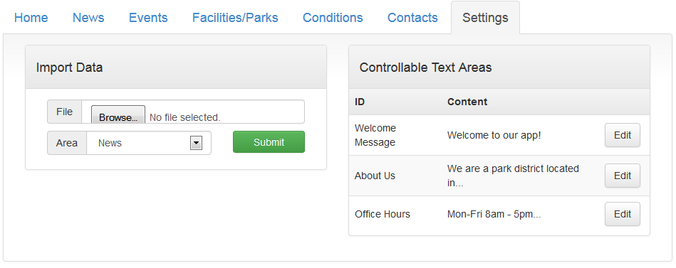

## Push Notifications:

Messages can be sent with specific pages as their target.

* When a specific page within news or events, the pull down shows:
  + The last 10 stories by publish date
  + The next 10 events by event date
* When a website is chosen, the user can enter website URL. (this may need to open browser IN the app to bypass security restrictions)

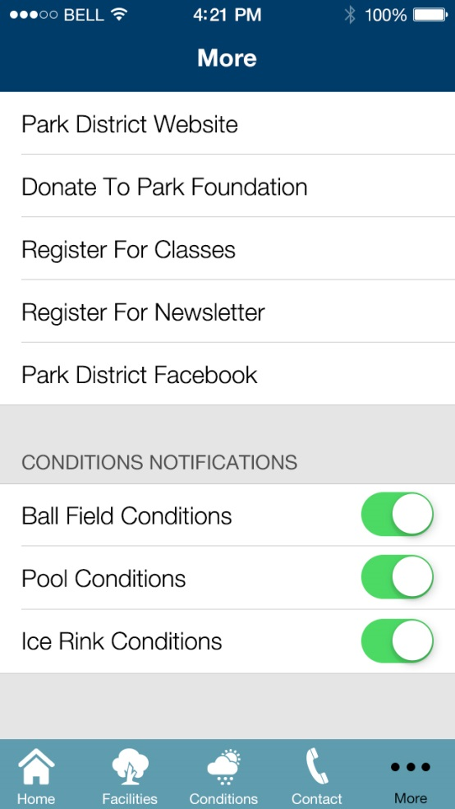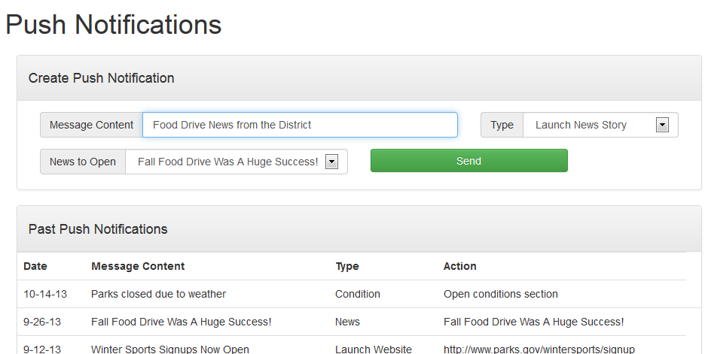

## User Management:

The Client can make users who are able to edit the content of the Middleware:

* Admin: has full access to client middleware site
* Content Editor: Can only access Data Management and Push Notifications areas (and help)
* The Client admin will set the users password and email will be used for the login.

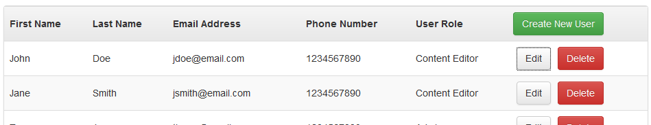

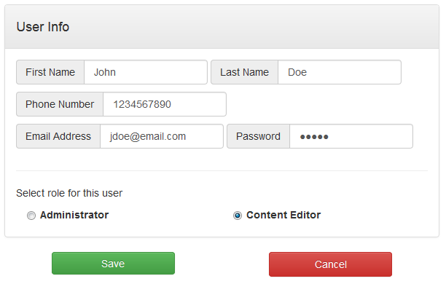

## Build Request

A set of items a user can adjust and submit to request a new build based on them.

## Help/Support

HTML page for later use.