Group_6 Simple Book Shop Managment Program

[ Member → Tamjid Hossain, Junayed Al Mubin*,* AKM Ashrafuzzaman ]

When the code runs the user is greeted with a warm welcome message stored in the system —

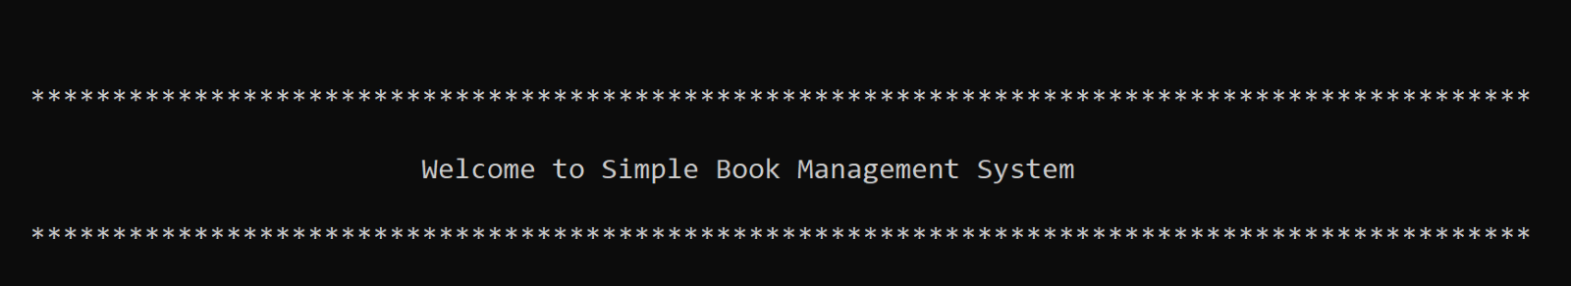

The program will then display all the options presented for the user to choose —

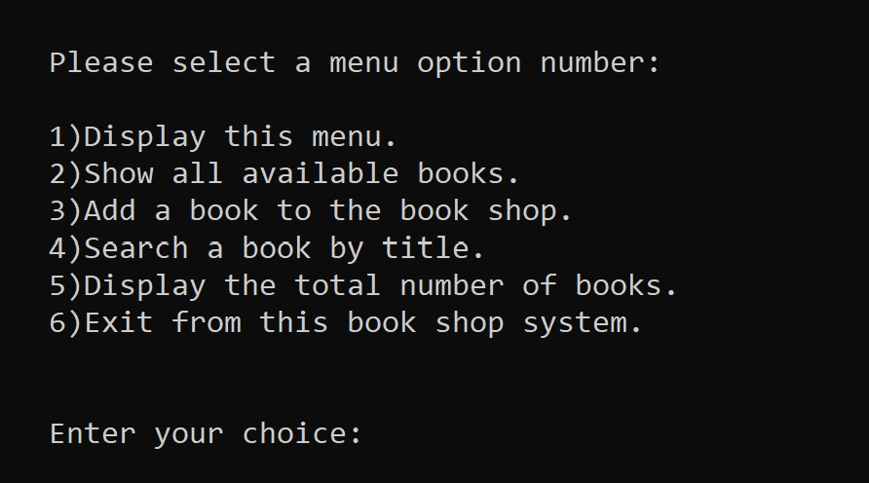

Then the user will be asked to enter an option of their choice.

Choosing Option 1 will display the showMenuOptions() and everytime the user enters 1 it will display the menu —

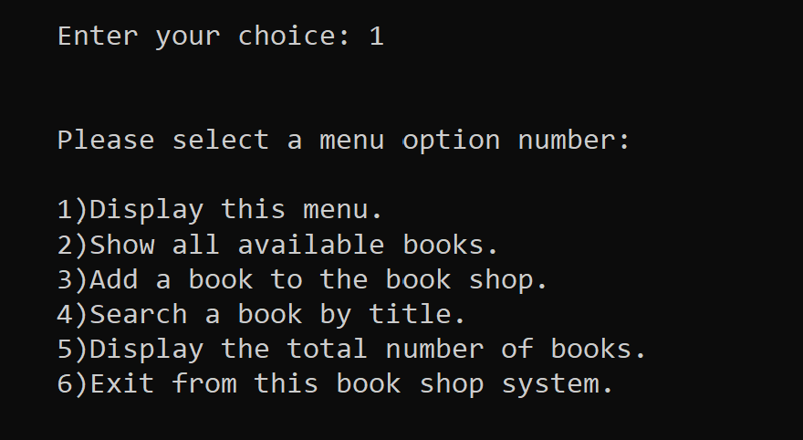

Choosing Option 2 will display all the books stored in the system as a list, but in the beginning there will be no books present in the system, and it will show a message to the user —

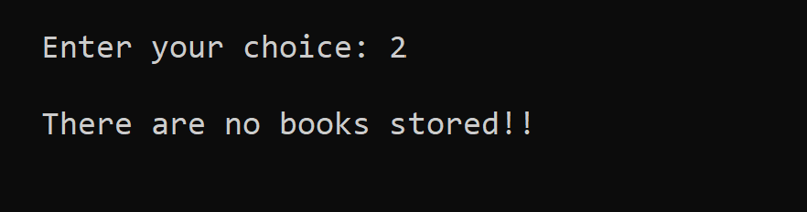

The user will have to choose Option 3 to add books in the system.

**Individual Test cases**

*Tamjid Hossain* ***(2022-3-60-015)***

The following books was addedby choosing option 3 —

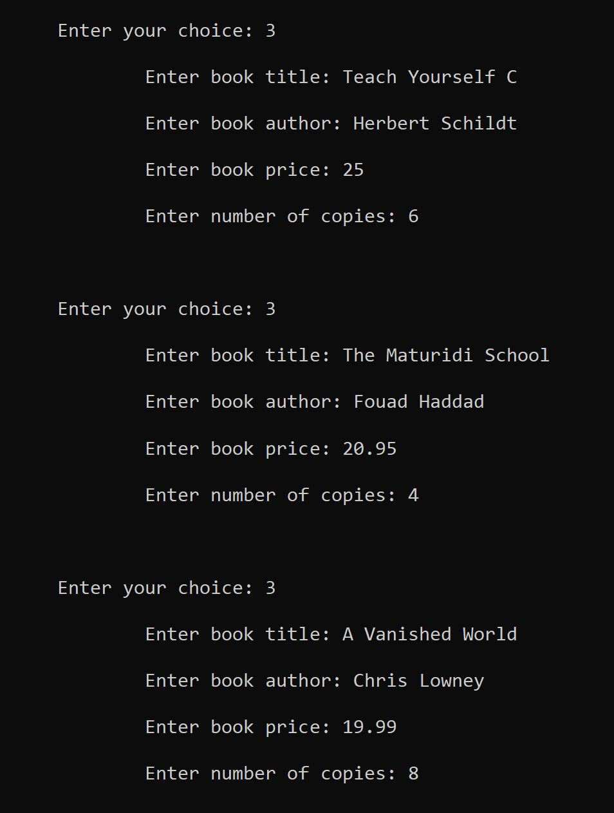

Now going back to Option 2, we can see by following results that the books have successfully added in the system —

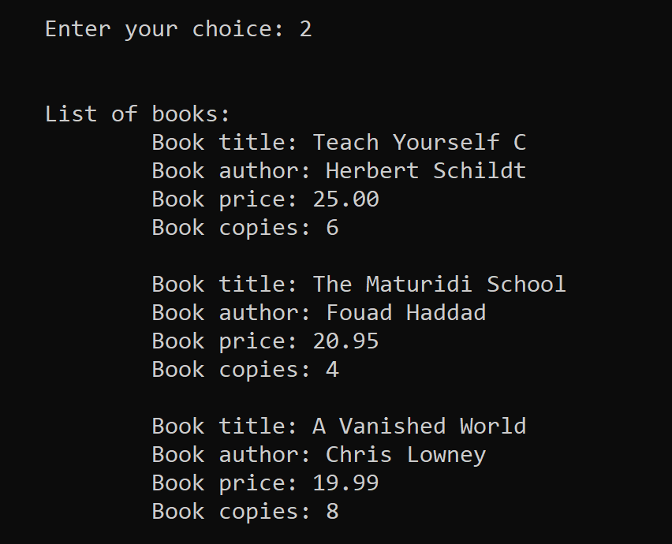

Now after adding many books in the system the user might want to search the system to find some books. They have the ability to do so.

Option 4 will ask the user to enter the title of the book to make sure if the desired book is present in the system —

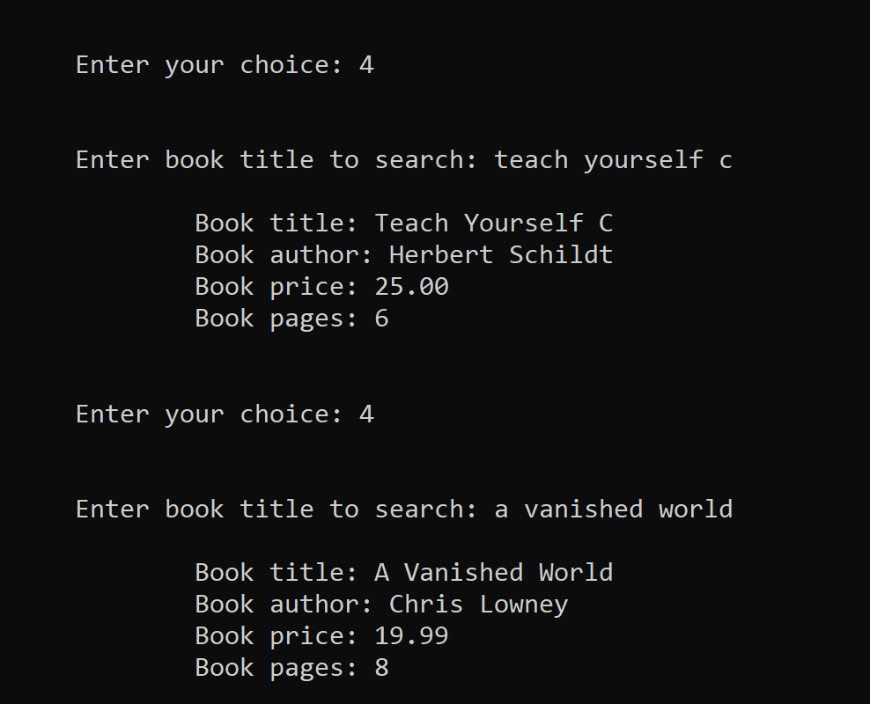

**If not**, the system will give user the following message —

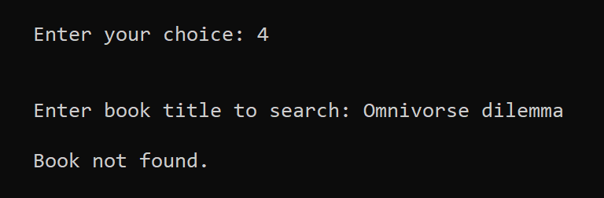

**Also**, the user do not have to worry about the case of the characters.

Choosing Option 5 will show the number of books present in the system —

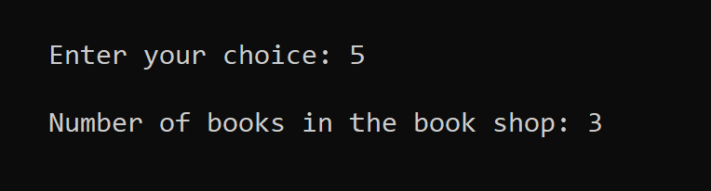

*Junaed Al Mubin* **(2021-3-60-122)**

Option 3 —

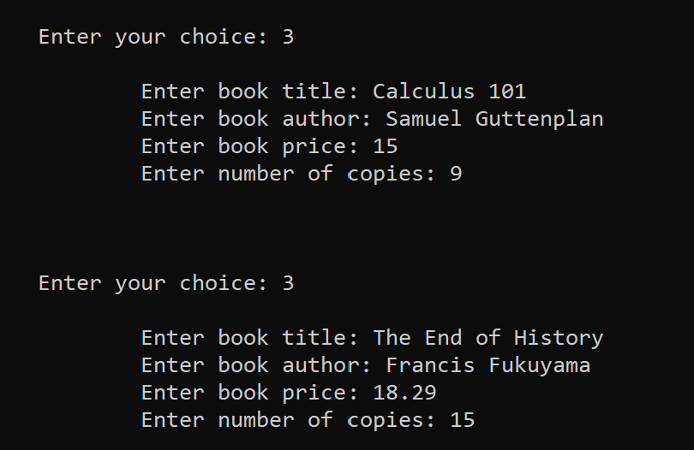

Option 2 —

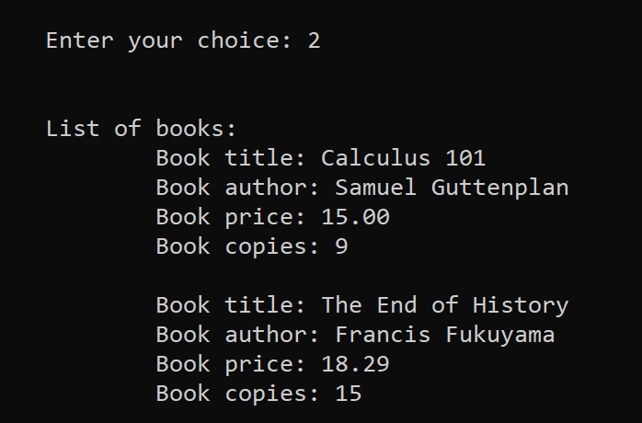

Option 4 —

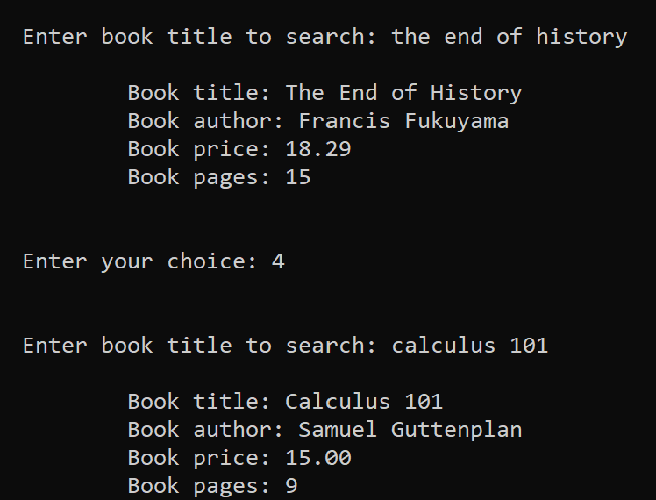

Option 5 —

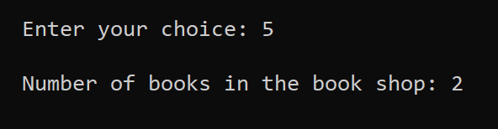

*AKM Ashrafuzzaman* **(2022-3-60-028)**

Option 3 —

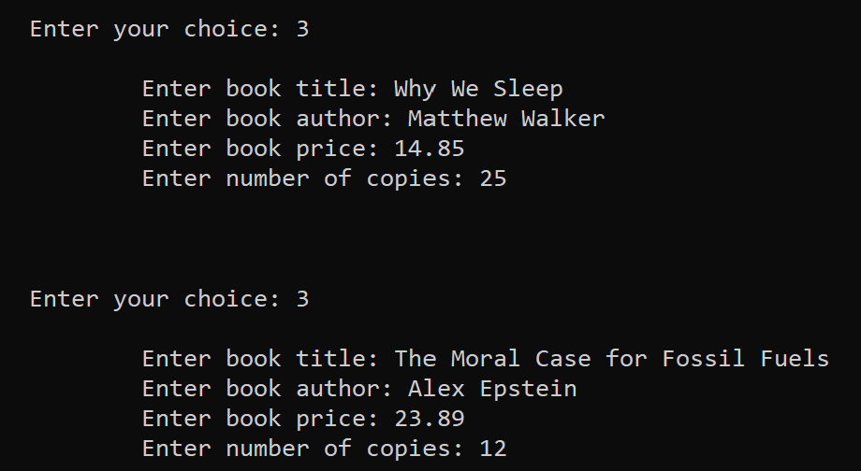

Option 2 —

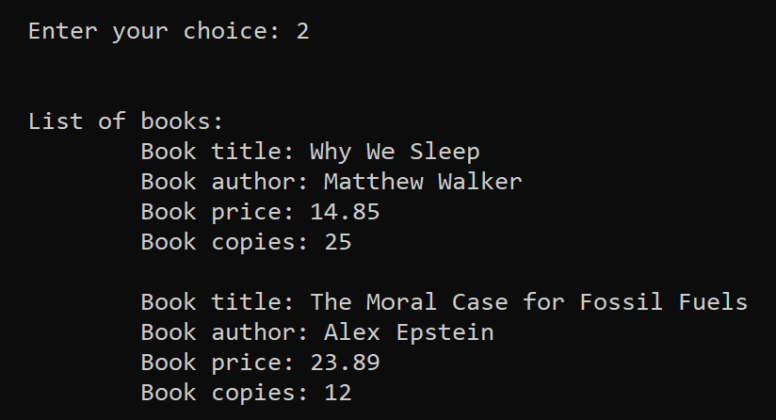

Option 4 —

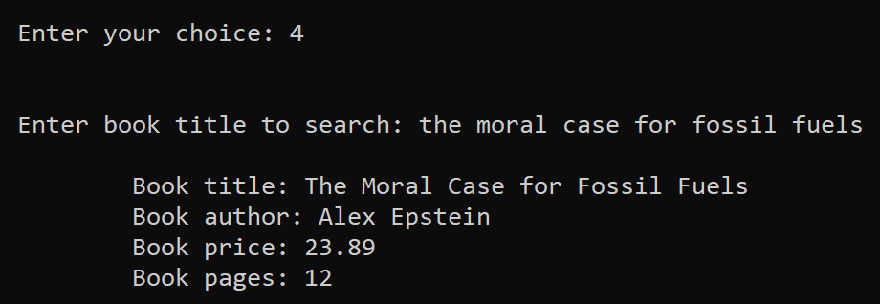

Option 5 —

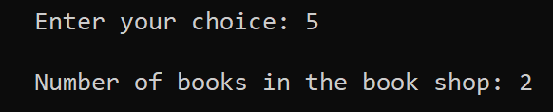

In the end, after the user has finished choosing the first 5 options, the last option-- number 6 will terminate the program by showing a Goodbye Message —

