CV:

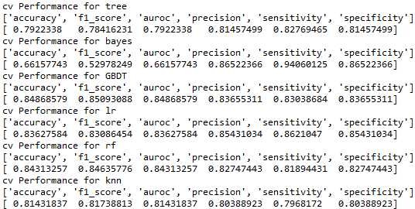

The best model is GBDT.

Test:

Tree

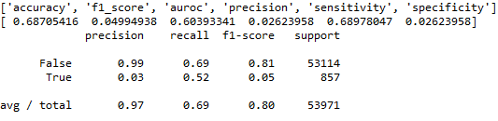

NBC

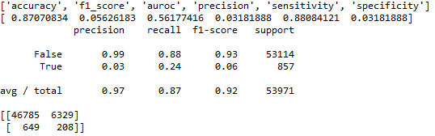

GBDT

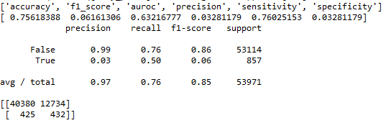

Logistic Regression

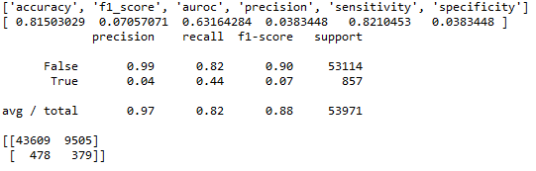

Random Forest

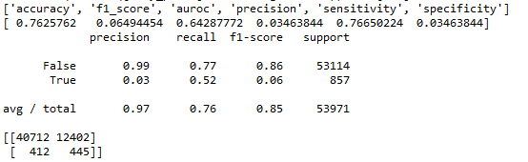

Feature importances:



kNN

