**WEEKLY STOCK MARKET DATA**

(a)

Table 1. Summary

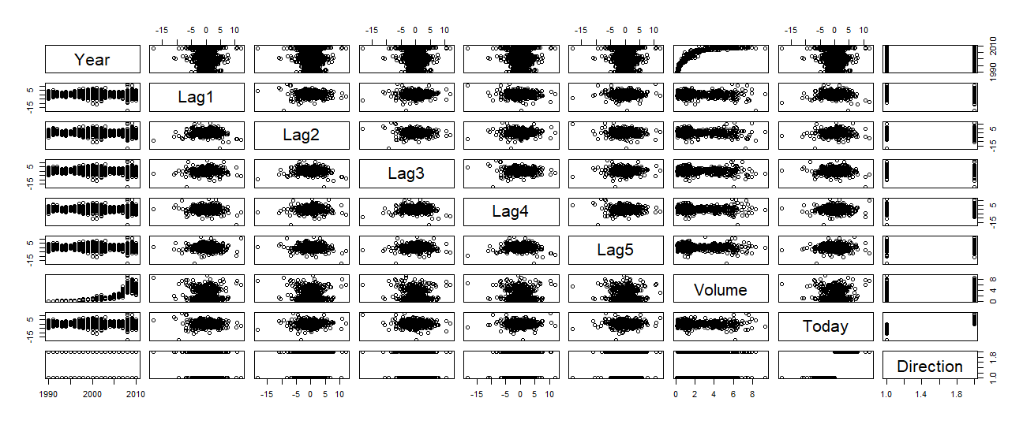

Figure 1. All information vs. Time(Weeks)

All these patterns are in this pairs plot. Volume goes up and down in the end, returns are all around 0 with similar standard deviation.

(b)

Table 2. Logistic Regression Fit

2 of the predictors appear to be statistical significant, “Intercept” and “Lag2” are significant in 0.001 and 0.01 significance level respectively.

(c)

Table 3. Confusion Matrix

overall fraction of correct predictions $=\frac{54+557}{1089}= 0.5610652$

Type I error rate is false positive rate $=\frac{430}{430+54}= 0.8884298$

Type II error rate False negative rate = $\frac{48}{48+557}=0.07933884$

(d)

Table 4. Confusion Matrix, Lag2 only

overall fraction of correct predictions $=\frac{9+56}{104}=0.625$

(e)

Table 5. LDA

(f)

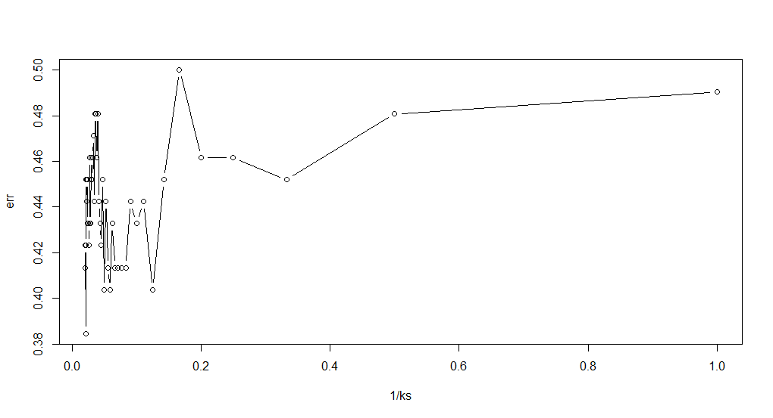

Figure 2. Misclassification Error Rate vs 1/k

Optimal k is 47 with minimum error rate 0.3846154

(g)

We have correct fraction of overall predictions

|  |  |
| --- | --- |
| Methods | Correct |
| Logistic | $$0.625$$ |
| LDA | $$0.625$$ |
| KNN | $$0.5961538$$ |

LDA and logistic have the best results, then KNN,.

(h)

Roc plots are below for Logistic regression, LDA, KNN(k=4,6,10)

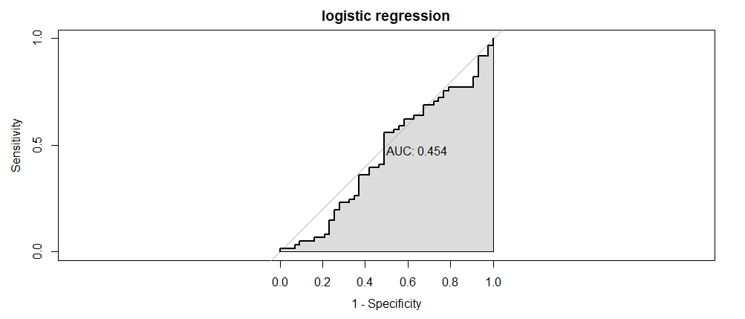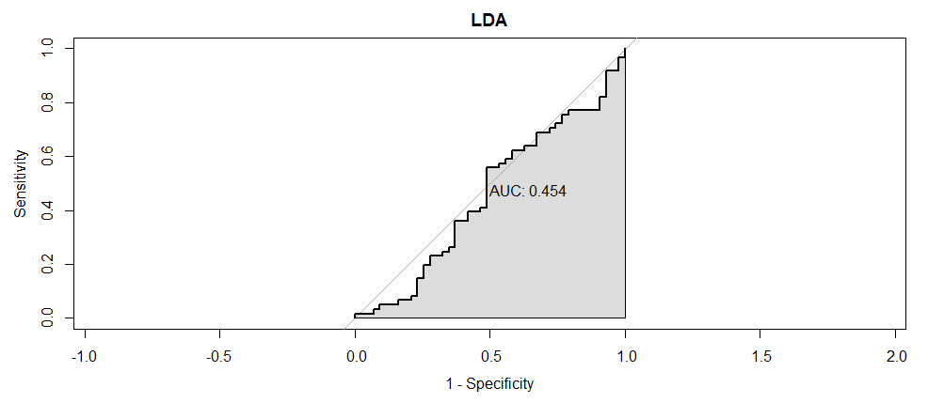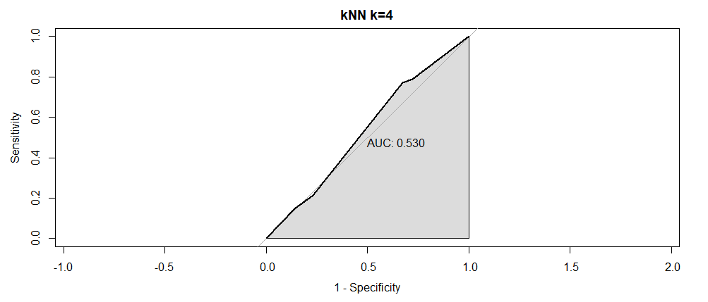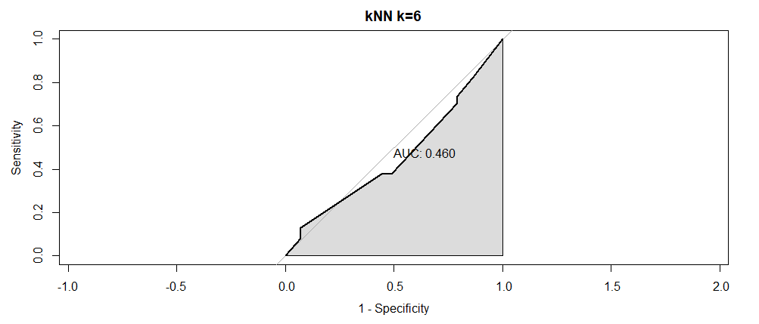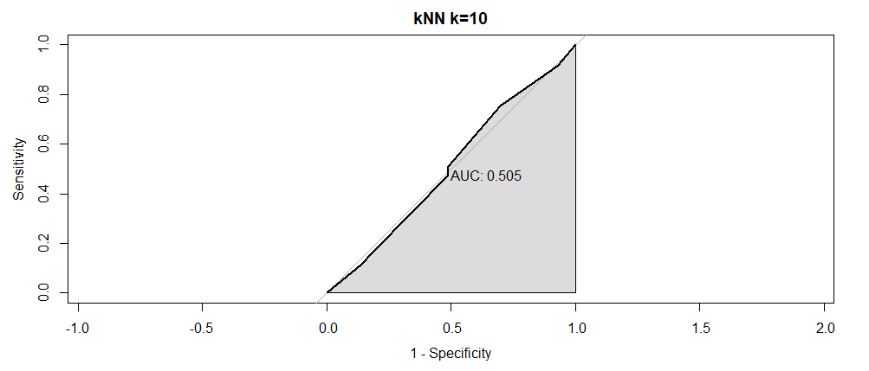

We can measure their performance by checking their AUC values.

Now we can rank them as follows:

$$k=4>k=10>k=6>LDA=Logistic regression$$