**PARKGENE Smart Contract page**

The repository contains the ERC-20 Smart Contract for PARKGENE token sale

**Description**

PARKGENE is a convenient and secure way to find parking, connecting drivers, individuals and businesses.

Our vision is to establish the GENE token as the currency for the automotive industry, allowing drivers to pay for parking and integrating it with mobility services, vehicles and infrastructure.

**Usage of Token**

Drivers looking for a parking spot meet virtually with parking owners through the PARKGENE app.

Once a driver reserves a parking spot, the reservation triggers the PARKGENE smart contract on the Ethereum Public Blockchain.

The PARKGENE App transfers the full parking fee amount, in GENEs, from the driver wallet, to a depository (a temporary wallet). In case there is not enough GENEs balance in the driver’s wallet, the driver can use his credit card or other means of payment (bitcoins, ethers) to buy GENEs realtime and pay for the transaction.

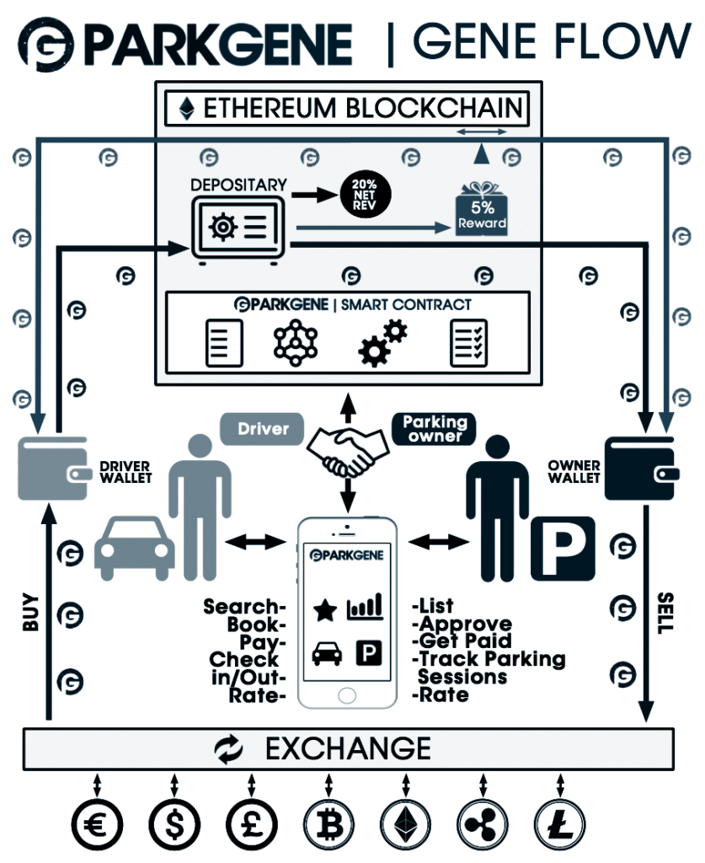

**Bug Bounty Program**

We are starting our bug bounty program for all PARKGENE smart contracts relating to our GENE Token sale.

**Total amount of GENE Tokens distributed for this category is  3,250,000 GENE.**

Most of the rules on https://bounty.ethereum.org apply:

* First come, first serve.
* Issues that have already been submitted by another user or are already known to the PARKGENE team are not eligible for bounty rewards.
* Public disclosure of a vulnerability makes it ineligible for a bounty.
* Anyone who was a paid auditor of this code is not eligible for rewards.
* Determinations of eligibility, score and all terms related to an award are at the sole and final discretion of the PARKGENE team.

**Scope**

All smart contracts relating to the GENE token sale.

**Token sale details**

Take a look at : <https://parkgene.io/token-sale-details/>

**Links**

[https://parkgene.io](https://parkgene.io/)